
THE KENYA NATIONAL EXAMINATION AND ASSESSMENT PREDICTION SERIES

Candidate’s Name |  | Assessment Number
School Name |  | School Code
Candidate’s Signature |  | Date

KENYA JUNIOR SCHOOL EDUCATION ASSESSMENT 903: MATHEMATICS
-MATHEMATICS-

Time: 1 hour 40 minutes INSTRUCTIONS TO CANDIDATES
- Write your name and assessment number in the spaces provided above.
- Write the name and code of your school in the spaces provided above.
- Sign and write the date of the assessment in the spaces provided above.
- This paper consists of two sections: A and B.
- Section A comprises Multiple Choice Questions numbered 1 to 30.
- Section B comprises short, structured questions number 31 to 42.
- Answer ALL the questions in section A on the separate ANSWER SHEET provided.
- Answer ALL the questions in section B in the spaces provided in this QUESTION PAPER.
- Do NOT remove any page from this question paper.
- Answer ALL the questions in English.

For official use only

Section | Task | Question Numbers | No. of Questions | Max Score | Candidate Score
A | Multiple Choice | Q1 – Q20 | 20 MCQs | 20 marks
B | Task 1: Operations & Word  Problems | Q21 – Q23 | 3 | 16 marks
B | Task 2: Algebra & Geometry | Q24 – Q25 | 2 | 14 marks
B | Task 3: Measurement &  Geometry | Q26 – Q28 | 3 | 20 marks
B | Task 4: Data Handling &  Probability | Q29 – Q31 | 3 | 18 marks
B | Task 5: Pie Chart & Time  Allocation | Q32 – Q33 | 2 | 12 marks
TOTAL |  |  | 33 (incl. 20  MCQs) | 100 marks
This paper consists of 17 printed pages. Candidates should check the question paper to ascertain that all the pages are printed as indicated and that no questions are missing.

© The Kenya National Examination and Assessment Prediction Series
Turn over

SECTION A (20 marks)
Answer all questions in this section

- Which of the following is NOT an integer? A. -7
  - 0
  - 3.5

  - 14

Working space

- The matrix is of order:
3
7
2
5

- 1×2
- 2×1
- 2×2
- 3×3

- Below is a cylinder.

17cm

21cm

What is half the volume of the cylinder?
A. 2016 cm³ B. 2560 cm³
C. 2944 cm³ D. 3072 cm³

- If the price of an item is Ksh 480 after a 20% discount, what was the original price? A. Ksh 384
B. Ksh 576 C.
Ksh 600 D. Ksh 720
- The equation 2x+3=7 has the solution:
A. 2 B. 5
C. -2 D. 10
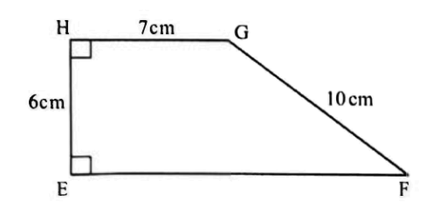
- The area of the trapezium EFGH shown below is 66cm2 What is the length of EF?

A. 4cm B. 8cm
C. 15cm D. 22cm

- Which inequality represents “y is less than or equal to 5”? A. y≥5
B. y≤5
C. y>5
D. y<5
- Find the gradient of the line 4x−2y+8=0. A. 2
  - -2
  - 1/2
  - -1/2
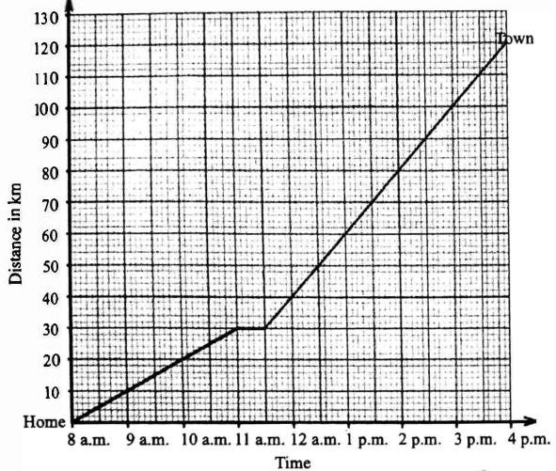
- A cyclist travels from home to town and back. What is his speed in km/h?

- 7.5km/h
- 120 km/h
- 30 km/h
- 15 km/h

- The density of a substance is 2.5 g/cm³. What is the mass of 10 cm³ of the substance?
- 0.25 g
- 2.5 g
- 25 g
- 250 g
- Round off 45.6789 to 3 significant figures.
- 45.7
- 45.67
- 45.68
- 46
- Which of the following is a solution to the inequality 2x−3>2

- x=3
- x=1
- x=0
- x=−1

Working space

- Given simultaneous equations: 2x+y=10 x−y=2 Find the values of x and y.
- x=3,y=4
- x=4,y=2
- x=2,y=6
- x=5,y=0
- Which of the following is a logarithmic expression?
- log28
- 23
- 3+5
- x2
- 29. Peter has sh x and Maria has four times as much money as Peter. Ali has sh 7 less than Maria. How much money do they have altogether?

- sh (5x-7)
- sh (6.x-7)
- sh (9x-7)
- sh (9x + 7)

- Find the area of a trapezium with parallel sides of lengths 8 cm and 5 cm, and height 6 cm.
- 39 cm²
- 26 cm²
- 40 cm²
- 78 cm²
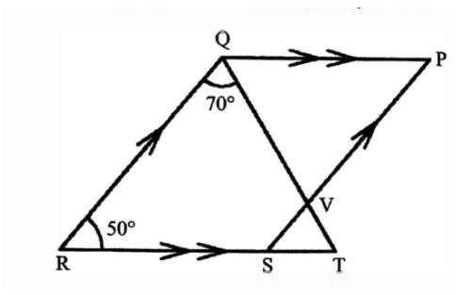
- In the figure below PQRS is a parallelogram. Lines QP and RT are parallel. Lines RQ and SP are parallel.Angle QRS = 50° and angle RQT = 70°.What is the size of angle PQV?

- 60°
- 110°.
- 0°
- 130°

- Twenty four men working at the same rate can finish a job in 6 days. Eight men failed to turn up to do the job. How many more days will the remaining men working at the same rate take to finish the same job?

A. 3 B. 4 C. 9 D. 15

Working space

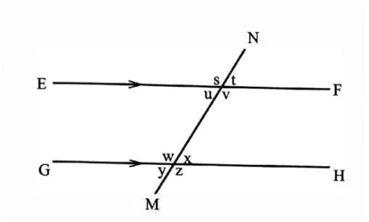
Working space
19. In the figure shown below, line EF is parallel to line GH. Line MN is a transversal. Which one of the following statements is correct?
- Angle (t + u) - 180°

- Angle (u + x) = 180°

- Angle (s + w) = 180°

- Angle (u + w) = 180°

Working space
- The number of fish sold by a fish monger was represented in a bar graph as shown.
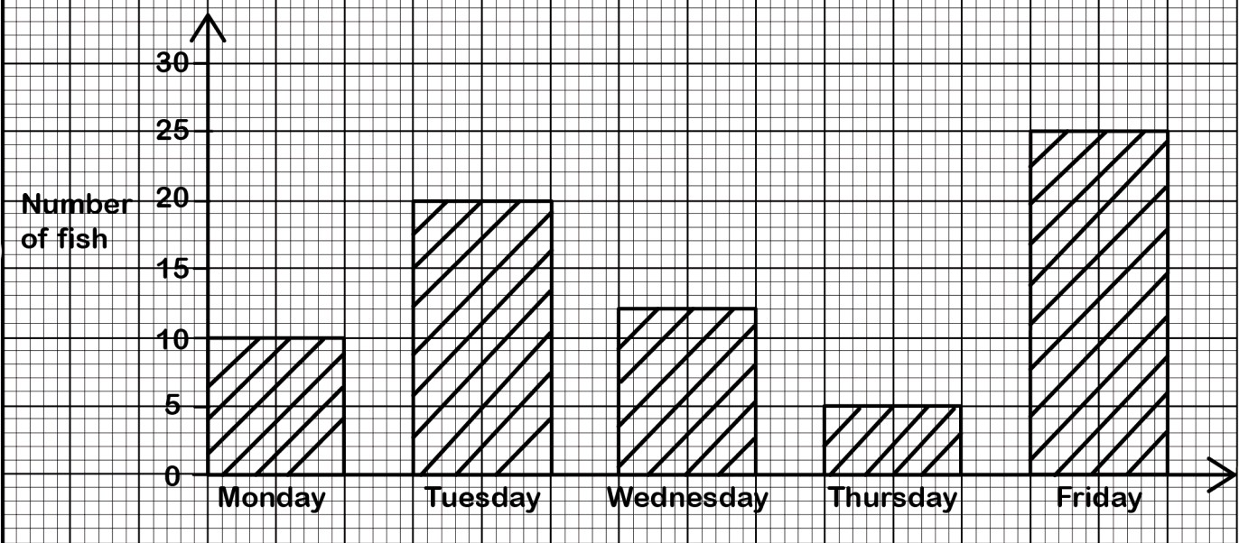

On which two consecutive days did the fish monger sell the highest number of fish?

  - Tuesday and wednesday
  - Monday and Tuesday
  - Thursday and Friday
  - Wednesday and Thursday

SECTION B (80 marks)
Answer ALL questions in the spaces provided.
21. A school is organizing a trip for 150 learners. They hire buses that can each carry a maximum of 35 learners.
- How many buses are needed for the trip? (2 marks)

- The cost of hiring each bus is Ksh 12,000. Calculate the total cost of hiring the buses. (2 marks)

- The school also budgets Ksh 80 per learner for meals during the trip. Calculate the total cost of meals for all the learners. (2 marks)

- What is the total expenditure for the school trip? (2 marks)

- The school decides to charge each learner Ksh 550 for the trip. Calculate the total amount of money collected from the learners. (2 marks)

- Determine the profit or loss the school makes from the trip. (2 marks)

22. A farmer has a rectangular piece of land measuring 80 meters long and 50 meters wide.
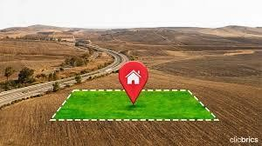

- Calculate the area of the farmer's land in square meters. (2 marks)

- Calculate the perimeter of the land. (2 marks)\

- The farmer decides to fence the land using wire mesh. The cost of the wire mesh is Ksh 150 per meter. What will be the total cost of fencing the land? (2 marks)

- The farmer plants maize on 43 of the land and beans on the remaining part. What area of the land is planted with maize? (2 marks)

- What area of the land is planted with beans? (2 marks)

- If the farmer harvests 5 kg of maize per square meter from the area planted with maize, what is the total mass of maize harvested in kilograms? (2 marks)

23. A shopkeeper buys 200 packets of juice at Ksh 25 per packet.
- What is the total cost of the juice packets? (2 marks)

- The shopkeeper sells each packet of juice at Ksh 40. What is the total revenue from selling all the juice packets? (2 marks)

- Calculate the profit made by the shopkeeper. (2 marks)

- The shopkeeper offers a discount of 10% on the selling price for customers who buy more than 10 packets at once. If a customer buys 15 packets of juice, what will be the discounted price per packet? (2 marks)

- What will be the total amount the customer pays for the 15 packets? (2 marks)

- The shopkeeper also sells bread. The cost price of a loaf of bread is Ksh 30, and the selling price is Ksh 36. What is the percentage profit the shopkeeper makes on each loaf of bread? (2 marks)



24. Given matrices A= 2 | 3 | and B= | 5 | 1 | , find the matrix A+B. (3 marks)
4 |  | 1 | 0 | 3

25. A bag contains 5 red, 3 blue, and 2 green balls. A ball is drawn at random. What is the probability that the ball is not red? (3 marks)

26. A trader exchanged 20,000 Kenyan shillings (Ksh) for US dollars at the rate of Ksh 120
= 1 USD. How many US dollars did the trader receive? (3 marks)

27. A rectangular tank measures 2 m by 1.5 m by 1 m. Calculate the capacity of the tank in liters. (1 m³ = 1000 liters) (3 marks)

28. A cylinder has radius 7 cm and height 10 cm. Calculate the total surface area of the cylinder. Use π=3.142. (4 marks)

- A mass of 1500 g occupies a volume of 500 cm³. Calculate the density of the substance. (2 marks)

- Find the approximate value of 50 to 3 significant figures. (2 marks)

- Express log₁₀1000 as a simple number. (2 marks)

- Solve the simultaneous equations: (4 marks) 3x+2y=12
x−y=3

- The number of learners selected to represent their school in various ball games was recorded as shown in the table below.

ame | Football | Netball | Volleyball | Handball | Basketball
Number of Learners | 18 | 12 | 10 | 9 | 11

Represent the number of learners selected for each game on a pie chart. (3 marks)

- A line passes through the point (2, 3) and has a gradient of 4. Find its equation in the form y=mx+c. hence draw the line in the graph below (3 marks)


- Represent the inequality 2x + y ≤ 6 on a graph.hence give one values that suits the inequality. (4 marks)

- Two triangles A and B are drawn in a grid as shown. Triangle B is an enlargement of triangle A

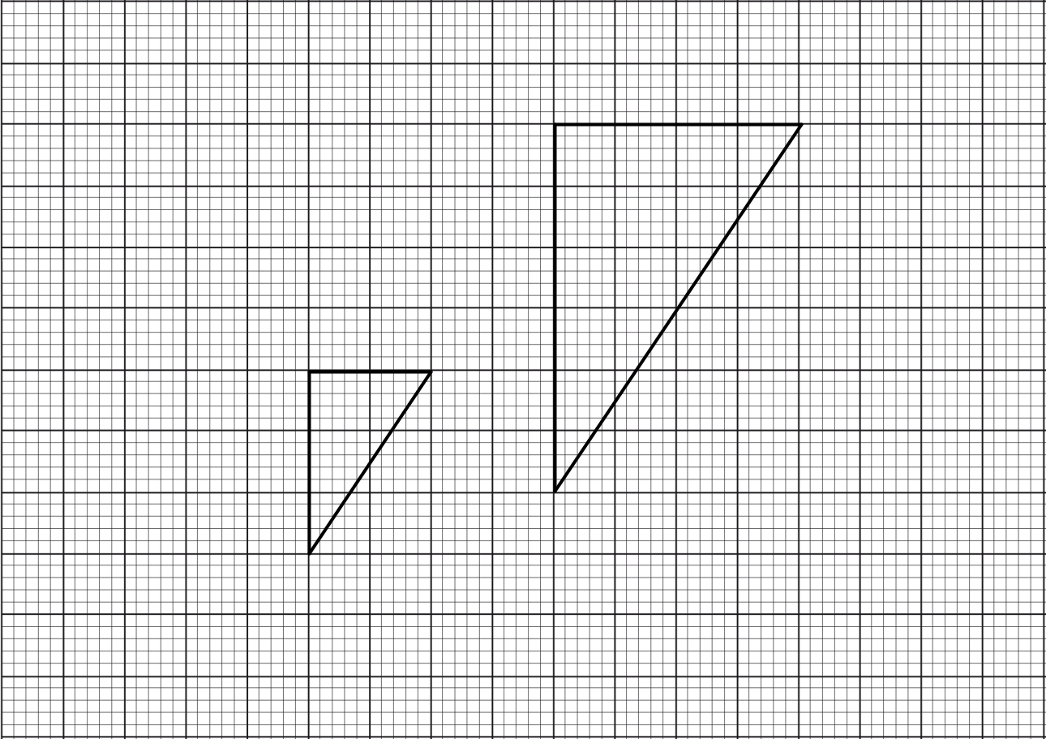
B
A

- Determine the scale factor of the enlargement. (2 marks)

- On the grid, mark point X, the centre of the enlargement. (1 mark)

37.(a) Using a ruler and compass only, construct a triangle ABC such that AB = 6 cm, BC = 8 cm, and AC = 10 cm. (5 marks)

(b) Measure angle ABC. (1 mark)

38.(a) Draw a Cartesian plane showing the x-axis and y-axis from -5 to 5. (2 marks)

(b) Plot the points P(1, 3) and Q(-2, -3). (2 marks)
(c) Draw the line passing through points P and Q. Find the equation of this line. (3 marks)

THIS IS THE LAST PRINTED PAGE


THE KENYA NATIONAL EXAMINATION AND ASSESSMENT PREDICTION SERIES

Candidate’s Name |  | Assessment Number
School Name |  | School Code
Candidate’s Signature |  | Date
KENYA JUNIOR SCHOOL EDUCATION ASSESSMENT
901/1: ENGLISH (Reading Comprehension, Oral Skills and Grammar) Paper 1

Time: 1 hour 40 minutes INSTRUCTIONS TO CANDIDATES
- You have been given this question paper and a separate answer sheet. The question paper consists of 50 multiple choice questions.
- Answer ALL questions on the ANSWER SHEET provided, NOT on the question paper.
- Do all the necessary rough work on the question paper.

HOW TO USE THE ANSWER SHEET


- Use an ordinary HB pencil.
- Confirm that the answer sheet you have been provided with has the following:

YOUR ASSESSMENT NUMBER YOUR NAME NAME OF YOUR SCHOOL NAME OF THE SUBJECT
-ENGLISH-

- Keep the answer sheet clean and dry. DO NOT fold it.
- For each of the questions 1 – 50, four options are given. The options are lettered A, B, C and D. In each case, only ONE of the four options is correct. Choose the correct option.
- On the answer sheet, the correct answer is to be shown by drawing a DARK LINE inside the box in which the letter you have chosen is written.

Example In the Question paper:

40. Which one of the following means the opposite of the word “better”?

A. weak B. wrong C. worse D. wasted

The correct answer is „C‟. On the answer sheet, in the set of boxes given for number 40, draw a DARK LINE inside the box with the letter C printed in it as marked below.

40 A B C D

- Your dark line MUST be within the box. DO NOT make any marks outside the boxes.
- For each question, ONLY ONE box is to be marked.

This paper consists of 6 printed pages. Candidates should check the question paper to ascertain that all the pages are printed as indicated and that no questions are missing.

© The Kenya National Examination and Assessment Prediction Series
Turn over

Read the passage below and then answer questions 1 to 6.
The sun is a giant star at the center of our solar system. It is a huge ball of hot, glowing gases. The sun gives us light and heat, which are essential for life on Earth. Without the sun, Earth would be a cold, dark place.
The sun's energy also helps plants grow, which in turn provide food for animals and humans. The sun is much larger than the Earth. In fact, you could fit over a million Earths inside the sun! Even though it looks small to us, it is actually very far away – about 150 million kilometers. This distance is just right to keep Earth warm enough for us to live comfortably. The sun has been shining for billions of years and will continue to do so for many more. It is a powerful and important part of our universe.

- According to the passage, the sun is
A. a small planet.
B. a hot, glowing star.
C. a cold, dark object.
D. a source of water.
- What are the two things that the sun provides for life on Earth?
- Air and water
- Food and shelter
- Light and heat
- Plants and animals
- Which of the following is true about the size of the sun compared to Earth?
- The sun is smaller than Earth.
- The sun is the same size as Earth.
- The sun is much larger than Earth.
- The passage does not mention their sizes.
- The phrase "essential for life" in the passage means
- not important for living things.
- very important for living things.
- sometimes needed by living things.
- harmful to some living things.
- The distance between the Earth and the sun is approximately
A. a few kilometers.
B. a million kilometers.
C. 150 million kilometers.
D. billions of kilometers.
- Which of the following would be the best title for this passage?
  - The Planets in Our Solar System
  - The Importance of Water on Earth
  - The Amazing Sun
  - How Plants Grow

Read the passage below and then answer questions 7 to 11.
Once upon a time, in a small village nestled beside a large forest, lived a young boy named Kofi. Kofi was known for his kindness and his love for animals. One sunny morning, as Kofi walked through the forest, he heard a small whimpering sound. He followed the sound and found a little bird with a broken wing. Kofi gently picked up the bird and took it home. He carefully cleaned its wing and made it a cozy nest in a basket. Every day, Kofi fed the bird with tiny crumbs and fresh water. He talked to it softly and kept it safe. Slowly, the bird's wing began to heal. One day, the bird fluttered its wings strongly and flew out of the basket. It circled Kofi's head a few times, chirped happily, and then soared into the sky. Kofi smiled, happy that he had helped the little creature.

- What was Kofi known for in his village?
  - His strength and speed
  - His kindness and love for animals
  - His singing and dancing skills
  - His cleverness and tricks
- Where did Kofi find the injured bird?
  - In his house
  - Beside a river
  - In the forest
  - In the village square
- What did Kofi do for the injured bird?
  - He ignored it and walked away.
  - He chased it further into the forest.
  - He took it home and cared for it.
  - He showed it to other villagers.

- The word "gently" as used in the passage means
  - in a rough way.
  - in a hurried manner.
  - with great care.
  - with loud noises.
- What lesson can we learn from this story?
  - Birds cannot heal their broken wings.
  - It is important to be kind and helpful to animals.
  - Forests are dangerous places for children.
  - Small villages are better than big cities.

Read the following dialogue between a teacher and a learner, and then answer questions 12 to 16.
Teacher: Good morning, Amina. How are you feeling today?
Amina: Good morning, Madam. I am not feeling very well. I have a terrible headache.
Teacher: Oh, I'm sorry to hear that. Have you taken any medicine?
Amina: Not yet, Madam.
Teacher: I think you should go home and rest. I will give you a note for your parents.
Amina: Thank you, Madam. But I will miss the science lesson.
Teacher: Don't worry about that. You can catch up when you are feeling better. Your health is more important.
Amina: Okay, Madam. Thank you for understanding.
Teacher: You're welcome, Amina. Take care.

- Why is Amina not feeling well?
  - She is tired from playing.
  - She has a terrible headache.
  - She is angry with the teacher.
  - She missed her breakfast.
- What does the teacher advise Amina to do?
  - To stay in class and study harder.
  - To go home and rest.
  - To take a science test.
  - To go and play with her friends.
- What will the teacher give Amina?
  - A book to read.
  - A note for her parents.
  - Some medicine for her headache.
  - Homework to do at home.
- The phrase "catch up" as used by the teacher means
  - to run faster than others.
  - to reach the same level as others.
  - to teach others what they missed.
  - to forget about something.
- What does Amina thank the teacher for?
  - For the interesting science lesson.
  - For the delicious food.
  - For understanding her situation.
  - For the beautiful flowers.

Read the passage below and then answer questions 17 to 20.
Kamau likes to read storybooks and draw pictures. Sarah enjoys playing netball and singing in the school choir. Peter's favorite activities are playing chess and solving puzzles. Maria loves to help in the school garden and also participates in drama club.

- Which activity is enjoyed by Sarah?
  - Reading storybooks
  - Playing chess
  - Playing netball
  - Helping in the school garden
- What are Peter's favorite activities?
  - Reading and drawing
  - Netball and singing
  - Chess and solving puzzles
  - Gardening and drama
- Who likes to help in the school garden?
  - Kamau
  - Sarah
  - Peter
  - Maria

- Which of the following activities is NOT mentioned in the passage?
  - Singing
  - Dancing
  - Reading
  - Drawing

Complete the following telephone conversation between two classmates, Juma and Wanjiku. Choose the best response for the blanks numbered 21 to 23.
Juma: Hello, Wanjiku. It's Juma here.
Wanjiku: Hello, Juma. How are things?
Juma: 21. …………………………………………………….………………………… Wanjiku: I'm doing well, thank you. Did you finish the homework for mathematics? Juma: Yes, I did. 22. …………………………………………………………………… Wanjiku: Oh, that's a good idea. I was having trouble with question number three.
Juma: 23. ……………………………………………………………………………….
Wanjiku: Great! Thanks a lot, Juma.
- A. I am fine, and you? B. I am going home now.
C. I have lost my pen. D. I don't understand this question.
- A. I think the teacher is absent today. B. I was wondering if you understood question number five.
C. Let's play football after school. D. I have a new storybook to read.
- A. Maybe you should ask your brother for help. B. I can explain it to you later if you like.
C. The answer is twenty-five. D. I don't remember how to do it either.

For questions 24 and 25, select the best response in the given situations.

- Your friend shows you a drawing they have just finished and asks for your opinion. You think it is very good. What should you say?
  - This is not bad.
  - It's okay, I guess.
  - Wow, this is fantastic!
  - You could have done better.
- You accidentally bump into someone in the hallway, causing them to drop their books. What should you say immediately?
  - What's wrong with you?
  - That's your problem.
  - Excuse me, I'm so sorry.
  - Just pick them up.

Read the passage below. It contains blank spaces numbered 26 to 35. For each blank space, choose the best alternative.
Many people enjoy listening to music. Music can make us feel happy, sad, or 26. It can also help
us to relax or feel ……27. Different types of music appeal 28 different people. Some prefer
fast, energetic music, 29 others enjoy slow, calming melodies. Music is often played at
celebrations and ……………….30. It can bring people 31 and create a sense of togetherness.
Learning to play a musical instrument can be a rewarding …………..32. It requires practice and…………… 33, but it can also be a lot of fun. Playing music can also help to improve concentration and 34
skills. Whether you are listening to it or playing it, music can be a big 35 in many people's lives.

26. A. angry | B. excited | C. sleepy | D. confused
27. A. bored | B. tired | C. energetic | D. worried
28. A. for | B. to | C. with | D. at
29. A. while | B. because | C. so | D. if
30. A. meetings | B. parties | C. schools | D. shops
31. A. apart | B. together | C. outside | D. inside
32. A. job | B. hobby | C. sport | D. game
33. A. laziness | B. carelessness | C. patience | D. rudeness
34. A. reading | B. writing | C. speaking | D. listening
35. A. problem | B. influence | C. secret | D. mistake

For questions 36 to 45, select the alternative that best completes the sentence.

- The farmer keeps a of cows in his field.
  - school B. herd
C. flock D. swarm
- We saw a of bees flying around the flowers.
  - pack B. pride
C. swarm D. team
- left the door open, as it is cold inside.
  - Anybody B. Nobody
C. Somebody D. Everybody

Which one of the following sentences is correctly punctuated?
  - "What time is it" she asked.
  - "What time is it?" she asked.
  - "What time is it", she asked?
  - "What time is it", she asked.

Choose the alternative that means the same as the underlined sentence.
The learners are cleaning the classroom.

- Did see my lost pen on the desk? A. The classroom was cleaned by the learners.

  - nobody B. somebody
C. anybody D. everybody
  - The classroom is cleaned by the learners.
  - The classroom is being cleaned by the learners.

- My mother is very good cooking D. The classroom has been cleaned by the learners. delicious meals.
A. on B. in C. at D. by
- She enjoys playing the piano, ?
  - doesn't she B. does she
C. didn't she D. did she
- They have visited that museum before,
?
  - haven't they B. have they
C. hadn't they D. had they
- it rains, we will still go for the picnic.
  - If B. Unless
C. Although D. Because
- Either the cat or the dogs broken the vase.
A. has B. have C. is D. are
- This beautiful dress belongs to my sister. It is
.
A. his B. hers C. theirs D. ours

Choose the alternative that correctly combines the following sentences.
The movie was very interesting. We enjoyed watching it.
  - The movie was very interesting so we enjoyed watching it.
  - The movie was very interesting but we enjoyed watching it.
  - The movie was very interesting or we enjoyed watching it.
  - The movie was very interesting because we enjoyed watching it.

For questions 49 and 50, choose the alternative that means the same as the underlined word.
- The old man narrated a story about his childhood.
  - wrote
  - read
  - told
  - acted
- It is important to obey your parents and teachers.
  - listen to
  - argue with
  - ignore
  - dislike

THIS IS THE LAST PRINTED PAGE.

THE KENYA NATIONAL EXAMINATION AND ASSESSMENT PREDICTION SERIES

Candidate’s Name |  | Assessment Number
School Name |  | School Code
Candidate’s Signature |  | Date
KENYA JUNIOR SCHOOL EDUCATION ASSESSMENT

901/2:
ENGLISH (Composition and Literary Analysis) Paper 2

Time: 1 hour 50 minutes INSTRUCTIONS TO CANDIDATES
- Write your name and assessment number in the spaces provided.
- Write the name and code of your school in the spaces provided.
- Write the date of the assessment and sign in the spaces provided.
- This question paper consists of two sections: A and B.
- Answer ALL questions in this paper.
- Write ALL the answers in the spaces provided in this question paper.
- Do NOT remove any page from this question paper.
- Answer the questions in English.

For official use only

SECTION | TASK | Question | Maximum Score | Candidate’s Score
A | Task 1 | 1 | 15
B | Task 2 | 2 | 10
 | Task 3 | 3 | 5
 | Task 4 | 4 | 10
 | Task 5 | 5 | 10
 |  |  | Total: 50

This paper consists of 9 printed pages. Candidates should check the question paper to ascertain that all the pages are printed as indicated and that no questions are missing.

© The Kenya National Examination and Assessment Prediction Series
Turn over

SECTION A: COMPOSITION (15 MARKS) TASK 1: COMPOSITION
- Write your composition in the spaces provided.
Write a composition beginning:
The heavy storm started suddenly. We were all caught unawares as the dark clouds gathered quickly overhead.

SECTION B: LITERARY ANALYSIS (35 MARKS)

Answer ALL questions in this section. TASK 2: ORAL LITERATURE (10 marks)
- Read the story below and then answer the questions that follow.
Long ago, Elephant and Tortoise were arguing about who was stronger. Elephant boasted about his size and strength, saying no one could defeat him. Tortoise, though small, was clever. He challenged Elephant to a tug- of-war.
Elephant laughed, agreeing easily. Tortoise then secretly went to River-horse and challenged him to the same tug-of-war, without revealing his plan. River-horse, proud of his strength, also agreed.
On the appointed day, Tortoise took a very long, strong rope. He gave one end to Elephant, hiding the other end in the bushes and taking it to the river where River-horse was waiting. He tied the other end to River- horse, again without either animal seeing the other.
Then, Tortoise stood in the middle and shouted, "Ready!" Elephant and River-horse began to pull with all their might, each thinking they were pulling against Tortoise. They pulled and pulled, growing tired but neither could win. Finally, exhausted, they both gave up.
Elephant and River-horse were amazed that Tortoise could be so strong. Tortoise simply smiled, his clever plan having worked perfectly.
  - Identify the following in this story. (2 marks)
    - Two animal characters:

    - A human character:

  - Imagine you are telling this story to a younger sibling. Give two ways you would make it more engaging. (2 marks)

  - What does Tortoise's action of challenging both Elephant and River-horse show about his character? (2 marks)

  - Give an example of each of the following features of style in this story.

    - Boasting (1 mark)

    - Surprise (1 mark)

  - What moral lesson can we learn from this story? (2 marks)

TASK 3: POETRY (5 marks)
- Read the poem below and then answer the questions that follow.

My School Day
The bell rings loud, the day begins, Friends gather close with happy grins. Lessons we learn, stories we hear, Knowledge we gain, year after year.
At break time, games we love to play, Running and laughing through the day.

Then back to class, our minds so bright, Learning new things with all our might. When school is done, we say goodbye, Ready for rest beneath the sky.
But memories made will always stay, Until we meet again next day.

  - How many stanzas are in this poem? (1 mark)

  - Identify two rhyming pairs of words from the poem. (2 marks)

  - What feeling is expressed in the line "Friends gather close with happy grins"? (2 marks)

TASK 4: DRAMA (10 marks)
- Read the section of a play below and then answer the questions that follow.

Scene Two
A village market. Mama Zawadi is selling fruits. Juma enters, looking worried.
JUMA: Mama Zawadi, have you seen my little brother, Kofi? He was here with me just a moment ago. MAMA ZAWADI: No, Juma. I haven't seen him. He wasn't by my stall. Was he wearing his blue shirt? JUMA: Yes, he was. We were looking at the wooden toys. Oh, I'm so worried!

(Fatuma approaches, carrying a small, crying child.)
FATUMA: Juma, is this your brother? I found him near the well. He seemed lost and scared.
JUMA: Kofi! (He rushes to Kofi and hugs him tightly.) Oh, thank you so much, Fatuma! I was so worried.
FATUMA: He just said he couldn't find his big brother. He's a sweet child.
JUMA: Yes, he is. Thank you again, Fatuma. Mama Zawadi, I have to go now. Thank you for your help.
MAMA ZAWADI: You're welcome, Juma. I'm glad you found him. Take care.

(Juma exits with Kofi.)
- Where does the action in this scene take place? (2 marks)

- What is the main problem in this scene? (2 marks)

- With examples, identify two character traits of Juma. (4 marks)

- What does Fatuma's action of helping Kofi show about her? (2 marks)

TASK 5: NOVELLA (10 marks)
- Read the section of a novella below and then answer the questions that follow.
The old house stood on a small hill overlooking the village. It had been empty for many years, and the villagers whispered stories about it being haunted. One day, a young family, the Mwangi's, moved into the house. They didn't believe in ghosts and were happy to have a new home.
On their first night, as they were having dinner, they heard a strange creaking sound from upstairs. Mr. Mwangi went to investigate, but found nothing. The next day, their daughter, Njeri, said she saw a shadow moving in one of the rooms.
Despite these strange occurrences, the Mwangi's decided to stay. They worked hard to clean and repair the old house, filling it with laughter and warmth. Slowly, the strange noises and shadows began to disappear. The villagers realized that it wasn't ghosts that had filled the house, but the silence of being empty. The Mwangi family had brought life back to the old house.
  - What is the setting of this part of the novella? (2 marks)

  - Describe two reactions the villagers had towards the old house. (4 marks)

  - Name two members of the Mwangi family mentioned in this section. (2 marks)

  - What message does this section of the novella convey about old, empty places? (2 marks)

THIS IS THE LAST PRINTED PAGE.


THE KENYA NATIONAL EXAMINATION AND ASSESSMENT PREDICTION

Jina Ya Mtahiniwa |  | Nambari Ya Mtihani
Jina Ya Shule |  | Namba Ya Shule
Saini Ya Mtahiniwa |  | Tarehe
SERIES

KENYA JUNIOR SCHOOL EDUCATION ASSESSMENT 902/1 KISWAHILI LUGHA
Karatasi ya 1
-KISWAHILI-

Muda: Saa 1 dakika 40

MAAGIZO KWA WATAHINIWA

- Umepewa kijitabu hiki chenye maswali 50.
- Jibu maswali yote kwenye karatasi ya majibu uliyopewa. Usijibu chochote kwenye kijitabu hiki.

JINSI YA KUTUMIA KARATASI YA MAJIBU

- Tumia penseli ya kawaida, aina ya HB.

- Hakikisha karatasi yako ya majibu ina:

NAMBARI YAKO YA MTIHANI JINA LAKO JINA LA SHULE YAKO JINA LA SOMO

- Weka karatasi yako ya majibu safi na usikunje.

- Kwa kila swali, 1 – 50, umepewa majibu manne, A, B, C, D. Chagua jibu sahihi.

- Kwenye karatasi ya majibu, onyesha jibu sahihi kwa kuchora kistari katika kisanduku chenye herufi uliyochagua kuwa jibu sahihi.

Mfano: Katika kijitabu cha maswali:

25. Orodha ifuatayo ni ya majina ya vitu vinavyopatikana katika mazingira yako. Ni jibu lipi lenye vitu vinavyotajwa na nomino za ngeli ya I-ZI?

A. kucha, sahani B. kuta, ngoma C. nyuta, kamba D. pamba, taa

Jibu sahihi ni ‘D’. Katika karatasi ya majibu, palipo na visanduku vinavyoonyesha majibu ya swali namba 25, chora kistari ndani ya kisanduku chenye herufi D.

25. [A] [B] [C] [D] Chora kistari chako vizuri. Kistari chako kiwe cheusi na kisijitokeze nje ya kisanduku.

Kwa kila swali, chora kistari katika kisanduku kimoja tu, kati ya visanduku vinne ulivyopewa.

Kijitabu hiki kina kurasa 10 zilizopigwa chapa. Watahiniwa ni lazima wahakikishe kwamba kurasa zote za karatasi hii zimepigwa chapa sawasawa na kuwa maswali yote yamo.

© The Kenya National Examination and Assessment Prediction Series
Geuza ukurasa

Soma kifungu kifuatacho kisha ujibu swali la 1 hadi la 6.
Siku hizi, kumekuwa na ongezeko kubwa la matumizi ya simu za mkononi miongoni mwa vijana. Simu hizi zimekuwa si tu chombo cha mawasiliano bali pia sehemu muhimu ya maisha yao ya kila siku. Wengi hutumia simu zao kwa ajili ya burudani, kujifunza, na hata kufanya biashara ndogo ndogo.
Moja ya faida kuu za simu za mkononi ni urahisi wa mawasiliano. Vijana wanaweza kuwasiliana na marafiki na familia zao kwa urahisi kupitia ujumbe mfupi, simu, na mitandao ya kijamii. Hii imewasaidia kuendeleza uhusiano wao na kujisikia karibu hata wakiwa mbali.
Aidha, simu za mkononi zimefungua fursa nyingi za kujifunza. Kuna programu na tovuti nyingi zinazotoa vifaa vya kujifunzia na taarifa mbalimbali. Vijana wanaweza kutumia simu zao kufanya utafiti, kusoma vitabu, na kujifunza lugha mpya.
Burudani pia ni sehemu kubwa ya matumizi ya simu za mkononi. Vijana hupenda kucheza michezo, kutazama video, na kusikiliza muziki kwenye simu zao. Hii huwasaidia kupumzika na kujifurahisha baada ya shughuli za shule au kazi.
Hata hivyo, matumizi mabaya ya simu za mkononi yanaweza kuwa na madhara. Baadhi ya vijana hutumia muda mwingi sana kwenye simu zao hadi wanapuuza masomo, kazi, na hata afya zao. Pia, kuna hatari ya kukumbana na watu wasiowazuri kwenye mitandao ya kijamii.
Ni muhimu kwa vijana kutumia simu za mkononi kwa busara. Wanapaswa kuweka mipaka ya muda wanaotumia na kuhakikisha wanazingatia mambo mengine muhimu katika maisha yao. Wazazi na walezi wana jukumu la kuwaongoza vijana katika matumizi sahihi ya teknolojia hii.

- Kulingana na kifungu, simu za mkononi zimekuwa nini kwa vijana?

- Chombo cha kuchezea tu.
- Sehemu isiyo na umuhimu katika maisha yao.
- Chombo cha mawasiliano na sehemu muhimu ya maisha yao.
- Kifaa kinachowatenganisha na familia zao.

- Ni faida gani ya simu za mkononi iliyotajwa kuhusu mawasiliano?

- Inafanya mawasiliano kuwa ghali.
- Inazuia vijana kuzungumza na wazazi wao.
- Inarahisisha kuwasiliana na watu walio mbali.
- Inapunguza umuhimu wa kukutana na marafiki.

- Kifungu kinasema kuwa simu za mkononi zimefunguaje fursa za kujifunza?

- Kwa kufanya shule kuwa za mbali.
- Kwa kupunguza idadi ya walimu shuleni.
- Kwa kutoa programu na tovuti za kujifunzia.
- Kwa kuwafanya vijana wasisome vitabu.
- Ni burudani gani ambazo vijana hupata kupitia simu zao?

- Kulima mashamba na kufanya kazi za nyumbani.
- Kucheza michezo, kutazama video, na kusikiliza muziki.
- Kusoma magazeti na kuandika barua.
- Kukutana na wazee na kusikiliza hadithi.

- Ni hatari gani inayotajwa kuhusu matumizi mabaya ya simu za mkononi?

- Kuongezeka kwa ufaulu shuleni.
- Kuimarika kwa afya ya vijana.
- Kupuuza masomo na kukumbana na watu wasiowazuri.
- Kuongezeka kwa muda wa kulala.

- Kifungu kinatoa wito gani kuhusu matumizi ya simu za mkononi kwa vijana?

- Kutumia simu kwa muda mrefu bila kupumzika.
- Kutumia simu kwa ajili ya michezo pekee.
- Kutumia simu kwa busara na kuweka mipaka.
- Kutumia simu bila kuongozwa na wazazi.

Soma kifungu kifuatacho kisha ujibu swali la 7 hadi la 12.

Kulikuwa na fisi mmoja aliyekuwa mjanja sana lakini pia mvivu. Hakupenda kufanya kazi bali alitaka kupata chakula kwa njia rahisi. Siku moja, aliona kuku wengi wakila nafaka kwenye uwanja wa jirani. Fisi alifikiria jinsi angeweza kuwakamata kuku hao bila kufanya kazi ngumu.
Fisi aliamua kujifanya mgonjwa. Alilala chini karibu na uwanja wa kuku na kuanza kulia kwa sauti ya huzuni. Kuku waliposikia kilio hicho, walishangaa na baadhi yao wakaanza kumkaribia fisi kwa hofu na udadisi.

Mmoja wa kuku jasiri alimwuliza fisi, "Wee fisi, una nini? Kwa nini unalia hivyo?"
Fisi alijibu kwa sauti dhaifu, "Ah jamani, mimi ni mgonjwa sana. Nina homa kali na siwezi hata kusimama. Nimekuja hapa kutafuta sehemu ya kupumzika."
Kuku walimsikitikia fisi na wengine wao wakaanza kumletea maji na nafaka wakidhani wanamsaidia. Fisi alikunywa maji kidogo na kula nafaka alizoletewa lakini akawa anawaza jinsi angeweza kuwakamata kuku kwa urahisi zaidi.
Baada ya muda, fisi alijifanya kana kwamba amezidiwa sana. Alianza kukohoa na kujigaragaza chini. Kuku walizidi kumhurumia na wengine wao walimkaribia zaidi ili kumsaidia. Ghafla, fisi aliruka juu kwa nguvu na kumkamata kuku mmoja kwa haraka. Kuku wengine walishtuka na kukimbia kuokoa maisha yao.
Fisi alimpeleka kuku wake kwenye kichaka na kumla. Kisha akarudi tena kwenye uwanja akijifanya mgonjwa ili awadanganye kuku wengine. Lakini kuku walikuwa wamemgundua ujanja wake na hawakumkaribia tena. Fisi alijaribu sana kuwadanganya lakini hawakudanganyika. Mwishowe, fisi alilazimika kwenda kutafuta chakula kwingine kwa nguvu zake mwenyewe.

- Fisi alikuwa na tabia gani mbili zilizotajwa mwanzoni mwa kisa?

- Ujasiri na uaminifu.
- Uvivu na ukarimu.
- Ujanja na uvivu.
- Upole na unyenyekevu.

- Fisi alifanya nini ili kuwadanganya kuku?

- Aliwaimbia nyimbo nzuri.
- Alijifanya mgonjwa na kulia.
- Aliwafundisha michezo.
- Aliwajengea banda zuri.

- Kuku walifanyaje waliposikia kilio cha fisi?

- Walimpuuza na kuendelea kula.
- Walimshambulia kwa mawe.
- Walishangaa na kumkaribia kwa hofu na udadisi.
- Walikimbia mara moja.
- Alimwomba kuku amkaribie.
- Alimpa kuku zawadi.
- Aliruka juu kwa ghafla na kumkamata.
- Alimfukuza kuku kwa muda mrefu.

- Kuku walifanyaje baada ya fisi kumkamata kuku mmoja?

- Walimsaidia fisi kumla kuku.
- Waliendelea kumkaribia fisi.
- Walishtuka na kukimbia.
- Walimfunga fisi.

- Ni somo gani tunajifunza kutokana na kisa hiki?

  - Ni vizuri kuwa mvivu ili upate msaada.
  - Ujanja unaweza kukusaidia kupata unachotaka kila wakati.
  - Usidanganye watu kwa sababu wanaweza kugundua uongo wako.
  - Ni vizuri kuamini kila mtu anayelia.

- Fisi alifanikiwaje kumkamata kuku?
Soma kifungu kifuatacho kisha ujibu swali la 13 hadi la 17.

Teknolojia ya intaneti imebadilisha jinsi watu wanavyofanya mambo mengi. Mojawapo ya mabadiliko makubwa ni katika jinsi tunavyopata habari. Zamani, watu walitegemea magazeti, redio, na televisheni kupata taarifa. Lakini sasa, intaneti imekuwa chanzo kikuu cha habari kwa watu wengi.
Faida moja kubwa ya intaneti katika upatikanaji wa habari ni kasi. Tunaweza kupata taarifa kuhusu matukio yanayotokea duniani kote kwa muda mfupi sana. Habari huandikwa na kuchapishwa mtandaoni mara tu zinapotokea. Pia, intaneti inatoa habari nyingi zaidi kuliko vyombo vya habari vya jadi. Tunaweza kusoma makala, kutazama video, na kusikiliza podikasti kuhusu mada mbalimbali. Hii inatusaidia kuwa na uelewa mpana wa mambo yanayotuzunguka.
Zaidi ya hayo, intaneti inaruhusu watu kupata habari kutoka vyanzo mbalimbali. Tunaweza kusoma taarifa kutoka kwa mashirika ya habari ya kimataifa, blogu za watu binafsi, na mitandao ya kijamii. Hii inatusaidia kupata mtazamo mpana wa masuala mbalimbali.
Hata hivyo, kuna changamoto pia katika kupata habari kupitia intaneti. Moja ya changamoto kubwa ni kuenea kwa habari za uongo au zisizo sahihi. Watu wanaweza kuandika na kusambaza taarifa za uongo kwa urahisi sana, na ni vigumu kutofautisha kati ya habari za kweli na za uongo.
Changamoto nyingine ni wingi wa habari. Kuna taarifa nyingi sana zinazopatikana mtandaoni, na inaweza kuwa vigumu kupata habari muhimu na zinazoaminika. Tunahitaji kuwa na ujuzi wa kuchagua na kuchambua habari tunazosoma mtandaoni.

Licha ya changamoto hizi, intaneti inaendelea kuwa chombo muhimu sana cha kupata habari. Ni muhimu kujifunza jinsi ya kuitumia kwa busara ili tuweze kufaidika na faida zake na kuepuka madhara yake.

- Kifungu kinazungumzia nini hasa kuhusu intaneti na habari?

- Jinsi magazeti na redio bado ni muhimu kuliko intaneti.
- Jinsi televisheni inavyotoa habari sahihi zaidi kuliko intaneti.
- Jinsi intaneti imebadilisha upatikanaji wa habari na faida zake na changamoto zake.
- Jinsi watu wanavyopaswa kuacha kutumia intaneti kupata habari.

- Ni faida gani ya intaneti katika upatikanaji wa habari iliyotajwa kwenye kifungu?

- Upatikanaji wa habari polepole.
- Upatikanaji wa habari chache.
- Upatikanaji wa habari kwa kasi.
- Upatikanaji wa habari kutoka chanzo kimoja tu.

- Intaneti inawasaidiaje watu kuwa na uelewa mpana wa mambo?
- Kwa kutoa habari fupi na rahisi tu.
- Kwa kuzuia watu kusoma vitabu.
- Kwa kutoa habari nyingi kuhusu mada mbalimbali.
- Kwa kuwafanya watu waamini kila kitu wanachosoma.

- Ni changamoto gani kubwa iliyotajwa kuhusu kupata habari kupitia intaneti?

- Gharama kubwa ya kutumia intaneti.
- Ukosefu wa habari yoyote mtandaoni.
- Kuenea kwa habari za uongo au zisizo sahihi.
- Urahisi wa kupata habari za kweli kila wakati.

- Ni ujuzi gani tunahitaji kuwa nao tunaposoma habari mtandaoni?

- Ujuzi wa kuamini kila kitu tunachosoma.
- Ujuzi wa kusoma haraka bila kufikiria.
- Ujuzi wa kuchagua na kuchambua habari.
- Ujuzi wa kupuuza habari zote tunazosoma.

Soma kifungu kifuatacho kisha ujibu swali la 18 hadi la 20.

Familia ya Bwana Simba ina wajukuu wanne: Jino, Kucha, Mkia, na Manyoya. Kila mjukuu ana mnyama kipenzi anayempenda sana. Jino anapenda sana mbwa wake anayeitwa Roki. Kucha anapenda paka wake anayeitwa Mau. Mkia anapenda kasuku wake anayeitwa Kiki. Manyoya anapenda samaki wake wawili wanaoitwa Bubbles na Finny. Kila Jumapili asubuhi, wajukuu huwapeleka wanyama wao kwenye bustani kubwa iliyo karibu na nyumba ya babu yao. Jino humrusha Roki mpira na Roki hukimbia kuurudisha. Kucha humfunga Mau kamba na kumvuta huku na huko. Mkia hufundisha Kiki maneno mapya na Kiki huiga kwa sauti yake ya kipekee. Manyoya huwajaza Bubbles na Finny chakula kwenye beseni lao kubwa.
Baada ya masaa mawili, wajukuu hurudi nyumbani na wanyama wao wakiwa wamechoka lakini wana furaha. Wanawapa wanyama wao maji na chakula kisha wanapumzika nao hadi jioni. Bwana Simba na bibi Simba hufurahia sana kuwaona wajukuu zao na wanyama wao wakicheza pamoja kwenye bustani.

- Ni mjukuu gani anayependa mbwa?

- Jino
- Kucha
- Mkia
- Manyoya

- Ni mnyama gani kipenzi anayefundishwa maneno na mjukuu wake?

- Roki
- Mau
- Kiki
- Bubbles

- Wajukuu huwapeleka wanyama wao bustanini siku gani?

- Jumatatu
- Jumatano
- Jumamosi
- Jumapili

Soma kifungu kifuatacho kisha ujibu swali la 21 hadi la 25.

(Bibi Zola ameketi sebuleni kwake akisoma gazeti. Ghafla, anasikia mlio mkubwa kutoka nje.)

Bibi Zola: (Akishtuka) Loo! Nini kimetokea? (Anaweka gazeti chini na kwenda dirishani kutazama.)

(Anaona gari la jirani yake, Bwana Juma, limegonga mti uliokuwa kando ya barabara. Bwana Juma anatoka garini akishika kichwa.)

Bibi Zola: (Akihuzunika) Oh, la hasha! Bwana Juma! (Anatoka nje haraka kumsaidia.) (Anamkuta Bwana Juma ameketi chini akionekana mwenye maumivu.)
Bibi Zola: Bwana Juma, pole sana! Umeumia sana?

Bwana Juma: (Akipumua kwa shida) Ah, Bibi Zola. Nashukuru kwa kuja. Kichwa kinaniuma sana na pia nina maumivu kwenye mguu.

Bibi Zola: Ngoja nikusaidie uingie ndani upumzike. Kisha nitakupigia simu daktari.

Bwana Juma: Asante sana Bibi Zola. Wewe ni jirani mwema sana.

(Bibi Zola anamwongoza Bwana Juma ndani ya nyumba yake na kumsaidia kuketi kwenye sofa.) Bibi Zola: Sasa kaa hapa utulie. Nitakupigia simu daktari aje akuchunguze. Usijali, utakuwa sawa. Bwana Juma: Nashukuru sana kwa msaada wako. Sijui ningefanya nini bila wewe.
Bibi Zola: Si kitu Bwana Juma. Tuko pamoja katika shida na raha.

- Bibi Zola alikuwa akifanya nini aliposikia mlio?

  - Akipika chakula.
  - Akifua nguo.
  - Akisoma gazeti.
  - Akilala.

- Nini kilimtokea Bwana Juma?

- Alishinda bahati nasibu.
- Alipanda mti.
- Gari lake liligonga mti.
- Alitembea kwa miguu umbali mrefu.

- Bibi Zola alifanyaje baada ya kuona ajali?
C. Alitoka nje haraka kumsaidia Bwana Juma.
D. Alianza kulia kwa hofu.

- Bwana Juma alikuwa na maumivu gani?

- Maumivu ya tumbo na mgongo.
- Maumivu ya kichwa na mguu.
- Maumivu ya mikono na kifua.
- Maumivu ya meno na masikio.

- Bibi Zola alimhakikishia nini Bwana Juma?

- Atampeleka kwenye sherehe.
- Atampa pesa nyingi.
- Atampigia simu daktari na atakuwa sawa.
- Atampeleka nyumbani kwake.

- Alipiga kelele na kuwaita watu.
- Alibaki ndani ya nyumba yake.
Kifungu kifuatacho kina nafasi 26 hadi 35. Umepewa majibu manne hapo. Chagua jibu lifaalo zaidi kujaza nafasi.

Mazingira yetu ni muhimu sana kwa uhai wetu. Tunategemea mazingira kwa ajili ya hewa safi tunayopumua, maji safi tunayokunywa, na chakula tunachokula. 26 , shughuli za binadamu zimekuwa zikiathiri mazingira kwa njia nyingi.
Moja ya matatizo makubwa ni 27 wa misitu. Watu hukata miti kwa ajili ya kuni, mbao, na kupanua mashamba. Hii husababisha mmomonyoko wa udongo na kupotea kwa makazi ya wanyama. Ni muhimu 28
miti zaidi ili kulinda ardhi yetu.
Pia, uchafuzi wa mazingira ni tatizo lingine kubwa. Taka za viwandani na majumbani hutupwa ovyo kwenye mito, maziwa, na bahari. Hii 29 maji na kuhatarisha uhai wa viumbe hai wanaoishi humo. Tunapaswa kuwa makini na 30 tunavyotupa taka zetu.

Mabadiliko ya hali ya hewa pia yanaathiri mazingira yetu. Ongezeko la joto duniani husababisha kuyeyuka kwa barafu kwenye ncha za dunia na kupanda kwa kina cha bahari. Hii inaweza 31 maisha ya watu wanaoishi karibu na pwani. Ni muhimu kupunguza matumizi ya nishati 32 ili kupunguza gesi zinazochangia ongezeko la joto.
Sote tuna wajibu wa kutunza mazingira yetu. Tunapaswa kupanda miti, kutumia maji kwa 33 , na kuepuka kuchafua mazingira. Serikali na mashirika mbalimbali yana jukumu la kutunga 34 kali ili kulinda mazingira. Tukifanya kazi pamoja, tunaweza kuhakikisha kuwa tunakuwa na mazingira safi na salama kwa vizazi 35 .

26. A. Lakini | B. Kwa sababu | C. Hivyo | D. Au
27. A. upandaji | B. uhifadhi | C. ukataji | D. uoteshaji
28. A. kupanda | B. kuvuna | C. kuuza | D. kusambaza
29. A. husafisha | B. huimarisha | C. huchafua | D. hulinda
30. A. jinsi | B. wakati | C. mahali | D. kwa nini
31. A. kuathiri | B. kusaidia | C. kuboresha | D. kuponya
32. A. safi | B. mbadala | C. chafu | D. nyingi
33. A. wingi | B. ukarimu | C. akili | D. busara
34. A. sheria | B. zawadi | C. adhabu | D. mikakati
35. A. zilizopita | B. zilizopo | C. zijazo | D. za sasa

Kutoka swali la 36 hadi la 50 chagua jibu sahihi.

  - Neno, amani katika sentensi, Amani itatawala, ni kitenzi. Chagua sentensi ambayo neno lililopigiwa mstari ni nomino.

- Watoto wanacheza uwanjani.
- Mama anapika chakula jikoni.
- Safari yetu ilikuwa nzuri sana.
- Jua linachomoza asubuhi.

  - Chagua sentensi ambayo kitenzi kikuu kiko katika hali ya wakati ujao.

- Walikuwa wamefika tayari.
- Tunaimba wimbo mpya.
- Kesho tutasafiri kwa ndege.
- Jana walikula pamoja.

  - Ni sentensi gani inayoonyesha matumizi sahihi ya viambishi vya ngeli ya U-I kwa nomino ua?

- Ile ua ni zuri sana.
- Hii ua ni nzuri sana.
- Ule ua ni mzuri sana.
- Hiyo ua ni nzuri sana.

  - Chagua kielezi cha wakati kutoka katika sentensi ifuatayo: Tutakutana kesho asubuhi.

- Tutakutana
- kesho
- asubuhi
- na
  - Ni methali gani inamaanisha kuwa matendo yako yanaweza kukulemea mwenyewe?

- Akili ni nywele, kila mtu ana zake.
- Bandu bandu huisha gogo.
- Kila chombo kwa umbo lake.
- Kikulacho ki nguoni mwako.

  - Ukanusho wa sentensi, Wanafunzi wanasoma, ni upi?

- Hawajasoma.
- Hawatasoma.
- Hawasomi.
- Hawakuwa wanasoma.

  - Chagua sentensi ambayo imetumia vizuri kiunganishi au.

- Alikunywa chai na kahawa.
- Utasoma au utaandika insha?
- Walifanya mazoezi kwa bidii sana.
- Baba alikwenda kazini kwa gari.

  - Badilisha sentensi ifuatayo iwe katika hali ya wingi: Kijana mmoja ameimba.

- Vijana wengi wameimba.
- Kijana ameimba wengi.
- Ujana mwingi umeimba.
- Kijana mmoja wameimba.

  - Chagua sentensi ambayo ina kivumishi cha kumiliki.

- Nimepoteza funguo zangu.
- Huyu ni mwalimu mkuu.
- Wanafunzi watano walifika.
- Kitabu hiki ni cha kusisimua.

  - Ni sentensi gani iliyoandikwa kwa usahihi kwa kuzingatia alama za uandishi?

- Leo tutakwenda Mombasa Nairobi na Kisumu.
- Leo tutakwenda Mombasa, Nairobi na Kisumu.
- Leo tutakwenda Mombasa Nairobi, na Kisumu.
- Leo tutakwenda Mombasa, Nairobi, na Kisumu.

  - Sentensi, Mama alimnunulia kaka saa, ina maana gani nyingine?

- Mama na kaka walinunua saa pamoja.
- Kaka alijinunulia saa kutoka kwa mama.
- Mama alinunua saa kwa ajili ya kaka.
- Kaka alimnunulia mama saa.
  - Chagua sentensi ambayo imetumia tamathali ya usemi ya jazanda.

- Mvua ilinyesha kama maji ya mfereji.
- Jua lilikuwa kali sana kama moto wa jiko.
- Nimekuambia mara elfu usifanye hivyo!
- Mtoto alilia kama mbwa aliyeumizwa.

  - Ni maana gani ya neno gumu?

- Si laini.
- Si fupi.
- Si refu.
- Si pana.

  - Chagua sentensi ambayo kitenzi kiko katika hali ya amri.

- Tunakwenda sokoni.
- Nenda sokoni sasa!
- Walienda sokoni jana.
- Wanaenda sokoni kesho.

  - Rafiki yako amefanya jambo lisilofaa. Ni msemo gani unaweza kumwambia kumkemea kwa upole?

A. Asante sana. B. Hongera kwa kazi nzuri.
C. Hiyo si sawa. D. Endelea na kazi yako.

HUU NDIO UKURASA WA MWISHO ULIOPIGWA CHAPA.


THE KENYA NATIONAL EXAMINATION AND ASSESSMENT PREDICTION

Jina Ya Mtahiniwa |  | Nambari Ya Mtihani
Jina Ya Shule |  | Namba Ya Shule
Saini Ya Mtahiniwa |  | Tarehe
SERIES

KENYA JUNIOR SCHOOL EDUCATION ASSESSMENT

902/2 KISWAHILI (Insha na Utangulizi wa Fasihi) Karatasi ya 2
-KISWAHILI-
MUHULA 2 END-TERM 2025

Muda: Saa 1 Dakika 45 MAAGIZO KWA WATAHINIWA
- Andika jina lako na nambari yako ya mtihani kwenye nafasi uliyoachiwa hapo juu.
- Andika jina na nambari ya shule yako kwenye nafasi uliyoachiwa hapo juu.
- Tia sahihi kwenye nafasi uliyoachiwa hapo juu.
- Andika tarehe ya mtihani ipasavyo.
- Karatasi hii ina sehemu mbili; A na B.
- Jibu maswali yote.
- Andika majibu yote kwa nafasi ulizoachiwa katika kijitabu hiki.
- Majibu yote ni lazima yaandikwe kwa lugha ya Kiswahili.

Kwa Matumizi ya Mtahini Pekee

SEHEMU | ZOEZI | Swali | Alama ya upeo | Alama ya mtahiniwa
A | Zoezi I | 1 | 15
B | Zoezi II | 2 | 10
 | Zoezi III | 3 | 10
 | Zoezi IV | 4 | 10
 | Zoezi V | 5 | 5
JUMLA |  |  | 50
Kijitabu hiki kina kurasa 9 zilizopigwa chapa.
Watahiniwa ni lazima wahakikishe kwamba kurasa zote za karatasi hii zimepigwa chapa sawasawa na kuwa maswali yote yamo.

© 2025 The Kenya National Examination and Assessment Prediction Series
Geuza ukurasa

SEHEMU A (Alama 15) ZOEZI I: INSHA
Maagizo
- Inapendekezwa uchukue muda wa dakika 40 katika zoezi hili.
- Andika insha yenye maneno kati ya 300 - 350 katika nafasi uliyoachiwa.
  - Jadili umuhimu wa teknolojia katika maisha ya vijana leo.

SEHEMU B (Alama 35)

ZOEZI II: FASIHI SIMULIZI (Alama 10)

  - Soma hadithi ifuatayo kisha ujibu maswali.

Hapo zamani za kale palikuwa na mwanamke mmoja mwerevu sana aliyeitwa Nanjala. Nanjala aliishi katika kijiji kilichoandama ukame wa muda mrefu. Shida ya maji ilikuwa kubwa, na watu walisafiri umbali mrefu kutafuta maji kidogo ya kunywa na matumizi mengine ya nyumbani. Mfalme wa kijiji, Mfalme Baridi, alikuwa mchoyo na hakujali shida za watu wake. Alikuwa na kisima kirefu kilichokuwa kimejaa maji safi, lakini alikizuia watu wengine wasichote.
Nanjala aliumia sana kuona wanawake wenzake na watoto wakiteseka. Aliamua kutafuta njia ya kupata maji kutoka kwa Mfalme Baridi kwa ajili ya kijiji chote. Alimwendea Mfalme na kumwambia, "Mfalme wetu mkuu, nimesikia kuwa wewe ni mkarimu sana na unawajali watu wako. Watu wako wanateseka kwa kiu, je, kuna chochote tunaweza kufanya kupata maji kutoka kisima chako?"
Mfalme Baridi, ambaye alipenda kusifiwa, alitabasamu na kusema, "Nanjala, wewe ni mwanamke jasiri kuweza kunijia na swali hilo. Ndio, ninaweza kuwagawia maji, lakini kwa sharti moja. Mtu yeyote anayechota maji kutoka kisima changu lazima aniachie zawadi yenye thamani kubwa."
Nanjala alirudi kwa wanakijiji na kuwaeleza sharti la Mfalme. Watu walihuzunika, hawakuwa na vitu vya thamani vya kumpa Mfalme. Lakini Nanjala hakuwa amekata tamaa. Aliwaza sana kisha akapata wazo. Alirudi kwa Mfalme na kumwambia, "Mfalme, sisi hatuna mali nyingi, lakini tumekubali sharti lako. Kila mtu atakayechota maji atakupa zawadi."
Mfalme alifurahi sana na kuwaruhusu wanakijiji kuchota maji. Watu walijitokeza na vyombo vyao kuchota maji. Kila mtu alipomaliza kuchota, alimwachia Mfalme zawadi ya "asante" ya dhati kutoka moyoni. Wengine walimwambia "Asante Mfalme," wengine "Shukran sana," wengine "Mungu akubariki," na wengine maneno mengine ya shukrani. Mfalme Baridi alikasirika sana! Alitarajia dhahabu, fedha au mifugo, sio maneno!
Alimwita Nanjala kwa hasira na kumwambia, "Umenidanganya! Hizi si zawadi za thamani!"

Nanjala alijibu kwa utulivu, "Mfalme, ulisema zawadi yenye thamani kubwa. Je, kuna kitu kingine chenye thamani kubwa zaidi ya shukrani za dhati kutoka kwa moyo wa mwanadamu mwenye shida? Mali hupotea, lakini shukrani huishi milele na huleta baraka." Mfalme Baridi alibaki kimya, akitafakari maneno ya Nanjala. Aliona ukweli ndani yake na akahisi aibu kwa uchoyo wake. Tangu siku hiyo, alibadilika na kuwa mfalme mkarimu na mwenye kujali watu wake.

- Bainisha kipera cha hadithi hii na utoe sababu moja kutokana na dondoo. (Alama 2)

- Eleza sifa mbili za Mfalme Baridi kabla ya kukutana na Nanjala. (Alama 2)

- Eleza mbinu mbili za lugha zilizotumiwa katika hadithi hii. (Alama 2)

- Hadithi hii inatupa mafunzo gani? Eleza mafunzo mawili. (Alama 2)

- Bainisha jukumu moja la fasihi simulizi linalojitokeza katika hadithi hii. (Alama 1)

- Taja tabia moja ya Nanjala inayostahili kuigwa. (Alama 1)

ZOEZI III: NOVELA (Alama 10)

  - Soma sehemu ifuatayo ya novela kisha ujibu maswali.

Mzee Juma alikaa kwenye kiti chake cha mkeka, akitazama jua lilivyokuwa likizama nyuma ya milima ya mbali. Hewa ilikuwa imetulia, ikiwa imebeba harufu ya udongo wa mvua na mimea ya porini. Kijiji cha Mwangaza kilikuwa kimelala kimya, ukimya uliovurugwa tu na milio ya wadudu na sauti za mbali za watoto wakicheza. Lakini ndani ya moyo wake, Mzee Juma alihisi mtafaruku. Ulimwengu ulikuwa unabadilika haraka, na alihisi kama alikuwa ameachwa nyuma. Vijana hawakuheshimu tena mila na desturi za mababu zao. Walikuwa wakifuata njia ngeni, njia za mji ambazo zilikuwa zimejaa tamaa na upotovu.
Binti yake, Zawadi, alikuwa mfano dhahiri wa mabadiliko hayo. Alikuwa amemaliza masomo yake ya sekondari kwa alama nzuri, na badala ya kukaa kijijini na kusaidia katika shughuli za kilimo au kuolewa na kijana mwema wa kijijini kama ilivyotarajiwa, alisisitiza kwenda mjini kutafuta 'fursa'. Mzee Juma alijaribu kumsihi, kumueleza hatari za maisha ya mjini, lakini Zawadi alikuwa mkaidi. Macho yake yaling'aa kwa matumaini ya maisha bora, matumaini ambayo Mzee Juma alihisi hayakuwa na mizizi katika uhalisia wa maisha ya kijijini.
Wiki iliyopita, Zawadi alikuwa ametuma barua. Haikuwa barua ya kawaida. Badala ya kuandika kwa mkono kwenye karatasi, ilikuwa ni ujumbe mfupi kupitia simu ya mkononi ya jirani yao. Ujumbe ulisema yuko salama na anatafuta kazi. Lakini sauti yake kwenye simu ilikuwa na uchovu, na Mzee Juma alihisi kuna kitu hakikuwa sawa. Kila siku iliyopita iliongeza wasiwasi wake. Je, alikuwa amefanya kosa kumruhusu aende? Je, hekima ya wazee bado ilikuwa na nafasi katika ulimwengu huu mpya?
- Eleza aina mbili za mandhari zinazojitokeza katika dondoo hili. (Alama 2)

- Bainisha sifa mbili za Mzee Juma kama zinavyojitokeza katika dondoo hili. (Alama 2)

- Fafanua masuala mawili ya kijamii yaliyoshughulikiwa katika dondoo hili. (Alama 2)

- Eleza mbinu mbili za lugha zilizotumiwa na athari zake. (Alama 2)

- Taja na ueleze jinsi utamaduni unavyoathiri maamuzi katika dondoo hili. (Alama 2)

ZOEZI LA IV: TAMTHILIA (Alama 10)

  - Soma sehemu ifuatayo ya tamthilia kisha ujibu maswali.

SEHEMU YA 1 Onyesho la 2

(Nyumbani kwa familia ya bwana tare. Kunguja jioni. Ruhusa, mwanafunzi wa kidato cha tatu, amekaa chumba cha mazungumzo, anakaa kwenye sofa akiangalia runinga huku akicheza simu ya mkononi. Dawa, mdogo wake ruhusa, anaingia akitokea jikoni akiwa amebeba jiki la maji na kitamba cha kufuta meza.)
DAWA: (Kwa sauti ya chini, yenye unyonge) Kaka Ruhusa, naomba unisaidie kumaliza hizi kazi kabla Mama hajarudi. Nimechoka sana.
RUHUSA: (Bila kumtazama, macho yakiwa runingani) Nisaidie nini? Si nilikwambia wewe ndiye wa kike, kazi za nyumbani ni zako! Tafuta jiko.
DAWA: Lakini nina kazi nyingi za shule za kufanya. Tuna mtihani kesho. Na Mama alisema tusaidiane... RUHUSA: (Akiongeza sauti ya runinga) Sikii chochote! Nimefunga shule, nataka kupumzika. Wewe endelea na mtihani wako.
DAWA: (Machoni mwa machozi) Haki kaka, usinifanyie hivi. Kila siku mimi ndiye nafanya kila kitu. Unacheza tu.
RUHUSA: (Akigeuka kwa hasira) Nilikuambia nini? Hivi ndivyo unanijibu mimi kaka yako mkubwa? Rudi jikoni kabla sijakukomesha! (Dawa anashusha kichwa, analia kimyakimya huku akitoka polepole, kuelekea jikoni tena. Ruhusa anarudi kuangalia runinga, akitabasamu kana kwamba hakuna kitu kilichotokea.)

- Bainisha aina ya tamthilia hii kwa kuzingatia dondoo hili. (Alama 1)

- Eleza sifa mbili za mhusika Ruhusa kama zinavyojitokeza katika dondoo. (Alama 2)

- Fafanua umuhimu wa maelezo ya jukwaa yaliyoandikwa kwa herufi za mlazo (italiki) katika dondoo hili. (Alama 2)

- Masuala gani ya kijamii yameshughulikiwa katika dondoo hili? Eleza mawili. (Alama 4)

- Nini kinaweza kumfanyikia Dawa baadaye kulingana na dondoo hili? (Alama 1)

ZOEZI V: USHAIRI (Alama 5)

  - Soma shairi lifuatalo kisha ujibu maswali

Dunia duara, wengi hawajui, Wazunguka bara, na pia bahari, Mabaya yara, na mema huwezi, Matendo aghari, mwisho wajutia.

Wapanda miti, ya chuki uani, Wadumaza kati, upendo moyoni, Mabaya yaati, wakwepa mezani, Matendo aghari, mwisho wajutia.

Wakubwa kwa wadogo, wote mnashuhudia, Hata wale viongo, wanavyotudandia, Tabia za mingo, mwisho wajutia.
Matendo aghari, mwisho wajutia.

- Eleza ujumbe mkuu wa shairi hili. (Alama 2)

- Bainisha mbinu mbili za lugha zilizotumiwa katika shairi hili. (Alama 2)

- Taja na ueleze aina moja ya urari wa sauti katika shairi hili. (Alama 1)

HUU NDIO UKURASA WA MWISHO ULIOPIGWA CHAPA.


THE KENYA NATIONAL EXAMINATION AND ASSESSMENT PREDICTION SERIES

Candidate’s Name |  | Assessment Number
School Name |  | School Code
Candidate’s Signature |  | Date
KENYA JUNIOR SCHOOL EDUCATION ASSESSMENT 911/2: CREATIVE ARTS AND SPORTS (Theory)
-CREATIVE ARTS AND SPORTS-
Paper 2

ENDTERM 2, 2025 TIME: 1 Hour 40 Minutes

INSTRUCTIONS TO CANDIDATES

  - Write your name and assessment number in the spaces provided above.
  - Write the name and code of your school in the spaces provided above.
  - Put your signature and write the date of the assessment in the spaces provided above.
  - This paper consists of two sections A and B.
  - Each section has THREE parts: Part I - Performing Arts, Part II - Sports, Part III - Visual Arts.
  - Section A comprises Multiple Choice Questions number: 1 to 40.
  - Section B comprises short structured and analysis questions number: 41 to 52.
  - Answer ALL the questions in section A on the separate answer sheet provided.
  - Answer ALL the questions in section B in the spaces provided on this question paper for Part I - Performing Arts and Part III - Visual Arts.
  - For Part II - Sports, questions 45 and 46 are COMPULSORY. Choose EITHER question 47 or 48.
  - Do not remove any page from this question paper.
  - Answer all questions in English.

For official use only: SECTION B

Part | Task Number | Question Number | Maximum score | Candidate’s Score
Part I: Performing Arts | 1 | 41 | 04
 | 2 | 42 | 04
 | 3 | 43 | 10
 | 4 | 44 | 06
Part II: Sports | 5 | 45 | 04
 | 6 | 46 | 04
 | 7 | 47 | 5
OPTIONAL | 8 | 48 | 5
Part III: Visual Arts | 9 | 50 | 04
 | 10 | 51 | 04
 | 11 | 52 | 10
TOTAL |  |  | 60
This paper consists of 11 printed pages. Candidates should check the question paper to ascertain that all the pages are printed as indicated and that no questions are missing.
© 2025 The Kenya National Examination and Assessment Prediction Series

Turn over

SECTION A: MULTIPLE CHOICE QUESTIONS (40 Marks)

Read the instructions carefully.

- You have been given this question paper and an answer sheet. This section of the question paper consists of 40 multiple-choice questions.
- Answer ALL questions on the answer sheet provided, NOT on the question paper.
- Do all the necessary rough work on the question paper.

HOW TO USE THE ANSWER SHEET

- Use an ordinary HB pencil.
- Confirm that the answer sheet you have been provided with has the following:

 YOUR ASSESSMENT NUMBER
 YOUR NAME
 NAME OF YOUR SCHOOL
 NAME OF THE SUBJECT

- Keep the answer sheet clean, dry and DO NOT fold it.
- For each of the questions 1 – 40, four answers are given. The answers are lettered A, B, C and D. In each case, only ONE of the four answers is correct. Choose the correct answer.
- On the answer sheet, mark the correct answer by drawing a dark line inside the box as shown in the example below.
Example: 17. Understanding the role of colour is important for artists to effectively communicate their ideas. Which of the following best describes the role of colour as an art element? A. Colour is used to make artwork visually appealing. B. Colour helps to show emotions and mood in artworks. C. Colour plays a role in realistic and abstract artworks. D. Colour enhances the subject matter in an artwork.

The correct answer is ‘B’.

On the answer sheet, in the set of boxes given, draw a dark line inside the box with the letter C printed in it as marked below.

[A] [B] [C] [D]

- The dark line MUST be within the box. DO NOT make any marks outside the boxes.
- For each question, mark ONLY ONE box.

SECTION A: (30 marks)

Answer all question in this section

PART I: PERFORMING ARTS

- Which of the following describes the relationship between music, dance, and drama in a traditional performance?
  - They are distinct and unrelated art forms.
  - Music provides the rhythm, dance provides the movement, and drama provides the story, often intertwined.
  - Dance is always accompanied by music, but drama is separate.
  - Drama dictates both the music and dance, with no reciprocal influence.
- Rhythm in music is best described as:
  - The highness or lowness of a sound.
  - The loudness or softness of a sound.
  - The organization of sound durations in time.
  - The quality of a musical note.
- The term for a musical note that receives four beats in 4/4 time is a:
  - Minim
  - Crotchet
  - Semibreve
  - Quaver
- A 'rest' in music indicates:
  - A prolonged note.
  - A period of silence.
  - A change in tempo.
  - A repeated melodic pattern.
- On the treble staff, the note found on the ledger line directly below the staff is:
A. D
B. C
C. B
D. A
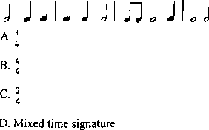
- Grade 9 learners of Ilmeshuki Junior school studied the following grouping of notes. Identify the time signature applied.
- When a performer focuses on making their voice audible and clear to the entire audience, they are demonstrating good:
  - Articulation
  - Expression
  - Projection
  - Diction
- In music, the term "pitch" refers to the:
  - Speed of the music.
  - Loudness of the sound.
  - Highness or lowness of a sound.
  - Timbre of an instrument.
- Which of the following is a key element that distinguishes a play from a short story?
  - Plot
  - Characters
  - Dialogue meant for performance
  - Theme
- Study the following image
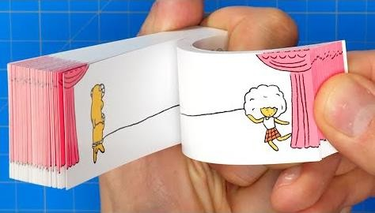
A flipbook is an early form of animation that demonstrates the principle of:
  - Stop-motion
  - Persistence of vision
  - Claymation
  - Digital rendering

- What is the main purpose of creating a storyboard for a film or animation?
  - To determine the film's budget.
  - To outline the visual sequence of scenes.
  - To choose the actors.
  - To write the film's dialogue.
- The musical quality that refers to how fast or slow a piece of music is played is:
  - Pitch
  - Rhythm
  - Tempo
  - Dynamics

- Which of the following is a characteristic of a good melody?
  - It has many dissonant intervals.
  - It is difficult to remember.
  - It has a logical and pleasing flow.
  - It uses only one note value.
- When playing a descant recorder, "fingering" refers to:
  - The way you hold the instrument.
  - The technique of covering and uncovering holes to produce different notes.
  - The process of warming up the instrument.
  - The embouchure used for blowing.
- What is the primary role of costumes and adornment in Kenyan folk dances?
  - To make the dancers look uniform.
  - To provide historical context and express cultural identity.
  - To make the dance performance longer.
  - To make the dancers more comfortable.
- The role of creative arts and sports in fostering national identity is primarily through:
  - Providing job opportunities for artists and athletes.
  - Promoting unity, cultural preservation, and national pride.
  - Encouraging competition among different ethnic groups.
  - Generating revenue for the government.
- In music, a Crotchet is equivalent to how many quavers?
  - One
  - Two
  - Three
  - Four
- During a music lesson, the teacher shown the sfollowing solfa sign:

  - do
  - ti
  - la
  - so
- Which of the following is an element of music?
  - Plot
  - Setting
  - Rhythm
  - Form
- A musical interval that spans three diatonic steps is typically a:
  - Major 2nd B. Major 3rd
C. Perfect 4th D. Perfect 5th

PART II: SPORTS

- The ability of the body to move quickly and change direction with ease is known as:
  - Strength B. Endurance
C. Agility D. Coordination
- Which athletic event involves throwing a spear- like implement for distance?
  - Discus throw B. Shot put
C. Javelin throw D. Hammer throw
- What is the primary purpose of a "carving" on a javelin?
  - For aesthetic appeal.
  - To improve the grip for the thrower.
  - To make the javelin lighter.
  - To increase air resistance.
- A key skill in handball that involves propelling the ball towards the opponent's goal with force is called:
  - Dribbling B. Passing
C. Jumpshot D. Catching
- The ability of a player to maintain control of the ball while moving in football is called:
  - Kicking B. Dribbling
C. Heading D. Passing
- Mwangi was playing football, identify the skill demontrated?

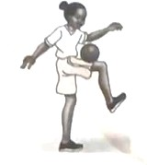

  - chest trap.
  - thigh trap.
  - foot trap.
  - placed shot.

- In netball, which footwork rule restricts a player from taking more than one step while holding the ball?
A. Stepping B. Pivoting C. Landing D. Dodging
- In volleyball, a play conducted the activity as demonstrated below

This type of play is called:

A. Spiking B. Setting C. Serving D. Passing

- "Endurance" in physical fitness refers to the body's ability to:
  - Generate maximum force in a single effort.
  - Maintain physical activity for prolonged periods.
  - Change direction quickly.
  - Move joints through a full range of motion.
- In swimming, the "backstroke" is unique because:
  - It is the fastest swimming style.
  - It is performed lying on the back.
  - It uses only arm movements.
  - It is only performed in open water.
- Which of the following is a common type of pass used in Netball?
  - Chest pass B. Overhead pass
C. Bounce pass D. All of the above
- Which type of physical fitness focuses on the ability of muscles to exert force?
  - Endurance B. Flexibility
C. Strength D. Agility
- When playing handball, a player makes a "jump shot" when they:
  - Pass the ball while jumping.
  - Shoot the ball at the goal while airborne.
  - Dribble the ball and jump over an opponent.
  - Catch the ball after jumping.
- Maintaining good "posture" while performing in sports is crucial for:
  - Reducing fatigue and preventing injury.
  - Making the performance more visually appealing.
  - Increasing speed only.
  - Improving communication with teammates.
- "Coordination" in physical fitness is the ability to:
  - Sustain prolonged physical activity.
  - Use different parts of the body together smoothly and efficiently.
  - Exert maximal force.
  - Change direction rapidly.
- In football, a "shot" refers to:
  - A pass to a teammate.
  - An attempt to score a goal by kicking or heading the ball towards the opponent's net.
  - A defensive maneuver to block an opponent.
  - A foul committed by a player.
- Which of the following is a fundamental dribbling technique in basketball or handball?
  - Dribbling with both hands simultaneously.
  - Keeping the ball in continuous contact with the hand.
  - Pushing the ball with the fingertips.
  - Using only one hand to dribble while running.
- "Agility" is a crucial component of fitness in sports like netball because it allows players to:
  - Jump higher.
  - Change direction quickly to evade opponents or get open.
  - Throw the ball further.
  - Have greater stamina.
- The main objective of "footwork" in Netball is to:
  - Show off skill.
  - Avoid contact with opponents.
  - Move legally while in possession of the ball.
  - Confuse the opposing team.
- During an athletic competition, athletes were observed applying a certain skill as shown below.
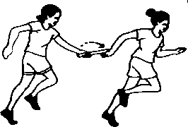

What skill is demonstrated?

  - Visual baton exchange

  - non visual baton exchange

  - standing start D.Elongsted start

SECTION B: (60 marks)

PART I: PERFORMING ARTS

Answer ALL the questions in the spaces provided after each question.

- Learners at Kibera Junior School are preparing a musical presentation for their school's annual drama and music festival. The presentation includes a choral verse and a performance of a Swahili folk song.

- For the choral verse, the learners are working on vocal expression.

  - Identify two distinct vocal qualities that a group of performers can use to create emphasis on a particular word or phrase in a choral verse. (2 marks)

  - Explain how varying the pace (tempo) of speaking can affect the overall mood of a section in a choral verse. (2 marks)

- For the Swahili folk song, the learners plan to incorporate traditional musical instruments.

  - Name two common types of traditional Kenyan musical instruments that could accompany a Swahili folk song. (2 marks)

- Both the choral verse and the folk song aim to engage the audience.

  - State one non-verbal cue that performers can use to invite audience participation during the performance. (1 mark)

  - Give one reason why performing traditional folk songs and verses is important for cultural preservation in Kenya. (1 mark)

- Learners from Umoja Junior School participated in a cultural festival where they presented a traditional Kenyan dance. Their teacher emphasized the importance of storytelling through movement and expression.

  - Outline five ways in which movement and gestures contribute to effective storytelling in a traditional dance performance. (5 marks)

  - Identify five roles played by vocal expressions (e.g., singing, chanting, ululating) in this dance performance. (5 marks)

- During their Creative Arts lesson, Grade 8 learners discussed the process of creating a short play from a local folktale.

- Outline two ways in which sound effects could be used to enhance the play's setting and atmosphere. (2 marks)

- Explain two benefits of involving the audience in a drama performance (e.g., through call-and-response, participation). (2 marks)

PART II: SPORTS

Answer questions 45 and 46. For question 47 and 48, answer only ONE of them.

- During a school sports day, a Grade 8 learner participated in the long jump event.

  - Outline two key safety precautions that should be observed at the long jump pit. (2 marks)

  - Describe two phases of the long jump technique after the athlete takes off from the board. (2 marks)

- A netball team captain is teaching her teammates how to perform a strong 'chest pass'.

Identify four common errors that players often make when performing a chest pass and explain how to correct each. (4 marks)

EITHER

- A teacher introduced learners to the basic skills of playing basketball.

- What is the main objective of dribbling in basketball? (2 marks)

- Describe two types of dribbling techniques that a player might use during a game. (4 marks)

- Explain two reasons why teamwork is crucial for success in a game of basketball. (4 marks)

OR

- During a physical education lesson, learners were introduced to traditional Kenyan games.

(i) What distinguishes traditional games from modern sports? (2 marks)

(ii) Choose one traditional Kenyan game and describe how it is played. (4 marks)

(iv) Outline two ways in which traditional Kenyan games can be promoted among young learners today. (2 marks)

PART III: VISUAL ARTS

Answer ALL the questions in the spaces provided after each question.

- (a) As a curator at an art gallery, proper display of artworks is essential.


In the reproduction below of a painting, use dotted lines to mark how the artwork would look like when mounted on a larger piece of plain white paper to enhance its presentation. (2 marks)

(b) Learners are preparing an art exhibition for their school's open day. Describe two creative ways they could make their art display space exciting and engaging for visitors. (2 marks)

- During a practical lesson, learners created a collage artwork using various materials found around the school compound.

Outline four steps they followed in the process of creating their collage. (4 marks)

- Learners in an art appreciation lesson were analysed various aspects of the reproduction of the painting below.
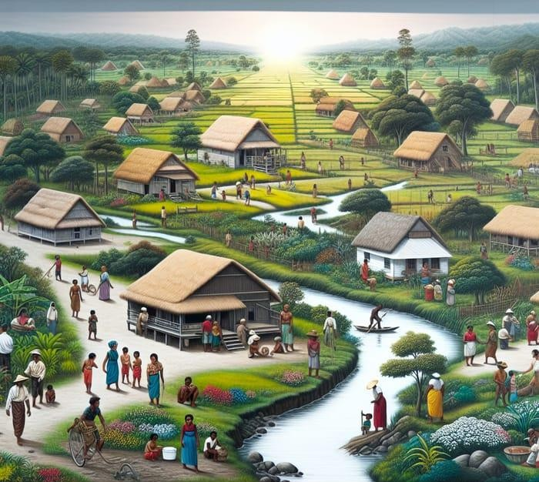

Analyze the possible title for the painting and discuss how the subject matter and use of space are applied in the artwork. (10 marks)

THIS IS THE LAST PRINTED PAGE.

THE KENYA NATIONAL EXAMINATION AND ASSESSMENT PREDICTION SERIES

Candidate’s Name |  | Assessment Number
School Name |  | School Code
Candidate’s Signature |  | Date
KENYA JUNIOR SCHOOL EDUCATION ASSESSMENT 905/1: INTEGRATED SCIENCE (Theory)
-INTEGRATED SCIENCE-
PAPER 1

TERM 2: END-TERM 2025

TIME: 1 hour 30 minutes INSTRUCTIONS TO CANDIDATES
- Write your name and assessment number in the spaces provided above.
- Write the name and code of your school in the spaces provided above.
- Sign and write the date of the assessment in the spaces provided above.
- This paper consists of two sections: A and B.
- Section A comprises Multiple Choice Questions numbered 1 to 30.
- Section B comprises short, structured questions number 31 to 40.
- Answer ALL the questions in section A on the separate ANSWER SHEET provided.
- Answer ALL the questions in section B in the spaces provided in this QUESTION PAPER.
- Do NOT remove any page from this question paper.
- Answer ALL the questions in English. For official use only

SECTION B

Task | Question | Score per question | Maximum score | Candidate’s score
Task 1 | 31 |  | 03
Task 2 | 32 |  | 13
Task 2 | 33 |  | 13
Task 2 | 34 |  | 13
Task 3 | 35 |  | 16
Task 3 | 36 |  | 16
Task 4 | 37 |  | 08
Task 4 | 38 |  | 08
Task 4 | 39 |  | 08
Task 4 | 40 |  | 08
Total |  |  | 40
This paper consists of 12 printed pages. Candidates should check the question paper to ascertain that all the pages are printed as indicated and that no questions are missing.

© 2025 The Kenya National Examination and Assessment Prediction Series

SECTION A

Read all the instructions carefully

- You have been given this question paper and a separate answer sheet. This section consists of 30 multiple choice questions.
- Answer ALL questions on the ANSWER SHEET provided, NOT on the question paper.
- Do all the necessary rough work on the question paper.

HOW TO USE THE ANSWER SHEET 4. Use an ordinary HB pencil. 5. Confirm that the answer sheet you have been provided with has the following:

YOUR ASSESSMENT NUMBER YOUR NAME
NAME OF YOUR SCHOOL NAME OF THE SUBJECT
- Keep the answer sheet clean and dry. DO NOT fold it.
- For each of the questions 1 – 30, four options are given. The options are lettered A, B, C and D. In each case, only ONE of the four options is correct. Choose the correct option.
- On the answer sheet, the correct answer is to be shown by drawing a DARK LINE inside the box in which the letter you have chosen is written.

Example:

In the Question Paper:

16. At Junior School, learners study Integrated Science. A learner in Junior School chose Mathematics, Physics, Chemistry and Biology for study at Senior School. Which of the subjects chosen by the learner are components of Integrated Science?

  - Mathematics, Physics and Biology.

  - Physics, Chemistry and Biology.

  - Mathematics and Physics.

  - Chemistry and Biology.

The correct answer is B.

On the answer sheet, in the set of boxes given for number 16, draw a DARK LINE inside the box with the letter B printed in it as marked below.

- Your dark line MUST be within the box. DO NOT make any marks outside the boxes.
- For each question, ONLY ONE box is to be marked.

SECTION A (30 marks)

Answer ALL the questions in this section.

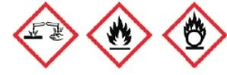

- During a lab safety lesson, learners were shown various hazard symbols. Which of the following symbols (if provided as images) would indicate a substance that can cause severe burns upon contact with skin or other materials?
A B C D
- A community leader noticed that local farmers struggle with understanding plant diseases, and the community also faces issues with waste management. Which two aspects of Integrated Science could best help them address these challenges?
  - Understanding religious texts and cultural practices.
  - Applying knowledge of biological processes and environmental science.
  - Memorizing historical dates and artistic movements.
  - Focusing only on abstract mathematical theories.
- During a science class, learners were asked to write down the chemical symbols for the elements Potassium, Nitrogen, and Calcium. Which of the following sets correctly lists the symbols for these elements?
  - P, N, Ca B. K, N, Cal
C. Po, Ni, C D. K, N, Ca
- A chemist is working with two unknown substances. Substance X readily forms rust when exposed to air and moisture, while substance Y is found in a clean glass bottle. Which one of the following pairs correctly classifies these substances as an element and a compound?
  - Copper and Iron.
  - Water and Carbon dioxide.
  - Copper and Carbon dioxide.
  - Iron and Water.
- At a local bakery, the owner mixes sugar into warm water to make syrup. Separately, they also mix flour and water, creating a lumpy paste. Which two mixtures are homogeneous?
  - Sugar and water, and flour and water.
  - Sugar and water, and air.
  - Flour and water, and sand and water.
  - Air, and sand and water.
- During a practical session, learners were given samples of different materials: Zinc, Chlorine, Sodium, and Phosphorus. Which two of these elements are metals?
  - Zinc and Chlorine.
  - Sodium and Phosphorus.
  - Zinc and Sodium.
  - Chlorine and Phosphorus.
- A teacher illustrated the kinetic theory of matter by showing diagrams of particles in three different states.
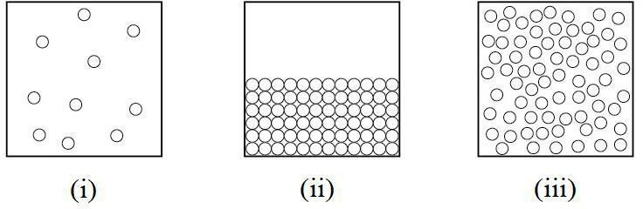

Which two diagrams correctly represent the arrangement of particles in a solid and a gas, respectively?
  - (i) solid, (ii) gas
  - (ii) solid, (iii) gas
  - (i) solid, (iii) gas
  - (iii) solid, (ii) gas

- A small fire broke out in the school library due to a faulty electrical wire. The school's fire response team immediately cut off the electricity supply to the building. Which component of the fire triangle were they aiming to remove?
  - Fuel
  - Heat
  - Oxygen
  - Chain reaction

- A household in a rural area complains that their water supply does not lather well with soap, and their kettles often develop a white, crusty buildup. Which two methods would be most effective in making their water lather easily?
  - Boiling the water and adding a water softener.
  - Filtering the water and adding cooking oil.
  - Boiling the water and adding salt.
  - Filtering the water and using less soap.
- A learner observed ice melting into water, milk fermenting to yogurt, and iron nails rusting over time. Which of these changes are permanent and result in new substances?
  - Ice melting and milk fermenting.
  - Milk fermenting and iron nails rusting.
  - Ice melting and iron nails rusting.
  - All of them are permanent.
- A pharmaceutical company is developing new antacids to neutralize excess stomach acid. Another company is producing car batteries. Which of the following pairs correctly identifies the class of substance primarily used for antacids and in car batteries, respectively?
  - Acid for antacids, Base for car batteries.
  - Base for antacids, Acid for car batteries.
  - Neutral salt for antacids, Acid for car batteries.
  - Base for antacids, Neutral salt for car batteries.
- During a biology lesson on human reproduction, learners were discussing the changes that occur during adolescence. Which of the following changes is commonly observed in both boys and girls during this stage?
  - Deepening of the voice.
  - Widening of hips.
  - Growth of pubic hair.
  - Development of breasts.
- The diagram below represents a part of the female reproductive system.
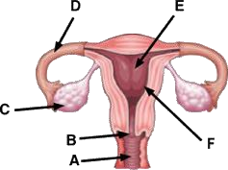

Fertilization, the fusion of male and female gametes, typically takes place at the part labelled:
A. C B. D C. E D. F
- During a guidance and counseling session, adolescents were advised on ways to cope with frequent mood swings. Which of the following would be the most constructive advice?

A | Isolate themselves from friends and family
B | Engage in regular physical exercise and seek support.
C | Consume more sugary foods to boost energy.
D | Avoid talking about their feelings.
- The diagram below shows a simplified representation of the human urinary system.
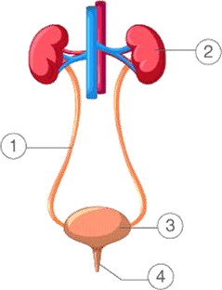
Which part is primarily responsible for filtering waste products from the blood to form urine?
    - B. 4 C. 3 D. 2

- Sarah feels cold on a chilly morning and notices her skin developing "goosebumps." Which part of her skin contains the tiny muscles responsible for this reaction, helping to trap a layer of air for insulation?
  - Epidermis B. Dermis
C. Subcutaneous layer D. Hair follicle
- A patient presents with symptoms including frequent and painful urination, and sometimes blood in the urine. These symptoms are most indicative of a disorder affecting which part of the urinary system?
A. Kidney B. Ureter C. Bladder D. Urethra
- A gardener wanted to remove small pieces of iron filings that had accidentally mixed with sand. Which of the following laboratory instruments would be most effective for separating the iron filings from the sand?
  - Filter funnel B. Evaporating dish
C. Magnet D. Separating funnel

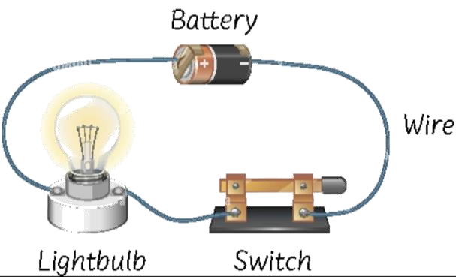
- A simple circuit consists of a battery, a switch, and a light bulb.

When the switch is closed, the bulb lights up. Which of the following correctly describes the main energy transformation in the light bulb?
  - Chemical energy to electrical energy.
  - Electrical energy to light and heat energy.
  - Mechanical energy to electrical energy.
  - Heat energy to light energy.

- Which of the following diagrams (if provided) represents a correctly connected simple electric
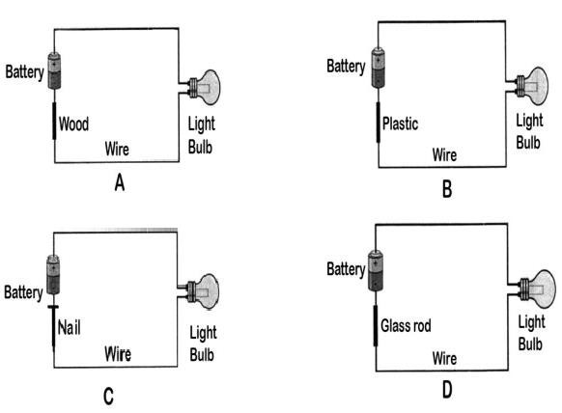
- A learner is working with several electrical appliances in the lab. Which of the following actions demonstrates good electrical safety practice?
  - Plugging multiple high-power appliances into a single wall socket.
  - Using an appliance with a visible frayed electrical cord.
  - Unplugging an appliance by pulling the plug itself, not the cord.
  - Touching electrical switches with wet hands.
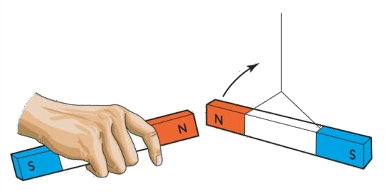
- During a demonstration, a teacher brought the North pole of one magnet close to the North pole of
another magnet.
What observation was made?
  - The magnets attracted each other strongly.
  - The magnets repelled each other.
  - Nothing happened; the magnets remained still.
  - The magnets briefly attracted then repelled.

- A group of friends is playing with various objects. They observe that a piece of paper, a plastic spoon, and a rubber band are not attracted to a magnet. Which of the following materials would also be non-magnetic?
A. Iron B. Nickel C. Copper D. Steel
- Dr. Anya, a forensic chemist, has received an unknown substance for analysis. Her first step is to identify the elements present. Using a specialized mass spectrometer, she determines that one of the
predominant elements in the sample has atoms with
17 protons each.
Based on this information, what is the atomic number of this element, and which element is it likely to be?
- Atomic Number: 17, Element: Chlorine (Cl)
- Atomic Number: 35, Element: Bromine (Br)
- Atomic Number: 18, Element: Argon (Ar)
- Atomic Number: 17, Element: Sulfur (S)

- A learner is listing the uses of common elements. Which of the following correctly matches an element with its common use?
  - Hydrogen - used in incandescent light bulbs.
  - Oxygen - used for respiration.
  - Nitrogen - used in electrical wiring.
  - Carbon - used for making magnets.
- During a laboratory experiment, a learner mixed two clear liquids, and immediately a cloudy precipitate formed, and the test tube felt warm. This observation indicates that a:
  - Physical change has occurred.
  - Reversible change has occurred.
  - Chemical change has occurred.
  - Change of state has occurred.
- A science enthusiast poured water into a freezer tray. After a few hours, the water turned into ice. This change of state is an example of a:
  - Chemical change, which is permanent.
  - Physical change, which is temporary.
  - Chemical change, which is temporary.
  - Physical change, which is permanent.

- During a health education seminar, learners learned about common sexually transmitted infections. Which of the following STIs is caused by bacteria and can lead to infertility if untreated, characterized by painful urination and discharge?
  - Herpes
  - HIV
  - Syphilis
  - Gonorrhea

- Mr.Lipton asked his learners to identify the electron configuration for Sodium. Which one is correct?

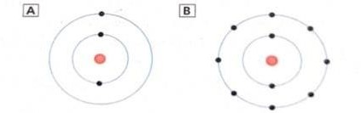
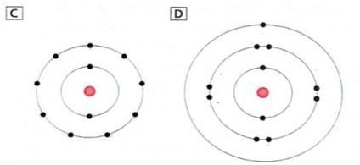
- Study the following scenarios given below.

- Large herds of cattle graze in the fields, and often, small white birds called cattle egrets walk among them, feeding on insects stirred up by the movement of the livestock. The cattle appear unaffected by the presence of these birds.
- A local farmer observes that some of his prize Boran cattle have become weak and their coats are dull. Upon closer inspection, he finds numerous ticks embedded in their skin, feeding on their blood. These ticks are known to transmit diseases that can be fatal to the cattle if left untreated.

Which of the following statements accurately identifies the type of ecological relationship described in each scenario?

- The relationship between the cattle and the cattle egrets is mutualism, and the relationship between the cattle and the ticks is commensalism.
- The relationship between the cattle and the cattle egrets is parasitism, and the relationship between the cattle and the ticks is mutualism.
- The relationship between the cattle and the cattle egrets is commensalism, and the relationship between the cattle and the ticks is parasitism.
- Both relationships are examples of mutualism.

SECTION B (40 marks)

Answer ALL the questions in this section.

- (a) During a practical lesson, learners were asked to measure the length of their laboratory bench using a metre rule and then estimate its length without the rule.

- Identify two basic science skills applied in this activity. (2 marks)

- State the International System of unit (SI unit) of length. (1 mark)

- A group of learners was given a mixture of water and ethanol to separate. Ethanol has a boiling point of approximately 78°C, while water boils at 100°C.

- Is this a homogeneous or heterogeneous mixture? Give a reason. (2 marks)

- Describe a suitable method the learners can use to separate pure ethanol from the water-ethanol mixture. (4 marks)

- What separation technique would be used to obtain pure solid salt crystals from a salt solution? (1 mark)

- (a) A curious learner found an unknown clear liquid in the lab. They noticed it felt soapy to touch and turned red litmus paper blue. State the general physical properties of this unknown liquid, other than what is mentioned. (2 marks)

(b) Describe how you would prepare a plant extract from red cabbage to use as an acid-base indicator. (3 marks)

- (a) A science teacher provided learners with a prepared temporary slide of a cheek cell and a prepared temporary slide of an onion epidermal cell.

- State two organelles that would be clearly visible in both cells under a light microscope. (2 marks)

- Describe the process of preparing a temporary slide of an onion epidermal cell for observation under a light microscope. (3 marks)

iii) Identify the following parts of a cell.( 2 marks)

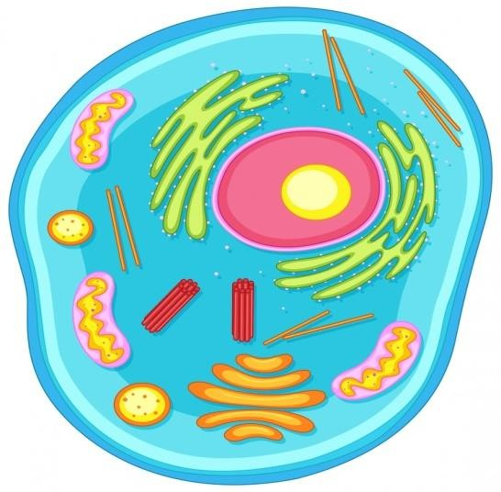


S

T

S:

T:

(b) Explain two roles of diffusion in living things. (2 marks)

- (a) A person was rushed to the hospital complaining of severe pain during urination and the presence of pus in their urine. The doctor diagnosed them with a urinary tract infection affecting the bladder.

- Name the two main parts of the human urinary system responsible for producing and transporting urine to the bladder. (2 marks)

- State one common cause of urinary tract infections. (1 mark)

- During a reproductive health class, the teacher explained the menstrual cycle.

  - Name the two main hormones that control the menstrual cycle. (2 marks)

  - Briefly describe the process of implantation in human reproduction. (2 marks)

- (a) A school dormitory caught fire due to a short circuit from faulty electrical wiring.

- What class of fire is this, and what type of fire extinguisher would be most appropriate to put it out? (2 marks)

- Explain two dangers posed by such a fire in a dormitory setting. (2 marks)

(b) State one method of fire control that involves removing the heat from a burning object. (1 mark)

- (a) A village relies on energy sources for lighting and cooking. They currently use kerosene lamps and firewood. Suggest two alternative renewable energy sources that could be introduced to the village. (2 marks)

(b) Explain the energy transformation that occurs when a hand-cranked generator is used to light a bulb. (2 marks)

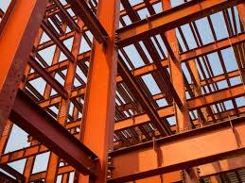
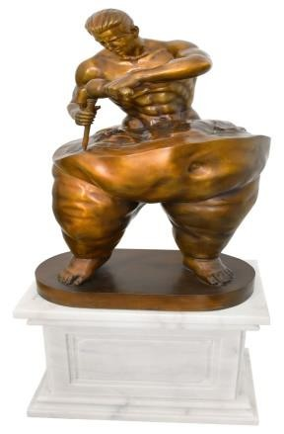
- A construction worker is using steel beams for building a skyscraper, while a sculptor is using pure copper to create a statue.
steel beams copper statue

- Describe two physical properties that make steel a suitable material for construction, considering it is an alloy. (2 marks)

- Name the types of magnets shown below. (2 marks)

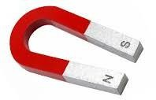

- (a) A science learner was tasked with writing word equations for simple chemical reactions.

- Write a word equation for the reaction where Carbon burns in Oxygen to form Carbon Dioxide. (1 mark)

- Write a word equation for the reaction between Magnesium and Oxygen to form Magnesium Oxide. (1 mark)

- An element has an electron arrangement of 2.8.1.

  - Name this element. (1 mark)

  - Is this element a metal or a non-metal? (1 mark)

- (a) A farmer observes that the leaves of his maize plants are yellowing, and the growth is stunted despite adequate watering. Upon inspection, he notices that the underside of the leaves has fewer stomata than expected.

- What process in plants is likely being affected by the reduced number of stomata? (1 mark)

- Name the parts of a leaf shown below. (2 marks)
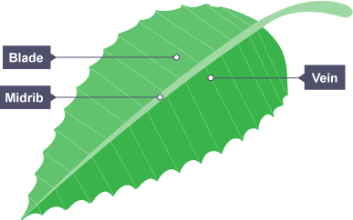
O
N
M
N:

O:




- During a school trip, Marsabit Junior School learners were told that carnivores like lions have specific types of teeth for tearing meat. Name the type of teeth that are well-adapted for tearing. (1 mark)

T

THIS IS THE LAST PRINTED PAGE.


THE KENYA NATIONAL EXAMINATION AND ASSESSMENT PREDICTION SERIES
Candidate’s Name |  | Assessment Number
School Name |  | School Code
Candidate’s Signature |  | Date


KENYA JUNIOR SCHOOL EDUCATION ASSESSMENT 905/2: INTEGRATED SCIENCE (Practical)
-INTEGRATED SCIENCE-
PAPER 2
TERM 2 END-TERM 2025

TIME: 1 hour 30 minutes INSTRUCTIONS TO CANDIDATES
  - Write your name and assessment number in the spaces provided above.
  - Write the name and code of your school in the spaces provided above.
  - Sign and write the date of the assessment in the spaces provided above.
  - This paper consists of 2 questions.
  - Answer BOTH questions in the spaces provided on this QUESTION PAPER.
  - Do NOT remove any page from this question paper.
  - Answer the questions in English.

For official use only

Task | Task 1 | Task 2 | TOTAL
Question | 1 | 2 | SCORE
Maximum Score | 20 | 10 | 30
Candidate’s Score

This paper consists of 4 printed pages.
Candidates should check the question paper to ascertain that all the pages are printed as indicated and that no questions are missing.

© 2025 The Kenya National Examination and Assessment Prediction Series

Turn over

QUESTION ONE (20 marks)

You are required to separate a mixture of sand, maize flour, and salt using simple laboratory techniques. You are provided with the following:
Θ A mixture of sand, maize flour, and salt
Θ Water
Θ Sieve
Θ Beaker
Θ Filter funnel
Θ Filter paper
Θ Evaporating dish
Θ Source of heat (e.g., Bunsen burner, spirit lamp)
Θ Tripod stand and wire gauze

Procedure:

- Observe the mixture and record its appearance in the table below.
- Use the sieve to separate the larger particles from the finer ones. Transfer the mixture to the sieve and shake gently over a piece of paper. Record what passes through the sieve and what remains on the sieve.
- Transfer the material that passed through the sieve into a beaker. Add water and stir until the salt dissolves. Record your observation.
- Filter the contents of the beaker using the filter funnel and filter paper. Record what is collected in the beaker below the funnel (filtrate) and what remains on the filter paper (residue).
- Pour the liquid (filtrate) from the beaker into an evaporating dish. Heat the evaporating dish gently until all the water evaporates. Record what remains in the dish.

Record your observations and what is separated/recovered at each step in the table below. (12 marks)

Step | Procedure | Observation | Material Separated/Recovered
1 | Initial Observation of Mixture |  | N/A
2 | Sieving | What remains on sieve: | What remains on sieve:
 |  | What passes through sieve: | What passes through sieve:
3 | Adding Water and Stirring
4 | Filtration | Filtrate (liquid collected): | Residue (on filter paper):
 |  | Residue (on filter paper):
5 | Evaporation of Filtrate | What remains in evaporating dish: | What remains in evaporating dish:
- Name the separation technique used in step 2. (1 mark)

- Name the separation technique used in step 4. (1 mark)

- What were the three original components of the mixture? (3 marks)

- State three basic science skills you applied in this practical. (3 marks)

QUESTION TWO (10 marks)

You are provided with some water and apparatus to measure its volume and temperature. You are provided with the following:
Θ Water
Θ Measuring cylinder
Θ Thermometer
Θ Beaker

Procedure:

  - Pour some water into the beaker.
  - Using the measuring cylinder, carefully measure 60 cm³ of the water from the beaker. Record the volume.
  - Pour the 60 cm³ of water into a clean beaker.
  - Measure the temperature of the water in the beaker using the thermometer. Record the temperature.

- Record your measurements:

  - Measured volume of water = cm³ (3 marks)

  - Measured temperature of water = °C (3 marks)

- State the SI unit for volume. (1 mark)

- State the SI unit for temperature. (1 mark)

- Name the two main pieces of apparatus you used for measurement in this practical. (2 marks)

THIS IS THE LAST PRINTED PAGE.

CONFIDENTIAL GUIDE FOR TEACHERS
THE KENYA NATIONAL EXAMINATION AND ASSESSMENT PREDICTION SERIES

Teacher’s Name |  | TSC NO.
School Name |  | School Code
Teacher’s Signature |  | Date
KENYA JUNIOR SCHOOL EDUCATION ASSESSMENT 905/2 INTEGRATED SCIENCE
PAPER 2 (practical)
-INTEGRATED SCIENCE-
TERM 2 ENDTERM 2025

Experiment: Separation of a Mixture (Sand, Maize Flour, Salt) Overall Guidance for Teachers:
- This experiment reinforces concepts of mixtures, solutions, and various separation techniques.
- Ensure all listed apparatus and materials are prepared.
- Emphasize careful execution of each separation step to minimize loss of material.
- Safety with heat source is critical.

Preparation of Materials (Prior to Exam):

Θ Mixture of Sand, Maize Flour, and Salt: Prepare a homogenous mixture in advance. Ensure sand is visibly coarser than maize flour.
Θ Water: Tap water.
Θ Sieve: A sieve with mesh size that retains sand but allows maize flour and salt to pass.
Θ Beaker: For dissolving and filtering.

Θ Filter Funnel:
Θ Filter Paper: Appropriate size for the funnel.
Θ Evaporating Dish: Heat resistant.
Θ Source of Heat: Bunsen burner, spirit lamp, or hot plate.
Θ Tripod Stand and Wire Gauze: For heating.

Question One (20 marks) Procedure Monitoring:
Θ Step 1 (Initial Observation):
Teacher's Role: Guide learners to describe the mixture's appearance.

Θ Step 2 (Sieving):
Teacher's Role: Ensure gentle shaking to effectively separate.
Expected Outcome: Sand remains on the sieve; maize flour and salt pass through.

Θ Step 3 (Adding Water and Stirring):
Teacher's Role: Ensure adequate stirring for salt to dissolve fully.
Expected Outcome: Salt dissolves, maize flour forms a suspension/settles, sand settles at the bottom.

Θ Step 4 (Filtration):

Teacher's Role: Guide learners on proper filter paper folding and pouring techniques to avoid spillage or tearing the filter paper.
Expected Outcome: Filtrate (salt solution) is collected; residue (maize flour and possibly some fine sand) remains on the filter paper.

Θ Step 5 (Evaporation):
Teacher's Role: Emphasize gentle heating to avoid splattering and burning the salt. Monitor flame size.
Expected Outcome: Water evaporates, leaving behind solid salt crystals.

Recording Observations and Materials Separated/Recovered in Table (12 marks):

- Marking Guidance:
1 mark for each accurate observation (6 marks total).
1 mark for each correct material separated/recovered (6 marks total).

Row 1 (Initial Observation):
Observation: "Heterogeneous mixture, visible particles of different sizes/colors." Material: N/A

Row 2 (Sieving):
Observation (remains on sieve): "Larger, granular particles." Material (remains on sieve): "Sand."
Observation (passes through sieve): "Fine powder."
Material (passes through sieve): "Maize flour and salt."

Row 3 (Adding Water):
Observation: "Some solid dissolves, some settles/suspends."
Material: (Implied separation of salt from insoluble components).

Row 4 (Filtration):
Observation (filtrate): "Clear liquid."
Material (residue): "Maize flour (and possibly fine sand)." Observation (residue): "Solid residue on filter paper."

Row 5 (Evaporation):
Observation (remains in dish): "White solid crystals." Material (remains in dish): "Salt."

Analysis of Results:

- Separation Technique in Step 2 (1 mark):

Θ Marking Guidance: 1 mark for "Sieving."
Θ Expected Answer: "Sieving."

Separation Technique in Step 4 (1 mark):

Θ Marking Guidance: 1 mark for "Filtration."
Θ Expected Answer: "Filtration."

(The question seems cut off, but assuming it asks for another separation technique or skill, or perhaps identifying the components of the filtrate/residue).

Θ If it asks for another separation technique (e.g., evaporation): 1 mark for "Evaporation" or "Distillation."

Θ If it asks for components of filtrate: 1 mark for "Salt solution (dissolved salt and water)."
Θ If it asks for components of residue: 1 mark for "Maize flour (and sand)."
Θ If it asks for a science skill: 1 mark for "Observing," "Measuring," "Filtering," etc.

General Notes for Exams:

- Teacher Supervision: Continuous supervision is crucial, especially for practical aspects involving tools, heat, and chemicals.
- Differentiation: For group projects, encourage varied roles for learners with different strengths.
- Record Keeping: Ensure learners are diligently recording their observations and data as they go.
- Post-Practical Discussion: A follow-up discussion helps reinforce the concepts and correct any misconceptions.
- Cleanliness: Emphasize keeping the workspace clean and tidy throughout and after the practical.
- Fairness: Ensure equal access to materials and tools for all groups/learners.

THIS IS THE LAST PRINTED PAGE

THE KENYA NATIONAL EXAMINATION AND ASSESSMENT PREDICTION SERIES

Candidate’s Name |  | Assessment Number
School Name |  | School Code
Candidate’s Signature |  | Date
KENYA JUNIOR SCHOOL EDUCATION ASSESSMENT
AGRICULTURE AND NUTRITION

906/1 AGRICULTURE AND NUTRITION (Theory) PAPER 1 TERM 2 ENDTERM 2025
Time: 1 hour 40 minutes

INSTRUCTIONS TO CANDIDATES
- Write your name and assessment number in the spaces provided above.
- Write the name and code of your school in the spaces provided above.
- Sign and write the date of the assessment in the spaces provided above.
- This paper consists of two sections: A and B.
- Section A comprises Multiple Choice Questions numbered 1 to 30.
- Section B comprises short, structured questions number 31 to 42.
- Answer ALL the questions in section A on the separate ANSWER SHEET provided.
- Answer ALL the questions in section B in the spaces provided in this QUESTION PAPER.
- Do NOT remove any page from this question paper.
- Answer ALL the questions in English.

For official use only SECTION B
 |  | Task 1: Agriculture |  |  |  |  | Task 2: Nutrition
Task | Question | 31 | 32 | 33 | 34 | 35 | 36 | 37 | 38 | 39 | 40 | 41 | 42
Maximum Score |  | 3 | 3 | 3 | 3 | 4 | 4 | 4 | 2 | 2 | 5 | 2 | 5
Candidate’s score
This paper consists of 8 printed pages.
Candidates should check the question paper to ascertain that all the pages are printed as indicated and that no questions are missing.

© 2025 The Kenya National Examination and Assessment Prediction Series
Turn over

SECTION A (30 marks)
Answer ALL the questions in this section.

- During a soil analysis lesson, learners examined soil samples. They found one type had large, gritty particles that drained water very quickly. Which soil type has the largest particle size and high drainage?
  - Clay B. Sand
C. Silt D. Loam
- Mr. Omondi always writes down details like how many bags of fertilizer he bought, how much he sold his maize for, and the date he sprayed his crops. These activities are part of keeping simple farm
  - weather forecasts.
  - records.
  - labour lists.
  - market price predictions.
- After harvesting his maize, Mr. Koech collects the stalks and leaves and mixes them with animal manure and kitchen waste in a heap. This mixture is allowed to decompose to produce organic manure. This process is called
  - irrigation.
  - mulching.
  - composting.
  - drainage.
- A farmer noticed that some of his cattle were weak, losing weight, and had swollen lymph nodes. A blood test confirmed they had contracted a disease transmitted by ticks. Which common animal disease is transmitted by ticks?
  - Newcastle disease
  - Mastitis
  - East Coast Fever
  - Foot and Mouth disease
- Mama Pendo harvests passion fruits from her farm and processes them into passion fruit juice which she sells at a higher price than the fresh fruits. Selling the juice instead of fresh fruit is an example of
  - simple farming.
  - value addition.
  - market research.
  - direct marketing.
- Before starting an apple orchard, a farmer in Kenya researched areas with specific cool temperature requirements. Which environmental factor, often related to height above sea level, is crucial for such crops?
  - Topography
  - Climate
  - Altitude
  - Latitude
- In the school garden, some rows of sukuma wiki seedlings are too crowded. The teacher instructs the learners to remove the weaker seedlings so the remaining ones have enough space and nutrients. This process is called
  - planting. B. weeding.
C. thinning. D. gapping.
- A farmer aims to produce a large number of eggs for sale. Which housing system is most commonly used for keeping a large flock of egg-laying chickens (layers) confined indoors?
  - Free range B. Deep litter system
C. Perching system D. Paddocking
- Which farm tool is specifically used for cutting tough grass, clearing thick bushes, or removing sugarcane tops?
  - Spade B. Pruning saw
C. Slasher D. Garden fork
- Mr. Ali takes his harvested beans to a person who sells them on his behalf at the market and takes a percentage commission from the sale. This method of selling farm produce through an intermediary is called
  - auction.
  - direct marketing.
  - brokerage.
  - co-operative marketing.
- When a farmer calculates the cost of production (like seeds, fertilizer, labour) and compares it to the income from selling produce to determine if they made a profit or loss, they are applying principles of
  - agricultural law.
  - agribusiness economics.
  - farm structures design.
  - environmental science.

- On a farm with severe soil erosion due to a gully, the farmer decided to fill the gully with stones and wire mesh structures to slow down water flow and trap soil. Which method of soil and water conservation is this?
  - Terracing
  - Gabions
  - Contour ploughing
  - Strip cropping
- Mrs. Ruto manages pests in her vegetable garden by rotating crops, encouraging beneficial insects, and only using natural sprays when necessary. This approach of combining different control methods is called
  - chemical pest control.
  - biological pest control.
  - cultural pest control.
  - integrated pest management.
- Which essential plant nutrient is particularly important for strong root growth and helps plants flower and set fruit?
  - Nitrogen
  - Phosphorus
  - Potassium
  - Sulphur
- Ensuring that animals in the school farm, like the rabbits and chickens, always have access to clean water is essential primarily for
  - increasing their aggression.
  - preventing dehydration and the spread of waterborne diseases.
  - reducing their feed intake.
  - making their coats shiny.
- Where on a farm would you typically find structures like cattle sheds, chicken coops, or pig sties? This refers to structures used for housing livestock.
  - Silo
  - Granary
  - Kraal
  - Store
- A farmer aims to grow crops using methods that protect the environment, conserve natural resources like soil and water, and are economically viable in the long term. This approach aligns with the principles of
  - intensive farming.
  - subsistence farming.
  - sustainable agriculture.
  - monoculture farming.
- During a lesson on propagating plants, learners were shown how to join a part of one plant (scion) onto the root system of another plant (stock) so they grow together. Which vegetative propagation method was demonstrated?
  - Cutting
  - Layering
  - Budding
  - Grafting
- Which specific breed of chicken is well- known globally for its high rate of egg production and is commonly used in commercial egg farms?
  - Broiler
  - Kenbro
  - Leghorn
  - Kuchi
- The school farm keeps records of when each batch of chicks was vaccinated against common diseases like Newcastle disease. Keeping track of vaccination dates for poultry is a critical part of
  - feeding management.
  - marketing management.
  - health management.
  - housing management.
- To cook vegetables while retaining most of their nutrients and natural flavour, your teacher suggests cooking them above boiling water without direct contact. Which cooking method is this?
  - Baking B. Frying
C. Boiling D. Steaming
- John's grandmother has difficulty seeing clearly at night. The doctor advised her to eat more foods rich in a particular vitamin that is important for healthy eyesight. Which vitamin was the doctor referring to?
  - Vitamin C B. Vitamin D
C. Vitamin A D. Vitamin K
- Your family harvested a large amount of vegetables from the garden. To keep them from spoiling quickly, they decide to put them in the freezer. Which food preservation method uses very cold temperatures to slow down the growth of microorganisms?
  - Salting B. Drying
C. Pickling D. Freezing

- Which main nutrient group is the primary source of quick energy for the body, found abundantly in foods like ugali, bread, rice, and pasta?
  - Protein
  - Carbohydrates
  - Vitamins
  - Minerals
- After washing your clothes, you use a hot iron to remove wrinkles and make them smooth. The correct term for using heat to remove creases from fabric is
  - laundering.
  - ironing.
  - stitching.
  - folding.
- In the Home Science room, learners are taught about the parts of the sewing machine. Which part is located underneath the needle plate and holds the thread that forms the lower part of a stitch?
  - Needle
  - Presser foot
  - Bobbin
  - Tension disc
- To collect dust and small debris from hard floors like wood or tile, which pair of cleaning equipment is most commonly used together?
  - Mop and bucket
  - Broom and dustpan
  - Scrubbing brush and water
  - Vacuum cleaner
- Sarah is darning a hole in her sock. To make the repair strong and less noticeable, how should a well-darned patch appear?
  - Visible thick stitches on the surface.
  - A piece of fabric sewn over the hole.
  - Stitches that are close together and blend in with the fabric.
  - Threads hanging loose from the repair.
- When planning meals for a family member who has diabetes, the meal planner must be careful to limit foods that cause a rapid increase in blood sugar levels. They should particularly limit foods high in
  - protein.
  - fibre.
  - sugar and simple carbohydrates.
  - vitamins.
- Which food item, after being cooked in hot water, is often sealed in airtight containers (cans or jars) for long-term storage?
  - Fresh vegetables
  - Dried beans
  - Salted meat
  - Frozen fish

SECTION B (40 marks)
Answer ALL the questions in this section.
- Your class is learning about sustainable farming practices that protect the environment.
- Define what is meant by "sustainable agriculture". (1 mark)

- Give two specific practices that a farmer following organic farming principles would use. (2 marks)

- Farmers use different methods to get new plants growing. Some use seeds, while others use parts of the parent plant.
- Name two methods of propagating plants that involve using parts of the parent plant, such as stems, leaves, or roots. (2 marks)

- What is one significant advantage of using vegetative propagation methods compared to planting seeds for certain crops? (1 mark)

- Your school agriculture club is thinking about starting a poultry project.

- Name two common breeds of chickens that are primarily raised for their meat. (2 marks)

- State one reason why ensuring there is enough fresh air circulating (proper ventilation) is very important in a chicken house. (1 mark)

- Successful farmers keep good records of their farming activities.

- Name two specific types of records that would be essential for a farmer raising dairy cattle. (2 marks)

- What is the primary purpose or benefit of keeping production records (e.g., milk yield, egg collection)? (1 mark)

- Farmers use different materials to add nutrients and improve their soil.
- Differentiate between materials that are produced from decomposed organic matter (organic fertilizers) and those that are manufactured chemicals (inorganic fertilizers). (2 marks)

- Give two ways in which growing specific crops like legumes and incorporating them into the soil (green manure) helps to improve soil fertility. (2 marks)

- Weeds are unwanted plants that grow in farm fields and gardens.

- State two negative effects that weeds have on the crops growing in a field. (2 marks)

- Outline two methods of controlling weeds that involve using farming practices or manual labour, rather than chemicals. (2 marks)

- In areas with low or unpredictable rainfall, farmers need to collect and store water. (a) Name two
specific structures that can be built or created on a farm or compound to collect and store rainwater. (2 marks)

(b) Give two important benefits for a farmer who successfully conserves water on their farm. (2 marks)

- Your family harvested some fish and wants to preserve it to eat later without refrigeration. Outline two common food items that are often preserved using the method of smoking. (2 marks)

- When preparing food, it is important to prevent the spread of germs. State two specific reasons why food handlers should avoid sneezing or coughing directly over food. (2 marks)

- You have been asked to plan a balanced lunch meal for a group of teenagers who are very active in sports.
- State two important nutritional needs that are particularly high for growing and active teenagers. (2 marks)

- Suggest a balanced meal suitable for their lunch, listing three different food items or dishes that provide the necessary nutrients. (3 marks)

- In your Home Science class, you are learning simple textile crafts like knitting. Name two essential tools specifically used for the craft of knitting. (2 marks)

- Maintaining cleanliness in different parts of the house is crucial. The bathroom requires regular cleaning.
- Outline two reasons why cleaning a bathroom regularly is particularly important for hygiene and health. (2 marks)

- You find that your kitchen sink is draining very slowly, indicating a blockage. Describe three steps you would follow to safely attempt to unblock the kitchen sink. (3 marks)

THIS IS THE LAST PRINTED PAGE.


THE KENYA NATIONAL EXAMINATION AND ASSESSMENT PREDICTION SERIES

Candidate’s Name |  | Assessment Number
School Name |  | School Code
Candidate’s Signature |  | Date
KENYA JUNIOR SCHOOL EDUCATION ASSESSMENT

912/1 PRETECHNICAL STUDIES (theory) PAPER 1 TERM 2 ENDTERM 2025
-PRETECHNICAL STUDIES-

Time: 1 hour 40 minutes INSTRUCTIONS TO CANDIDATES
  - Write your name and assessment number in the spaces provided above.
  - Write the name and code of your school in the spaces provided above.
  - Sign and write the date of the assessment in the spaces provided above.
  - This paper consists of two sections: A and B.
  - Section A comprises Multiple Choice Questions.
  - Section B comprises Short Structured questions.
  - Answer ALL the questions in section A on the separate ANSWER SHEET provided.
  - Answer ALL the questions in section B in the spaces provided in this question paper.
  - Do NOT remove any page from this question paper.
  - Answer all questions in English.

For official use only: SECTION B

Task | Question | Candidate’s Score per Question | Maximum Score per Question | Candidate’s Score per Task
Task 1 | 31 |  | 4 | 20
 | 32 |  | 3
 | 33 |  | 4
 | 34 |  | 4
 | 35 |  | 5
 | Subtotal Task 1 |  | 20
Task 2 | 36 |  | 3 | 15
 | 37 |  | 3
 | 38 |  | 2
 | 39 |  | 4
 | 40 |  | 3
 | Subtotal Task 2 |  | 15
Task 3 | 41 |  | 2 | 15
 | 42 |  | 3
 | 43 |  | 1
 | 44 |  | 2
 | 45 |  | 2
 | 46 |  | 2
 | 47 |  | 1
 | 48 |  | 1
 | 49 |  | 2
 | Subtotal Task 3 |  | 16
TOTAL |  |  | 51 | 51
This paper consists of 13 printed pages. Candidates should check the question paper to ascertain that all the pages are printed as indicated and that no questions are missing.

© 2025 The Kenya National Examination and Assessment Prediction Series
Turn over

SECTION A (30 marks)

Answer All questions in this section on the answer sheets provided.

- Pre-Technical Studies equips learners with valuable skills for future careers. Which of the following best describes a key outcome of learning Pre-Technical Studies?
  - Memorizing historical facts about technology.
  - Acquiring practical skills for problem-solving and innovation.
  - Becoming an expert in theoretical physics.
  - Developing solely academic research abilities.
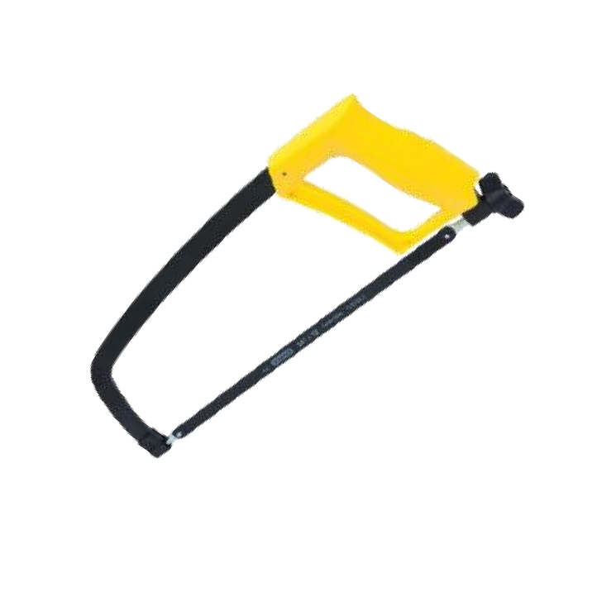
- A learner is about to mark out the shape of a new shelf on a piece of timber before cutting it. Which one of the following tools is most appropriate for precisely marking the timber?
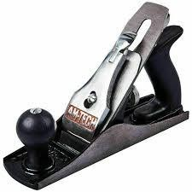
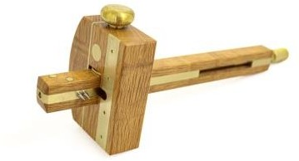
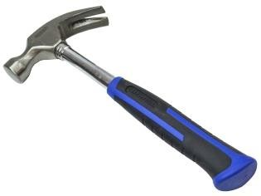
B. C. D.

- In technical drawing, different lines have specific meanings. Identify the type of line that is correctly matched with its description.
A.

Types of line | Description
A. Hidden detail line | Continuous thin line
B. Cutting plane line | Long chain thin line, thickened at ends
C. Dimension line | Thin short dashes
D. Centre line | Continuous thick line

- A designer is planning to create lightweight, durable, and corrosion-resistant parts for an aircraft. She is considering various materials. Which material is best suited for this purpose?
A. Cast iron. B. Mild steel. C. Aluminum alloy. D. Copper.
- A Grade 9 learner needs to securely join two pieces of metal temporarily for welding. He needs a tool that can hold them firmly in place. Choose from the following, the appropriate tool to use for holding the metal pieces.
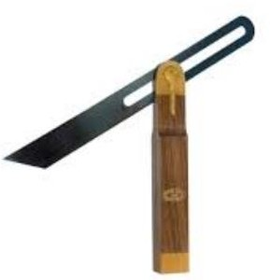
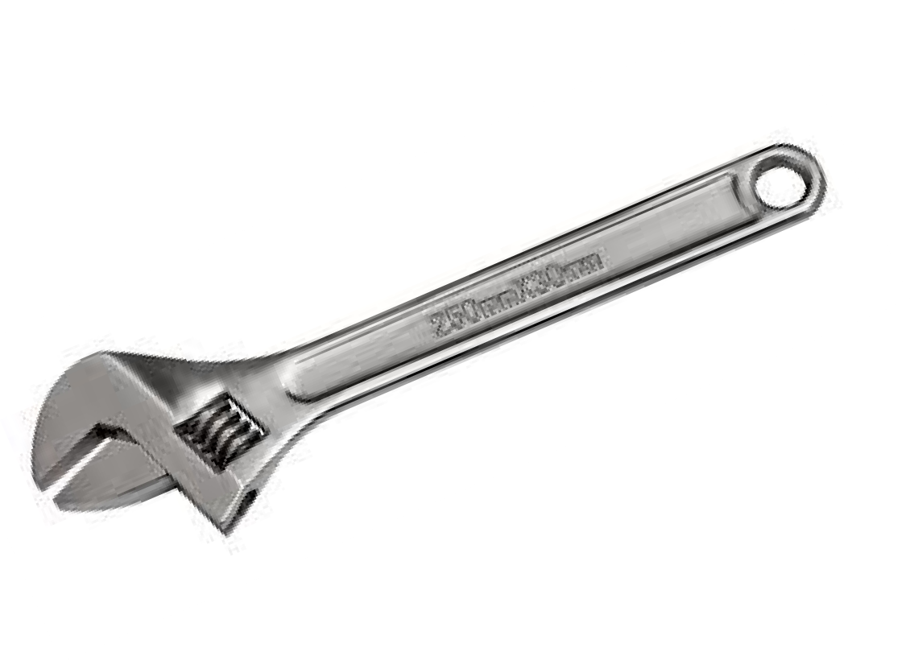
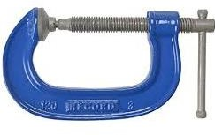

A B C D

- Learners in a workshop are using power drills. To prevent eye injuries from flying debris or dust, their teacher insists they wear protective gear. What is the most important personal protective equipment they should wear in this situation?
  - Safety gloves.
  - Safety goggles.
  - Dust mask.
  - Ear defenders.

- A construction worker is mixing materials to create concrete for a foundation. He knows he needs aggregates, binding material, and water. Which of the following is the essential binding material used for making concrete?
  - Sand.
  - Gravel.
  - Cement.
  - Water.
- A Grade 8 learner has finished using a chisel to carve wood. To protect the sharp edge and ensure safety, she needs to store it correctly. Which of the following is the correct way of protecting the sharp edge of the chisel when storing?
  - Leave it exposed on the workbench.
  - Store it in a tool box with other sharp tools. C. Cover the cutting edge with a guard or sheath.
D. Place it in a drawer with the blade facing up.
- A potter is explaining how various products like teacups, floor tiles, and sanitary ware are made. He mentions they all originate from a specific category of materials. Which one of the following combinations consists only of ceramic materials?
  - Rubber, glass, plastics.
  - Clay, bricks, concrete.
  - Porcelain, glass, tiles.
  - Wood, steel, cement.
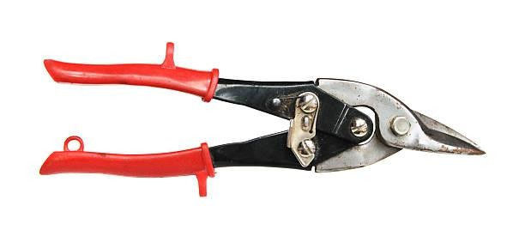
- A learner needs to cut a thin, flexible plastic sheet for a model. He selects a tool that resembles large, heavy- duty scissors designed for cutting sheet materials.

The tool shown above is used to cut:

A. Wood planks. B. Thick metal rods. C. Sheet metal. D. Fabric.

- During a safety audit in a manufacturing plant, several potential fire hazards were identified. The manager wants to address causes related to human action. Which of the following is a possible cause of a fire outbreak related to worker action?

  - Spontaneous combustion of chemicals.
  - Faulty electrical wiring.
  - Leaving flammable materials near heat sources.
  - Lightning strike.
- Firefighters are battling a fire in a building. They are explaining their strategy to a new recruit, mentioning the principles of putting out fires. Which one of the following shows the correct methods of putting off fire by removing elements of the fire triangle?
  - Cooling, fanning, igniting.
  - Smothering, cooling, adding fuel.
  - Starving, smothering, cooling.
  - Heating, starving, smothering.

- In a plumbing workshop, a learner needs to hold pipes firmly while joining them. He is looking for a tool specifically designed to grip and turn pipes. The following are general-purpose holding tools except:
A. Vice. B. Pliers. C. Pipe wrench. D. Clamp.
- Many companies are now collecting used plastic bottles and converting them into new products like fleece jackets or outdoor furniture. The primary reason for recycling these materials is to:
  - Increase the cost of new products.
  - Deplete natural resources faster.
  - Reduce environmental pollution and conserve resources.
  - Create more waste for landfills.
- A carpenter is choosing timber for outdoor decking. He needs wood that is durable and resistant to decay, even if it grows slowly. Which of the following are characteristics of the type of wood he should choose (hardwood)?
  - Needle-like leaves, faster growth, light weight.
  - Broad leaves, slow growth, dense structure.
  - Conical shape, fast growth, soft texture.
  - Easily absorbs moisture, quick to dry, pale colour.
- Kevin has just graduated and wants to start his own mobile repair business. He is naturally creative, takes initiative, and is not afraid of challenges. Which one of the following characteristics is most essential for Kevin to become a successful entrepreneur?
  - Being highly risk-averse.
  - Relying heavily on others for decisions.
  - Possessing strong leadership and risk-taking abilities.
  - Preferring stable, predictable routines.
- Jane wants to open a small bakery. She is considering two locations: one in a busy town center with many competitors and high rent, and another in a quiet residential area with fewer potential customers but lower rent. Which of the following factors would most likely discourage Jane from choosing the busy town center location?
  - High demand for bakery products.
  - Good access to suppliers.
  - High operating costs (e.g., rent, competition).
  - Availability of skilled labour.
- Biashara Limited provides IT services. As of 31st December 2024, their assets included Computers (Ksh 200,000) and Cash (Ksh 50,000). Their liabilities were a Bank Loan (Ksh 80,000). Which of the following represents the owner's capital for Biashara Limited?
  - Ksh 200,000
  - Ksh 250,000
  - Ksh 170,000
  - Ksh 80,000
- Mr. Omondi receives regular payments from his tenants for a house he owns. This income does not require his active daily involvement. This type of income, where one receives earnings without directly working for it, is classified as:
  - Active income.
  - Passive income.
  - Salary.
  - Wages.
- Sarah and David are discussing their personal spending habits. Sarah noticed that David often buys things impulsively and ends up borrowing money before his next allowance. From the following practices, identify what Sarah could have observed in David that indicates an unethical budgeting or spending practice. He:
  - Saved a portion of his allowance first.
  - Created a shopping list before going to the supermarket.
  - Spent money without tracking where it went.
  - Compared prices before making a purchase.
- A small hardware shop in a rural area needs to replenish its stock of tools and building materials. They rely on a larger supplier who offers various benefits to small businesses. Which one of the following services offered by a wholesaler is the retailer most likely to benefit from to minimize upfront costs and manage cash flow?
  - Providing consumer feedback reports.
  - Offering credit facilities.
  - Conducting market research for the retailer.
  - Setting the retail prices for the goods.
- Amina wants to start a small online business but is struggling to come up with unique product ideas. She has limited funds but a lot of free time to research. Which of the following is a key source of business ideas Amina can explore?
  - Ignoring what competitors are doing.
  - Analyzing trends and identifying unmet customer needs.
  - Only focusing on expensive, high-profit products.
  - Waiting for an investor to give her an idea.





- A user is interacting with a computer, moving a cursor on the screen to select items and open programs. He is using a device that fits in his hand. The following pictures show computer input devices. Which one is a pointing device?
A B C D

- A learner needs to buy a computer primarily for graphic design, video editing, and complex simulations. She needs something with powerful processing and large memory, but portability is not a primary concern. The computer that is most appropriate for this use is a:
A. Laptop computer. B. Tablet computer. C. Desktop computer. D. Smartphone.
- Learners are on a school trip visiting a computer lab used for server management. The lab contains many sensitive electronic components. Their teacher gives them safety instructions. The following are safety precautions they should observe while in the lab except:

  - Avoiding eating or drinking near the computers.

  - Touching exposed wires or components.

  - Keeping the workstation tidy.

  - Reporting any faulty equipment immediately.

- Mr. Ben, an online entrepreneur, regularly receives payments and sends money through his mobile phone. He wants to protect his financial transactions from unauthorized access. Which one of the following measures can Mr. Ben use to secure his transaction details from cybercriminals?

  - Sharing his mobile PIN with a trusted friend.

  - Using complex, unique passwords and two-factor authentication.

  - Connecting to public Wi-Fi networks for all transactions.

  - Ignoring software updates for his mobile banking app.

- A learner is typing a formal letter in a word processor. She has just finished a paragraph in lowercase and wants to start the next paragraph with a capitalized word, then continue with small letters. Which key on the computer keyboard should the learner press once to capitalize only the first letter of the next word, without affecting the rest of the text?

A. | Caps Lock.
B | Shift key.
C | Ctrl key.
D | Alt key.

- The school librarian wants a computer program that can help her organize the school's book inventory, track borrowed books, and generate overdue reports. Identify the category of computer software that the librarian needs for this specific task.

A. System software. B. Programming software. C. Application software. D. Operating system.

- A Grade 8 learner is learning to program a simple game. She uses a visual block-based interface where she drags and connects blocks like "move 10 steps" and "repeat until" to create actions.
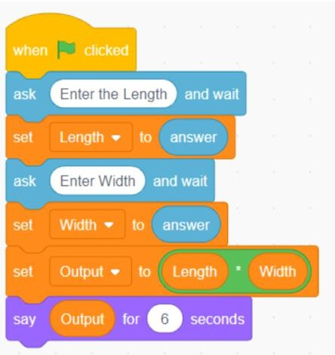

The instructions created by the learner are part of a:

  - Text-based programming language.

  - Command-line interface.

  - Visual programming environment.

  - Database management system.

- A Pre-Technical Studies teacher is showing different computer icons on a projector. She asks the class to identify the icon used for saving a document after making changes. Which icon would be used to save a document in word processing?




A B C D

SECTION B (50 marks)

Answer ALL the questions in this section in the spaces provided.

Task 1: Technical Drawing & Materials (20 marks)

- A Grade 9 learner is comparing two types of woods for use in furniture work. State two differences between
softwood and hardwood. (4 marks)

Softwood | Hard wood
1. | 1.
2. | 2.
a) Mention two examples of hard wood trees in Kenya. (2 marks)

.

.

- Your teacher has given you a rectangular piece of paper measuring 10 cm by 5 cm and asked you to draw a smaller version of it accurately for a model.

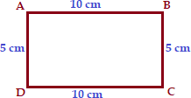

Reduce the rectangular shape above to a scale of 1:2. (3 marks)

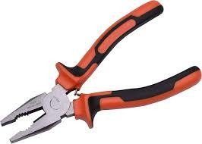


- Your Pre-Technical Studies teacher introduces a workshop tool that has two distinct parts, often used for gripping and cutting wires.

Q

P

- Identify the parts labeled P and Q. (2 marks)

P: Q:

- State two uses of the tool shown above. (2 marks)

- Your school is participating in a recycling initiative to help the environment. They have collected various waste materials from classrooms.

- Give two non-metallic materials that can be recycled. (2 marks)

- Name one item that can be made from each material identified in 34(a). (2 marks)

- As part of a design project, you need to quickly sketch a basic 3D shape without using any drawing instruments, showing its depth. Make a freehand sketch of a cube whose side is 3.0 cm in oblique projection. (5 marks)

- A timber dealer explains to a customer that timber must be 'seasoned' before it can be used for building furniture. State three reasons for seasoning timber. (3 marks)

- You are designing a square-shaped decorative tile for a craft project. You need to ensure all sides are exactly 4 cm. Construct a square of length 4 cm. (3 marks)

- Grade 7 learners visited two different factories in their town, one small and one very large, and wanted to describe their differences in size. State two factors that the learners considered when comparing the size of the factories. (2 marks)

- Kamau, a fruit vendor, wants to know if his business was profitable in the past year. He collected the following financial information for the year ending 31st December 2023.

Item | Ksh
Revenues for the year | 50,000
Cost of sales | 20,000
Rent | 6,000
Salaries | 10,000
Transport expenses | 1,500

Prepare a simple Income Statement for Kamau for the year ending 31st December 2023. (4 marks)

- Some consumers have reported that a few businesses in their area are selling products at excessively high prices or with hidden charges. State two ways in which the government of Kenya protects consumers against such exploitation. (3 marks)

- Mwanesi is an upcoming entrepreneur specializing in juice processing. She wants to sell her juice in a specific location or to a particular group of customers. Outline two factors Mwanesi should consider when selecting a suitable market for the juice. (2 marks)

- Abel plans to buy a smartphone worth Ksh.18,000 in four months. He has targeted to save at least Ksh 5,000 per month to raise the amount required.

- Use the information above to formulate Abel’s financial goals by filling in the following table. (2 marks)

Goal | Time frame | Amount required | Action plan
- Outline one benefit that Abel will get from setting his financial goal. (1 mark)

- The deputy headteacher would like to display information stored in a computer, such as a presentation, during a parent’s day meeting for a large audience to see clearly. State one computer hardware device that the deputy headteacher may use to display the information. (1 mark)

- Your teacher shows you different computer parts and asks you to identify their function. You need to categorize them based on whether they put information into the computer, store it, or show it out. Match each of the following computer hardware devices with their respective category. (2 marks)

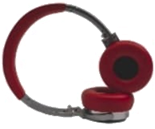
Input


Output

Storage

- Mwengo Company wants to engage directly with its customers online, share updates, and receive feedback instantly. They are exploring popular online platforms. Name two social media platforms that the company may use for networking with its customers. (2 marks)

- Your computer is off, and you need to use it to complete an assignment. You remember the steps taught in class but need to put them in the correct sequence. The following instructions were written to guide learners on how to start up and use a computer. They are not arranged in the correct order.

- Shut down the computer after use.

- Press the power button on the computer.

- Wait for the computer to start up.

- Use the computer to perform a task.

Arrange the instructions in the correct order. (2 marks)

- You want to create simple animations or games using a block-based coding environment that allows you to drag and drop commands rather than typing code. State one example of a Visual Programming Application that can be used to create such instructions. (1 mark)

- Benard has discovered that someone has created a fake social media account using his name, photos, and other personal details, pretending to be him. State the type of online threat Benard is experiencing. (1 mark)

- Grade 9 learners prepared the following shopping list in a spreadsheet application to calculate the total cost automatically.

A | ITEM NAME | UNIT COST | NUMBER OF ITEMS | TOTAL COST
1 | Ruler | 50 | 5 | 250
2 | Drawing book | 100 | 10 | 1000
3 | Pencils | 30 | 5 | 150
4 | Rubber | 20 | 2 | 40
5 | GRAND TOTAL COST |  |  | 1440

Write the formula that the learners would use to calculate the grand total cost in cell D6. (2 marks)

- A Pre-Technical Studies teacher created a basic program to categorize learner performance in an assessment. The program's logic is shown below, with conditions for "meeting expectation" and "approaching expectation".
Start
Enter score If score > 50
Output X
Else
Output Y
End

Complete the instructions by writing the correct output for X and Y based on the given criteria: Scores > 50: learner is meeting expectation. Scores < 50: learner is approaching expectation.

X: (1 mark) Y: (1 mark)

THIS IS THE LAST PRINTED PAGE.


THE KENYA NATIONAL EXAMINATION AND ASSESSMENT PREDICTION SERIES

Candidate’s Name |  | Assessment Number
School Name |  | School Code
Candidate’s Signature |  | Date
KENYA JUNIOR SCHOOL EDUCATION ASSESSMENT 912/2 PRETECHNICAL STUDIES (project) PAPER 2 TERM 2 ENDTERM 2025
-PRETECHNICAL STUDIES-
Time: 1 hour 40 minutes

Duration: 1 month

INSTRUCTIONS TO CANDIDATES

- You are supposed to work in groups of 4 to 5 learners.
- Each member of the group is expected to be actively involved in the implementation of the project.
- Use locally available materials in the implementation of the project as much as possible.

- In case of any clarification, seek help from your subject teacher.
- Your project will be assessed based on the criteria outlined in the tasks below.

For official use only

Task | Question Numbers | Maximum Score | Learner’s Score
Task 1: Technical Skills | 1, 2, 3, 4 | 14
Task 2: Business/Entrepreneurship | 5, 6 | 3
Task 3: ICT/Computer Studies | 7, 8 | 3
TOTAL SCORE |  | 20

This paper consists of 3 printed pages.
Candidates should check the question paper to ascertain that all the pages are printed as indicated and that no questions are missing.

© 2025 The Kenya National Examination and Assessment Prediction Series
Turn over

PROJECT SCENARIO:
Your group has identified a need in the school or local community for a simple, useful product that can be made using readily available materials and basic workshop skills. You have decided to design, make, and plan the potential sale of a Multi-purpose Desk Organizer (e.g., for pens, pencils, small stationery, or even a phone/tablet/laptop).

TASK 1: Technical Skills (14 Marks)
- Design and Planning:
  - As a group, brainstorm and agree on a design for your multi-purpose desk organizer. Consider its shape, size, and the different compartments needed.
  - Make a freehand pictorial sketch of your chosen design. The sketch should clearly show the overall appearance of the organizer and indicate approximate dimensions for the main parts. (4 marks) (Space for sketch)
  - List the main materials you will use to construct the desk organizer. (2 marks)

Material Preparation and Tool Selection:
  - Based on your chosen materials, list at least four appropriate hand tools you will need for marking, cutting, shaping, and joining the parts of your organizer. (4 marks)

Briefly describe one safety precaution you must observe when using one of the cutting tools you listed. (1 mark)

Construction:
  - Carefully measure, mark out, and cut the pieces according to your design sketch using the selected tools.
  - Assemble the cut pieces using appropriate joining methods (e.g., glue, nails, screws, interlocking parts).
  - Apply a simple finish to your organizer (e.g., sanding, painting, varnishing) to improve its appearance and durability.
  - Submission: Present your completed Multi-purpose Desk Organizer. (Marking will be based on accuracy of construction, quality of joints, and finish). (3 marks)

TASK 2: Business/Entrepreneurship (3 Marks)
- Market and Pricing:
  - Considering the materials used and the effort involved, suggest a reasonable selling price for your Multi-purpose Desk Organizer if you were to sell it to learners or teachers. (1 mark)
Selling Price: Ksh .
  - State two qualities of your completed desk organizer that would make it attractive to potential buyers. (2 marks)

TASK 3: Computer Studies (3 Marks)
7. Documentation and Presentation:
- Take clear photos or short video clips during the different stages of your project (design, cutting, joining, finishing). (1 mark)
- Create a simple electronic presentation (e.g., using presentation software or a shared document with images) or a digital poster showcasing the process of making your desk organizer and the final product. Include the photos/videos taken. (2 marks)

THIS IS THE LAST PRINTED PAGE.

CONFIDENTIAL GUIDE FOR TEACHERS
THE KENYA NATIONAL EXAMINATION AND ASSESSMENT PREDICTION SERIES

Teacher’s Name |  | TSC NO.
School Name |  | School Code
Teacher’s Signature |  | Date
KENYA JUNIOR SCHOOL EDUCATION ASSESSMENT

912/2
-PRETECHNICAL STUDIES
PAPER 2 (project)
TERM 2 ENDTERM 2025
1. PRETECHNICAL STUDIES (PROJECT)

Project Scenario: Multi-purpose Desk Organizer Overall Guidance for Teachers:
- The aim of this paper project is to give learners practical skills and competencies required at junior school level.This is in lie with preparing learners for National Examinations and future carrers thereafter.
- This is a group project. Emphasize collaboration and active participation from all members.
- Encourage learners to be innovative and use locally available materials.
- The duration of 1 month allows for iterative design, construction, and refinement.
- Safety is paramount. Ensure learners are aware of and practice safety precautions, especially when handling tools.
- Assessment should be ongoing, observing group dynamics, individual contributions, and the final product.

Task 1: Technical Skills (14 Marks)

- Design and Planning:

  - Brainstorming and Design Agreement:

Teacher's Role: Facilitate brainstorming sessions. Guide groups to consider functionality, aesthetics, material constraints, and the target user (learner/teacher). Ensure they agree on a clear design before proceeding.

Expected Outcome:

A brief discussion/agreement among group members on the chosen design.

Freehand Pictorial Sketch (4 marks):

Teacher's Role: Look for clarity, proportionality, and inclusion of approximate dimensions. The sketch should be a realistic representation of their intended product.

Marking Guidance: 2 marks for a clear, recognizable pictorial sketch of a multi-purpose desk organizer. 2 marks for indicating approximate dimensions for main parts (e.g., length, width, height of compartments).

Common Challenges: Learners may struggle with accurate representation or dimensioning. Guide them to understand the importance of clear communication through sketching.

List of Main Materials (2 marks):

Teacher's Role: Guide learners to list materials that are genuinely locally available and suitable for the project. Encourage variety.

Marking Guidance: 1 mark for listing 2-3 appropriate materials. 2 marks for listing 4 or more appropriate and relevant materials (e.g., cardboard, wood offcuts, plastic bottles, thick paper, fabric scraps, recycled cans).

Expected Outcome: A list of at least four appropriate materials relevant to the design.

Material Preparation and Tool Selection:

  - List of Appropriate Hand Tools (4 marks):

Teacher's Role: Ensure learners link tools to specific processes (marking, cutting, shaping, joining). This shows understanding of tool function.

Marking Guidance: 1 mark for each correct and appropriate hand tool listed (max 4 marks).

Examples: Ruler, pencil, scissors, utility knife, saw (hand saw, coping saw), sandpaper, glue gun, hammer, screwdriver, pliers.

Expected Outcome: A list of at least four hand tools suitable for their chosen materials and design.

Safety Precaution for Cutting Tools (1 mark):

Teacher's Role: Emphasize the importance of safety. Discuss potential hazards and correct usage before they begin construction.

Marking Guidance: 1 mark for a clear and relevant safety precaution (e.g., "Always cut away from your body," "Use a cutting mat," "Keep fingers clear of the blade," "Ensure the tool is sharp").

Expected Outcome: A concise and correct safety precaution.

Construction and Submission:

  - , b), c) Construction Process:

Teacher's Role: Monitor groups during construction. Provide guidance on measuring, cutting techniques, joining methods, and finishing. Encourage neatness and attention to detail. This is an ongoing observation.

Submission of Completed Organizer (3 marks):
Teacher's Role: Assess the final product based on the criteria.

Marking Guidance:
1 mark for accuracy of construction (Does it resemble the sketch? Are measurements generally correct?). 1 mark for quality of joints (Are the parts securely joined? Is it stable?).
1 mark for finish (Is it neatly sanded, painted, varnished, or decorated? Is it appealing?).
Expected Outcome: A functional, stable, and reasonably well-finished multi-purpose desk organizer.

Task 2: Business (3 Marks)

5. Market and Pricing:

- Reasonable Selling Price (1 mark):

Teacher's Role: Guide learners to consider material costs, time invested, and potential market (school community) when suggesting a price.

Marking Guidance:

1 mark for a realistic and justified selling price (e.g., Ksh 50 - Ksh 200, depending on materials and complexity). A price that is either too low (undervaluing effort) or too high (unrealistic for the market) should be questioned.

Expected Outcome: A stated selling price.

Attractive Qualities for Buyers (2 marks):

Teacher's Role: Encourage learners to think from a consumer's perspective. What makes a product desirable?
Marking Guidance: 1 mark for each relevant quality (max 2 marks).

Examples: Durability, aesthetic appeal, functionality (holds various items well), unique design, made from recycled materials (eco-friendly), good finish, stability.

Expected Outcome: Two distinct qualities that highlight the product's value.

Task 3:Computer Studies (3 Marks)

7. Documentation and Presentation:

- Taking Photos/Video Clips (1 mark):

Teacher's Role: Ensure learners capture the process, not just the final product. Guide them on taking clear, well-lit images/videos.

Marking Guidance:

1 mark for clear photos/videos showing at least 3 distinct stages of the project (e.g., design, cutting, assembly, finishing).

Expected Outcome: A collection of digital visual evidence of the project's development.

Creating Electronic Presentation/Digital Poster (2 marks):

Teacher's Role: Guide learners on using appropriate software (e.g., Google Slides, PowerPoint, Canva, Word document with embedded images). Focus on organization and visual communication.

Marking Guidance:
1 mark for successfully creating a simple electronic presentation/digital poster.

1 mark for including the photos/videos and logically showcasing the process and final product.

Expected Outcome:

A simple digital presentation or poster effectively documenting the project.

General Notes for Exams:

- Teacher Supervision: Continuous supervision is crucial, especially for practical aspects involving tools, heat, and chemicals.
- Differentiation: For group projects, encourage varied roles for learners with different strengths.
- Record Keeping: Ensure learners are diligently recording their observations and data as they go.
- Post-Practical Discussion: A follow-up discussion helps reinforce the concepts and correct any misconceptions.
- Cleanliness: Emphasize keeping the workspace clean and tidy throughout and after the practical.
- Fairness: Ensure equal access to materials and tools for all groups/learners.

THIS IS THE LAST PRINTED PAGE.


THE KENYA NATIONAL EXAMINATION AND ASSESSMENT PREDICTION SERIES

Candidate’s Name |  | Assessment Number
School Name |  | School Code
Candidate’s Signature |  | Date
KENYA JUNIOR SCHOOL EDUCATION ASSESSMENT TERM 2 ENDTERM 2025

907: SOCIAL STUDIES

Time: 1 Hour 30 Minutes
-SOCIAL STUDIES-
INSTRUCTIONS TO CANDIDATES

- Write your name and assessment number correctly.
- Write the name and code of your school in the spaces as indicated above.
- Write the date of the assessment.
- This paper consists of two sections: A and B.
- Section A comprises Multiple Choice Questions.
- Section B comprises structured questions and essay questions.
- Answer ALL the questions in Section A on the separate ANSWER SHEET provided.
- Answer ALL the questions in Section B in the spaces provided on this question paper.
- Do NOT remove any page from this question paper.
- Answer the questions in English.

For official use only

SECTION  B | Question | Candidate’s Score per  Question | Maximum  Score | Candidate’s Score per  Task
Task 1 | 21 |  | 10
 | 22 |  | 5
 | 23 |  | 6
 | 24 |  | 5
 | 25 |  | 2
 | 26 |  | 3
Task 2 | 27 |  | 5
 | 28 |  | 5
 | 29 |  | 10
 | 30 |  | 4
 | 31 |  | 4
Task 3 | 32 |  | 10
 | 33 |  | 3
Task 4 | 34 |  | 8
TOTAL |  |  | 100 | 100
This paper consists of 16 printed pages. Candidates should check the question paper to ascertain that all the pages are printed as indicated and that no questions are missing.

© 2025 The Kenya National Examination and Assessment Prediction Series
Turn over

- You have been given this question paper and a separate answer sheet. Answer all the questions in Section A on the separate answer sheet provided.
- When you have chosen your answer, mark it on the ANSWER SHEET, not on this question paper.

HOW TO USE THE ANSWER SHEET

- Use an ordinary HB pencil.
- Confirm that the answer sheet you have been provided with has the following:

YOUR ASSESSMENT NUMBER YOUR NAME
NAME OF YOUR SCHOOL NAME OF THE SUBJECT
- Keep the answer sheet clean, and dry and DO NOT fold it.
- For each of the questions 1 – 20, four answers are given. The answers are lettered A, B, C and D. In each case, only ONE of the four answers is correct. Choose the correct answer.
- On the answer sheet, the correct answer is to be shown by drawing a dark line inside the box in which the letter you have chosen is written.

Example

In the Question Booklet:

17. Your class is planning to start an enterprise project in the school. The first activity the class should do is to: A. agree on how to share the profits from the project B. agree on roles during the project C. discuss where to sell the products D. discuss the type of project to start.

The correct answer is ‘D’.

On the answer sheet, in the set of boxes given for number 17, draw a dark line inside the box with the letter B printed in it as indicated below.

- [A] [B] [C] [D]
- Your dark line MUST be inside the box.
- For each question, ONLY ONE box is to be marked in each set of four boxes.

SECTION A (20 marks)

Answer ALL the questions in this section.

- Which period of the Stone Age is characterized by the development of microliths and bow and arrow technology?

  - Early Stone Age

  - Middle Stone Age
  - Late Stone Age

  - Iron Age

- Before the introduction of money, trade in Africa was mainly conducted through bartering. Which of the following factors contributed most to the eventual introduction of money in Africa?

  - Abundance of gold deposits

  - Increased population growth

  - Challenges associated with the barter system

  - Influence of European traders

- Which of the following describes the human ability to understand and manage one's own feelings?

  - Personal values

  - Self-esteem
  - Emotional intelligence

  - Personal awareness

- The ancient civilization of Egypt was highly influential. Which of the following is a direct influence of Ancient Egypt on modern African governance systems?

  - The concept of democratic elections.

  - Centralized bureaucratic administration.

  - The establishment of constitutional monarchies.

  - The principle of separation of powers.

- The Indian Ocean Slave Trade and the Trans-Saharan Slave Trade were significant historical events. A key difference between them was:

  - The Trans-Saharan Slave Trade primarily involved female slaves.

  - The Indian Ocean Slave Trade ended much earlier than the Trans-Saharan Slave Trade.

  - The Trans-Saharan Slave Trade routes were mainly inland, while Indian Ocean routes were maritime.

  - The Indian Ocean Slave Trade involved slaves from the Americas.

- Historical information is gathered from various sources. Which of the following is the best example of an

archaeological primary source?

  - An academic journal article about early humans.

  - A clay pot unearthed from an ancient settlement.

  - A traditional oral story passed down through generations.

  - A photograph of a historical monument.

- The Earth's crust is constantly undergoing changes due to internal processes. Which geological process is primarily responsible for the formation of fold mountains?

  - Faulting

  - Volcanism
  - Folding

  - Erosion

- Weather instruments help us understand atmospheric conditions. Learners observed the instrument shown below.
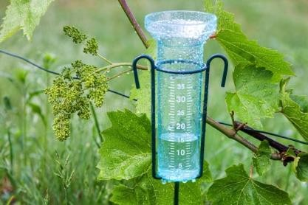

What is the name of the instrument shown above?

  - Wind vane

  - Hygrometer
  - Rain gauge

  - Anemometer

- Longitudes and latitudes are used to pinpoint locations on Earth.
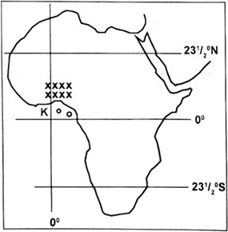
The longitude 0° passes through which significant city?

A. Dakar B. Nairobi C. Accra D. Cairo

- Personal values are fundamental to self-exploration. Which of the following best reflects a strong personal value of integrity?

  - Always seeking personal gain.

  - Acting honestly and morally, even when no one is watching.

  - Adapting your beliefs to fit different social situations.

  - Avoiding difficult decisions.

- The Berlin Conference of 1884-1885 had lasting impacts on Africa. Which of the following was a major term agreed upon by European powers at the conference?

  - Respect for existing African traditional boundaries.

  - Open access to all African rivers for international trade.

  - The need for effective occupation to validate territorial claims.

  - Joint administration of all African colonies.

- The Constitution of Kenya enshrines fundamental human rights. Which characteristic of human rights implies that they apply to all people equally, regardless of their background?

  - Inalienable

  - Universal
  - Indivisible

  - Interdependent

- Population pyramids graphically represent age and sex distribution. A population pyramid with a narrow base and bulging middle suggests:

  - High birth rates and a young population.

  - Rapid population growth.

  - Low birth rates and an aging population.

  - High infant mortality rates.

- Self-esteem is crucial for a learner's well-being. Which of the following best demonstrates a learner with healthy self-esteem?

  - Always comparing their grades with others.

  - Being able to accept both praise and constructive criticism.

  - Avoiding participation in activities to prevent failure.

  - Relying on others for validation and approval.

- During a video lesson in school, learners were shown a clip on continental drift theory. A geographer responsible for the development of the theory was discussed.
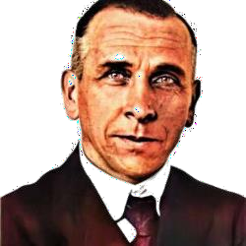

His name was?

A. Sir Isaac Newton B. Sir. Charles Darwin C. Gregor Mendel D. Alfred Wegener.

- Weather and climate in Africa are affected by various factors. Which factor primarily influences the formation of the Great Rift Valley and associated landforms?

  - Ocean currents

  - Latitude
  - Continental drift and plate tectonics

  - Prevailing winds

- Vegetation distribution in Africa is highly diverse. Which type of vegetation is typically found at the highest altitudes on African mountains?

A. Savannah grasslands B. Tropical rainforest C. Montane vegetation D. Mediterranean vegetation

- Lalibela in Ethiopia is a renowned World Heritage Site. What makes it particularly significant?

  - Its extensive fossil discoveries.

  - Its ancient trade routes connecting to Asia.

  - Its unique rock-hewn churches carved out of solid rock.

  - Its historical role as a major port city.

- Community Service Learning projects are part of CBC. Which of the following is a primary goal of a community service learning project?

  - To earn academic credits quickly.

  - To gain personal recognition from the community.

  - To apply classroom knowledge to address real community needs.

  - To avoid traditional classroom assignments.

- At 10:00 a.m., Fatuma, who is at Kisumu, on longitude 32° E calls her friend Halima, who is at Dar es Salaam, on longitude 39° E. What time will it be at Dar es Salaam?

A. 9:32 a.m. B. 8:10 a.m. C. 10:28 a.m. D. 9:23 a.m.

SECTION B (80 marks)

Answer ALL questions in this section.

- Use the map below to answer question 21.
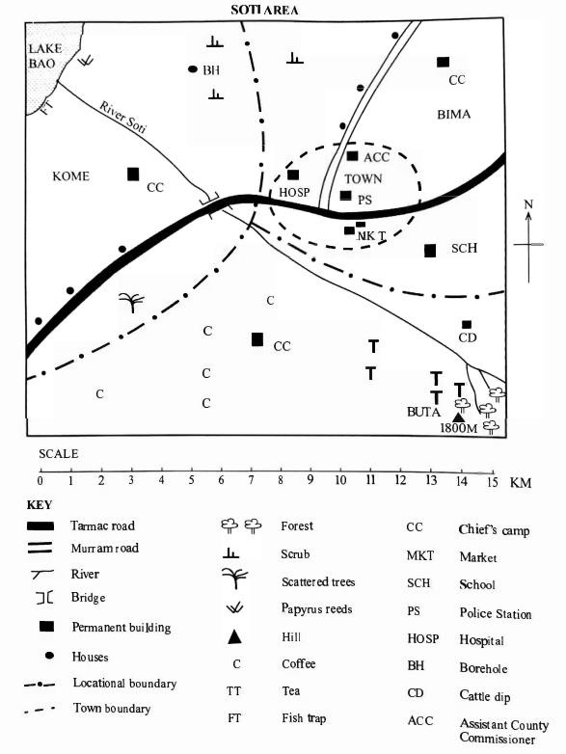

- The direction of the cattle dip from the Lake Bao

- The town has developed mainly because of

- The approximate area of Lake Bao is

- The climate of Buta is likely to be

- The main type of vegetation found in the northern part of Soti Area is

- Human origin and early man are key areas of historical study.

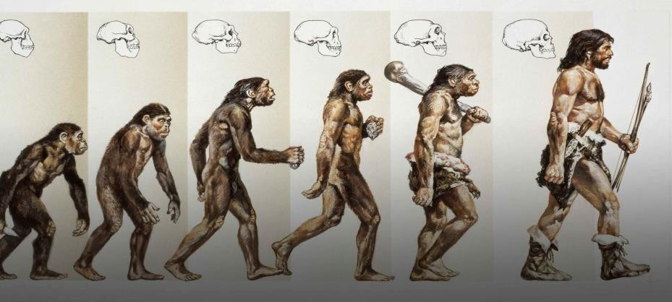

- Describe the main characteristics of the tools used by Early Stone Age man. (3 marks)

- Explain three significant changes that took place as a result of evolution during the different Stone Age periods of man. (2 marks)

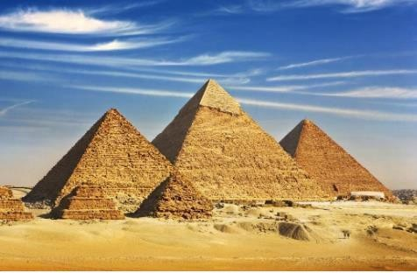
- Identify the following Egyptian innovations A.
.

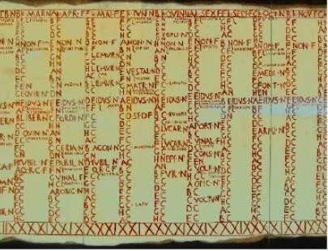
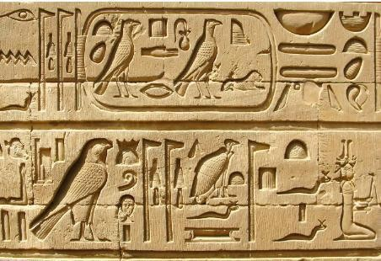
B. .

C. .

- Early African civilizations were centers of innovation and development.

- Name two early African civilizations known for their significant architectural achievements. (2 marks)

- Outline three ways the Kongo Kingdom influenced the political organization of subsequent communities in Central Africa. (3 marks)

- Understanding historical information requires a critical approach.

- Differentiate between primary and secondary sources of historical information. (2 marks)

- Explain four reasons why it is important to consult both primary and secondary sources when researching historical events. (4 marks)

- The internal structure of the Earth is dynamic, leading to various landforms.

- Differentiate between horizontal and vertical earth movements. (2 marks)

b) Explain three resultant features formed by faulting. (3 marks) *

- Personal awareness contributes to healthy relationships. State two characteristics of healthy interpersonal relationships. (2 marks)

- African Diasporas have a significant connection to the continent. State three reasons for the historical movement of African people to other parts of the world, leading to the formation of the African Diasporas. (3 marks)

- Social Studies entrepreneurial opportunities can be found in various sectors. Outline two entrepreneurial opportunities related to the preservation and promotion of historical sites in Africa. (2 marks)

- Identify the historical monument Located at positions EFG. ( 3 marks)
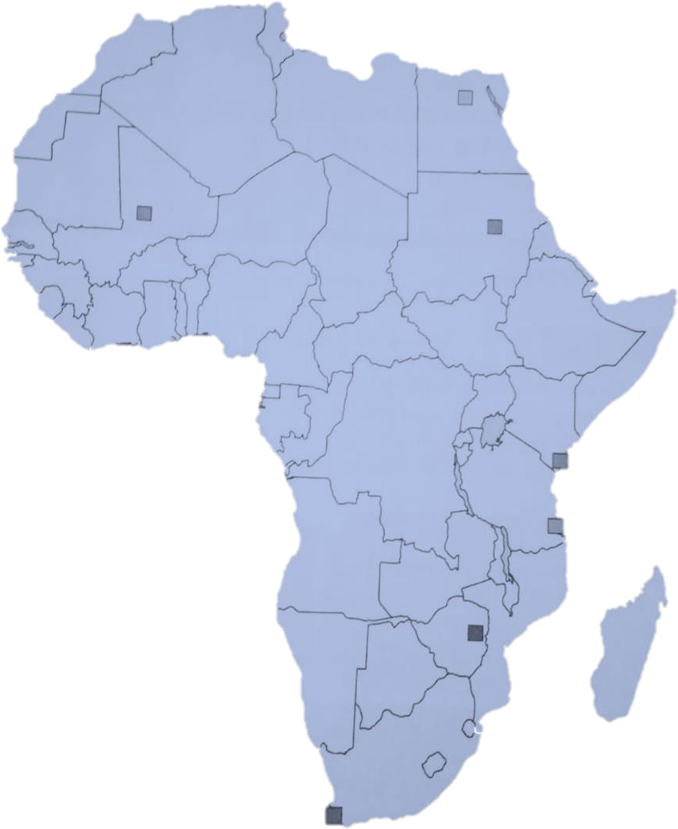
E
F
G

E

F

G

- Personal values are crucial for self-improvement and community well-being. Highlight five national values as enshrined in the Constitution of Kenya. (5 marks)

- Population distribution and structure are key demographic concepts.

- Draw a sketch map of Kenya and mark any two physical features and two cities. (4 marks)

- Explain three evidence supporting continental drift theory. (3 marks)

- Identify the following types of faults. (3 marks)

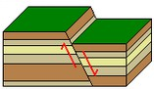
a.

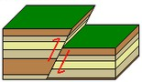
b. .

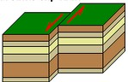
c. .

- Poverty remains a major challenge in many parts of Africa. Outline four causes of poverty in African communities. (2 marks)

b) Outline two solution to combert of poverty in African communities. (2 marks)

- Multipurpose River Projects play a crucial role in development. Discuss two conditions that led to the establishment of multipurpose river projects in Africa. (2 marks)

b)Name the main multipurpose river project found in the following country. (2 marks)

a. | Egypt
b. | Kenya

- Weather and climate are interconnected geographical concepts.

- Highlight one elements of weather. (1 mark)

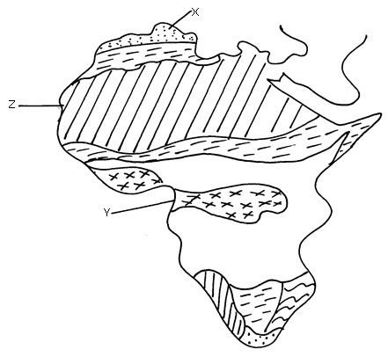
- Identify the climatic regions XYZ(3 marks)

X

Y

Z

b) State three factors that affect vegetation distribution in Africa. (3 marks)

b) Describe three characteristics of savannah vegetation (3 marks)

- Conflict resolution is essential for maintaining peace. State three non-violent ways of solving conflicts in a community. (3 marks)

- Map reading and interpretation are vital skills in Social Studies.

- Outline two types of scales used on topographical maps. (2 marks)

- Explain three challenges of fieldwork when collecting geographical data. (3 marks)

- Name the types of maps shown below. (3 marks)
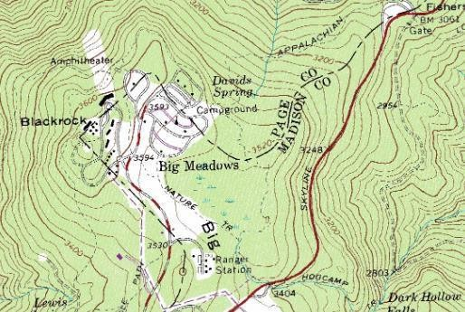
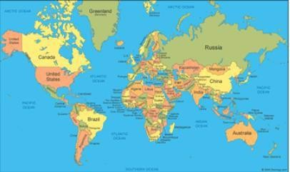
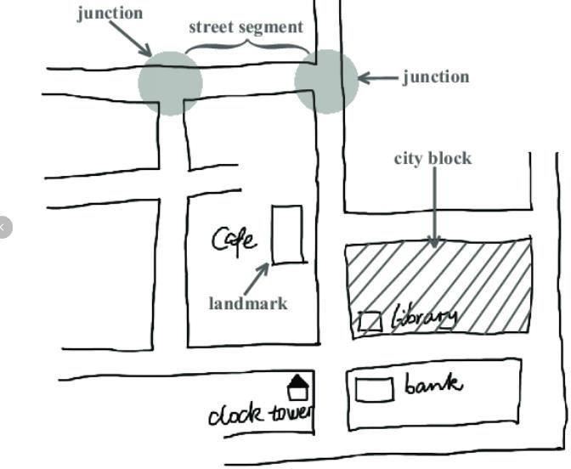

A B C

A:

B:

C:

THIS IS THE LAST PRINTED PAGE


THE KENYA NATIONAL EXAMINATION AND ASSESSMENT PREDICTION SERIES

Candidate’s Name |  | Assessment Number
School Name |  | School Code
Candidate’s Signature |  | Date
KENYA JUNIOR SCHOOL EDUCATION ASSESSMENT CHRISTIAN RELIGIOUS EDUCATION (Theory)
CHRISTIAN RELIGIOUS EDUCATION
TERM 2 ENDTERM 2025

908: CRE

Time: 1 hour 40 minutes INSTRUCTIONS TO CANDIDATES
  - Write your name and assessment number in the spaces provided above.
  - Write the name and code of your school in the spaces provided above.
  - Sign and write the date of the assessment in the spaces provided above.
  - This paper consists of two sections: A and B.
  - Section A comprises Multiple Choice Questions numbered 1 to 20.
  - Section B comprises short, structured questions number 21 to 28.
  - Answer ALL the questions in section A on the separate ANSWER SHEET provided.
  - Answer ALL the questions in section B in the spaces provided in this QUESTION PAPER.
  - Do NOT remove any page from this question paper.
  - Answer ALL the questions in English. Standard Islamic terms may be used.

For official use only SECTION B
Question | 21 | 22 | 23 | 24 | 25 | 26 | 27 | 28 | Total
Maximum Score | 10 | 10 | 10 | 10 | 10 | 10 | 10 | 10 | 80
Candidate’s Score
This paper consists of 8 printed pages.
Candidates should check the question paper to ascertain that all the pages are printed as indicated and that no questions are missing.

© 2025 The Kenya National Examination and Assessment Prediction Series
Turn over

SECTION A (20 marks)
Answer ALL the questions in this section.

- Which attribute of God means He is present everywhere at the same time?
  - Omnipotence
  - Omnipresence
  - Omniscience
  - Immutability
- The collection of books in the Bible that tell the story of Jesus' life, ministry, death, and resurrection are called the
  - Gospels.
  - Epistles.
  - Major Prophets.
  - Historical Books.
- God called Abraham to leave his home in Ur of the Chaldeans and go to a new land. What was the name of this land promised to Abraham's descendants?
  - Egypt
  - Canaan
  - Babylon
  - Assyria
- The covenant God made with the Israelites through Moses is often referred to as the
  - New Covenant.
  - Abrahamic Covenant.
  - Mosaic Covenant.
  - Davidic Covenant.
- King David is known for many things, including composing many of the psalms found in the Bible. Psalms are primarily a book of
  - History.
  - Law.
  - Wisdom.
  - Songs and prayers.
- Which of the following events marked the beginning of Jesus' public ministry?
  - His birth
  - His baptism
  - The feeding of the five thousand
  - Calling of the disciples
- The Sermon on the Mount (Matthew 5-7) contains many of Jesus' core teachings, including the
  - Lord's Supper.
  - Great Commission.
  - Beatitudes and the Lord's Prayer.
  - Parable of the Sower.
- Which miracle of Jesus showed His power over evil spirits?
  - Healing the blind man
  - Exorcising the demoniac in Gerasenes
  - Walking on water
  - Raising Jairus' daughter
- In the parable of the Good Samaritan, Jesus teaches primarily about
  - racial prejudice.
  - religious rituals.
  - the meaning of neighbourly love.
  - avoiding dangerous roads.
- The disciples were first called Christians in the city of
  - Jerusalem.
  - Bethlehem.
  - Antioch.
  - Rome.
- Which fruit of the Holy Spirit helps a Christian to be reliable and trustworthy?
  - Patience
  - Faithfulness
  - Gentleness
  - Self-control
- In African Traditional Religion, the Supreme Being is often considered
  - remote and uninvolved.
  - close and personal.
  - weak and powerless.
  - evil and destructive.
- Baptism and the Lord's Supper are considered sacred rituals or practices in many Christian denominations. These are often called
  - commandments.
  - virtues.
  - ordinances.
  - parables.
- According to Christian teaching, sin is
  - only breaking the law.
  - separation from God.
  - making mistakes.
  - feeling guilty.

- Which Christian value involves giving money or resources to help the poor and needy?
  - Honesty
  - Chastity
  - Generosity
  - Obedience
- The resurrection of Jesus Christ is celebrated by Christians during
  - Christmas.
  - Lent.
  - Good Friday.
  - Easter.
- Pentecost is the Christian celebration of
  - Jesus' birth.
  - Jesus' death.
  - The descent of the Holy Spirit.
  - Jesus' ascension.
- Which book of the Bible tells the story of the early church and the spread of Christianity after Jesus' ascension?
  - Romans
  - Acts of the Apostles
  - Hebrews
  - Revelation
- Prayer is a vital part of Christian life. What is prayer primarily about?
  - Asking for things only.
  - Talking to God.
  - Listening to sermons.
  - Reading the Bible aloud.
- The Christian response to social issues like poverty, injustice, and sickness is often motivated by the call to
  - gain political power.
  - perform acts of service and compassion.
  - build large churches.
  - judge others.

SECTION B (80 marks)
Answer ALL the questions in this section in the spaces provided.
- The death and resurrection of Jesus Christ are the foundation of Christian faith.
- Describe the events leading to the crucifixion of Jesus Christ. (5 marks)

- State three reasons why the death of Jesus is important to Christians. (3 marks)

- Outline two proofs of Jesus' resurrection according to the biblical accounts. (2 marks)

- The Holy Spirit plays a vital role in the lives of Christians and the church.
- Describe the events of the day of Pentecost as recorded in the book of Acts. (5 marks)

- State three roles of the Holy Spirit in the life of an individual Christian. (3 marks)

- Give two ways the Holy Spirit empowers the church today. (2 marks)

- The early church, described in the book of Acts, serves as a model for Christians today.
- Outline four characteristics of the early Christian community in Jerusalem (Acts 2:42-47). (4 marks)

- State four ways Christians today can practice the characteristics of the early church in their communities. (4 marks)

- Give two challenges faced by the early church. (2 marks)

- African Traditional Religion (ATR) has some connections and contrasts with Christianity.
- Outline four similarities between the Christian concept of God and the ATR concept of the Supreme Being. (4 marks)

- State four ways in which ATR beliefs and practices differ from Christian beliefs and practices. (4 marks)

- Give two reasons why some people convert from ATR to Christianity. (2 marks)

- Prayer is essential for Christian growth and relationship with God.
- State four reasons why prayer is important for a Christian. (4 marks)

- Outline four different types of prayer that Christians engage in . (4 marks)

- Give two things that might hinder a Christian's prayer life. (2 marks)

- Christian ethics guide believers on how to live morally.
- Explain the Christian understanding of sin. (3 marks)

- State four consequences of sin in a person's life or in society. (4 marks)

- Give three ways Christians can overcome sin in their lives. (3 marks)

- The Bible provides guidance on how Christians should use their resources.
- Outline four ways Christians can responsibly use their time. (4 marks)

- State four ways Christians can use their talents and abilities to serve God and others. (4 marks)

- Give two reasons why generosity with finances is important in Christianity. (2 marks)

- Christians are called to respond to contemporary social issues from a biblical perspective.
- State four social issues facing the community in Kenya today. (4 marks)

- Outline four ways Christians can help address poverty in their communities. (4 marks)

- Give two ways the church can promote peace and reconciliation in times of conflict. (2 marks)

THIS IS THE LAST PRINTED PAGE.

THE KENYA NATIONAL EXAMINATION AND ASSESSMENT PREDICTION SERIES

Candidate’s Name |  | Assessment Number
School Name |  | School Code
Candidate’s Signature |  | Date

909: IRE
-ISLAMIC RELIGIOUS EDUCATION-
KENYA JUNIOR SCHOOL EDUCATION ASSESSMENT ISLAMIC RELIGIOUS EDUCATION (Theory)
TERM 2 ENDTERM 2025

Time: 1 hour 40 minutes INSTRUCTIONS TO CANDIDATES
  - Write your name and assessment number in the spaces provided above.
  - Write the name and code of your school in the spaces provided above.
  - Sign and write the date of the assessment in the spaces provided above.
  - This paper consists of two sections: A and B.
  - Section A comprises Multiple Choice Questions numbered 1 to 20.
  - Section B comprises short, structured questions number 21 to 28.
  - Answer ALL the questions in section A on the separate ANSWER SHEET provided.
  - Answer ALL the questions in section B in the spaces provided in this QUESTION PAPER.
  - Do NOT remove any page from this question paper.
  - Answer ALL the questions in English. Standard Islamic terms may be used.

For official use only SECTION B

Question | 21 | 22 | 23 | 24 | 25 | 26 | 27 | 28 | Total
Maximum Score | 10 | 10 | 10 | 10 | 10 | 10 | 10 | 10 | 80
Candidate’s Score

This paper consists of 8 printed pages.
Candidates should check the question paper to ascertain that all the pages are printed as indicated and that no questions are missing.

© 2025 The Kenya National Examination and Assessment Prediction Series
Turn over

SECTION A (20 marks)
Answer ALL the questions in this section.

- Which attribute of Allah means He is the Self- Sufficient, the Absolute?
  - Al-Ahad
  - Al-Samad
  - Al-Khaliq
  - Al-Malik
- The six Articles of Iman are listed in a famous Hadith known as the Hadith of
  - Aisha (R.A).
  - Abu Hurayrah (R.A).
  - Jibril (A.S).
  - Anas ibn Malik (R.A).
- Which Prophet was known for his patience and perseverance despite severe trials?
  - Prophet Ibrahim (A.S)
  - Prophet Ayub (A.S)
  - Prophet Yusuf (A.S)
  - Prophet Yunus (A.S)
- The book of Psalms (Zabur) was revealed to which Prophet?
  - Prophet Isa (A.S)
  - Prophet Musa (A.S)
  - Prophet Dawud (A.S)
  - Prophet Sulayman (A.S)
- The first pillar of Islam is Shahada, which is the declaration of
  - Faith.
  - Prayer.
  - Fasting.
  - Charity.
- The Islamic term for ritual purity, essential for Salah and other acts of worship, is
  - Tawhid.
  - Niyyah.
  - Taharah.
  - Sadaqah.
- Which angel is responsible for the affairs of sustenance and rain?
  - Angel Jibril (A.S)
  - Angel Mikail (A.S)
  - Angel Israfil (A.S)
  - Angel Malik
- Belief in the Day of Judgment (Yawm al- Qiyamah) means believing in
  - reincarnation.
  - accountability for one's actions.
  - eternal life on Earth.
  - fate only.
- Islamic law derived from the Quran and Sunnah is called
  - Fatwa.
  - Ijtihad.
  - Qiyas.
  - Sharia.
- The shortest Surah in the Holy Quran is
  - Surah Al-Fatiha.
  - Surah Al-Asr.
  - Surah Al-Kawthar.
  - Surah Al-Ikhlas.
- What was the last major event of Prophet Muhammad's (PBUH) life where he addressed a large gathering of Muslims?
  - Battle of Tabuk
  - Conquest of Makkah
  - Farewell Pilgrimage (Hajjatul Wada')
  - Treaty of Hudaybiyyah
- The Islamic term for earning a living through lawful and permissible means is
  - Haram.
  - Shirk.
  - Halal.
  - Riba.
- A charitable endowment made by a Muslim for religious or charitable purposes is called
  - Zakat.
  - Sadaqah.
  - Waqf.
  - Hibah.
- Which quality of Prophet Muhammad (PBUH) means intelligence and wisdom?
  - Al-Siddiq
  - Al-Amin
  - Al-Fatanah
  - Al-Amanah

- The Prophet Muhammad (PBUH) belonged to the tribe of
  - Banu Israel.
  - Quraysh.
  - Aws.
  - Khazraj.
- The prayer offered seeking guidance from Allah when making a decision is called
  - Tarawih prayer.
  - Eid prayer.
  - Istikhara prayer.
  - Witr prayer.
- Which Islamic month immediately follows Ramadan?
  - Shaban
  - Shawwal
  - Dhul-Qa'dah
  - Dhul-Hijjah
- The Islamic concept of Taqwa means
  - accumulating wealth.
  - being popular.
  - consciousness of Allah and fearing Him.
  - performing rituals without sincerity.
- The five Pillars of Islam are mentioned in the famous Hadith of
  - Jibril (A.S).
  - Aisha (R.A).
  - Umar ibn Al-Khattab (R.A).
  - Abdullah ibn Umar (R.A).
- The practice of fasting is prescribed in the Holy Quran primarily to help Muslims develop
  - patience.
  - thirst.
  - hunger.
  - laziness.

SECTION B (80 marks)
Answer ALL the questions in this section in the spaces provided.
- Tawhid is the fundamental concept in Islam.
- Differentiate between Tawhid al-Rububiyyah and Tawhid al-Uluhiyyah. (4 marks)

- Outline four names or attributes of Allah (Asma ul Husna) and their meanings. (4 marks)

- State two practical ways Muslims can live according to Tawhid. (2 marks)

- The Holy Quran is the primary source of Islamic Law.
- State four reasons why the Holy Quran is considered the ultimate guide for Muslims. (4 marks)

- Outline four etiquettes that a Muslim should observe when handling or reading the Holy Quran. (4 marks)

- Give two examples of how the Quran addresses issues relevant to modern life. (2 marks)

- Sharia is the divine law in Islam.
- Explain the meaning of Sharia. (2 marks)

- State four primary sources from which Islamic Sharia is derived. (4 marks)

- Outline four objectives (Maqasid) of Sharia. (4 marks)

- The Day of Judgment is a core belief in Islam.
- Explain the Islamic belief in the Day of Judgment (Yawm al-Qiyamah). (3 marks)

- Outline four signs of the coming of the Day of Judgment according to Islamic teachings. (4 marks)

- State three impacts that belief in the Day of Judgment has on a Muslim's life. (3 marks)

- Islamic financial practices are guided by Sharia.
- Explain the Islamic concept of Halal and Haram in relation to earning a living. (4 marks)

- State four examples of forbidden (Haram) ways of earning money in Islam. (4 marks)

- Give two examples of lawful (Halal) business practices in Islam. (2 marks)

- Islamic morals and ethics (Akhlaq) are comprehensive.
- Explain the importance of Niyyah (intention) in Islamic actions and worship. (3 marks)

- State four Islamic ethics related to truthfulness and honesty in communication. (4 marks)

- Give three ways Muslims can demonstrate humility. (3 marks)

- The life of Prophet Muhammad (PBUH) provides practical guidance for Muslims.
- Describe the significance of the Prophet's Farewell Pilgrimage (Hajjatul Wada'). (4 marks)

- Outline four key messages conveyed by the Prophet (PBUH) in his Farewell Sermon. (4 marks)

- State two lessons Muslims learn from the Prophet's death. (2 marks)

- The Muslim community (Ummah) has responsibilities towards its members and society.
- State four responsibilities of Muslim parents towards their children. (4 marks)

- Outline four rights that neighbours have upon each other in Islam. (4 marks)

- Give two ways Muslims can contribute positively to the wider Kenyan society. (2 marks)

THIS IS THE LAST PRINTED PAGE.

THE KENYA NATIONAL EXAMINATION AND ASSESSMENT PREDICTION SERIES

Candidate’s Name |  | Assessment Number
School Name |  | School Code
Candidate’s Signature |  | Date

910: HRE
-HINDU RELIGIOUS EDUCATION-
KENYA JUNIOR SCHOOL EDUCATION ASSESSMENT HINDU RELIGIOUS EDUCATION (Theory)
TERM 2 ENDTERM 2025


Time: 1 hour 40 minutes INSTRUCTIONS TO CANDIDATES
  - Write your name and assessment number in the spaces provided above.
  - Write the name and code of your school in the spaces provided above.
  - Sign and write the date of the assessment in the spaces provided above.
  - This paper consists of two sections: A and B.
  - Section A comprises Multiple Choice Questions numbered 1 to 20.
  - Section B comprises short, structured questions number 21 to 28, each with a scenario.
  - Answer ALL the questions in section A on the separate ANSWER SHEET provided.
  - Answer ALL the questions in section B in the spaces provided in this QUESTION PAPER.
  - Do NOT remove any page from this paper.
  - Answer ALL the questions in English. Standard Hindu terms may be used.

For official use only SECTION B

Question | 21 | 22 | 23 | 24 | 25 | 26 | 27 | 28 | Total
Maximum Score | 10 | 10 | 10 | 10 | 10 | 10 | 10 | 10 | 80
Candidate’s Score

This paper consists of 11 printed pages.
Candidates should check the question paper to ascertain that all the pages are printed as indicated and that no questions are missing.

© 2025 The Kenya National Examination and Assessment Prediction Series
Turn over

SECTION A (20 marks)
Answer ALL the questions in this section.

- Which Upanishadic concept refers to the ultimate goal of human life, liberation from the cycle of Samsara?
  - Dharma
  - Artha
  - Kama
  - Moksha
- The philosophy that emphasizes the non- duality of Atman and Brahman is known as
  - Dvaita.
  - Advaita Vedanta.
  - Vishishtadvaita.
  - Samkhya.
- The four stages of life in Hindu tradition are collectively called
  - Varnas.
  - Ashramas.
  - Purusharthas.
  - Yogas.
- Which stage of life focuses on fulfilling family and social responsibilities?
  - Brahmacharya
  - Grihastha
  - Vanaprastha
  - Sannyasa
- The path of renunciation, typically followed in the last stage of life, is called
  - Grihastha.
  - Vanaprastha.
  - Sannyasa.
  - Brahmacharya.
- The four legitimate aims of human life according to Hinduism are known as the
  - Ashramas.
  - Yogas.
  - Purusharthas.
  - Varnas.
- Which Hindu festival celebrates the victory of good over evil, particularly Lord Rama's victory over Ravana or Goddess Durga's victory?
  - Diwali
  - Holi
  - Navratri
  - Dussehra
- A Hindu temple complex, often associated with pilgrimage, is called a
  - Mandir.
  - Ashram.
  - Matha.
  - Tirtha.
- The pilgrimage to holy places in Hinduism is known as
  - Yatra.
  - Darsana.
  - Seva.
  - Vrat.
- Which principle means non-possession or non- attachment to material things?
  - Ahimsa
  - Satya
  - Asteya
  - Aparigraha
- The Hindu ethical principle related to cleanliness and purity of body and mind is
  - Tapas.
  - Santosha.
  - Shaucha.
  - Svadhyaya.
- Who is considered one of the most influential proponents of Advaita Vedanta philosophy?
  - Ramanuja
  - Madhvacharya
  - Shankaracharya
  - Swami Vivekananda
- The Hindu concept of cosmic illusion or the power that creates the perceived world is
  - Brahman.
  - Atman.
  - Maya.
  - Moksha.
- The sacred syllable considered the sound of the universe is
  - Hare.
  - Rama.
  - Om (Aum).
  - Shiva.

- Which Hindu scripture is considered an integral part of the Mahabharata and a key text for Karma Yoga, Bhakti Yoga, and Jnana Yoga?
  - Vedas
  - Upanishads
  - Bhagavad Gita
  - Ramayana
- The Hindu festival celebrating the bond between brothers and sisters is
  - Diwali.
  - Holi.
  - Raksha Bandhan.
  - Janmashtami.
- Respect for teachers and elders is an ethical teaching found in scriptures like the
  - Manusmriti.
  - Upanishads.
  - Puranas.
  - All of the above.
- Which concept refers to living a righteous life and fulfilling one's duties?
  - Artha
  - Kama
  - Dharma
  - Moksha
- The Hindu view on environmental ethics emphasizes
  - exploitation of nature.
  - dominion over nature.
  - harmonious co-existence and reverence for nature.
  - ignoring nature.
- The pursuit of material wealth and economic prosperity as one of the legitimate aims of human life is known as
  - Dharma.
  - Artha.
  - Kama.
  - Moksha.

SECTION B (80 marks)

Answer ALL the questions in this section in the spaces provided.

- You are nearing the end of your junior secondary education and thinking about your future career and life path.

- Name the four Ashramas (stages of life) in the traditional Hindu system. (4 marks)

- Briefly explain the main focus or responsibilities associated with the first two Ashramas (Brahmacharya and Grihastha). (4 marks)

- How can understanding the concept of Ashramas help a young person like you plan for different phases of life? (2 marks)

- Your community is facing a challenge, such as increased pollution or disregard for public property.
- Explain the Hindu ethical principle of environmental care and reverence for nature. (3 marks)

- State four reasons why Hindus believe it is important to protect the environment and natural resources. (4 marks)

- Give three practical steps you and your community can take to address environmental issues based on Hindu teachings. (3 marks)

- A relative from another country visits and is curious about the Hindu concept of liberation. They ask what happens after death and how Hindus believe one can escape the cycle of rebirth.
- Explain the Hindu concept of Moksha. (3 marks)

- How is Moksha related to the concepts of Karma and Samsara? (4 marks)

- State three paths or practices that Hindus believe can lead to the attainment of Moksha. (3 marks)

- You hear someone saying that Hindu philosophy is very complex and difficult to understand. You want to explain a basic concept from the Upanishads in simple terms.
- Explain the concept of Atman and Brahman. (4 marks)

- Describe the relationship between Atman and Brahman as taught in the Advaita Vedanta philosophy (the idea of non-duality). (4 marks)

- Give two reasons why understanding the Atman-Brahman relationship is considered important in Hindu philosophy. (2 marks)

- Your family is planning a spiritual journey to visit a famous temple in India. You are learning about the importance of pilgrimages.
- Explain the significance of undertaking a pilgrimage (Tirtha Yatra) in Hindu Dharma. (3 marks)

- Outline four preparations a Hindu might make before going on a pilgrimage. (4 marks)

- Name three famous Hindu pilgrimage sites. (3 marks)

- There is discussion in your class about how religion can guide people's behaviour. You decide to talk about Hindu ethics.

- Explain the importance of practicing Yamas (restraints) and Niyamas (observances) in Hindu ethical living. (4 marks)

- State four examples of Yamas and four examples of Niyamas. (4 marks)

- Give two benefits of incorporating these ethical principles into one's life. (2 marks)

- You are helping to organize a Hindu community event. You need to explain the importance of different community institutions.

- Name four types of Hindu community institutions or organizations (e.g., Mandir, Ashram, Samaj, educational institutions). (4 marks)

- Outline four roles that Hindu community institutions play in supporting individuals and preserving culture. (4 marks)

- Give two ways young people can get involved in their Hindu community institutions. (2 marks)

- You witness an act of injustice in society. You wonder how Hindu teachings guide believers to respond.
- How does the concept of Dharma guide a Hindu's response to injustice? (3 marks)

- State four ways Hindus are encouraged to work towards justice and righteousness in society, based on teachings like Karma Yoga or Seva. (4 marks)

- Give three examples from Hindu scriptures (epics, Puranas) that illustrate the importance of upholding justice. (3 marks)

THIS IS THE LAST PRINTED PAGE.


THE KENYA NATIONAL EXAMINATION AND ASSESSMENT PREDICTION SERIES

Candidate’s Name |  | Assessment Number
School Name |  | School Code
Candidate’s Signature |  | Date
KENYA JUNIOR SCHOOL EDUCATION ASSESSMENT
-KENYA SIGN LANGUAGE-

904/1 KENYAN SIGN LANGUAGE (Theory) PAPER 1 TERM 2 ENDTERM 2025
CANDIDATE INSTRUCTION BELOW READ CAREFUL CAREFUL//
  - QUESTION PAPER SAME ANSWER SHEET SEPARATE RECEIVE FINISH//
  - PAPER THIS QUESTION 60 HAVE ALL MULTIPLE CHOICE//
  - QUESTION ALL ANSWER SHEET THERE USE ANSWER//QUESTION PAPER ANSWER THERE WRITE ZERO//
  - WORK ROUGH YOUR QUESTION PAPER THERE WRITE FREE FREE//.
  - PENCIL ORDINARY HB USE//
  - ANSWER SHEET CONFIRM INFORMATION BELOW HAVE//
ASSESSMENT NUMBER YOUR NAME YOUR
NAME SCHOOL YOUR NAME SUBJECT
  - ANSWER SHEET CLEAN SAME DRY KEEP MUST// ANSWER SHEET FOLD ZERO//
  - QUESTION 1-60 CHOICE FOUR THERE LETTER A/ B/ C SAME D// ANSWER ONE ONLY CORRECT CHOOSE//
  - ANSWER SHEET USE HOW/BOX INSIDE SHOW LINE DARK DRAW/ ANSWER CORRECT SHOW// BOX OUTSIDE DRAW ZERO//
EXAMPLE
QUESTION PAPER: ?
40. WORD WHICH OPPOSITE WORD BETTER
- WEAK//
- WRONG//
- WORSE//
- WASTE// ANSWER CORRECT ‘C’//
ANSWER SHEET, BOX CHOICE A/B/C SAME D THERE QUESTION 40/ LINE DARK DRAW BOX LETTER C INSIDE SAME BELOW//
[A] [B] [D]
[C]
40
  - QUESTION EACH ANSWER ONE ONLY CHOOSE//
PAPER THIS PAGE 16 PRINT HAVE//
CANDIDATE EACH QUESTION PAPER CONFIRM PAGE ALL PRINT FINISH SAME QUESTION ALL 60 THERE//
PAGE TURN

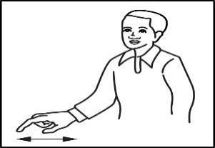
SECTION A: OBSERVE AND SIGN [15 MARKS] 3.

PART I: QUESTION 1 – 5 SIGN IDENTIFY [MARK 5]

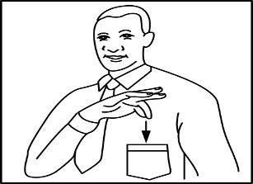

  - PROFIT
  - POCKET
  - KEEP
  - HEART

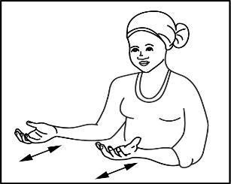

  - DANCE
  - EXCHANGE
  - BUSINESS
  - SERVE
- RUB
- MOUSE
- DRAW
- DRIVE

4.

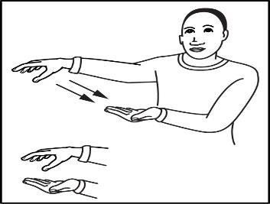

- EXERCISE
- SCRATCH
- GET
- SUPERMARKET

  - PERSON SIGN BELOW HOSPITAL WORK NOTHING
?
WHO

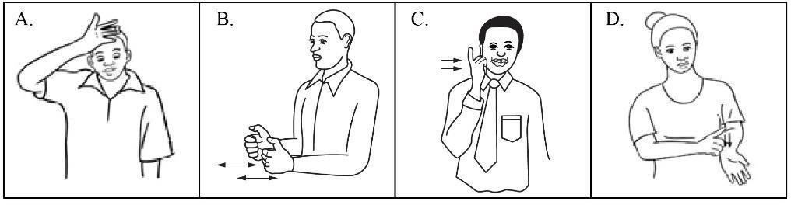

PART II: QUESTION 6 – 10 ANSWER CORRECT//
[MARK 5]

  - SIGN BELOW VIEW CAREFUL/ ELEMENT SIGN TWO
SIMILAR IDENTIFY//
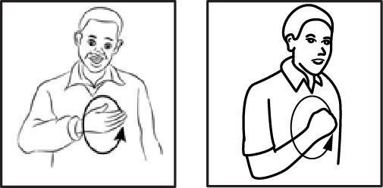

(i) LOCATION | (ii) | MOVEMENT
(iii) FACIAL EXPRESSION | (iv) | HANDSHAPE
    - i, ii B. i, iv
C. ii,iv D. iii, iv

?
  - SIGN BELOW REPRESENT WORD WHICH
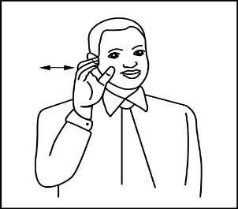

    - COUSIN
    - CONFUSE
    - CUSTOMER
    - COLLEGE
?
  - ELEMENT SIGN BELOW NON-MANUAL WHICH

    - HANDSHAPE
    - FACIAL EXPRESSION
    - MOVEMENT
    - PLACE ARTICULATE

PAGE TURN

?
  - SIGN SIGN BELOW DIFFERENT WHAT
PART III: PICTURE I -V OBSERVE/ QUESTION 11-15 ANSWER CORRECT//

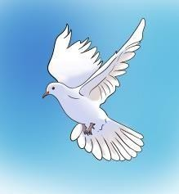
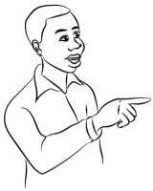
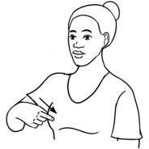

(i) (ii)

    - HANDSHAPE
    - ARTICULATION
    - ORIENTATION
    - LOCATION
(iii)
(iv)
(v)

  - TIME WORD WORD BELOW SIGN MOVEMENT REPEAT
? REPEAT WHICH
    - ALWAYS
    - BEAUTIFUL
    - WELL
    - BAD


?
  - PICTURE (i) SYMBOL MEAN WHAT
    - LOVE
    - BEAUTY
    - PEACE
    - FEAR

?
  - PICTURE (ii) SYMBOL MEAN WHAT
    - NATURE
    - VALENTINE
? C. BEAUTY
D. LOVE

?
PICTURE (iii) USE TIME PERSON ACTION WHAT
- SURRENDER
SECTION B: VIEW AND INTERPRET
PART 1: NOTICE BELOW READ/ QUESTION 16 – 25 ANSWER CORRECT// [MARK 10]
COMPANY KENYA RAILWAYS

- WIN
- DEFEAT
- MARRY
NOTICE PUBLIC TRAIN FARE ADJUST CUSTOMER ALL

?

COLOUR PICTURE (iv) SHOW WHAT

- DANGER
- HOT
- RIPE
- LOVE
? COLOUR PICTURE (v) SHOW WHAT
- SMART
- RAIN
COMPANY WISH INFORM ALL WHAT/
PRICE TRAIN SERVICE DIFFERENT INCREASE FINISH// SERVICE SAME WHAT/
MADARAKA EXPRESS SERVICE PASSENGER/ MADARAKA EXPRESS SERVICE COMMUTER/ NAIROBI COMMUTER SERVICE RAILWAY/ KISUMU TRAIN SAFARI/
NANYUKI TRAIN SAFARI//
PRICE INCREASE/ WHY/ SECTOR ENERGY PETROLEUM CHANGE FINISH//
MEANING PRICE FUEL INCREASE HIGH/ MAKE TRAIN OPERmATE EXPENSIVE MORE//
FARE NEW START IMPLEMENT DATE 1/


- BURN
- TROUBLE
MONTH JANUARY/ YEAR 2024// IF CUSTOMER PAY TICKET
MADARAKA EXPRESS SERVICE PASSENGER/ POSSIBLE SEE FARE ADJUST
FROM DATE 1 NOVEMBER 2023 FINISH/ THIS INCLUDE PEOPLE SOME
WHO TICKET PAY FINISH DAY 60 BEFORE DATE TRAVEL//
WE APPRECIATE BIG YOU CONTINUE BUSINESS WITH US DO SAME US SUPPORT // FROM MANAGEMENT
DATE 31 MONTH 10 YEAR 2023

?
  - NOTICE THIS WRITE DATE WHICH
    - DATE 1 MONTH 1 YEAR 2024//
    - DATE HAVE NOTHING//
    - DATE/ MONTH// YEAR 2023//
    - DATE 31 MONTH 10 YEAR 2023//
?
  - TRAIN FARE ADJUST MEAN WHAT
    - TRAIN TIME CHANGE//
    - TRAIN COST CHANGE//
    - TRAIN PEOPLE REDUCE//
    - TRAIN SERVICE REMOVE//
?
  - NOTICE SEND FROM OFFICE WHICH
    - MADARAKA EXPRESS SERVICE//
    - KISUMU TRAIN SAFARI//
    - COMPANY KENYA RAILWAY //
    - CUSTOMER RAILWAY KENYA//
?
- COMPANY FARE ADJUST GIVE REASON WHICH
- COST OPERATE TRAIN INCREASE FINISH//
- TRAIN ENOUGH NOTHING//
- SECTOR ENERGY MONEY HAVE NOTHING//
- PETROLEUM NOW CHEAP FINISH//
?

- FARE NEW IMPLEMENT WHEN
  - DAY FIRST MONTH// YEAR 2023//
  - DATE 31 MONTH 10 YEAR 2023
  - DAY FIRST MONTH 1 YEAR 2024//
  - DATE 31MONTH 2023 /YEAR 10/ //
?
- SENTENCE TRUE NOTHING NOTICE THERE WHICH

  - COMPANY THANK CUSTOMER THEIR//
  - FARE NEW AFFECT PEOPLE PAY MONTH 3 EARLY//
  - PRICE FUEL AFFECT COST TRAIN//

?
NOTICE AFFECT TRAIN SERVICE HOW MANY
- FIVE//
- NONE//
- FOUR//
- ONE ONLY//
  - CUSTOMER IMPOSSIBLE SEE FARE ADJUST //

?
- NOTICE THIS OBJECTIVE WHAT
  - PEOPLE INFORM NOTICE PUBLIC//
  - PEOPLE INFORM TRAVEL FARE ADJUST//
  - PEOPLE INFORM PETROLEUM CHANGE FINISH//
  - PEOPLE INFORM SERVICE TRAIN FIVE
HAVE//

?
- NOTICE THIS AFFECT PEOPLE WHO
  - CUSTOMER TRAIN NANYUKI//
  - CUSTOMER TRAIN MADARAKA//
  - CUSTOMER TRAIN ALL//
  - CUSTOMER TRAIN KISUMU//
?
- COMPANY KENYA RAILWAY PUBLIC THANK WHY
  - PUBLIC COMPANY SUPPORT //
  - PUBLIC FARE NEW ACCEPT//
  - PUBLIC BUSINESS SUPPORT ZERO//
  - PUBLIC FARE NEW HATE//
PART II:
PASSAGE BELOW READ WELL/ QUESTION 26 – 33 ANSWER CORRECT// [MARK 8]

BOY M-E-K-O BEHAVIOUR BAD / SELF LIKE HOME COME LATE ALCOHOL DRINK SAME DISSAPEAR DAY FEW / LATER COME / AGAIN SHORT DISAPPEAR //

WEEK LAST ARREST FINISH / COURT RULE FINISH JAIL YEAR 10 / TIME JAIL SELF MEET BOY OTHER BECOME FRIEND / K- E-N-T-A JAIL YEAR 12 MORE THAN M-E-K-O / MISTAKE HIS/WHAT/ SELF BEFORE FIGHT WOMAN OTHER / ACID POUR BODY ALL
?
BURN DIE / M-E-K-O SELF SHOCK / WHY / SELF MISTAKE WHAT / HOUSE BREAK / OWNER BEAT SAME STEAL BUT KILL NOTHING//
TIME JAIL M-E-K-O MEET MAN OTHER NAME K-E-L-L-Y /SELF JAIL YEAR 22// MAN BEFORE WORK COMPANY PLANE JOB AIR HOSTESS// HAPPEN SELF START DRUG CARRY DELIVER COUNTRY OTHER //DAY ONE POLICE ARREST JAIL FINISH // PRISONER OTHER MAN NAME O-M-I-D-E JAIL YEAR 25/ WHY/ GIRL RAPE //

NOW JAIL THERE TASK DIFFERENT EACH HAVE// M-E-K-O RESPONSIBLE CARPENTRY / FARM WORK SAME SWEEP/ / K-E-L- L-Y WORK CARPENTRY / COMPOUND CLEAN SAME FARM WORK
// K-E-N-T-A FOOD PRISONER COOK / BAKE SAME FARM / /O-M-I- D-E EXPERT TAILOR // SELF PRISONER TRAIN OTHER CLOTH MAKE / ROOM CLEAN SAME FARM FARM //

PAGE TURN

?
- K-E-N-T-A JAIL YEAR HOW MANY

A. 25 B. 22 C. 10 D. 12
?
- PEOPLE TWO JAIL TERM YEAR SAME WHO
  - K-E-N-T-A / K-E-L-L-Y
  - K-E-L-L-Y / O-M-I-D-E
  - M-E-K-O / K-E-N-T-A
  - K-E-L-L-Y / M-E-K-O
?
- PERSON JAIL MISTAKE MURDER WHO
  - M-E-K-O B. O-M-I-D-E
C. K-E-L-L-Y D. K-E-N-T-A

?
- JAIL THERE TASK INVOLVE PRISONER ALL WHICH

  - CARPENTER
  - FARM
  - SWEEP
  - FOOD COOK
?
- PERSON PRISONER TEACH SKILL CLOTH MAKE WHO
  - K-E-L-L-Y
  - M-E-K-O
  - O-M-I-D-E
  - NONE
- PEOPLE RESPONSIBLE ENVIRONMENT JAIL CLEAN
? WHO
  - O-M-I-D-E / K-E-L-L-Y / M-E-K-O
  - O-M-I-D-E / K-E-L-L-Y
  - O-M-I-D-E / M-E-K-O / K-E-N-T-A
  - O-M-I-D-E/K-E-N-T-A

?
32 PERSON RESPONSIBLE KITCHEN WHO
- O-M-I-D-E
- M-E-K-O
- K-E-N-T-A
- NONE

?
- SENTENCE TRUE NOTHING WHICH
- DRUG SELL / CARRY OR USE CRIME BIG //
- HOUSE BREAK/ STEAL/ KILL CRIME ZERO//
- PRISONER ONE ONLY MISTAKE KILL //
- CRIME RAPE JAIL YEAR MOST //

PART III: MAP BELOW STUDY QUESTION 34 - 40 ANSWER CORRECT// [MARK 7]

MAP ZIWA
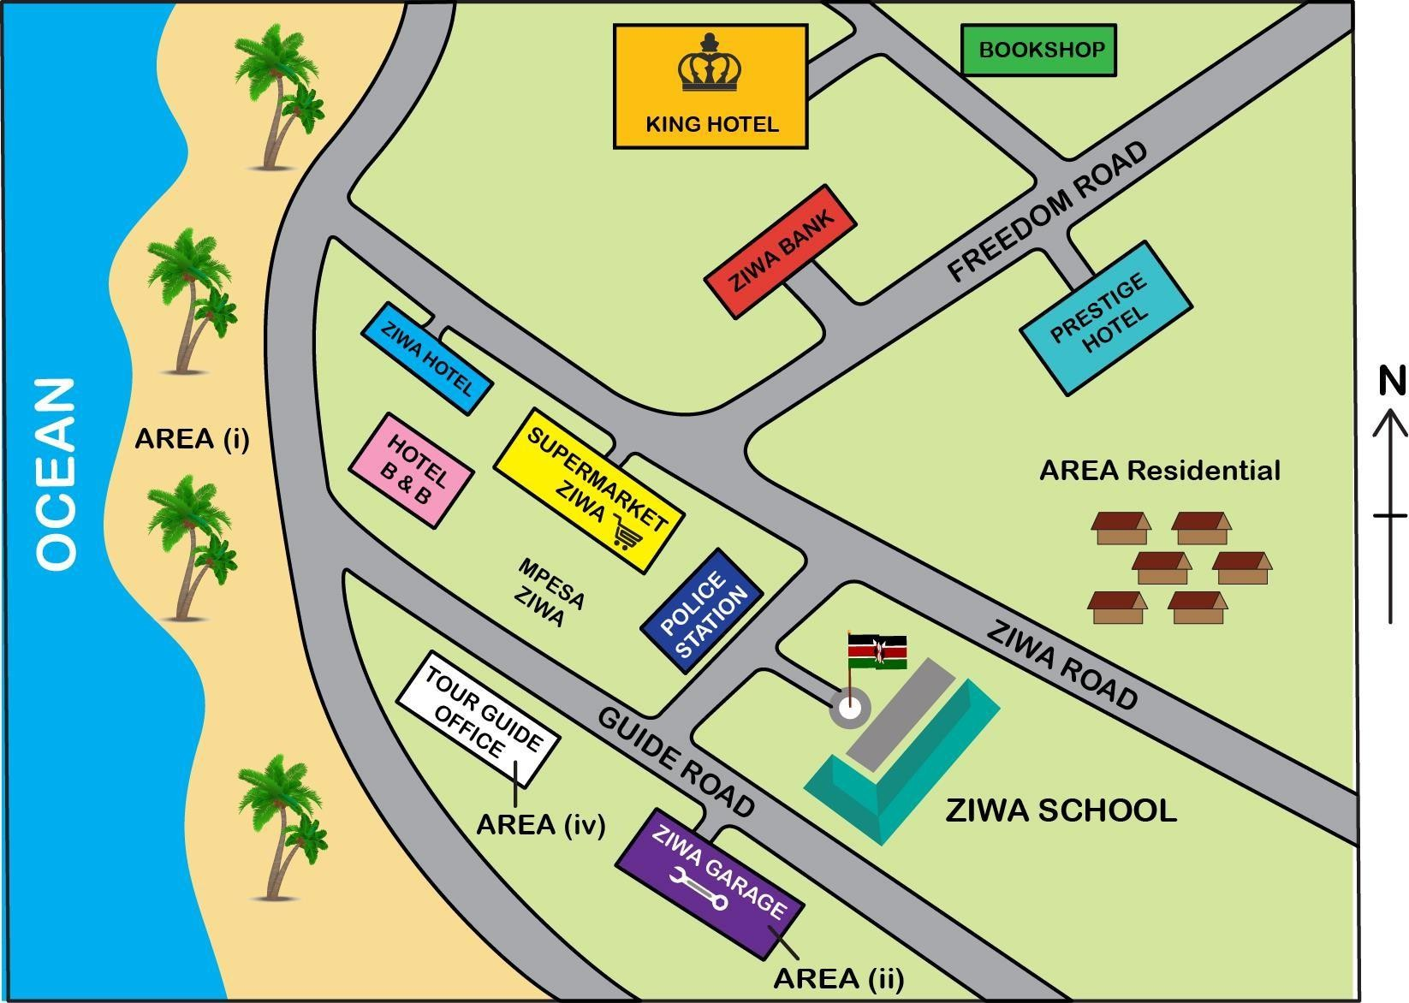

?
- AREA i NAME WHAT
  - BORDER //
  - DESERT //
  - BEACH //
  - PARK //

- AREA ZIWA POSSIBLE ACTIVITY ECONOMIC MAIN
?
- PEOPLE AREA (iv) WORK WHAT

- SCHOOL NEAR TEACH //
- MPESA THERE SECURITY //
- TOURIST AROUND SHOW //
- AREA (i) THERE CLEAN //
?

?
WHICH
- TOURISM//
- FARMING //
- FISHING //
- BOATING//

- IF PERSON SCHOOL ZIWA WANT BOOKSHOP GO /
? YOU GUIDE PERSON GO HOW
  - WALK GATE / LEFT TURN / LEFT TURN AGAIN / WALK GARAGE / ZIWA BANK PASS / BOOKSHOP THERE //
  - WALK GATE / TURN RIGHT JOIN ROAD ZIWA
/ LEFT TURN WALK ROAD FREEDOM/ BANK PASS/ LEFT TURN BOOKSHOP REACH//
  - WALK GATE / LEFT TURN / JUNCTION SEE / ROAD NORTH WEST FOLLOW STRAIGT HOTEL PRESTIGE NEXT BOOKSHOP //
  - WALK GATE / JOIN ROAD ZIWA/LEFT TURN/ WALK STRAIGHT BOOKSHOP THERE//
- SCHOOL ZIWA POSSIBLE MONEY KEEP WHERE

  - SUPERMARKET ZIWA //
  - HOTEL PRESTIGE //
  - POLICE STATION //
  - BANK ZIWA //

- HOTEL ZIWA SUPERMARKET ZIWA//

  - NEAR B. ACROSS
C. ABOVE D. BELOW
?
- AREA (ii) THERE WORK WHAT
  - VEHICLE SELL//
  - VEHICLE REPAIR//
  - VEHICLE DISPLAY//
  - VEHICLE PARK //

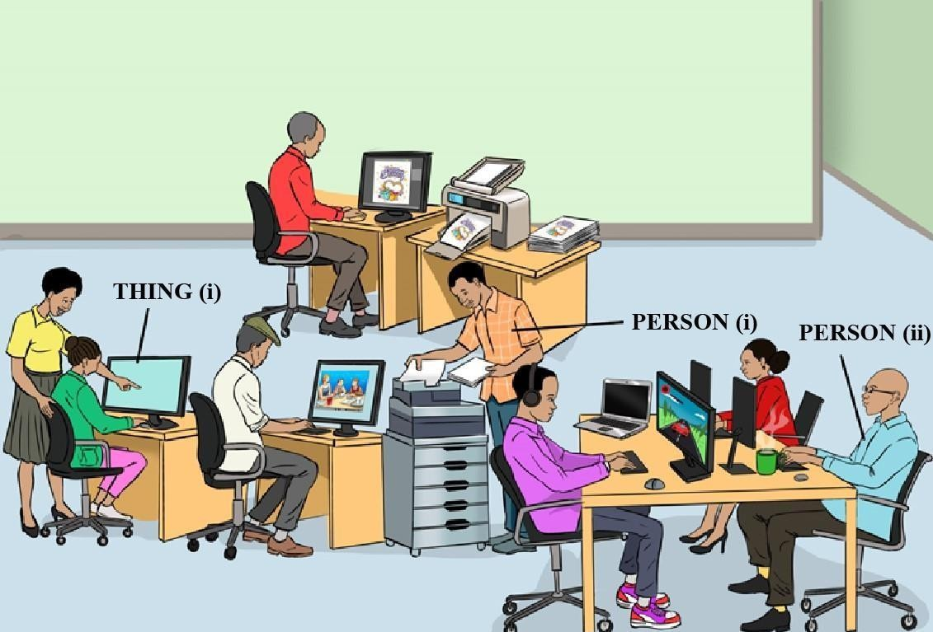
PART IV: VIEWING AND INTERPRETING [MARK 5] PICTURE BELOW STUDY CAREFUL QUESTION 41-45 ANSWER CORRECT

PAGE TURN
_____?

?
- PERSON (i) WORK WHAT
  - DOCUMENT COUNT//
  - DOCUMENT PHOTOCOPY//
  - DOCUMENT PRINT//
  - DOCUMENT DRY//

?
- THING (i) NAME WHAT
  - MONITOR//
  - MIRROR //
  - LAPTOP //
  - TELEVISION //
?
- PLACE PICTURE THING THERE NOTHING WHICH

- LAPTOP //
- PRINTER//
- COMPUTER//
- TELEVISION//

SECTION C: GRAMMAR [15 MARKS]

PART I :PARTS OF SPEECH [MARK 5]
QUESTION 46-50 CAREFUL READ ANSWER CORRECT CHOOSE//

?
ACTION PERSON (ii) WRONG WHAT
- IMPOSSIBLE SELF COMPUTER FOCUS //
- COMPUTER USE TIME HUNGRY //
- COMPUTER USE TIME SIT //
- POSSIBLE DRINK KEYBOARD DAMAGE //

?
?
- SENTENCE BELOW ADVERB WHICH
TIME ASSEMBLY A-N-I-T-A SING ALWAYS //
- ASSEMBLY
- TIME
- SING
- ALWAYS
?

- PLACE PICTURE THERE NAME WHAT
  - SHOP GENERAL//
  - BOOK STORE//
  - CYBER CAFE//
  - SHOP PHONE//
- SENTENCE BELOW VERB WHICH
DOG OUR CAT AWAY CHASE//
- AWAY
- OUR
- CHASE
- CAT

- SENTENCE SIGN BELOW ADVERB WHICH
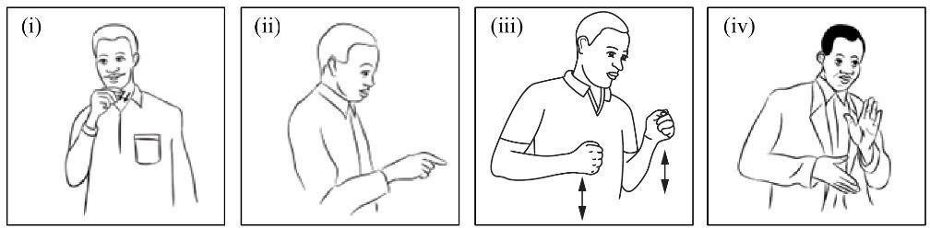

A. (iv) B. (i) C. (iii) D. (ii)

- ADJECTIVE SENTENCE BELOW CHOOSE //

A-S-H-A SUBJECT MATHEMATIC CLEVER //

A. | A-S-H-A | B. CLEVER
C. | SUBJECT | D. MATHEMATICS

- PICTURE / SIGN BELOW USE PREPOSITION
IDENTIFY //

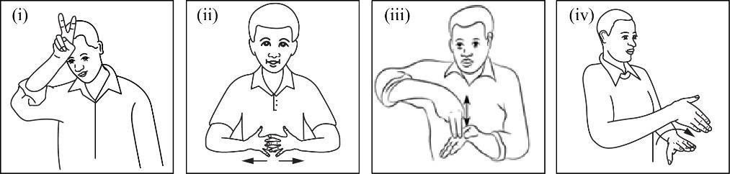
A. (i) B. (iii) C. (iv) D. (ii)
PART II :SENTENCE KSL [MARK 10]
QUESTION 51-60 CAREFUL READ ANSWER CORRECT CHOOSE//
- SIGN SIGN BELOW USE SENTENCE KSL CORRECT
MAKE //
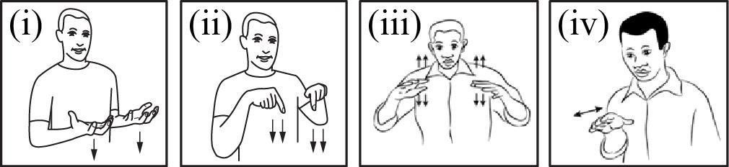

- iii, iv, i, ii B. iv, ii, iii, i
C. ii, i, iii, iv D. iv, iii, i, ii

- SIGN SIGN BELOW USE SENTENCE KSL CORRECT
MAKE //
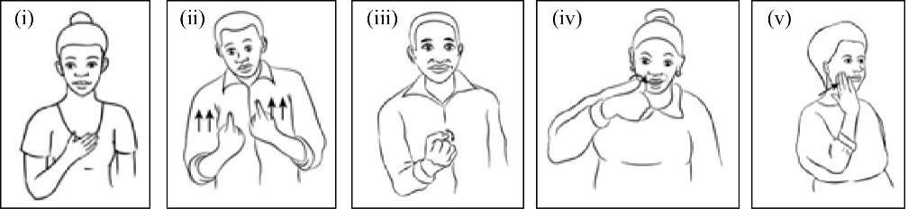
A. i, ii, iii, iv, v B. iii, v, iv, ii, i
C. v, iv, ii, iii, i D. v, i, iii, iv, ii

PAGE TURN

- SENTENCE BELOW GRAMMAR KSL CORRECT WHICH?
- LATE SCHOOL BUS YESTERDAY //
- YESTERDAY BUS SCHOOL LATE //
- SCHOOL BUS LATE YESTERDAY //
- SCHOOL YESTERDAY LATE BUS //
?
- SENTENCE BELOW PLURAL SHOW WHICH
- RAT BOOK MINE ONE DESTROY DESTROY //
- BOOK ONE MINE RAT DESTROY //
- RAT BOOK MINE GOOD DESTROY //
- RAT RAT BOOK MINE MANY DESTROY //
?

- SENTENCE BELOW NEGATE CORRECT WHICH
J-U-M-A STORY BOOK READ ENJOY //
- J-U-M-A STORY BOOK READ ENJOY POSSIBLE//
- J-U-M-A STORY BOOK READ ENJOY NOTHING//
- J-U-M-A STORY BOOK READ ENJOY ALOT//
- J-U-M-A STORY BOOK READ ENJOY MUST//
?
- SENTENCE BELOW ACTION FUTURE WHICH
  - A-N-N-A YESTERDAY MARKET CARROT BUY //
  - A-N-N-A MARKET GO CARROT BUY //
  - A-N-N-A TOMORROW MARKET CARROT BUY//
  - A-N-N-A MARKET CARROT BUY FINISH //
?
- SENTENCE BELOW PUNCTUATE CORRECT WHICH
  - J-O-H-N / FAT WHY? SELF CHIPS EAT LOVE.
  - J-O-H-N FAT WHY / SELF CHIPS EAT LOVE //
  - J-O-H-N FAT / WHY / SELF CHIPS EAT LOVE //
  - J-O-H-N FAT WHY SELF / CHIPS EAT LOVE //
?
- SENTENCE SINGULAR CORRECT WHICH
  - CHILD BALL CLASSROOM IN PLAY LOVE //
  - CHILDREN BALL BALL PLAY CLASSROOM IN
LOVE //
  - CHILD BALLS PLAY CLASSROOM IN LOVE //
  - CHILDREN BALL CLASSROOM IN PLAY
LOVE//
?
- SENTENCE BELOW KSL CORRECT WHICH
  - IN LIMURU GROW TEA//
  - AREA LIMURU TEA GROW//
  - LIMURU TEA AREA GROW//
  - TEA AREA LIMURU GROW//
- SENTENCE SHOW ACTION HAPPEN TIME PRESENT
WHICH?
  - J-A-N-E SOON KITCHEN SUKUMA COOK //
  - J-A-N-E KITCHEN SUKUMA COOK NOW //
  - J-A-N-E BEFORE KITCHEN SUKUMA COOK //
  - J-A-N-E KITCHEN SUKUMA COOK FINISH //

PAGE THIS LAST


THE KENYA NATIONAL EXAMINATION AND ASSESSMENT PREDICTION SERIES

Candidate’s Name |  | Assessment Number
School Name |  | School Code
Candidate’s Signature |  | Date
KENYA JUNIOR SCHOOL EDUCATION ASSESSMENT

KENYA JUNIOR SECONDARY EDUCATIONAL ASSESSMENT (KJSEA) 904/2

KENYAN SIGN LANGUAGE PRACTICAL
GRADE 8:
ENDTERM 2 ASSESSMENT 2025
HOUR 1 MINUTE 40
KENYA SIGN LANGUAGE

INSTRUCTION BELOW READ CAREFUL CAREFUL:
    - NAME YOUR SAME ASSESSMENT NUMBER SPACE ABOVE WRITE//
    - NAME SAME CODE SCHOOL YOUR SPACE ABOVE WRITE//
    - SIGNATURE YOUR SAME DATE ASSESSMENT SPACE ABOVE WRITE//
    - PAPER THIS TASK FOUR HAVE//
    - PAPER THIS SECTION TWO A SAME B HAVE//
    - SECTION A TASK 1 ONLY// QUESTION THIS PICTURE 4 USE STORY KSL SPACE THERE PERFORM//
    - SECTION B TASK 2, TASK 3, TASK 4 HAVE// EACH TASK PROMPT ONE CAREFUL LOOK ANSWER SPACE THERE PERFORM//
    - TASK ALL SPACE QUESTION PAPER USE PERFORM//
FOR OFFICIAL USE
SECTION | A | B |  |  | TOTAL
TASK | 1 | 2 | 3 | 4
WRITING | Narrative | Description | Explanation | Analysis
 | based on a | based on a | based on a | based on a
 | series of pictures | given authentic activity | given theme | given theme
SCORE | 20 | 10 | 5 | 5 | 40
CANDIDATE’S SCORE

PAPER THIS PAGE 6 PRINT HAVE//
CANDIDATE EACH QUESTION PAPER CONFIRM PAGE ALL PRINT FINISH SAME QUESTION ALL 4 THERE// QUESTION MISS ZERO//

© 2025 The Kenya National Examination and Assessment Prediction Series
PAGE TURN

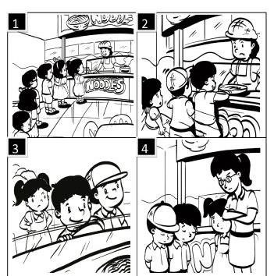
SECTION A (MARK 20) TASK 1.

PICTURE BELOW CAREFUL LOOK STORY KSL WRITE

.
PICTURE BELOW CAREFUL LOOK STORY KSL WRITE

SECTION B (MARK 20)
TASK 1: PICTURE CLASSROOM BELOW EXPLAIN CLEAN HOW ? (MARK 10 )
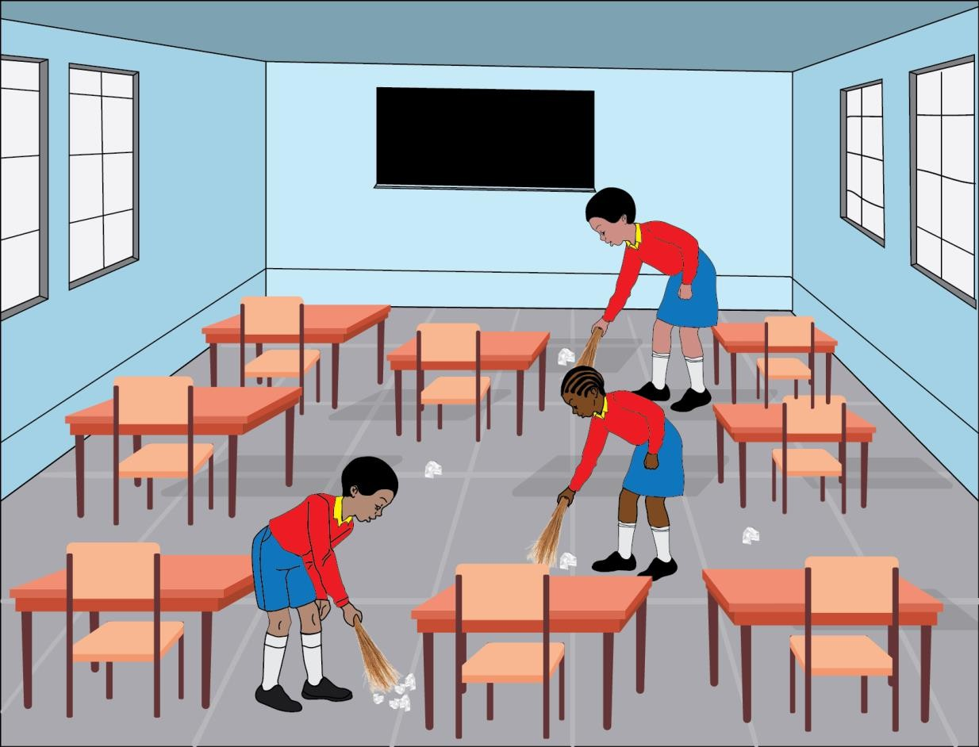

TASK 2: PERSON PICTURE BELOW WORK EXPLAIN. (MARK 5)



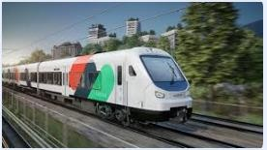
TASK 3: TIME USE THING BELOW ADVANTAGE WHAT (MARK 5)

PAGE THIS LAST//

