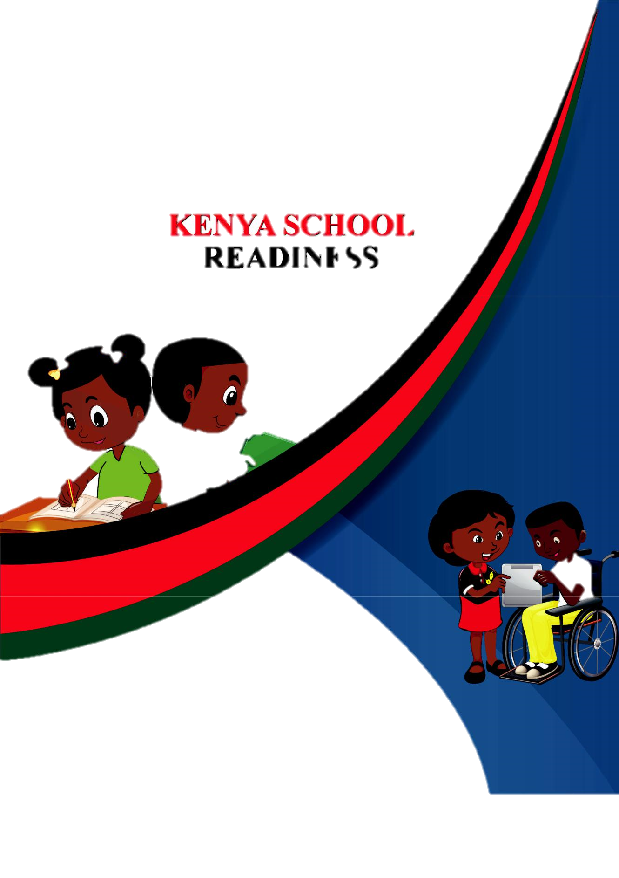

PRE-PRIMARY 2

HOMEWORK ACTIVITY

NAME:________________________________
LANGUAGE ACTIVITY

1. Fill in the missing letters

A ..... C ..... V ..... X

D .....

......

......

Z

G ..... ..... ..... ..... L ..... ..... ..... P ..... ..... ..... T

- Change to small letters

FLOWER
RABBIT-
STORY-
COMES-
NAME-
GO-

3. Write one and many

One | Many
Boy
Girl
Book
Bag
Cat
Duck

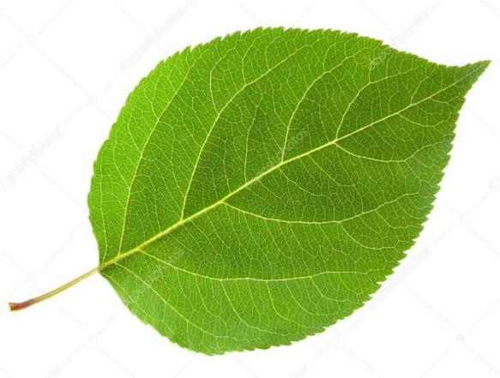
4. Name the pictures


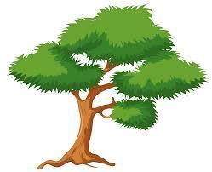
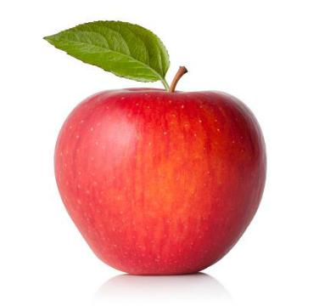

5. Fill in the missing sound

b .... .... k du .... ....

thr .... .... fi .... ....

be .... .... s .... n

p .... ter J .... ne

LITERACY ACTIVITY

Read the words

mat book

bees shop

flower rabbit

Daddy duck

- Here is my bag.

- Come and have a look.

- My name is

- This is my mummy.

- i have a red apple.

- Get me red flowers.

NUMBERWORK
1. Write numbers 1-50

____ ____ _____ _____ ______ _____ ____ ____ ____ ____

____ ____ _____ _____ ______ _____ ____ ____ ____ ____

____ ____ _____ _____ ______ _____ ____ ____ ____ ____

____ ____ _____ _____ ______ _____ ____ ____ ____ ____

____ ____ _____ _____ ______ _____ ____ ____ ____ ____
2. Count and write how many.
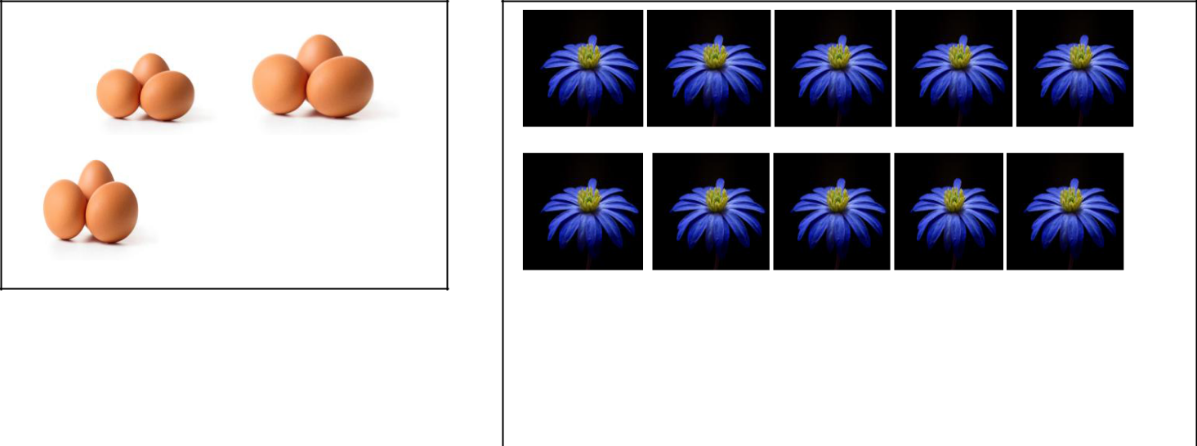

_____________

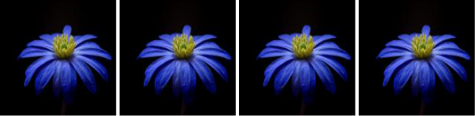

3. Work out | ________
3+2+1= | 10
 | +30

63

+ 41
8
0+2

8-4=

8+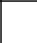 =10

4. Draw the shapes

SQUARE TRIANGLE

OVAL CIRCLE

5. Name the second day of the week .....................................
6. Write the number in words
8 – ___________________

2- __________________

4- ___________________

6- ___________________

ENVIRONMENTAL ACTIVITY

1. We use ............................ and ............................ to clean our

teeth. ( soap and water, toothbrush and toothpaste)

2. What do we use to clean our nose? .....................................

(towel, handkerchief)

3. Name 2 domestic animals.

.................................. and ..............................................

4. Name 2 wild animals.

.................................................... and ...............................................................

5. I am a puppy, who is my mother? (dog, cow)

- I am a lion, who is my baby? (duck, cub)

- Name parts of a plant
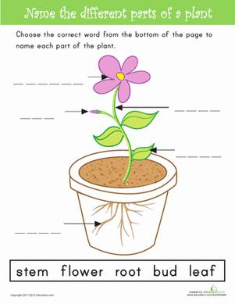

- Name the weather



(sunny, rainy)


( windy, cloudy)

9. A rainbow has ................................ colours.

RELIGIOUS ACTIVITY

- What is a bible?

- What is the name of your church?

- How do you call God with your language?

- Who is the mother of Jesus?

- What activities do we do in church?

- What is prayer?

- How do you know that God loves you?

CREATIVE ACTIVITY
- What do we use for modelling?

- complete these patterns
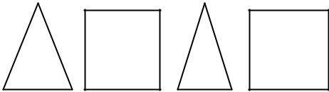


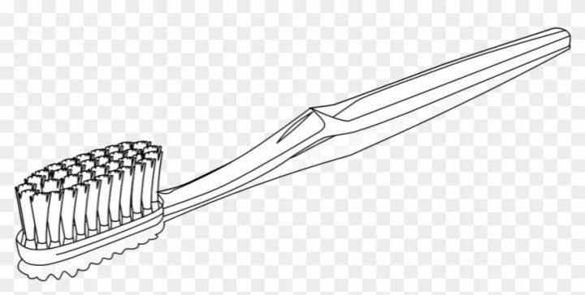

3. Colour the pictures

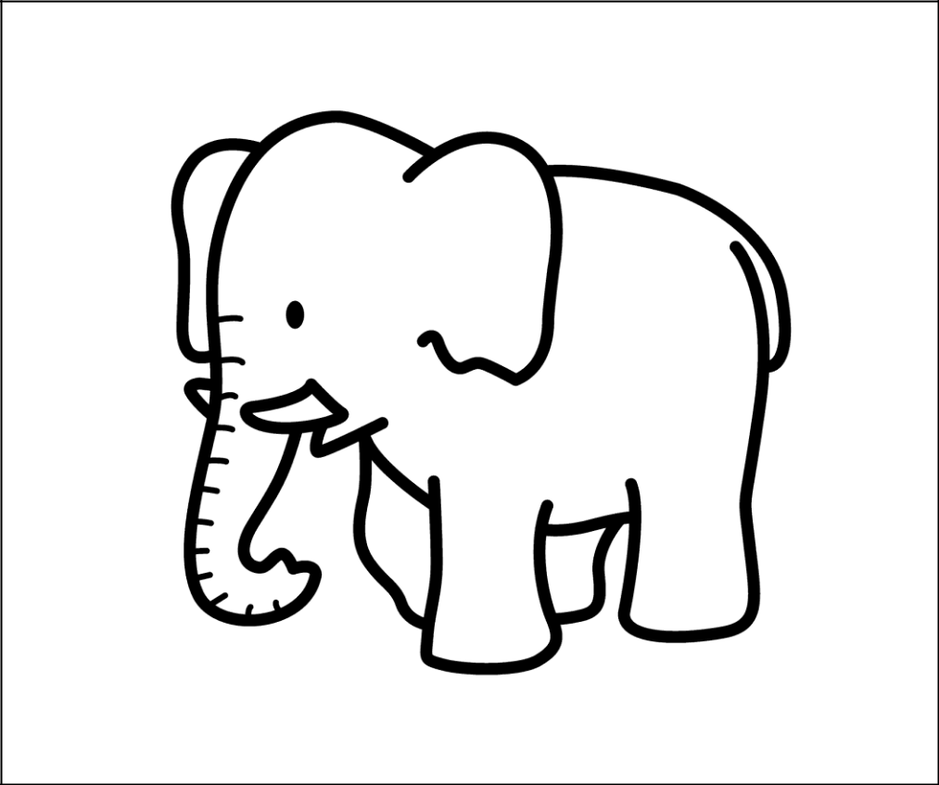

- Name materials used for making collage

________________

_________________

________________

_______________

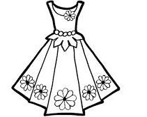
Count the following and write:
=________________
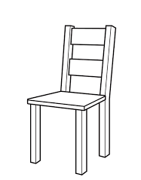

= ________________



= __________

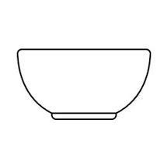
= _______
Complete the sentences
I have _____________ eyes.

A chair has ______________ legs.

I have ____________ fingers.
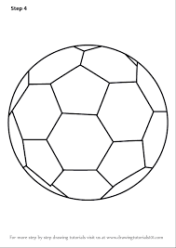
Count and put together;
+ = ____________

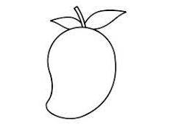
+ =____________
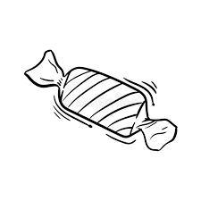

+ = ____________

Which numbers come before?
__________, 10 _____________, 5

___________, 20 ____________, 15

Fill in the missing numbers
1 | 2 |  | 4 | 5 |  |  |  | 9
11 | 12 | 13 |  |  | 16 | 17 | 18 |  | 20
 | 22 |  | 24 | 25 |  |  | 28 |  | 30
31 |  | 33 |  |  | 36 | 37 | 38 |  | 40
 | 42 |  | 44 | 45 |  |  |  | 49 | 50
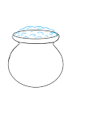
Tick out the bigger one;

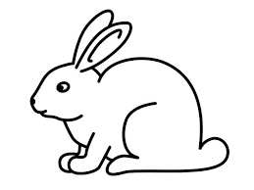

Add the following sums;
5 + 2 = ____________ 3 + 6 = ________________

1 + 3 + 1 = __________ 2 + 2 + 3 =__________

Circle out the correct numbers

Take away;
5 – 3 = __________ 7 - 2 = ___________

9 - 6 = ___________ 8 - 3 = _____________


- =____________



- = ________

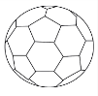
Draw the number value;
Example: 6 =

3 = ______________________________________________

8 = _________________________________________________

5 = _________________________________________________

LANGUAGE ACTIVITIES
What are they called [name by matching]
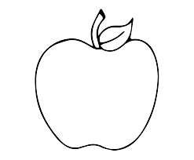

hat

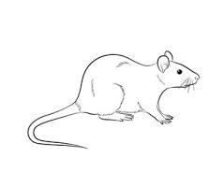

car

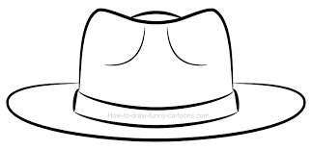

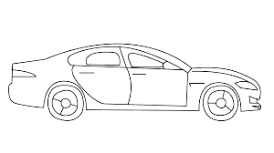
Apple

Rat

Re-write well;
Examples: tac cat

ebd ______________________
apt ______________________
yob ______________________
etn ______________________
nep ______________________
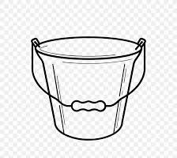
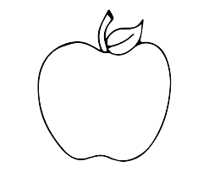
Colour the pictures

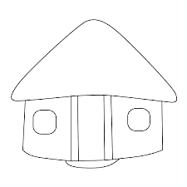

Fill in the alphabets
_____ b c _____ ______ f g _____ i j

k l _______ ________ o p q ______ ______ t

_______ ________ w x ________ ________

Fill the missing letters;
This is a c____p
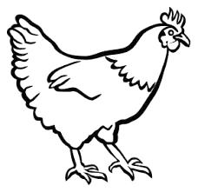
It is a big h _____ n
A man has a p_____t
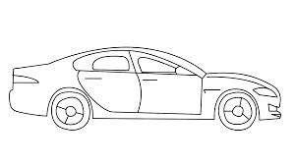
It is a c____ r

Tom has a h ___ t

Copy these words again
bed zip pen book
________ ___________ ___________ __________
Make words with sound “u”
Example: mu + d = mud
nu + t = _______________

cu + p =________________

hu + t = _________________

mu + d = _______________
Re-write under;
A B C D E F G
____ ____ ____ ____ ____ ____ ____

H I J K L M N
____ ____ ____ ____ ____ ____ ____

O P Q R S T U
____ ____ ____ ____ ____ ____ ____

V W X Y Z
____ ____ ____ ____ ____
ENVIRONMENTAL ACTIVITIES
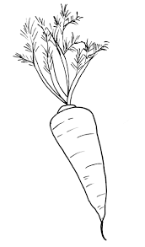
Colour the food we eat
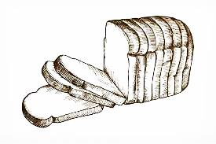

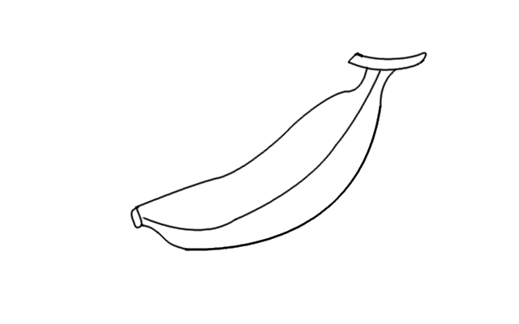

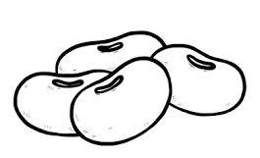

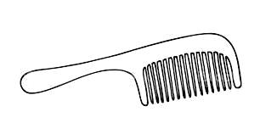
Match the picture with its name.

bed

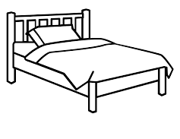

stool

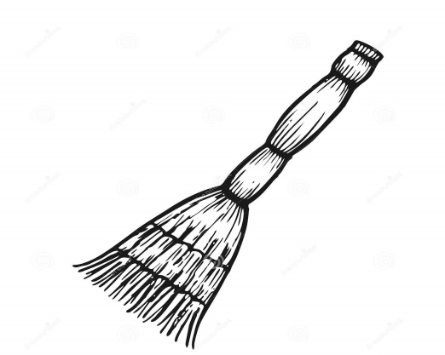

comb
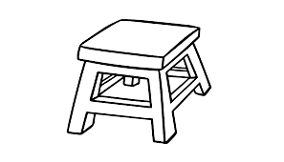

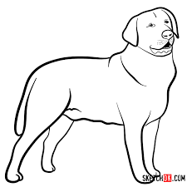
dog

broom

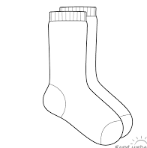
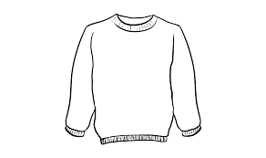
Colour our clothes

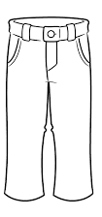
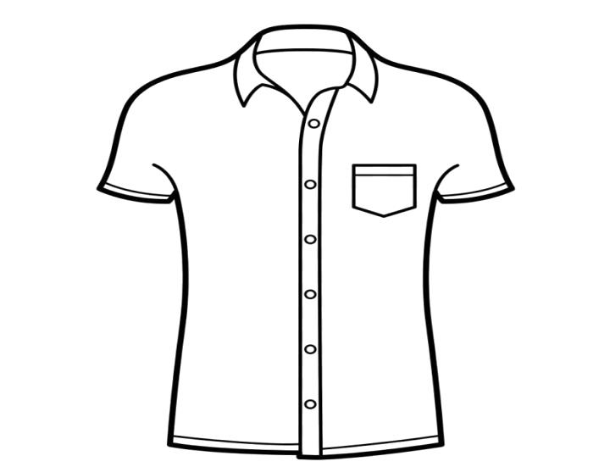

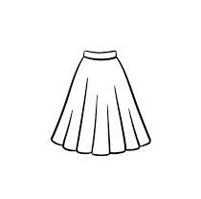



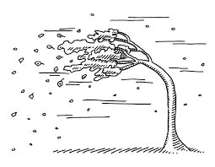
What is the weather today?

It is a _____________ day it is a __________ day

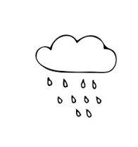


It is a ____________ day it is a _________ day
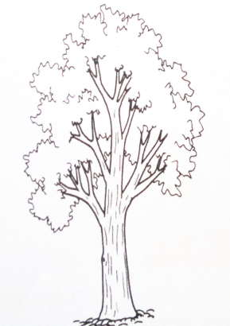
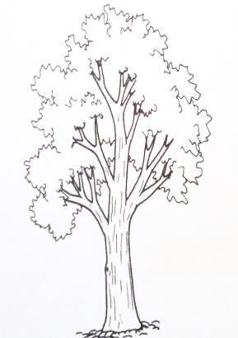

It is a ____________ day

[sunny, rainy, calm, windy, cloudy]
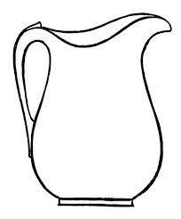
Match the utensils with their names

Cup

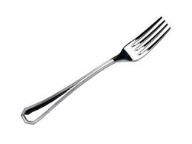

Pan

Jug
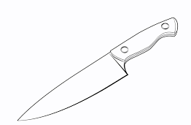

fork

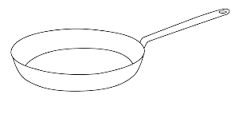

knife
RELIGIOUS ACTIVITIES
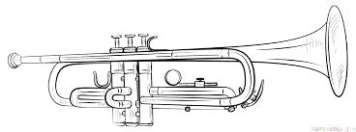
We sing and praise God with;

This is a ______________
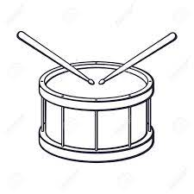

I can play a ______________

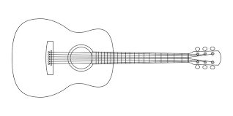

This is a ___________

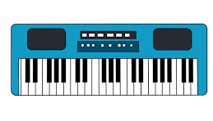

We play a _____________ at the church

Keyboard guitar drum trumpet

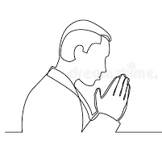
Match the pictures with the names

bible

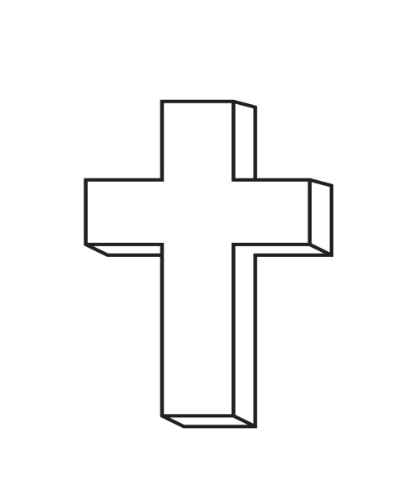

pray

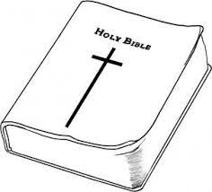

church



cross

Draw the creation of God below

Tree fish

Colour the pictures

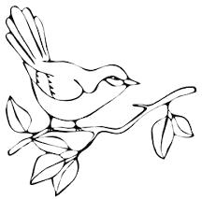
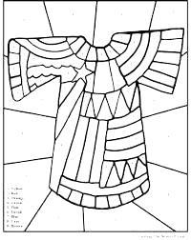

SHUGHULI ZA KISWAHILI
Kamilisha silabi hizi;
ba be bi _______ _________

ma ______ mi ______ mu

sa ______ si so _______

Unda jina;

mfano: du + du = dudu

me + ko = _____________

so + te = _____________

si + mu = _____________

ku + ku =______________

chu + i = ______________

nakili tena kwa herufi kubwa;

WEWE ________________________

JEMBE _______________________

Taja majina ya michoro kwa kuambatanisha
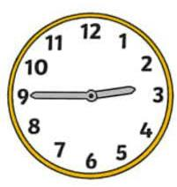

Simu

Saa


Kiti

Panya

Jaza pengo ukitumia - u –
K ___ ku

Sum____

b____ b____

dud_____

h___yu.

Soma maneno haya ukitumia michoro;

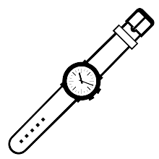

Koti uma

Jua saa
MATHEMATIC ACTIVITIES
- Write 1 – 50
___ ____ ____ ____ ____ ____ ____ ____ ____ ____

___ ____ ____ ____ ____ ____ ____ ____ ____ ____

___ ____ ____ ____ ____ ____ ____ ____ ____ ____

___ ____ ____ ____ ____ ____ ____ ____ ____ ____

___ ____ ____ ____ ____ ____ ____ ____ ____ ____

- Put together:

1 + 4 = ___________ 2 + 3 = __________

2 + 8 = ____________ 4 + 6 = ___________

3 + 1 + 1 = ____________ 2 + 2 + 0 = ________

- Write the number that comes after:

10, _________ 3, _________

5, ________ 19, ________

15, _________ 29, _______

- Draw the number value;

5 = ______________________________________________

7 = _______________________________________________

3= ________________________________________________

- Take away as you show your working;

7 – 5 = ___________ 10 – 3 = _____________

11 – 2 = _________ 3 – 3 = ______________

9 – 8 = __________ 15 – 6 = _____________

- Count and write;

= ____________

= ______________

=______________________

CREATIVE ACTIVITIES
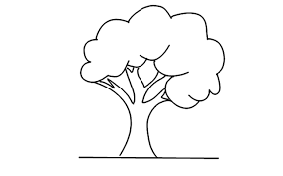
Colour the pictures;

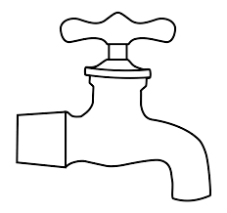

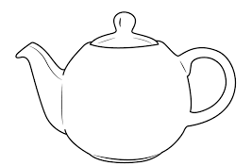


LANGUAGE ACTIVITIES
Match the shapes below with their names

Oval

Square

Rectangle

Triangle

Circle

fill in the missing letters
A B C ____ ____ ____ ____ H I J ___ ____ _____

N ___ ____ ____ R S ____ ____ ____ ____ X ____ _____

Write well
oxb _______________

atr ________________

etn ________________

mna ________________

ist _________________

gel _________________

itn _________________

otp __________________

