
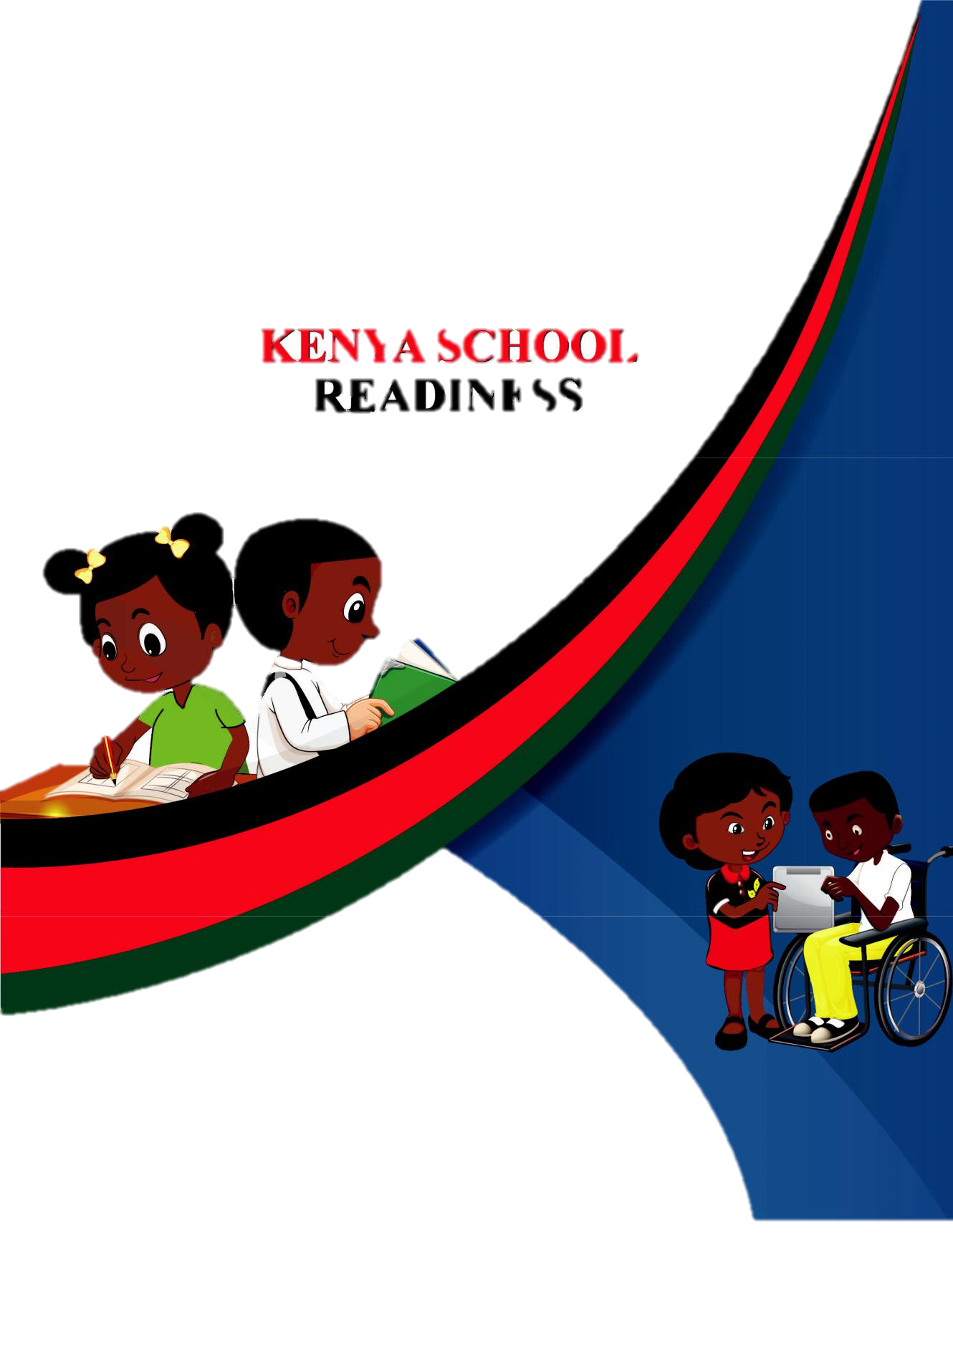
PRE-PRIMARY 1

HOMEWORK ACTIVITY

NAME:________________________________

RELIGIOUS ACTIVITY

1. Colour the church as a place of worship
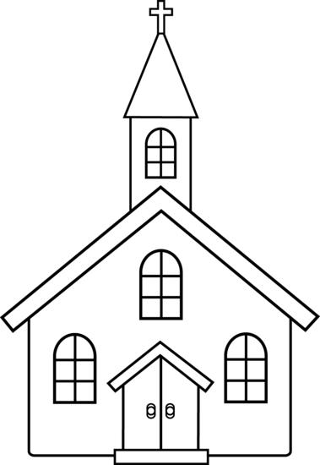

- Name some of the things that we do in church

- Recognise and colour the bible
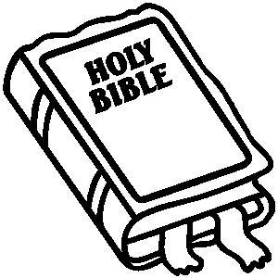

4. Recognise and colour the cross
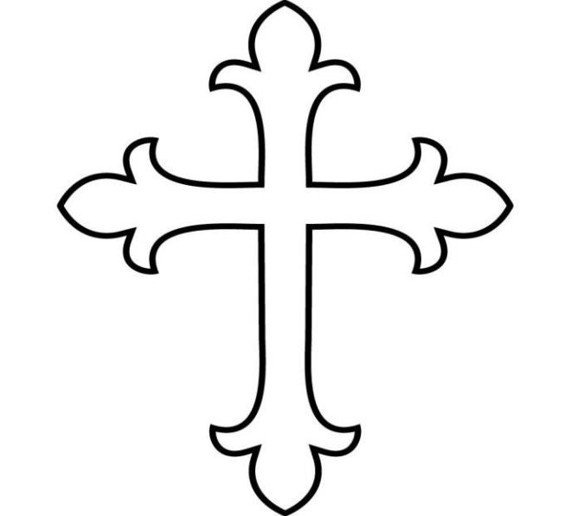

LANGUAGE ACTIVITY
1. Recognise the sounds

d b e h z y u r n m p

t o

s

v

a

j

w

i

c x

k l

f

g

2. Fill in the missing sounds

a ........ c ........ e ........ g ......... i ........ k ......... m ........ o ........ q ....... s ........ u ........ w ........ y ........

- Re-write the ‘a’ blends

a | ba | ca | da | fa | ga | ha | ja
__ | ____ | ____ _____ _____ _____ ______ ______
ka | la | ma | na | pa ra | sa |  | ta
___ | ___ | ____ _____ ____ _____ ______ ______
va | wa | ya | za
___ | _____ _____ ______

4. Read | the two letter words
at | us | in
am | as | an
is | or | up
on | it | he
of | if | ox

MATHEMATICS ACTIVITY

1. Recognise the number and colour
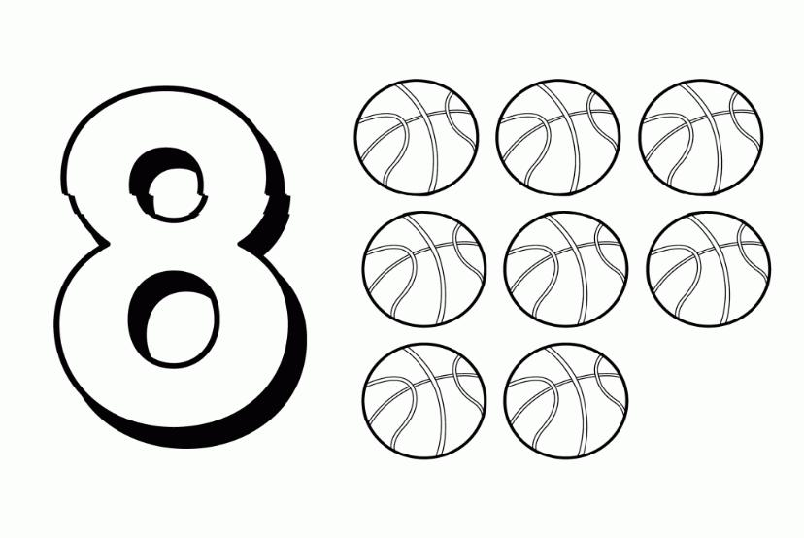

2. Join the dots
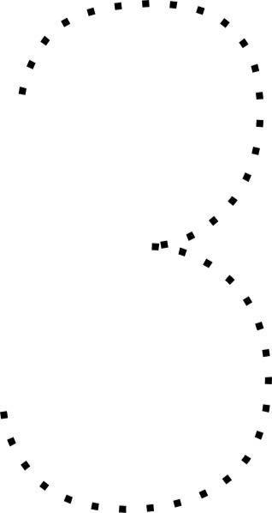

- Colour the rectangle

- Write numbers 1 – 10

__________ ___________ ________ ____________ ________

_________ ___________ ________ _____________ ________

5. Draw balls

6 | ___________________ | 8 | _______________________
3 ____________________ |  | 4 | ________________________
5 | ___________________ | 2 _________________________

LANGUAGE

1. Recognise and colour
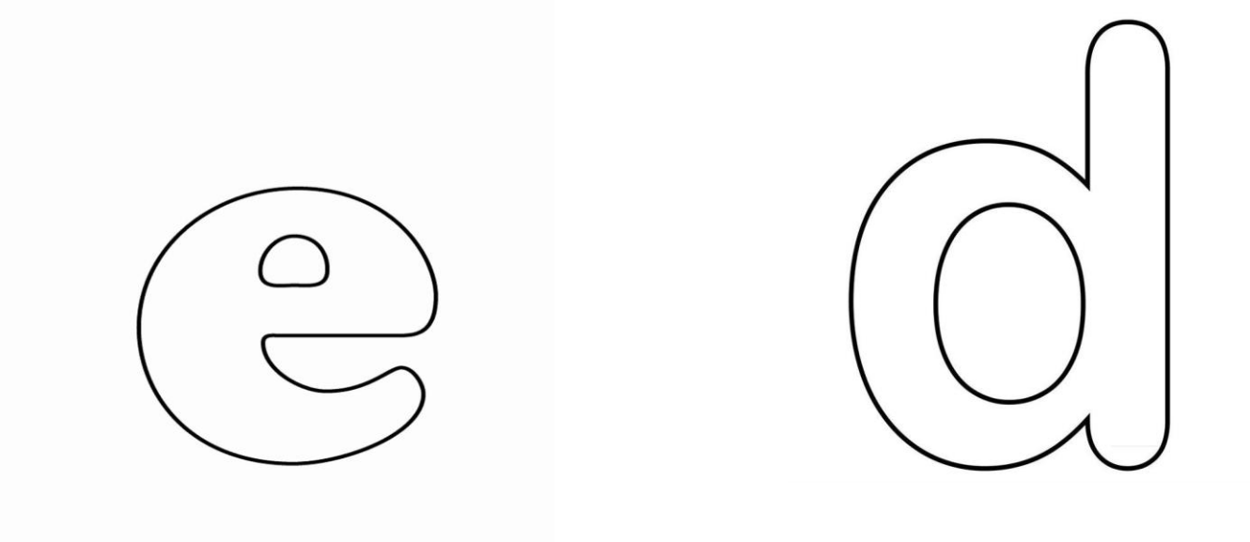

2. Join the dots
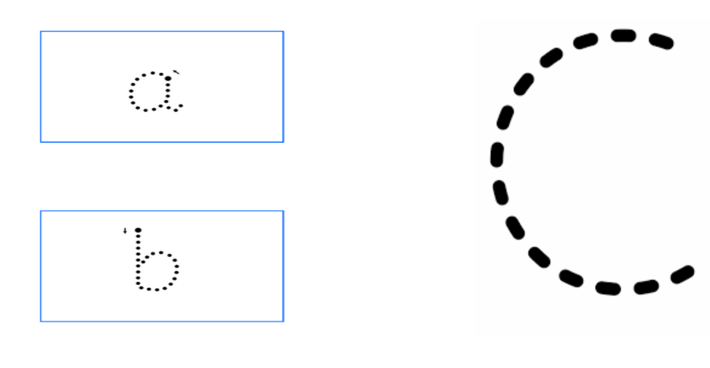

3. Match the pictures
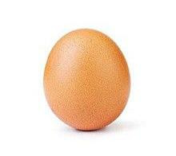
pot
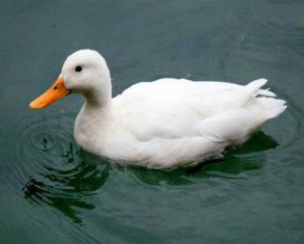

cat
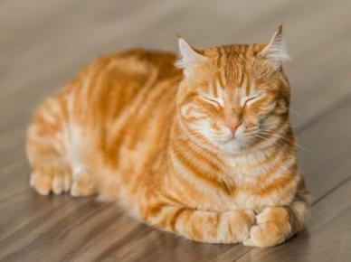

apple

egg

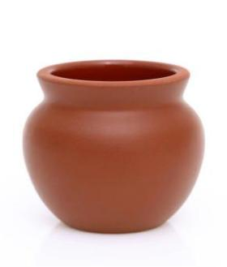

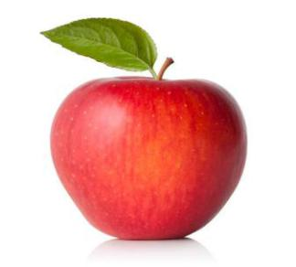
duck

ENVIRONMENTAL ACTIVITY

- Name 6 wild animals

- Name parts of the body

- Draw 2 domestic animals

cat

hen

CREATIVE ACTIVITY

1. Colour the giraffe
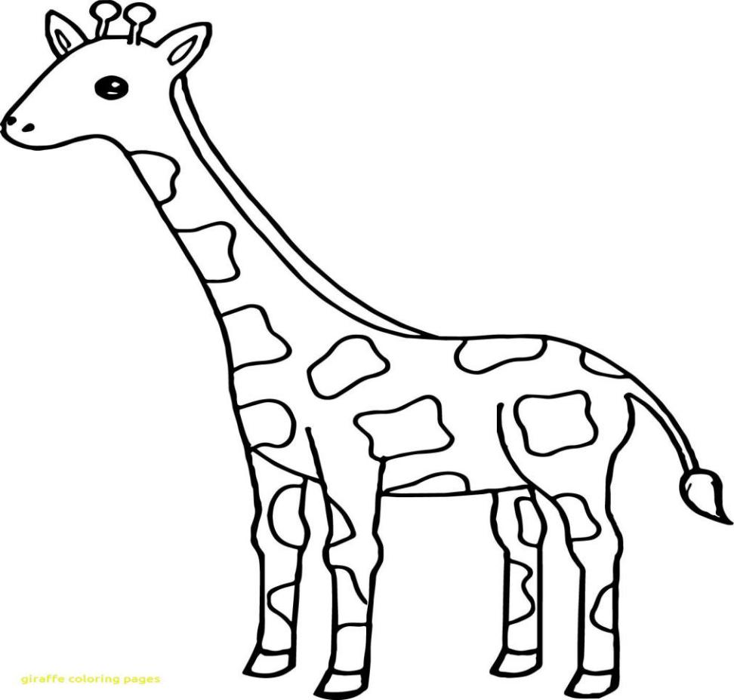

How many are they?
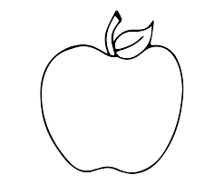

__________ apple

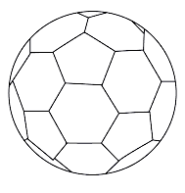

__________ balls
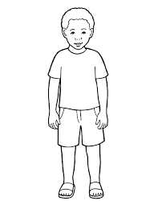

_______ boys

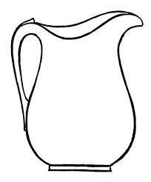

_______ jugs
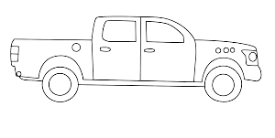

___________ cars

Write numbers 1 – 20 in the boxes;
1 |  |  |  |  |  |  |  |  | 10
11 |  |  |  |  |  |  |  |  | 20

Colour the shapes below;

Red colour blue colour

Green colour yellow colour

Brown colour

Add the sums
3 + 1 = ________ 2 + 2 = _________

1 + 1 = ________ 4 + 2 = _________

Draw balls to show the number value
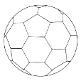
Example: 3 =

5 = _________________________________________________

7 = _________________________________________________

2 = _________________________________________________

4 = __________________________________________________

10 = _________________________________________________

3 = ___________________________________________________

Which one is smaller? [show by ticking]


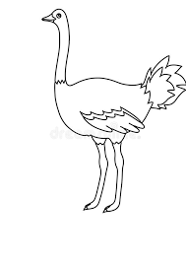

Circle the correct numbers

Match the same value
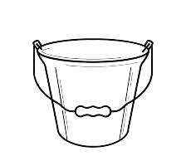
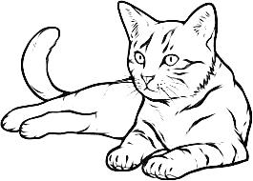

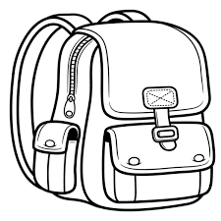
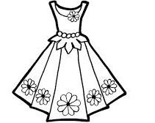









LANGUAGE ACTIVITIES

Fill in with sound - e –

b ___ ll t ___ ll

f ____ ll b ___ d

v___ st p ___ n

Re-write again
Example: bed bed

hen ___________________

hut ___________________

boy ___________________

cup ___________________

men ___________________
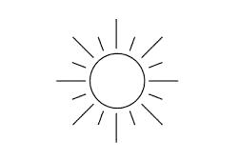
What are they? [name by matching]

Vest

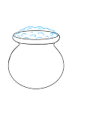

Tree

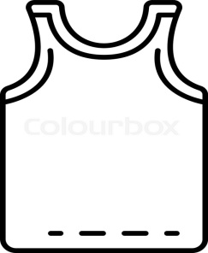
Van

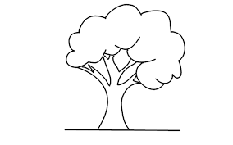
Sun

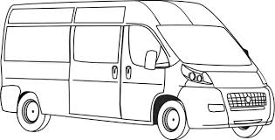
pot

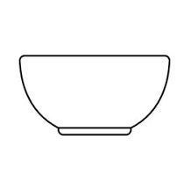
Colour these pictures

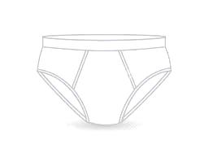

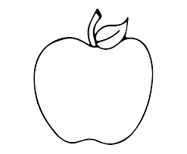
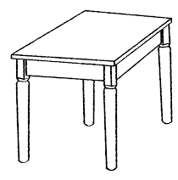

Complete the sounds

O bo _______ do __________ go

e be _______ _____ fe ________

Make words with these sounds;

Example: b = bed

C = _____________

d = ______________

t = _____________

h = _____________

f = _____________

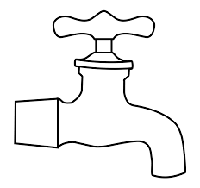
Complete these sentences

Tom has a ___________

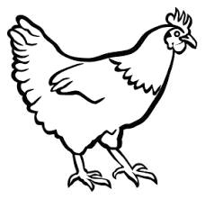

This is a big __________

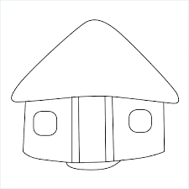

Look at a ___________

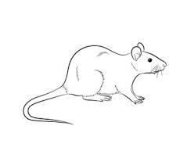

A ___________ is bad.

This is a __________

rat boy hut hen tap

ENVIRONMENTAL ACTIVITIES
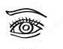
This is my ______________

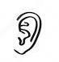

I have two _____________

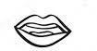
I have one _____________

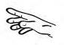
This is my ____________

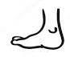

My ____________ are two

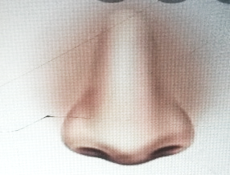

My ________ is big.

Legs nose hand ear mouth eye

What are they called? [match]

belt

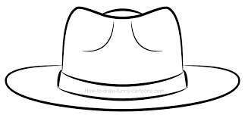

Socks
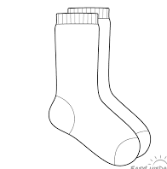

dress

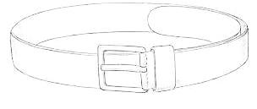

skirt

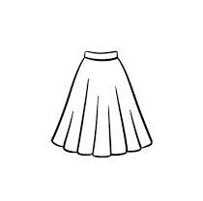

hat

Colour our foods
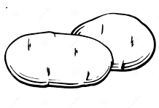
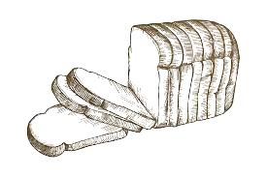

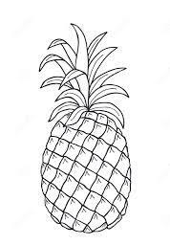

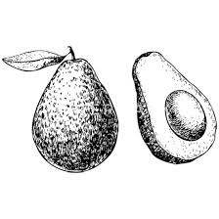

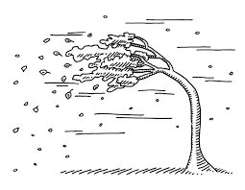
What is the weather?
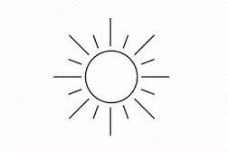

__________________ _________________

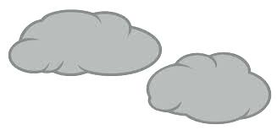
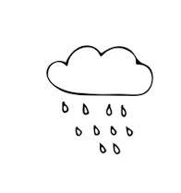

______________ _________________

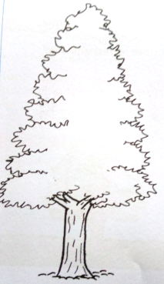
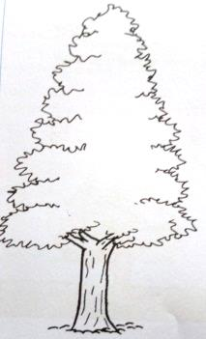

________________

Calm sunny windy cloudy rainy
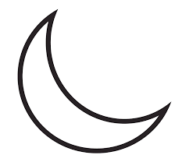
RELIGIOUS ACTIVITIES

God made ______________

____________ gives us light
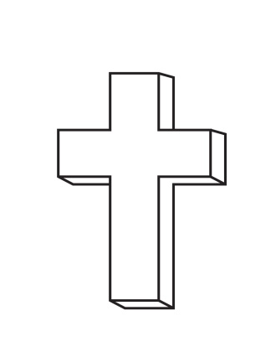

This is a ___________

Colour the church and the mosque
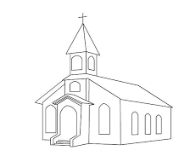
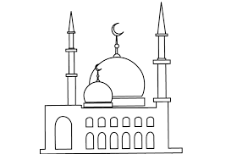

Draw the following creations of God

A fish a bird a man
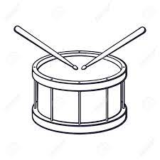

We play a _________________

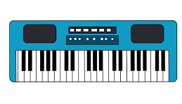
We use a keyboard to ________

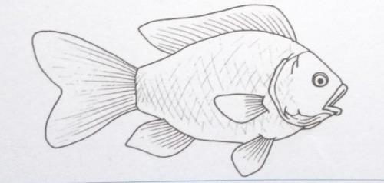
God created a ____________

drum fish sing
CREATIVE ACTIVITIES
Colour the pictures below;
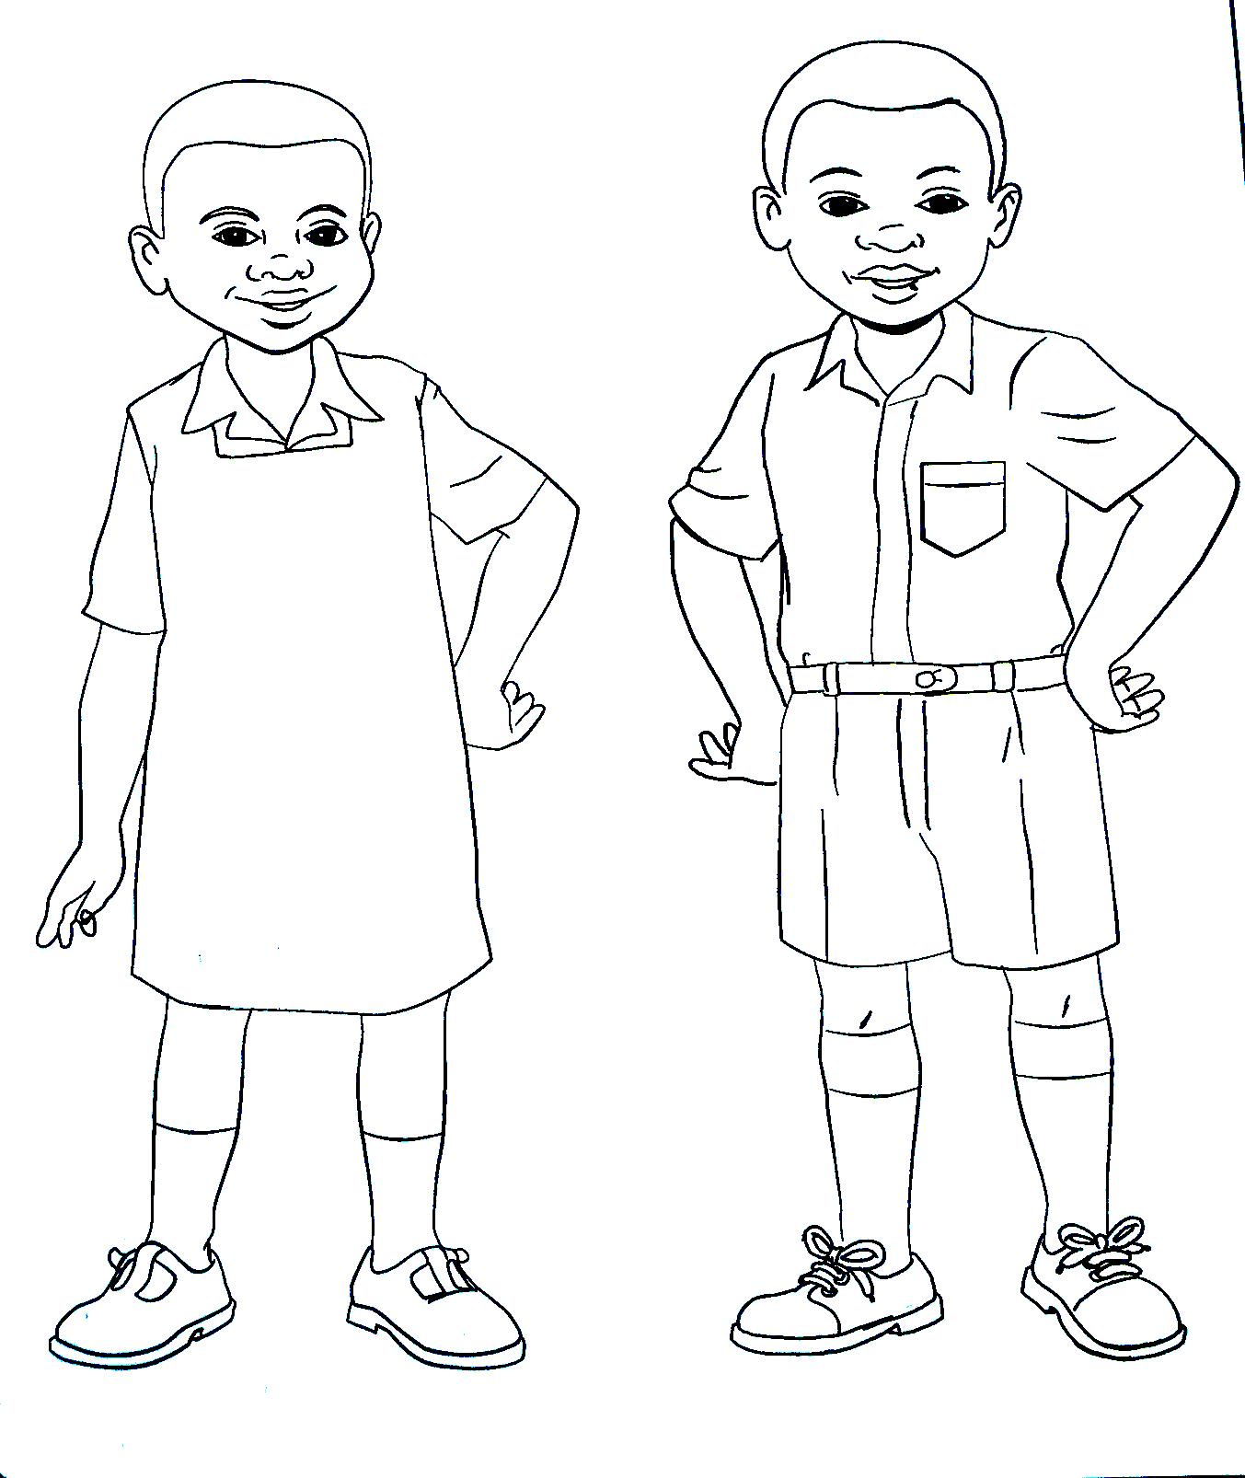

Complete the patterns

_________________________________

_________________________________

___________________________________

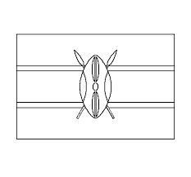
Colour our flag

Black

Red

Green

MATHEMATIC ACTIVITIES PART 2

- Fill in the missing numbers:

1 ___, ____, ____, 5, 6, ____, _____ 9, 10

____, _____, _____ , _____, ____, 16, 17, 18, ____, ____

- Put together

1 + 2 = ______ 2 + 2 = ________

3 + 1 = ______ 1 + 1 = _______

3 + 3 = _______ 3 + 4 = _____

- Which numbers come before;
_______, 3

_______, 6

________ , 9

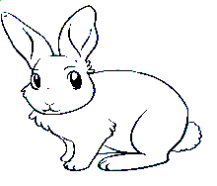
- Match the numbers with the value

2
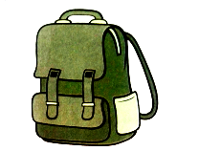

4
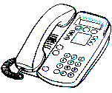
1


3

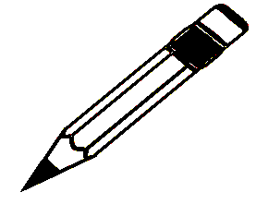
- Put together
+ = ___________

+ =__________

+ =___________
LANGUAGE ACTIVITIES
- Fill in with a e i o u

T __y g __ t b ___ y

S __ n f __ n c __ w

T __ t p __ n h __ d

- Make word with sounds given by adding ‘n’ at the end:

Example; Ma = man
Su: ______________

fa: ______________

Pe: ______________

Fi: _____________

Gu: ______________

Pa: _______________

This is a ______________

arrow
house
cup
bread
dress

I have a ______________

My father has an ______________

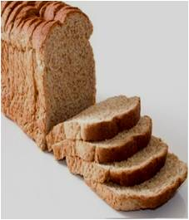

I like eating ______________

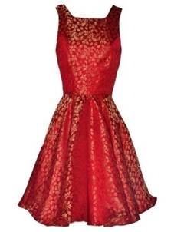

It is a beautiful _______________

- Re-write these words well

oyb _____________

upc _____________

cta _____________

acr _____________

- Draw the following objects

Car ball

- Complete the sentences below

My name is __________________

I am ______________ years old

I am a_________________ (boy, girl, man, woman)

I am in pre-primary _______ (one, two)

I go to __________ to learn (market, school)

