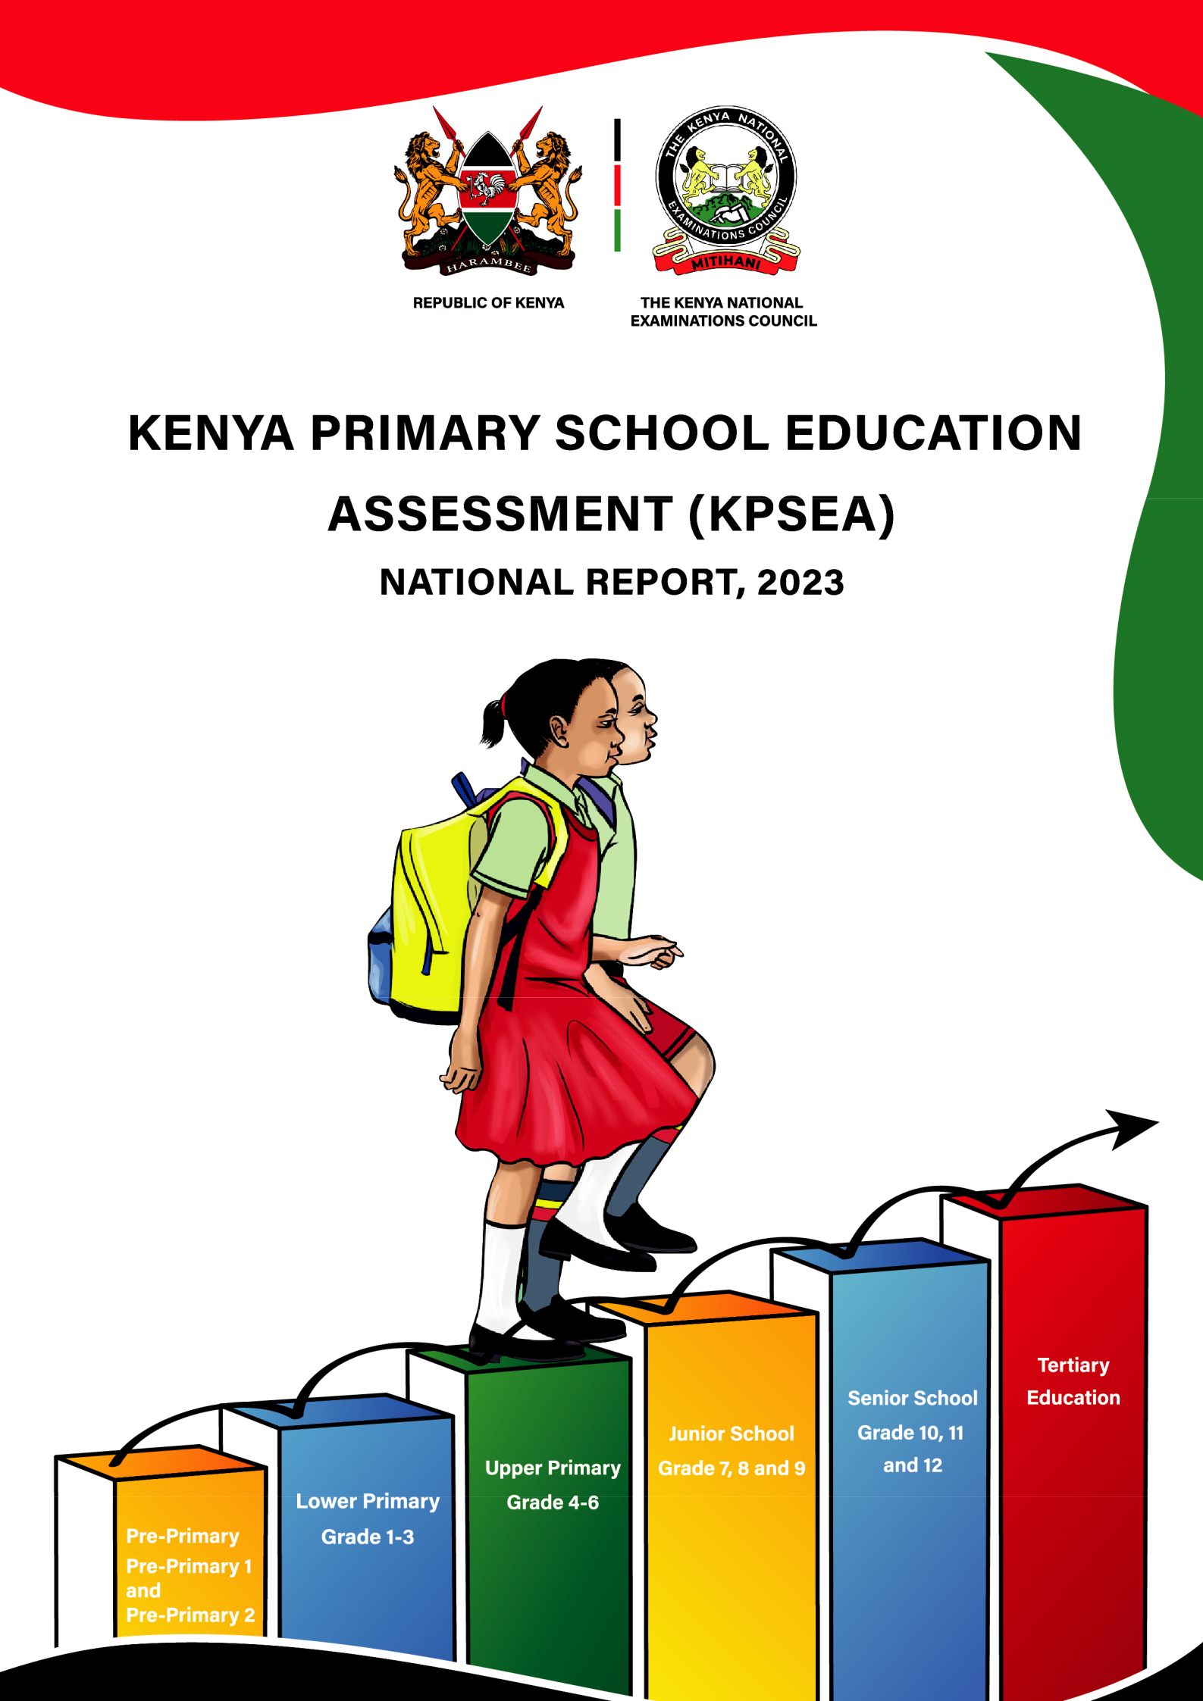

HOLIDAY ASSIGNMENT
GRADE6

NAME:
_______________


CBC

AGRICULTURE AND NUTRITION
- State two components of agriculture and nutrition. (2 mks)
- ______________________________________
- _______________________________________
- What is Soil pollution? (2 mks)
____________________________________________________________________________________________________________________________
- The harmful substances in the soil are known as _________________________.(1mk)
- Mention six causes of Soil Pollution in Farming.(6 mks)
  - _________________________________________________
  - _________________________________________________
  - _________________________________________________
  - _________________________________________________
  - _________________________________________________
  - _________________________________________________
- List four effects of soil pollution. (4mks)
- ______________________________________________________
- ______________________________________________________
- ______________________________________________________
- ______________________________________________________

Outline five Safe Soil pollution Control measures include the following methods: (5 mks)
  - __________________________________________________
  - __________________________________________________
  - __________________________________________________
  - __________________________________________________
  - __________________________________________________
- State three ways of creating the awareness message against soil pollution. (3 mks)
  - _______________________________________-
  - _________________________________________
  - _________________________________________
- Outline three damages caused by surface run off. (3 mks)
- _________________________________________________________
- _________________________________________________________
- _________________________________________________________
- Surface run off is conserved or collected in structures such as:(3 mks)
- __________________________
- ___________________________
- ____________________________
- Name four importance of conserving water in Farming.(4 mks)
- _______________________________________________________
- _______________________________________________________
- _______________________________________________________
- _______________________________________________________

What is the way or methods used to conserve Surface run-off? (3mks)

__________________________________________________________________

__________________________________________________________________

__________________________________________________________________

Mention three Crops that can be established in water retention structures:(3 mks)
- _____________________________________
- _____________________________________
- _____________________________________

Mention three importance of controlling soil pollution in farming? (3 mks)
- _____________________________________________________
- _____________________________________________________
- _____________________________________________________

- Give three importance of water conservation in farming.(3 mks)
- _______________________________________________________
- _______________________________________________________
- _______________________________________________________

- Match the following methods of planting ( 3mks)
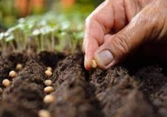
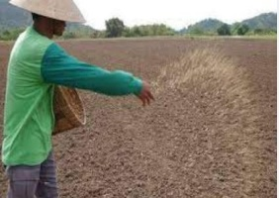
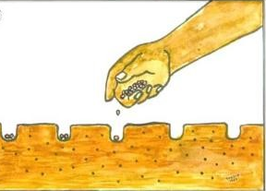

Drilling
Dibbling
Broadcasting

What is the term used for describing the water that runs on the ground surface during and after raining?( 1mk)
__________________________________________________-

Name three minimum tillage practices for water conservation carried out in farming.( 3 mks)
  - ________________________________________________
  - ________________________________________________
  - ________________________________________________
- Write down three practices you observe to maintain good health.(3mks)

  - _____________________________________________________________
  - _____________________________________________________________
  - _____________________________________________________________

- State four importance of health education for healthy living(4mks)

  - _____________________________________________________________
  - _____________________________________________________________
  - _____________________________________________________________

  - _____________________________________________________________

- List two types of diseases that can be prevented through studying Health Education. (2mks)

- _____________________________________________________________
- _____________________________________________________________
- Identify three community activities that help to promote good health.(3mks)
  - _____________________________________________________________
  - _____________________________________________________________
  - _____________________________________________________________

- Identify the functions of the following nutrients.

Food | Function

Protein

Carbohydrate

Vitamins

- What is the role of water in the body?(1mk)

  - _____________________________________________________________

THIS IS THE END OF AGRICULTURE AND NUTRITION PART

CREATIVE ARTS

What is creative arts? (2 mks)
__________________________________________________________________________________________________________________________________________
- What is sports? (2 mks)
__________________________________________________________________________________________________________________________________________
- Identify five roles of Creative arts and sports in the society.(5 mks)
- __________________________________________________________________
- __________________________________________________________________
- __________________________________________________________________
- __________________________________________________________________
- __________________________________________________________________
- State four components of Creative Arts and Sports.(4 mks)
- _________________________________________
- _________________________________________
- _________________________________________
- _________________________________________
- State two Principles of Visual arts.(2 mks)
  - ___________________________________________________________
  - ___________________________________________________________
- What is the meaning of: (2mks)
  - An artiste-________________________________________________________________________________________________________________________________
  - An audience- ________________________________________________________________________________________________________________________________

- Outline four Basic Elements of a play. (4 mks)
- _________________________________________________________________
- _________________________________________________________________
- _________________________________________________________________
- _________________________________________________________________
- State and explain three elements of Music in Creative Arts.(6 mks)
  - ________________________________________________________________
  - ________________________________________________________________
  - ________________________________________________________________

- State three Elements of Dance in Creative Arts.(3 mks)
- _____________________________________________________________
- _____________________________________________________________
- _____________________________________________________________
- The arts can be experienced through the following senses namely?(3 mks)
  - ________________________________________________________________
  - _______________________________________________________________
  - ________________________________________________________________
- Identify the three sections of a narrative (3mks)
- _________________________________________________________________
- _________________________________________________________________
- _________________________________________________________________

- Fill in the chart below;


________________________ _______________________

- Name the following parts of a note. (3 mks)

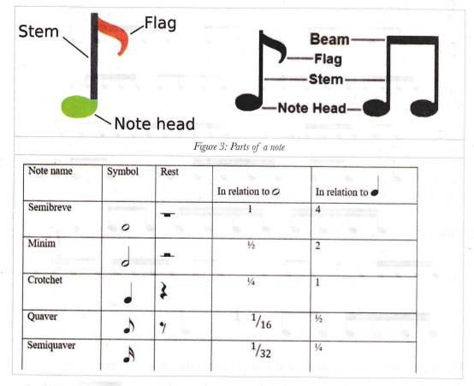

- Draw the following note. ( 5 mks)
Note name | Note symbol
semibreve
minim
crotchet
quaver
Semi quaver

- Draw the note of the French rhythm.(3 mks)

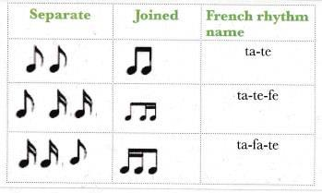
- State two categories of arts.(2 mks)
- ___________________________________________________________
- ___________________________________________________________
- Name three properties of colour.(3 mks)
- ________________________________________________________
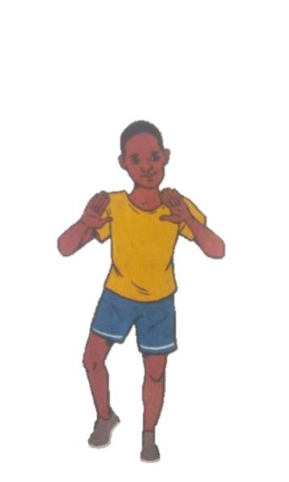
- ________________________________________________________
- _______________________________________________________
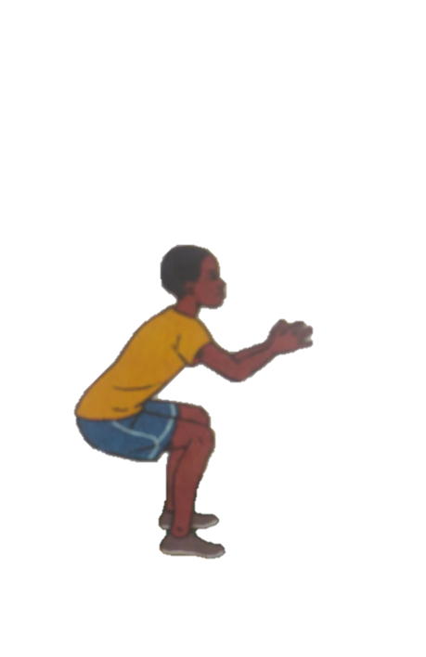
- Identify two landing techniques in footwork in netball.(2 mks)

- Mary and Caro were demonstrating a pass used in the game of netball as shown below
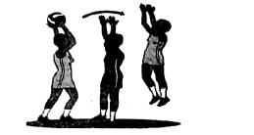

Identify the type of pass they executed(1mk)
___________________________________________________________________

- Bridget and Stacy improvised a football ball. List three readily available materials they used. (3mks)
  - ___________________________________________________________
  - ___________________________________________________________
- ___________________________________________________________
- In a class discussion, Esther, a learner in grade seven, mentioned the three finishing techniques in sprints. Write down the correct techniques she mentioned. (3mks)
  - ___________________________________________________________
  - ___________________________________________________________
- ___________________________________________________________

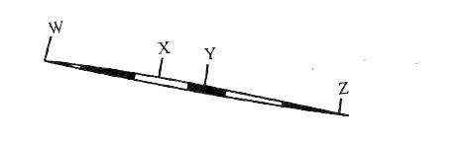
- Name the following parts of a javelin(4mks)
W_____________________
X_____________________
Y_____________________
Z_____________________
- You have been asked to name four phases of long jump. Write them down. (4mks)

  - ___________________________________________________________
  - ___________________________________________________________
  - ___________________________________________________________
  - ___________________________________________________________
- In a physical education and health the learner practised the jump rope skill shown below.
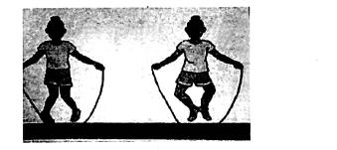

Identify the of jump rope skill________________(1mk)

- ______________players per team are allowed in the field of play during the start of kabaddi game.(1mk)

- List three swimming pool rules that need to be observed. (3mks)

- ___________________________________________________________
- ___________________________________________________________
- ___________________________________________________________
- When playing the game of kabaddi, a player entered the opposing team's side while chanting "kabaddi".What is the name of the player?(1mk)
_____________________________________________________________

- During the interclass handball competition, the coach asked a player to dribble the ball. Write down the three reasons the coach would request learners to use that skill. (3mks)
  - ___________________________________________________________
  - ___________________________________________________________
  - ___________________________________________________________
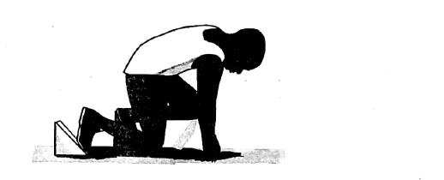
- During a 100m race start, an athlete was in a position as shown in the diagram.

What are the commands given during the start of this race on the above position? (3mks)
    - ___________________________________________________________
    - ___________________________________________________________
    - ___________________________________________________________

THIS IS THE END OF CREATIVE ARTS PART PART

CRE ACTIVITIES

- State four Attributes/nature of God from the Genesis stories of creation. (4 mks)
- _________________________________________________________
- __________________________________________________________
- ___________________________________________________________
- ____________________________________________________________
- State four Similarities in the two Biblical accounts of creation. (4 mks)
- _________________________________________________________
- __________________________________________________________
- ___________________________________________________________
- ____________________________________________________________

State four differences in the two Biblical accounts of creation. (8 mks)
First account | Second account
- State three importance of learning about creation. (3 mks)
- _________________________________________________________
- __________________________________________________________
- ___________________________________________________________

Identify three reasons why studying CRE is important (3 mks)

- _________________________________________________________
- __________________________________________________________
- ___________________________________________________________

- Explain How CRE helps us to relate well with others. (3 mks)

- _________________________________________________________
- __________________________________________________________
- ___________________________________________________________

- State four Moral and religious values acquired from studying of CRE. (4 mks)

- _________________________________________________________
- __________________________________________________________
- ___________________________________________________________
- ____________________________________________________________

- Outline the two Biblical accounts of creation. (2 mks)
- …………………………………………………..
- ………………………………………………….
- State the order of creation from the first to the last.(16 mks)
Day | God’s creation
- utline three points on Africans view on creation. (3 mks)

- _________________________________________________________
- __________________________________________________________
- ___________________________________________________________
- ____________________________________________________________
- _____________________________________________________________

- State three responsibilities given to human beings by God.(3 mks)
- _________________________________________________________
- __________________________________________________________
- ___________________________________________________________

- Outline three reasons why Christians take care of plants and animals.(3 mks)
- _________________________________________________________
- __________________________________________________________
- ___________________________________________________________

- State three contribution of Plants to economic growth.(3 mks)
- _________________________________________________________
- __________________________________________________________
- ___________________________________________________________
- Name three Natural resources in Kenya.(3 mks)

- _________________________________________________________
- __________________________________________________________
- ___________________________________________________________
- State four ways in which Christians protect and care of animals, fish and birds.(4 mks)

- _________________________________________________________
- __________________________________________________________
- ___________________________________________________________
- ____________________________________________________________

- Mention three reasons why Christians take care of animals, fish and birds.(3 mks)
- _________________________________________________________
- __________________________________________________________
- ___________________________________________________________
- ____________________________________________________________

- State four importance of protecting animals, fish and birds.(4 mks)
__________________________________________________________________________________________________________________________________________________________________________________________
__________________________________________________________________________________________________________________________________________________________________________________________
- Name four places where different religions go to worship.(4 mks)
- _________________________________________________________
- __________________________________________________________
- ___________________________________________________________
- ____________________________________________________________

THIS IS THE END OF CRE PART

ISLAMIC RELIGIOUS EDUCATION

      - Name the four holy scriptures revealed before the coming of prophet Muhammad(S.A.W).(4mks)
        - _________________________________________________________
        - __________________________________________________________
        - ___________________________________________________________
        - ____________________________________________________________

      - State any three reasons why the holy Qur'an was revealed.(3mks)

- _________________________________________________________
- __________________________________________________________
- ___________________________________________________________
- ____________________________________________________________

      - Which angel appeared to prophet Muhammad (S.A.W) in Cave Hira?(1mk)
_________________________________________________________

      - Describe Qur'an text of the first Wahyi revealed to prophet Muhammad (S.A.W) It was the first
a)___________________________ verses of Surah
b) ____________________________ The first command to the prophet was c) ________________"(3mks)

      - Name three states in which Allah (S.W.T) found prophet Muhammand and explain how he helped him, as revealed in Surah Dhuha(3mks)
        - He found him_______________He gave him_______________

b)He found him_______________He gave him________________

c)He found him_________________He gave him________________

      - Explain the following forms of Hadith.(4mks)

        - Qaul Hadith: The___________________of the prophet.
        - Fiil Hadith:The___________________of the prophet.
        - Taqrir Hadith: The___________________of the prophet.
        - Sifat Hadith: The_____________________of the prophet.

      - Differentiate between Hadith Qudsi and Hadith Nabawi.(2mks)
____________________________________________________________________________________________________________________________________________________________________________________________________________________________________________________________________________

      - From this Hadith,'Innal mal a'amaal bin niyaat, wa inna maa likullimri-in maa nawaa"We learn that every action one does is judged by_____________(1mk)

      - Define the following qualities manifested in Muslim believers.

  - Taqwa(1mk)
____________________________________________________________________________________________________________________________________________

  - Tawakkul(1mk)

____________________________________________________________________________________________________________________________________________

  - Tawba(1mk)

____________________________________________________________________________________________________________________________________________

      - List down three forms of Hadath Akbar(3mks)

- _________________________________________________________
- __________________________________________________________
- ___________________________________________________________

      - The battle of Badr and Uhud were fought consecutively after an interval of(1mk)

_______________________________________________________________

      - Which agreement deed was broken by the non-muslims that led to the conquest of Makka?

____________________________________________________________________________________________________________________________________________

THIS IS THE END OF IRE PART

ENGLISH ACTIVITIES
WRITING. (20 MARKS)

Imagine you are the Human Resource Manager of Sarova Group of Hotels. The manager of Serena had asked you to write a confidential report of your former employee, Mr Sammy Kamau, who is seeking a transfer to the Serena Hotel as a chef. Write a confidential report to the manager about Sammy Kamau.

…………………………………………………………………………………………………………………………………………………………………………………………………………………………………………………………………………………………………………………………………………………………………………………………………………………………………………………………………………………………………………………………………………………………………………………………………………………………………………………………………………………………………………………………………………………………………………………………………………………………………………………………………………………………………………………………………………………………………………………………………………………………………………………………………………………………………………………………………………………………………………………………………………………………………………………………………………………………………………………………………………………………………………………………………………………………………………………………………………………………………………………………………………………………………………………………………………………………………………………………………………………………………………………………………………………………………………………………………………………………………………………………………………………………………………………………………………………………………………………………………………………………………………………………………………………………………………………………………………………………………………………………………………………………………………………………………………………………………………………………………………………………………………………………………………………………………………………………………………………………………………………………………………………………………………………………………………………………………………………………………………………………………………………………………………………………………………………………………………………………………………………………………………………………………………………………………………………………………………………………………………………………………………………………………………………………………………………………………………………………………………………………………………………………………………………………….…………………………………………………………………………………………………………………………………………………………………………………………………………………………………………………………………………………………………………………………………………………………………………………………………………………………………………………………………………………………………………………………………………………………………………………………………………………………………………………………………………………………………………………………………………………………………………………………………………………………………………………………………………………………………………………………………………………………………………………………………………………………………………………………………………………………………………………………………………………………………………………………………………………………………………………………………………………………………………………………………………………………………………………………………………………………………………………………………………………………………………………………………………………………………………………………………………………………………………………………………………………………………………………………………………………………………………………………………………………………………………………………………………………………………………………………………………………………………………………………………………………………………………………………………………………………………………………………………………………………………………………………………………………………………………………………………………………………………………………………………………………………………………………………………………………………………………………………………………………………………………………………………………………………………………………………………………………………………………………………………………………………………………………………………………………………………………………………………………………………………………………………………………………………………………………………………………………………………………………………………………………………………………………………………………………………………………………………………………………………………………………………………………………………………………………………………………………………………………………………………………………………………………………………………..

TURN OVER FOR GRAMMAR USE
Q2. CLOZE TEST. (10 MARKS).

We do not want 1 ___________ subject ODM. Kenya supporters to elections at the grassroots 2 __________ when we are busy 3 __________ the presidential nomination ticket.

The fear of a fall out by disgruntled leaders was the overriding 4 __________ for parties to 5 ____________ grassroots elections. It is eminent 6 ___________ the latest events that Narc – Kenya and ODM – Kenya 7 ____________ be headed for a 8 ____________ if the grassroots polls are 9 ___________now.

In KANU, elections saw the party break up into the Uhuru Kenyatta 10 __________ and another led by Keiyo South MP, Mr Nicholas Biwott.
Q3. ORAL SKILLS. (30 MARKS)
- Read the following poem and answer the questions that follow.
HAPPY BABY.
Her lips suckle the nipples.
Milk bubbles, foams and ripples.
Little hands up in the air.
Catch on the mother’s hair.
Sweet sensations rise in pressure.
Tiny legs kick with pleasure.
Sleep comes gently and strong.
Sleep whispers softly and long.
- Describe the rhyme scheme of the poem. (2 Mks)

……………………………………………………………………………………………………………………………………………………………………………………………………………………………………………………………………

- Explain any other two oral features of style and show their effectiveness. (4 Mks)
………………………………………………………………………………………………………………………………………………………………………………………………………………………………………………………………………………………………………………………………………………………………………………………………………………………………………………………………………………………………………………………………………
- Which two words would you stress in line 2, and why? (2 Mks)

………………………………………………………………………………………………………………………………………………………………………………………………………………………………………………………………..
B. For each of the words below, write two sentences to bring out the meaning of the word as a
Noun and as a Verb. (6 Mks)
- Record.
…………………………………………………………………………………………………………………………………………………………………………………………………………………………………………………………………..
- Conduct.

………………………………………………………………………………………………………………………………………………………………………………………………………………………………………………………………….

- Subject

……………………………………………………………………………………………………………………………………………………………………………………………………………………………………………………………………

C. You have visited Amboseli National Park for the first time. Below is part of the conversation that takes place between you and the Game Ranger.

Ranger: Welcome to Amboseli National Park. My name is Biwott and I am in charge of showing people around.
You: ………………………………………………………………………………………
………………………………………………………………………………………
………………………………………………………………………………………
Ranger: The total area of this National Park is 100 acres. We have thirty species of big game and five species of small animals.
You: ………………………………………………………………………………………
………………………………………………………………………………………
………………………………………………………………………………………
Ranger: Other than viewing the animals, people come here to relax, not to mention photography.
You: ………………………………………………………………………………………
………………………………………………………………………………………
………………………………………………………………………………………
Ranger: Indeed yes. It generates revenue for the Government in form of entry fee. We charge sh 100 to Kenyan adults, sh 20 to Kenyan children and sh 500 to foreigners.
You: ………………………………………………………………………………………
………………………………………………………………………………………
………………………………………………………………………………………
Ranger: Thank you. Our mandate is to conserve Kenyan’s unique Heritage, care and protect animals.
You: ………………………………………………………………………………………
………………………………………………………………………………………
………………………………………………………………………………………

D. Identify three pairs of words with the same pronunciation from the list below.

Course ewe sit
Seat ate flower
Warm sum eight
Sit cause wring
Some ring floor
Worm coarse hue
Sam it who
Shom flour you
- ………………………………………………………………………………………
- ………………………………………………………………………………………
- ………………………………………………………………………………………

E. A guest speaker came to your school to give a motivational talk. All the students really
enjoyed the presentation. Mention three possible strengths of that speaker. (3 Mks)

………………………………………………………………………………………………………………………………………………………………………………………………………………………………………………………………………………………………………………………………………………………………………………………………………………………………………………………………………………………………………………………………………
Q4: GRAMMAR
Write the comparative form of the words below
- Big …………………………………
- Small ……………………………..
- Long ……………………………..
- Hot ………………………………
- Healthy …………………………
Fill in the blanks using the words below
some, many, any, much
- There were ________ pupils in the field.
- We do not have ________homework today.
- How _________money does he have?
- Do you have _________story book in your bag?
- I found _________marbles in the classroom.
Complete the following sentences using 'alot', 'alot of' or 'enough'.
- Please, look after the baby. She is not old____
- That rice is ____for me.
- Judy told me ____stories.
- They stayed long____ to see the giraffes feed.
- Our teacher talks ____about politeness.
Write the contracted form of these words
- you are ________________
- will not ________________
- did not _________________
- it is ___________________
- has not _________________
Write the plurals
- child ______________________
- ox _________________________
- goose _______________________
- knife ________________________
- potato _______________________ THIS IS THE END OF ENGLISH
SHUGHULI ZA KISWAHILI
MASWALI
- Tumia vitenzi vilivyo kwa mabano kujaza mapengo ukizingatia nyakati mbalimbali ya kuendelea. (alama 4)
Wanakijiji walikuwa wamewasili uwanjani kuhudhuria mkutano. Wachache walikuwa ……………………………..moja baada ya mwingine. Wakati huo, chifu alikuwa …………………………. kuhusu jinsi ya kuimarisha usawa wa kijinsia. Alisisitiza kuwa watoto wote ni sawa,wa kiume na wa kike.
Hivi maajuzi, watoto wengi walikuwa ……………………………. nyumbani badala ya kuenda shuleni. Hata hivyo, wachache wangali………………………. katika shule zilizo hapo karibu.
- Andika sentensi zifuatazo katika wakati ujao hali ya kuendelea. (alama 4)
- Polisi polisi wanadumisha usalama.
…………………………………………………………………………………………………………..……………
- Mwanafunzi mwenye bidii alipewa tuzo.
…………………………………………………………………….……………………………………..……………
- Wazazi wanapeleka watoto wao shule.
…………………………………………………………………….……………………………………..……………
- Walimu wanafunza hisabati.
…………………………………………………………………………………………………………..……………
- Chagua nomino ya pekee kujaza kila pengo kwa usahihi.(alama 3)
- Jiji kuu la ………………… liko karibu na ziwa Viktoria.
- Tunafunzwa somo la Kiswahili na……………………….……………………………………..…
- Siku kabla ya jumamiosi huitwa …………………………….………………………………..…

- vifaa vifuatavyo hutumikaje katika kudumisha usafi wa kibinafsi? (alama 2)
- Mswaki ……………………………………………………………………..…
- Mkasi wa nywele …………………………………..………………………………..…

- Taja mifano minne ya nomino za wingi. (alama 4)
- …………………………………………………………………………………..…
- ………………………………………………..………………………………..…
- ………………………………………..……….………………………………..…
- ………………………………………………..………………………………..…
- Tunga sentensi zilizo katika nyakati zifuatazo.( alama 3)
- Wakati uliopo ……………………………………………………………………………..…
- Wakati ujao ………………………………………………….………………………………..…
- Wakati uliopita hali ya kuendelea
………………………………………………………………………………………………………………..…
- Andika mifano miwili miwili ya (alama 3)
- Majina ya miezi
- ……………..…………………………………………..…
- ………………………..………………………………..…
- Majina ya watu
- ………………………………………..………………………………..…
- ………………………………………..………………………………..…
- Majina ya siku
- ………………………………..………………………………..…
- ……………………………….………………………………..…
- Jibu maamkizi na maagano yafuatayo. (alama 3)
- Salaam aleikum ………………………………………..………………………………..…
- Masalkheri ……………………………………………….………………………………..…
- Buriani …………………………………………………..………………………………..…
- Pigia mstari vitenzi vikuu kwenye sentensi zifuatazo.(alama 4)
- Jua lilikuwa …………………………sana.
- Baba angali ……………………… gazeti.
- Mtoto huyu huwa ………………………usalama wake.
- Mzalendo amekuwa ………………………….mazingira.

- Tunga sentensi tatu ukitumia nomino za vitenzi jina zifuatazo. (alama 2 )
- Kuruka
………………………………………………………………..…………………………………………
- Kulala
…………………………………………………………..…………………………………………………
- vifaa vifuatavyo hutumikaje katika kudumisha usafi wa kibinafsi? (alama 2)
- Mswaki …………………………………………………………..………………..
- Mkasi wa nywele ………………………………………………..………………
UFAHAMU
- Soma makala yafuatayo kisha ujibu maswali.
Nairobi, mji mkuu wa Kenya ,ni jiji Ia maajabu na mastaajabu chungu nzima.Nadhari ya mtu anayewahi kuingia jiji hili kwa mara ya kwanza huvutiwa na huo msheheneko wa majumba ya fahari, marefu ajabu ,kiasi chaminazi mitano-sita ,iliyounganishwa kuelekea juu. mbinguni.
Jumba linalowavutia watu wengi ni lile Ia makongamano ya kimataifa Iiitwalo kwa Kiingereza Kenyatta International Conference Centre Jumba hili,hadi miaka michache iliyopita, ndilo lililokuwa refu zaidi mjini Jumba lenyewe- lina ghorofa ishirini na tisa hivi ,usipohesabu hilo pambo kama kofia kileleni mwake,linalojulikana kama mwavuli. Hata hivyo ,miaka michache iliyopita jengo hili lilipitwa urefu na Mnara wa Nyakati (Times Tower).Mnara huo hasa ni jumba linaloafiki lakabu yake ya kikwaruza mawingu.Jumba hili lina ghorofa zisizopungua thelathini na mbili.

Mbali na majumba haya mawili ,kuna majumba mengine zaidi ya ishirini katikati ya jiji ambayo ,japo mengine ni mafupi kiasi ,yana maumbo ya kustaajabisha kweli kweli.Hebu zingatia mwenyewe jumba Iiitwalo “mdomo wa kengele” au “bell —bottom” ambalo ni vioo vitupu ,toka chini hadi juu.Fauka ya ,umbo lake ni Ia kipekee ulimwenguni kote. Jumba hili lina kama miguu, kisha kiuno mithili ya kinu hivi japo si mviringo.Linapaa juu ,mbali sana ,likichukua umbo pana kuliko lilivyo chini;umbo Ia fua pana kama kengele.
Halafu rudia barabara .hizi hazina hesabu katikati ya jiji na ni pana, tena safi sana.Magari yanayotumia barabara hizi ni kochokocho,ya kila ama yanashindania nafasi,
Ajabu kubwa ya Nairobi hata hivyo ni idadi ya watu.Hakuna hasa anayejua idadi kamili ya watu wa Nairobi ,lakini sio kupiga chuku ninaposema kwamba ,hasa nyakati za kuelekea kazini asubuhi ,kwenda kula chakula cha mchana ,kuelekea nyumbani baada ya kazi na kuvuka barabara wakati wa msongamano, watu hukanyangana .Mtu anayesema kwamba watu wa Nairobi ni wengi kama chungu ,au kama mchanga wa ufuo wa bahari, hatii chumvi.
Watu wa Nairobi ,kwa tabia na mavazi, si kama watu wa kwingineko nchini Kenya .Watu hawa huvalia nadhifu sana.Wanawake ni warembo ajabu na hutengeneza nywele zao mithiIi ya hurulaini peponi.Wengi huvaa suruali ndefu. Kucha zao na midomo yao hupaka rangi maridadi sana.Huzungumza Kiswahili na Kiingereza takriban wakati wote.Wanawake wengi ajabu huendesha magari yao wenyewe ,jambo ambalo litakushangaza mara tu uingiapo jijini ,hasa kama ulilelewa ukidhani maskani mwafaka ya wanawake ni jikoni peke yake;yaani kuzingatia ile falsafa kuwa “kuoa ni kupata jiko”.Wanaume nao huvaa suti safi ,maridadi na shingoni wamefunga tai stahiki yao.Wanaume hao huendesha magari na kuyaegesha karibu na afisi zao.Huingia afisini mwao kwa maringo na madaha,huku funguo za magari yao zikining’inia vidoleni. Hawa nao husema na Kiingereza kupitia puani, utadhani ni waingereza hasa.
Kwa upande mwingine ,watoto ni nadhifu kweli kweli hasa watoto wa shule.Hawa huvalia sare zilizofuliwa na kunyoshwa vizuri kwa pasi. Wake kwa waume ,shingoni huvalia tai Watoto wa shule za Nairobi huongea Kiswahili, Kiingereza na sheng,ambayo ni “lahja” yao waliyoibuni.”Lahja” hii ni mchanganyiko wa Kiswahili,Kingereza na msamiati mchache wa lugha nyingine za Wakenya zisemwazo jijini Nairobi na vitongoji vyake.
Kwa jumla ,watu wote wa Nairobi hutembea kasi sana.Hawana hata wakati wa kutembea polepole na kuangazaangaza huku na huko.lwapo wewe ni mgeni jijini,ukizubaa utapigwa kumbo na waendelee na hamsini zao kama vile hapakutokea jambo.Hili linapojiri, usidhani limefanywa maksudi.La, hasha.Ni vile tu kwamba Wanairobi hawana muda wa kupoteza.

Maswali
(a) Kwa nini majumba ya jiji la Nairobi yana majina au lakabu za Kiingereza? (ala 2)
………………………………………………………………………………………………………………………………………………………………………………………………..…………………………………..…
(b) (i) Baadhi ya maajabu ya Nairobi ni barabara safi, msongamano wa magari na majumba marefu. Ongezea maajabu mengine matatu. (ala 3)
……………………………………………………………………………………………………………………………………………………………………………………………………………….………………………………
(ii) Watu wa Nairobi wanajipenda kweli kweli, Fafanua (ala 3)
……………………………………………………………………………………………………………………………………………………………………………………………..…………………………………..…………………………………..…………………………………………………………………………………………………………………………………………………………………………………………………..……………………………
(c) (i) Je, Unadhani watu wa Nairobi kweli hukanyagana? Eleza ni kwa nini msimulizi ametoa maelezo hayo (ala 1)
………………………………………………………………………………………………………………………………………………………………………………………………..…………………………………..…
(ii) Unafikiri ni kwa nini hasa wanawake wa Nairobi wanaonekana nadhifu? (ala 2)
………………………………………………………………………………………………………………………………………………………………………………………………..…………………………………..…
(d) Kwa nini neno “lahja” limewekwa alama za mtajo? (ala 1)
………………………………………………………………………………………………………………………………………………………………………………………………..…………………………………..…
(e) Eleza maana ya maneno na tamathali za usemi zifuatazo. (ala 3)
(i) Nadhari
………………………………………………………………………………………………………………………………………………………………………………………………..…………………………………..…
- Linaloafiki
………………………………………………………………………………………………………………………………………………………………………………………………..…………………………………..…
(iii) Waendelee na hamsini zao
………………………………………………………………………………………………………………………………………………………………………………………………..…………………………………..…

- UFUPISHO
Kiswahili nchini Kenya kilisambazwa kwa njia ya biashara kutoka upwa wa Kenya kwenda bara yake ,ingawa si kwa wingi sana kwa sababu wenyeji wa upwa wa Kenya —Mombasa, Siu na Pate-walikuwa katika vita vya kupigana na utawala wa Kisultani wa Seyyid Said, Sayyid Majid na Seyyid Barrgash.Hata hivyo kuna baadhi ya misafara iliyokwenda bara na kueneza Kiswahili.Kwa mfano, Waswahili wa kutoka Jomvu na Mvita walifanya biashara na Wakamba.Baadhi yao walioa Ukambani na mpaka wa leo kuna milango ya Waswahili ambao nyanya zao wanatoka Ukambani.Wafanyabiashara wengine Waswahili walifika mpaka Umaasaini.
Utawala wa kikoloni ulikitweza sana Kiswahili. Waingereza walitilia mkazo utumiaji wa lugha za kikabila kwa vile walisema kwamba mtu angeeleza hisia zake vizuri kwa kutumia lugha yake ya kwanza.Kiswahili kilitwezwa na kuchukuliwa kuwa ni lugha ya maboi.Wajerumani walikitweza sana nchini Kenya.Wamisheni pia walikipinga Kiswahili kwa sababu ya ufungamanao na Uislamu,
Hata hivyo, Kiswahili kilikuwa kinatumika katika mawasiliano, kwa hivyo wakakata shauri kwamba kitumike katika kufundashia shuleni.Lugha za makabila zilitumiwa katika madarasa ya chini-Kiswahili katika madarasa ya kati, na Kiingereza katika madarasa ya juu.Mtihani wa Kenya African Preliminary Examination (KAPE), ulikuwa ukifanywa katika lugha ya Kswahili nchini Kenya, uliondolewa,

Kiswahili kilitumika katika kuwaunganisha wakenya katika shughuli za ukombozi wa nchi na pia kama lugha ya umma.Mnamo mwaka wa 1964,Tume ya Ominde ilipendekeza kwamba Kiswahili kitumike kwa vile ndiyo lugha ya kumuunganisha Mwafrika, na pia ingetuwezesha kuwasiliana na nchi zingine za Afrika Mashariki na Kongo,

Mnamo mwaka wa 1969, chama cha Kenya National Africa Union (KANU) ,kilifanya Kiswahili kuwa lugha ya taifa, Raisi wa kwanza wa KANU alikuwa akitolea hotuba zake nyingi katika lugha ya Kiswahili, na alitoa kwa Kiingereza kwa ajili ya mabalozi tu.Fasihi ya Kiswahili ilianzishwa mwaka wa 1973, na kwa hivyo wanafunzi wakaanza kuifanya katika kidato cha nne na cha sita.

Ingawa Kiswahili kilitwezwa sana na Waingereza, bado kinatumika na watu wengi kama lugha ya mawasiliano.Mwaka wa 1968, Berndt Heine alifanya uchunguzi na aliona kwamba asilimia 85.25 ya Wakenya hutumia Kiswahili kama lugha yao ya pili na ndiyo lugha ya mawasiliano.Hivi sasa lugha ya Kiswahili imepewa kipaumbele;ni lugha ya taifa na pia lugha rasmi.Katika sekta ya elimu,Kiswahili ni somo Ia lazima katika shule za msimgi na za sekondari.Ni somo ambalo linanaendeelezwa hata katika vyuo vikuu vya Kenya.

Ni muhimu kutaja kuwa Kiswahili hakikuenea katika bara ya Kenya kama kilivyoenea Tanganyika. Kiswahili kilienea sana Tanzania kwa sababu ya wakoloni, yaani Wajerumani,waliosisitiza matumizi ya Kiswahili;lakini Waingereza walikitweza katika nchi ya Kenya
Licha ya hayo,nchi ya Tanzania ina lugha 120, na Kenya ina lugha kama 41.Nchi ikiwa na lugha nyingi na watu wachache wanaoitumia kila mojawapo ya lugha hizi,ni rahisi kukuza au kuinua lugha moja kuwa lugha ya taifa inayotumiwa na watu wengi.Hoja hii ilifanya Kiswahili kisienee sana Uganda na Kenya ,lakini kikaenea sana Tanzania.
Kiswahili hakikuenea sana nchi ya Kenya kwa sababu biashara haikufana sana katika pwani ya Kenya kama mji wa Unguja.Wanyamwezi na Wayao waliokuwa wakishughulika na biashara huko Tanzania walieneza Kiswahili katika bara, jambo ambalo Wakamba walioshughulika na biashara Kenya hawakushughulika nalo.Wakamba hawakuiga lugha ya watu wa pwani,Wamaasai waliogopwa sana na wafanyabiashara,na kwa hivyo biashara haikufana sana.
(a) Bila kupoteza maana iliyokusudiwa fupisha aya ya kwanza na ya pili (maneno 50-60)
(ala 7)
Nakala chafu
……………………………………………………………………………………………………………………………………………………………………………………………………………….………………………………..…………………………………..………………………………………………………………………………………………………………………………………………………………………………………………………………….
……………………………………………………………………………………………………………………………………………………………………………………………………………….……………………………………………………………………………………………………………………………………………………………………………………………………………….……………………………………………………………………………………………………………………………………………………………………………………………………………….………………………………………………………………………………………………………………………………………………………………………………………………………………………………………….
Nakala safi
……………………………………………………………………………………………………………………………………………………………………………………………………………….……………………………………………………………………………………………………………………………………………………………………………………………………………….……………………………………………………………………………………………………………………………………………………………………………………………………………….……………………………………………………………………………………………………………………………………………………………………………………………………………….…………………………
(b) Kwa kuzingatia aya za mwisho, eleza mambo muhimu yanayoshughulikiwa na
mwandishi (maneno 60 – 70) (ala 8)
Nakala chafu
……………………………………………………………………………………………………………………………………………………………………………………………………………….……………………………………………………………………………………………………………………………………………………………………………………………………………….……………………………………………………………………………………………………………………………………………………………………………………………………………….……………………………………………………………………………………………………………………………………………………………………………………………………………….……………………………………………………………………………………………………………………………………………………

Nakala safi
……………………………………………………………………………………………………………………………………………………………………………………………………………….……………………………………………………………………………………………………………………………………………………………………………………………………………….……………………………………………………………………………………………………………………………………………………………………………………………………………….……………………………………………………………………………………………………………………………………………………………………………………………………………….……………………………………………………………………………………………………………………………………………………

FUNGUA UKURASA UNAOFUATA KWA ZOEZI LA INSHA
INSHA
Mwandikie mwalimu wako wa darasa barua ukimwelezea sababu ya kutokuja shuleni wiki iliyopita.
…………………………………………………………………………………………………………………………………………………………………………….…………………………………………………………………………………………………………………………………………………………………………….…………………………………………………………………………………………………………………………………………………………………………….…………………………………………………………………………………………………………………………………………………………………………….…………………………………………………………………………………………………………………………………………………………………………….…………………………………………………………………………………………………………………………………………………………………………….…………………………………………………………………………………………………………………………………………………………………………….…………………………………………………………………………………………………………………………………………………………………………….…………………………………………………………………………………………………………………………………………………………………………….…………………………………………………………………………………………………………………………………………………………………………….…………………………………………………………………………………………………………………………………………………………………………….…………………………………………………………………………………………………………………………………………………………………………….…………………………………………………………………………………………………………………………………………………………………………….…………………………………………………………………………………………………………………………………………………………………………….…………………………………………………………………………………………………………………………………………………………………………….…………………………………..…………………………………………………………………………………………………………………………………………………………………………….…………………………………………………………………………………………………………………………………………………………………………….…………………………………………………………………………………………………………………………………………………………………………….…………………………………………………………………………………………………………………………………………………………………………….…………………………………………………………………………………………………………………………………………………………………………….…………………………………………………………………………………………………………………………………………………………………………….…………………………………………………………………………………………………………………………………………………………………………….…………………………………………………………………………………………………………………………………………………………………………….…………………………………………………………………………………………………………………………………………………………………………….…………………………………………………………………………………………………………………………………………………………………………….…………………………………………………………………………………………………………………………………………………………………………….…………………………………………………………………………………………………………………………………………………………………………….…………………………………………………………………………………………………………………………………………………………………………….…………………………………………………………………………………………………………………………………………………………………………….…………………………………………………………………………………………………………………………………………………………………………….…………………………………..…………………………………………………………………………………………………………………………………………………………………………….…………………………………………………………………………………………………………………………………………………………………………….…………………………………………………………………………………………………………………………………………………………………………….…………………………………………………………………………………………………………………………………………………………………………….…………………………………………………………………………………………………………………………………………………………………………….…………………………………………………………………………………………………………………………………………………………………………….…………………………………………………………………………………………………………………………………………………………………………….…………………………………………………………………………………………………………………………………………………………………………….…………………………………………………………………………………………………………………………………………………………………………….…………………………………………………………………………………………………………………………………………………………………………….…………………………………………………………………………………………………………………………………………………………………………….…………………………………………………………………………………………………………………………………………
HUU NDIO MISHO WA ZOEZI LA KISWAHILI
MATHEMATICS
- What is the place value of the underlined digits?(3mks)
  - 67828105 ……………………………………
  - 12313460……………..…………………….
  - 9878935………………………………………
- Write the digits that are in the place value indicated in the brackets.(3mks)
  - 2562569 (Thousands)……………………………….………..
  - 67813978 (Tens of thousands)……………………………..
  - 8906834 (Hundreds)……………………………………………
- What is the total value of digit 7 in the following numbers? (4mks)
  - 564378………………………………………..
  - 1237613………………..……………………
  - 34571438……………….…………………..
  - 546107………………………………………
- Write in symbols (6mks).
  - Two million, three thousand and eight.

  - Eight hundred and eighty eight thousand eight hundred and eighty eight.

  - Ten thousand and twenty.

- Write in words.(6mks)
  - 999,999
…………………………………………………………………………………………………..………………………………………..……………………………………………………………………………………………………………………………………………………………………………………………………………………………..
9,099,099
………………………………………………………………………………………………………………………………………………………………………………………………………….………………………………………………………………………………………………………………………………………………………………..
  - 10,002,345
…………………………………………………………………………………………………………………………………………………………………………………………………………………………………………………………………………………………………………………………………………………………..………………
- Use the digits 7, 3 and 5 to form six 3-digit numbers.(2mks)
  - ………………………………………………………………………………………
  - …………………………………………………………………………………..…
  - ………………………………………………………………………………………

- Round off the following numbers to the nearest (8mks)
  - 987,654(thousands)

  - 4,084,089.(tens of thousands)

  - 190.(tens)

  - 88,888,888.(hundreds of thousands)

- List the next 4 multiples of 8 after 40. (2mks)

- What is the place value of digit 6 in 452.697?(2 mks)

- How many prime numbers are there between 30 and 40?list them (2mks)

- Complete the patterns:(4mks)
  - 4, 9, 16, _ ,
  - 1, 3, 5,7, 11 , ,_______
- A certain petrol station sold 4,356,778 litres of petrol on Monday. On Tuesday they sold 39,125,689 litres of petrol. How many litres of petrol were sold on Monday and Tuesday altogether? (2mks)

- Circle numbers which are divisible by:
  - 5, 55, 60, 95, 200 ( both 5 and 10) (2 mks)
  - 24, 35, 53, 66, 123 ( 3 only) (2 mks)
  - 41, 96, 99, 121, 300 (11 only) (2 mks)
- What is the difference between the LCM of 6, 12 and 24 and the GCD of 5, 15 and 25? (6mks)

- Work out(6 mks)
  - 21× $\frac{1}{7}$=

  - $\frac{2}{5}$ ÷ $\frac{5}{2}$ =

- Write the following fractions in words.(6 mks)
½ $\frac{3}{5}$
¼ $\frac{6}{7}$
¾ $\frac{1}{10}$
- Un-Shade the fractions below. (6mks)
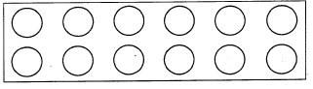
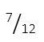
  - ³/₈
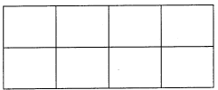
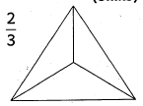

- Name three types of fractions.(3 mks)
  - ……………………………………..
  - ……………………………………..
  - ……………………………………...
- Identify the parts of a fraction shown below.(2 mks)
$\frac{3}{5}$

- Convert to improper fractions (4mks)
  - 3²/₃

  - 8½

- What is the place value of digit 8 in the number. (1mk) 8.03

- Measure the line below in cm. (2mk)
20m
15m
10m
- Find the area of the swimming pool below.(6 mks)

- Make a pattern using ovals and squares. (3mks)

THIS IS THE END OF MATHEMATICS ACTIVITIES
PRETECHNICAL STIDIES
- What is Pre-technical studies? (2 mks)
……………………………………………………………………………………………………………………………………………………………………….…………....................................................................

State three Components of Pre-technical studies. (3 mks)
- ………………………………………………………………………………………………
- ……………………………………………………………………………………………
- ……………………………………………………………………………………………

Outline five roles of Pre-technical studies in day today life. (5 mks)
- ………………………………………………………………………………….
- …………………………………………………………………………………..
- ………………………………………………………………………………….

Give three examples of Data. (3 mks)
  - ………………………………………………..……………………………………………
  - ……………………………………………….……………………………………………
  - ………………………………………………….……………………………………………

List five examples of computers used today.(5 mks)
- ………………………………………………………………………………………………………………………..
- …………………………………………………………………………………………………………………………
- …………………………………………………………………………………………………………………………
- …………………………………………………………………………………………………………………………
- …………………………………………………………………………………………………………………………
- State and explain three characteristics of computers. (6 mks)
- ……………………………………………………………………………………………………………………
- ……………………………………………………………………………………………………………………
- ……………………………………………………………………………………………………………………
- We can classify computer by looking at the following: name three. (3 mks)
- ………………………………………………………………………………………………
- ………………………………………………………………………………………………
- ………………………………………………………………………………………………
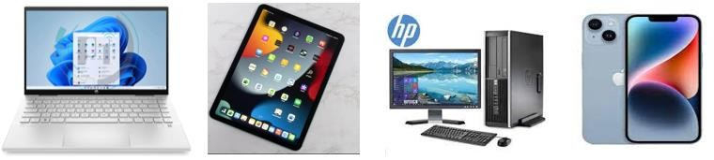
- Name the following digital computers. (4 mks)

- List any two computer hardware components. (2mks)
- ………………………………………………………………………………………
- ………………………………………………………………………………………
- State three examples of safety. (3 mks)
- …………………………………………………………………………………………………………………
- …………………………………………………………………………………………………………………
- …………………………………………………………………………………………………………………

Mention three physical threats at the workplaces. (3 mks)
- ……………………………………………………………………………………………………………
- ……………………………………………………………………………………………………………
- ……………………………………………………………………………………………………………

Name four Examples of online threats at work place. (4 mks)
- ……………………………………………………………………………………………
- ………………………………………………..……………………………………………
- ……………………………………………….……………………………………………
- ……………………………………………….……………………………………………

- Name any four tools found in the first aid kit. (8mks)
- …………………………………..…………………………………………….
- …………………………………...……………………………………………
- …………………………………………………………………………………
- …….……………………………………………………………………………

- Name the tools below (4mks)

- List any two professions that require training on safety. (2mks)
- …………………………………………………………………………….……………………………………………
- ……………………………………………………………………………..…………………………………………

Name the parts of the computer shown below. (5 mks)
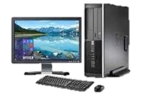

- Name the following safety wears. (7 mks)
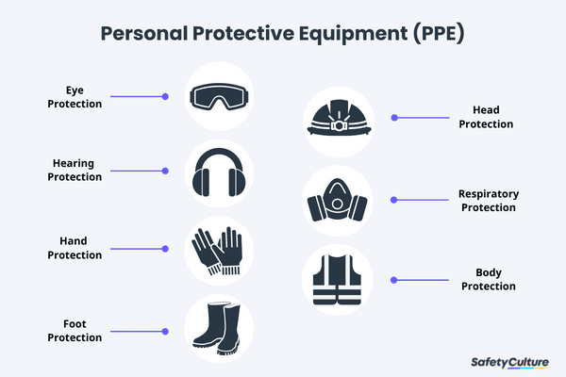

THIS IS THE LAST PAGE OF PRETECHNICAL STUDIES
INTEGRATED SCIENCE
- State three components of integrated science. (3 mks)
  - ……………………………………….……………………………………………
  - ……………………………………….……………………………………………
  - ……………………………………………………………………………………

- Outline two laboratory safety measures. (2 mks)
- ………………………………………….…………………………………………………………………………………………………………………………………………………………………………………………….…………………
- …………………………………………………………………………………………………………………………………………………………………………………………………………………………………………………………

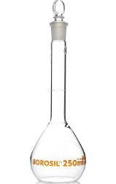
- Name the following laboratory apparatus.(8mks)
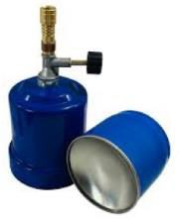
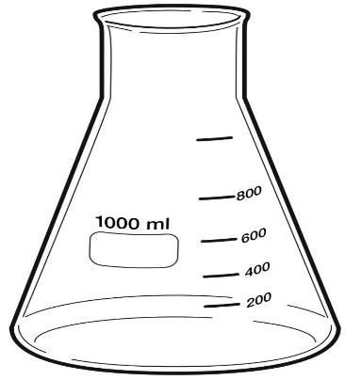

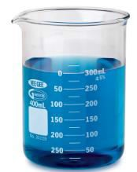
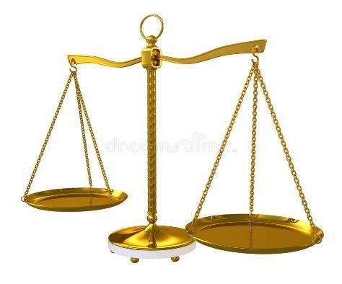

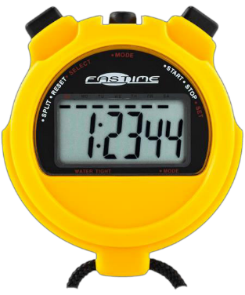
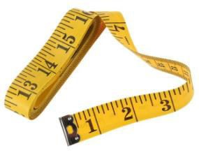

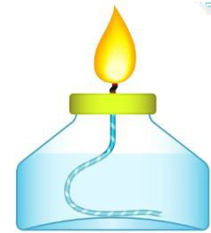

- State the functions of the parts of a Bunsen burner.(4 mks)
Part | Function
Collar
Air hole
Base

Gas hose

- State the meaning of the following laboratory hazard symbol. (3 mks)
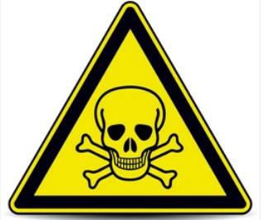
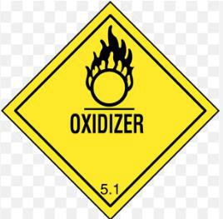
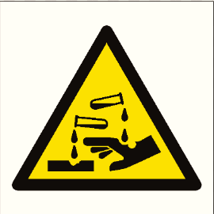

- The table below shows the basic quantity, write their SI unit and their symbols.(10 mks)
Basic quantity | SI unit | Symbol
Mass
Length
Time
Temperature
Electric current

- Calculate the volume of the box below. (5 mks)

5cm

10m

5m

- What is the density of a solid whose mass is 450grams having a volume of 90cm³?(5 mks)

- Calculate the area of a piece of land which measures 50m and 100 m.(5 mks)

- State three units that are used in measuring temperatures. (3 mks)
  - ………………………………………….……………………………………………
  - ………………………………………….……………………………………………
  - ……………………………………….……………………………………………

- Name four common accidents in the laboratory.(4 mks)
- …………………………….……………….……………….………………………………………………
- …………….……………….……………….……………….………………………………………………
- …………….……………….……………….………………………………………………………………
- ……………….…………….…………….………………….……………………………………………
- Name four protective wear for safety in the laboratory.(4 mks)
- ……………………….…………….…………….…………….…………….…………….…………….
- …………….…………….…………….…………….…………….…………….…………….…………….
- …………….…………….…………….…………….…………….…………….…………….…………….
- …………….…………….…………….…………….…………….…………….…………….…………….
- Name three laboratory apparatus used for measuring mass of substances.(3 mks)
- . …………….…………….…………….…………….……………………………………………
- …………….…………….…………….…………….……………………………………………
- …………….…………….…………….…………….………………………………………………
- Give four differences between luminous and non-luminous flame.(8 mks)
Luminous flame | Non-luminous flame

- Name the following parts of the light microscope.( 5 mks)
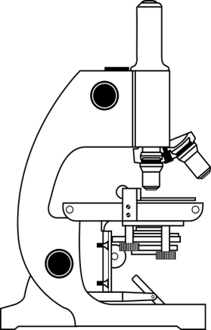

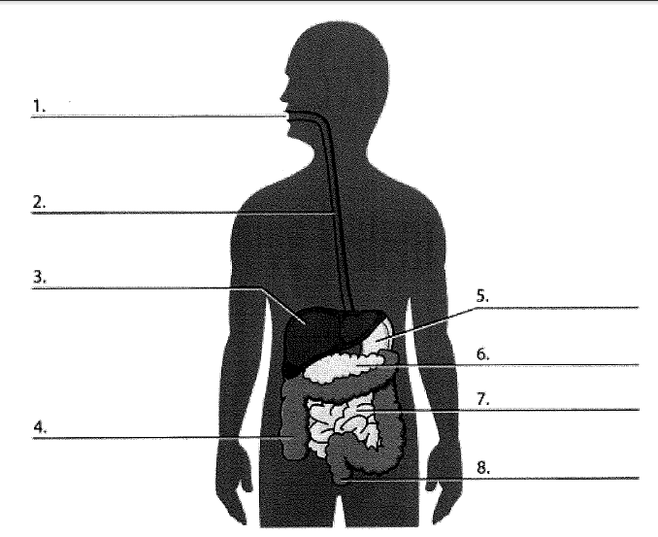
- Name the following parts of the digestive system.(8 mks)

- Name the parts of the breathing system shown below. (2mks)
b

a

- Identify four types of blood groups.(4 mks)
- _____________________________
- _____________________________
- _____________________________
- _____________________________
- Name the missing parts.(5 mks)

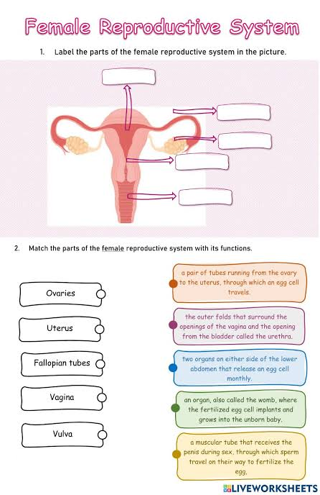

- Name the parts of a Bunsen burner shown below. (3 mks)
R-…………………..………………
T-…………………………………..
P-……………………………………

Outline two Acid-Base indicators used in Integrated Science. (2 mks)
- ……………………………………………
- ……………………………………………

- Grade six learners were asked by their teacher to collect two different types of roots and mount them on a cardboard. The picture below shows what they did.
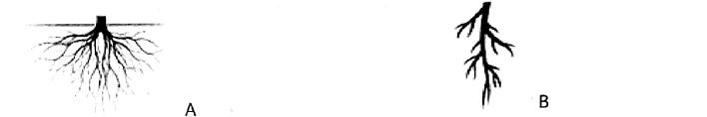

It is true to say that root A is a_______________________while root B is a _____________________(2mks)

- List four physical changes that take place in girls during the adolescent period. (4mks)
  - __________________________________________________________
  - __________________________________________________________
  - __________________________________________________________

- Define the term spreadsheet and state two of its uses.

  - Definition
______________________________________________________________________________________________________________________________________

  - Uses
_________________________________________________________________________________________________________________________________________

- Write down the meaning of the following words used in water conservation.(3mks)

- Reducing
___________________________________________________________________________________________________________________________________

- Reusing
____________________________________________________________________________________________________________________________________

- Recycling
____________________________________________________________________________________________________________________________________

- Grade 7 learners were asked to list components of Integrated Science. Write down three components they listed.
        - ______________________________________
        - _______________________________________
        - _______________________________________

- Which gas is used by plants to make proteins?(1mk)
___________________________________________________________

- State three uses of Carbon Dioxide.
              - _____________________________________________________________________
              - _____________________________________________________________________

- State any two ways of reducing friction.(2mks)

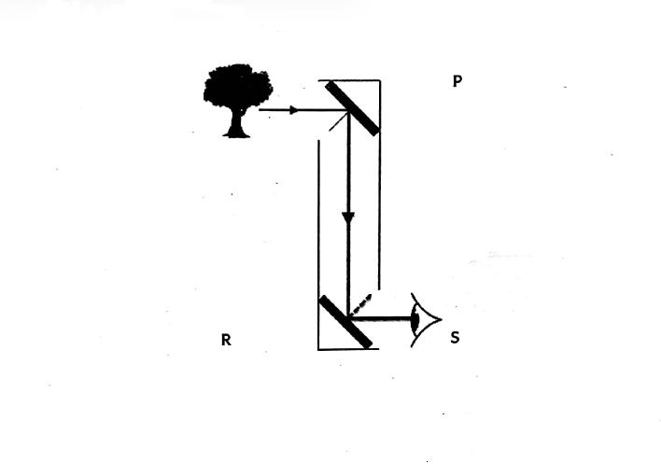
  - ___________________________________________________________________
  - ___________________________________________________________________
- During a science project, learners made an instrument and used it to observe an object as shown below.

        - The instrument made by the learners is called_______________________________

        - From which among the points P, R, S, was the image seen
_____________________________________________________________________

- Give two types of reflection.
  - ________________________________________________________________
  - ________________________________________________________________

- List down two main differences between arteries and veins.(2mks)
______________________________________________________________________________________________________________________________________________________________________________________________________
- Identify any two career opportunities related to knowledge and skills gained in Integrated Science.
  - _________________________________________
  - __________________________________________
THIS IS THE LAST PAGE OF INTEGRATED SCIENCE

SOCIAL STUDIES
- What is elf-exploration? (2 mks)
__________________________________________________________________________________________________________________
- State four ways of improving personal abilities and Interests for Self-Improvement. (5 mks)
- ____________________________________________________
- ____________________________________________________
- ____________________________________________________
- ____________________________________________________
- ____________________________________________________

- Mention five opportunities related to social studies. (5 mks)

_____________________

_____________________

_____________________

_____________________

_____________________

How do you set a goal in decision-making strategy? (6 mks)
  - ______________________________________________
  - ______________________________________________
  - ______________________________________________
- Goals set must be SMART. The initials SMART stands for?(5 mks)

S-_______________________________
M-______________________________
A-_______________________________
R-_______________________________
T-_______________________________
- Some of the entrepreneurial opportunities for social studies in our society include? (4 mks)
- ________________________________________________
- ________________________________________________
- ________________________________________________
- ________________________________________________
- Some people believe that certain careers or entrepreneurial opportunities belong to a given gender (male or female). These are called _________________________________________.(1 mk)

We can address gender stereotypes in career and entrepreneurial opportunities related to social studies through the following strategies.name four strategies (4 mks)
- _______________________________________________________
- _______________________________________________________
- _______________________________________________________
- _______________________________________________________
- Outline the origin of man according to the following community.(6 mks)

Maasai
- __________________________________________________________
- __________________________________________________________
- __________________________________________________________

- State four factors that led to growth of Ancient Egypt Civilization. (4 mks)
  - _________________________________________________
  - ________________________________________________
  - _________________________________________________
  - ________________________________________________

State four contributions of early civilization to modern world. (4 mks)
- ____________________________________________________
- ____________________________________________________
- ____________________________________________________
- ____________________________________________________
- Identify the two stages of evolution of man.(2 mks)

  - ____________________________________________________
  - ____________________________________________________
- Use the map of Kenya below to answer the questions that follow.
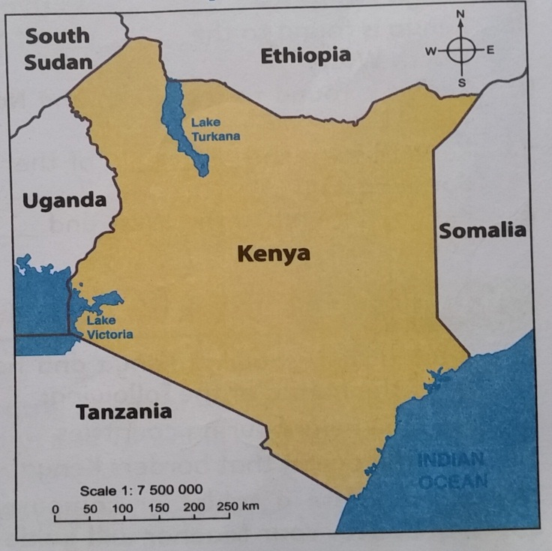
- Name the countries that boarder Kenya represented by the letters. (5 mks)
- _____________________

- _____________________

- _____________________

- _____________________
D
E
B
A
C

- On the map, draw the line of latitude(1 mk) ( check on the map)
- Locate the position of the following mountains.( use the symbol to show the mountains.)(3 mks) ( check on the map)
- Mount Kenya
- Mount Elgon
- Mount Kilimanjaro

- Give two examples of communities in each of the groups below. (5 mks)
Bantu | Nilotes | Cushites | Europeans | Asians
- Name the capital cities for the following African countries. (3 mks)
  - Kenya –_______________________________
  - Eritrea- _______________________________
  - Somalia –____________________________
- List four continents in the worlds. (4 mks)
- __________________________________________
- __________________________________________
- ___________________________________________
- ___________________________________________
- Name
- The major longitude passing through Africa. _________________
- The major latitude passing through Africa ____________________

- Grade 7 Social Studies teacher asked the learners to identify three branches of Social Studies. Which response did they give?(3mks)
- …………………………………………………………………………….……………
- ………………………………………………………………………………………….
- ………………………………………………………………………………………….

- Name four communities found in Uganda who belong to the Bantu speakers.(4mks)
- …………………………………………………………………………….……………
- ………………………………………………………………………………………….
- ………………………………………………………………………………………….
- …………………………………………………………………………………………

- Identify four elements of weather.(4mks)

- …………………………………………………………………………….……………
- ………………………………………………………………………………………….
- ………………………………………………………………………………………….
- …………………………………………………………………………………………
- Allan, a grade six learner was asked to name three historic built environments in Eastern Africa.Write the historic built environments he named.(3mks)
  - ___________________________________________________________________
  - ___________________________________________________________________
  - __________________________________________________________________
- Population in Africa is not evenly distributed. This is influenced by various factors. Name three factors that influence this.(3mks)

  - ___________________________________________________________________
  - ___________________________________________________________________
  - ___________________________________________________________________
- A Social Studies teacher asked learners to do research from their grandparents and define the following terms. Which explanation did they come up with?(3mks)
  - A clan
__________________________________________________________________________________________________________________________________________________
  - Age group
__________________________________________________________________________________________________________________________________________________
  - Age set
__________________________________________________________________________________________________________________________________________________

- Identify where the following minerals are mined in Eastern Africa.

  - Gold______________________________________________

  - Limestone__________________________________________

  - Petroleum__________________________________________

  - Soda ash____________________________________________

- Grade six learners were asked to name traditional methods of education. List three methods they gave?(3mks)

  - ______________________________________________________________
  - ______________________________________________________________
  - ______________________________________________________________
- What is self awareness?(2mks)
________________________________________________________________________________________________________________________________________
- Which roles were performed by the leaders below in the traditional Buganda kingdom.(4mks)
a)Kabaka ___________________________________________________

b)Katikiro ___________________________________________________

c)Omulamuzi ___________________________________________________

d)Omwanika ___________________________________________________

- Differentiate between talent and ability.(2mks)
____________________________________________________________________________________________________________________________________________________________________________________________________________
- Name three countries that first founded East African Community (E.A.C)(3mks)
  - ___________________________________________________
  - ___________________________________________________
  - ___________________________________________________
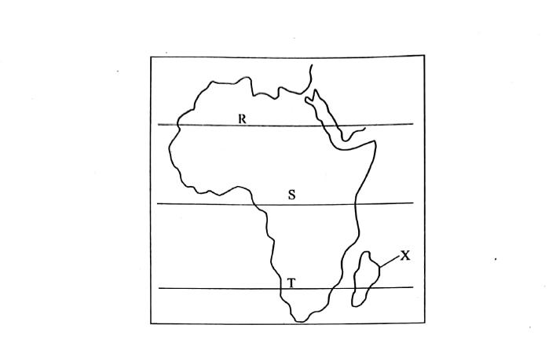
- Use the map of Africa to answer questions

  - Name the tropics labelled

R ___________________________________________________

S ___________________________________________________

T ___________________________________________________

b) The country marked X is called

___________________________________________________

- Name three careers related to Social Studies.(3mks)
  - ___________________________________________________
  - ___________________________________________________
  - ___________________________________________________

- List four characteristics of a person with high self esteem.(4mks)
  - ______________________________________________________________
  - ______________________________________________________________
  - ______________________________________________________________
  - _______________________________________________________________
- Which is the second largest continent in the world?(1mk)

___________________________________________________

THIS IS THE LAST PAGE OF SOCIAL STUDIES
MWANGI O705443680

