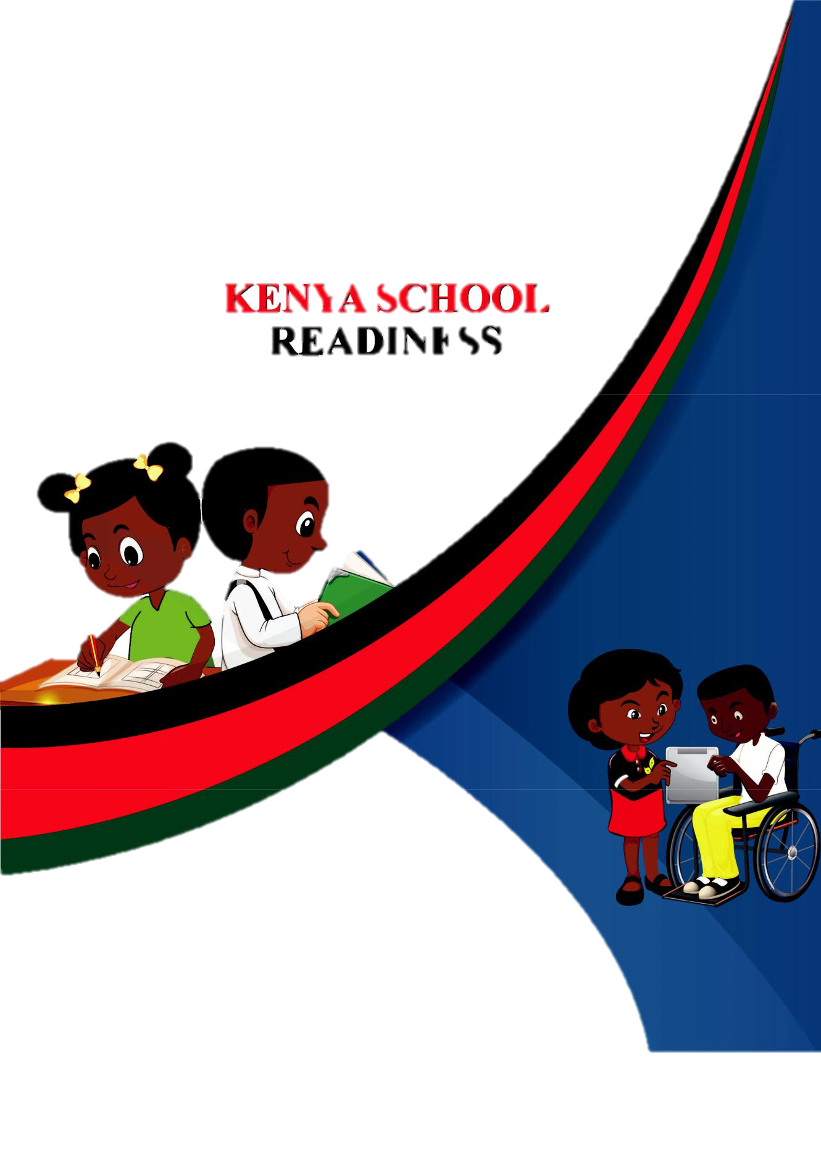

GRADE 2

HOMEWORK ACTIVITY

NAME:________________________________
CREATIVE ARTS
Through the help of your parent / guardian, kindly attempt all the following questions.
- Write four types of songs performed for different purposes in your community.
- ……………………………………………………………………………
- ……………………………………………………………………………
- ……………………………………………………………………………
- ……………………………………………………………………………
- Explain the message in the songs you have written in number 1 above.
- ……………………………………………………………………………
- ……………………………………………………………………………
- ……………………………………………………………………………
- ……………………………………………………………………………
- Write the occasions in which the songs you have written above are performed in your community.
- ……………………………………………………………………………
- ……………………………………………………………………………
- ……………………………………………………………………………
- ……………………………………………………………………………

- Write four activities that take place when one is singing. The first answer is given.
- Clapping.
- ………………………………………
- ………………………………………
- ………………………………………
- ………………………………………
- Write four percussion instruments that can be used to accompany our singing. The first answer is given.
- A kayamba.
- …………………………………………………….
- ……………………………………………………..
- ……………………………………………………..
- ……………………………………………………..
- A part from the percussion instruments you have learned in school, write other 3 instruments that you know or you have ever seen.
- ………………………………………………………….
- ………………………………………………………….
- ………………………………………………………….
- Write 4 tittles of any 4 songs we have learned in school. The first answer is given.
- Miti ya yumbayumba.
- ………………………………………………………………..
- ………………………………………………………………..
- ………………………………………………………………..
- ………………………………………………………………..
- Write 5 things that we require when dancing. The first answer is give.
- Dancing space.
- ……………………………………………………………………………
- ……………………………………………………………………………
- ……………………………………………………………………………
- ……………………………………………………………………………
- ……………………………………………………………………………
- Name the following 3 signs used in music writing.

………………………………………………….

- …………………………………………………

- …………………………………………………

- Name the parts shown on the following musical sign.

……………………………………………………

……………………………………………………

- Match the following musical signs with their correct names.

Semibreve.

Minim.

Crotchet.

- In music maths, a semibreve ( ) has 4 counts, a minim( ( ) has 2 counts and a

crotchet ( ) has one count. Write how many counts are in the music maths below. The first answer is given.

- + = 2 counts. b) + + = _______ counts.

c) - = _______ counts. d) - = ________ counts.
- Write the first and the second stanza of our Kenya National Anthem in English.
……………………………………………………………………………………………………………………………………………………………………………………………………………………………………………………………………………………………………………………………………………………………………………………………………………………………………………………………………………………………………………………………………………………………………………………………………………………………………………………………………………………………………………………………………………………………………………………………………………………………………………………………………………………………………………………………………………………………………………………………………………………………………………………………………………………………………………………………………………………………………………………………………………………………………………………………………………………………………………

- Write the first, second stanza and the chorus of the East African Anthem.
……………………………………………………………………………………………………………………………………………………………………………………………………………………………………………………………………………………………………………………………………………………………………………………………………………………………………………………………………………………………………………………………………………………………………………………………………………………………………………………………………………………………………………………………………………………………………………………………………………………………………………………………………………………………………………………………………………………………………………………………………………………………………………………………………………………………………………………………………………………………………………………………………………………………………………………………………………………………………………

- Write the first and the second stanza of our Kenya National Anthem in Kiswahili.
………………………………………………………………………………………………………………………………………………………………………………………………………………………………………………………………………………………………………………………………………………………………………………………………………………………………………………………………………………………………………………………………………………………………………………………………………………………………………………………………………………………………………………………………………………………………………………………………………………………………………………………………………………………………………………………………………………………………………………………………………………………………………………………………………………………………………………………………………………………………………………………………………………………………………………………………………………………………………………………………………………………………
- Sticking pictures on the wall is called ______________________
(posting, pasting)
- Awinja wants to make a paint. She can powder paint and _____________________________
(milk, water, leaves)
- A toy wheel can be made from _________________________
(bottle tops, soil)
- Grade two learners can dance in different __________________________________
( shapes, styles, faces)
- Draw and colour a pig.
- I should obey the rules when playing any game for ___________________________( danger, happiness, safety)
- Colours of our National flag are ____________________and ______________________
(yellow, red, blue, green)
FRENCH
1(i).Write the responses to these greetings in French.
- Salut!_______________________________________
- Comment çava?________ _____________________
- Bonjour______________________________________
- Bonsoir_______ _______________________________
- Bon après-midi___________________________________
(ii).Practice saying the above greetings loudly with your guardian.
2.Write these numbers in English.
a.Dix-huit______________________________
b.Neuf________________________________
c.Sept________________________________
d.Quinze________________________________
e.Vingt_________________________________

3.Draw and colour these items.
a.une banane. b.une gomme

c.un tableau noir. d.une pomme

4.Match the days of the week.
Dimanche__________Monday
Vendredi___________Saturday
Samedi____________Friday
Lundi______________Sunday



ENVIRONMENTAL

a. The day to day changes in the atmosphere is called

____________________. (__/1mark)

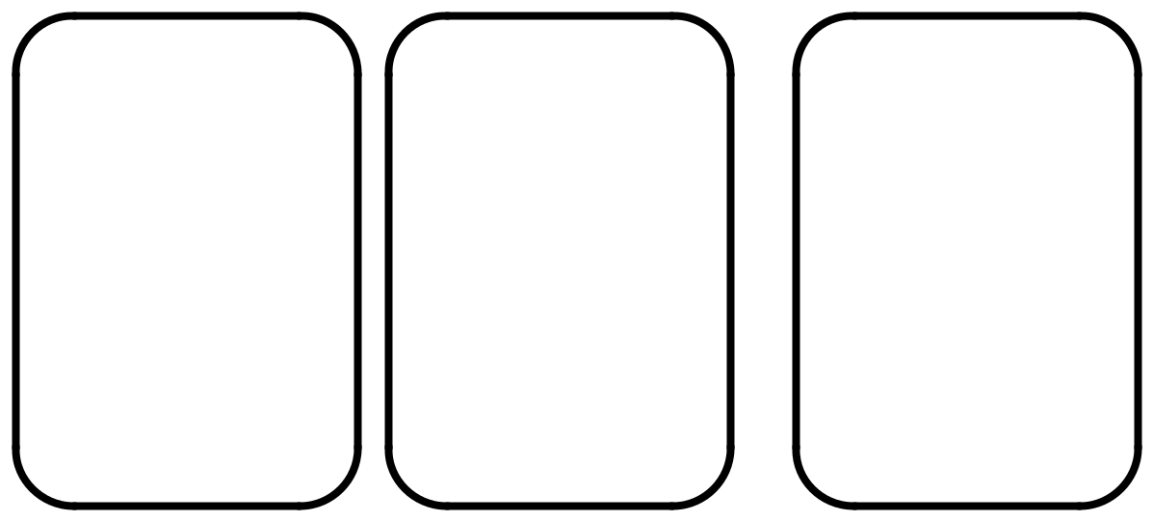
b. Draw and name three weather conditions. (__/6marks)

______________ _____________ _______________

c. Mother is carrying an umbrella. The weather is

___________________________. (__/1mark)

d. Clothes dry fast when the weather is ______________ and

___________________. (__/2marks)

e. Name two different clothes we can wear during this weather.

 |  | _____________________. |  | (__/2marks)
 |  | _____________________.
f. Tick the clothes worn during cold weather. |  |  |  | (__/5marks)
kikoi | socks | trousers | sweater
jacket | dress | scarf | vest


g. When we wear heavy clothes on a hot day, we ______________.

(sweat, don’t sweat) (__/1mark)

h. Pictures used to record weather are called weather

 | ________________. (sins, symbols) |  | (__/1mark)
- Study the pictures below and answer the questions.
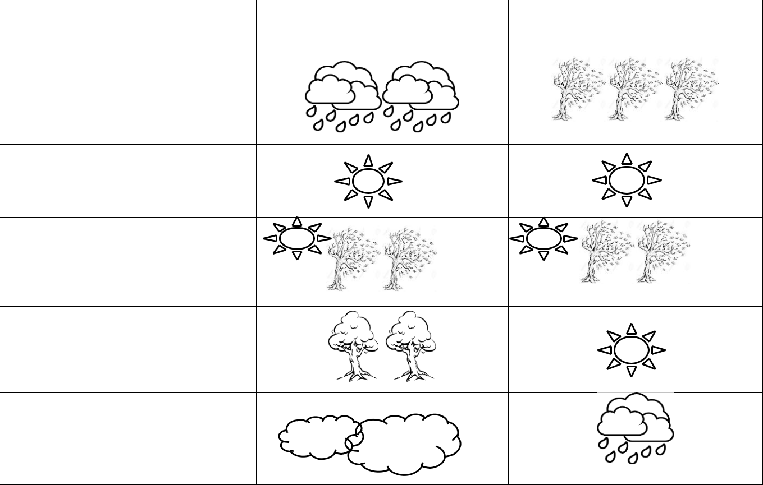 | Day | Morning | Afternoon
 | Monday
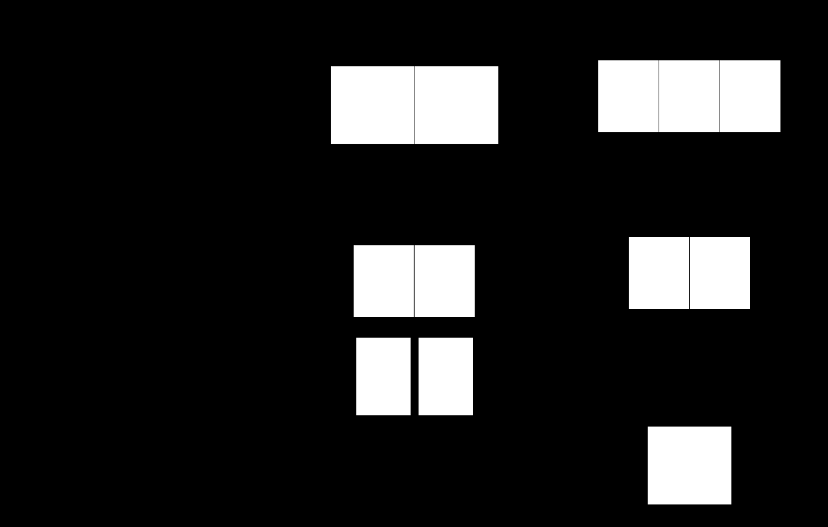

Tuesday

Wednesday

Thursday

Friday

- We record weather on a weather __________ (__/1mark)
- Mother washed clothes and they dried very fast. Which day was
 | it? ___________________________. | (__/1mark)
3. On Thursday the weather was _______________ and
 | ________________. | (__/2marks)
4. | The best days for winnowing grains were the afternoons of
 | _____________________. | (__/1mark)
5. | When did the pupils wear gumboots on their way to school in the
 | morning? ____________________. | (__/1mark)

- Pupils enjoyed swimming on _______________ (__/1mark)
- It was cloudy and rainy on ________________ (__/1mark)
c. During the windy days. (__/3marks)

- We can fly ________________.

- We can sail ________________.

- Avoid wearing _____________ clothes. (light, heavy)

d. When the winds are very strong, we say the weather is

e.

_____________________. (__/1mark)

Write True or False. (__/5marks)

- Weather keeps changing _________________.

- We wear heavy clothes on a sunny day. ______________.
- Rain is important to us. _________________.
- Dark clouds bring rain. _________________.
- We should play in the rain. ______________.
f. Name the following bad weather condition. (__/1mark)
 |  |  | _____________________.
Storing
Storing | water.
a. Name three uses of water. |  |  |  | (__/3marks)

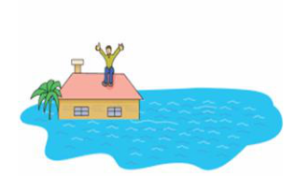
  - ______________________________.

  - ______________________________.
  - ______________________________.

b. Draw, name and colour three containers of storing water at home.
(__/9marks)



_____________ _____________ _______________



A. 1 . What is breakfast? (__/2marks) __________________________________________________________. 2 . Why is it important to have breakfast. (__/6marks)

- _____________________________________________________.

- _____________________________________________________.

- _____________________________________________________.

3 . Food that we eat in the morning is called?

___________________________.

(__/

2marks)

B. Draw and name food we eat in the morning.

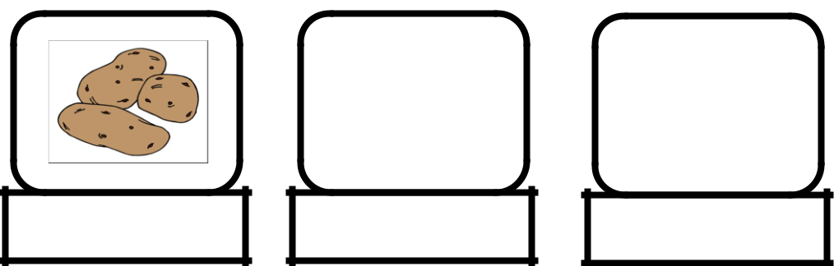

(__/10marks)

sweet potato


C. Name five things you can do after eating breakfast.

(__/10marks)

- ______________________________________________________.

- ______________________________________________________.

- ______________________________________________________.

- ______________________________________________________.

- ______________________________________________________.

D. Match things I use to brush my teeth. (__/10marks)

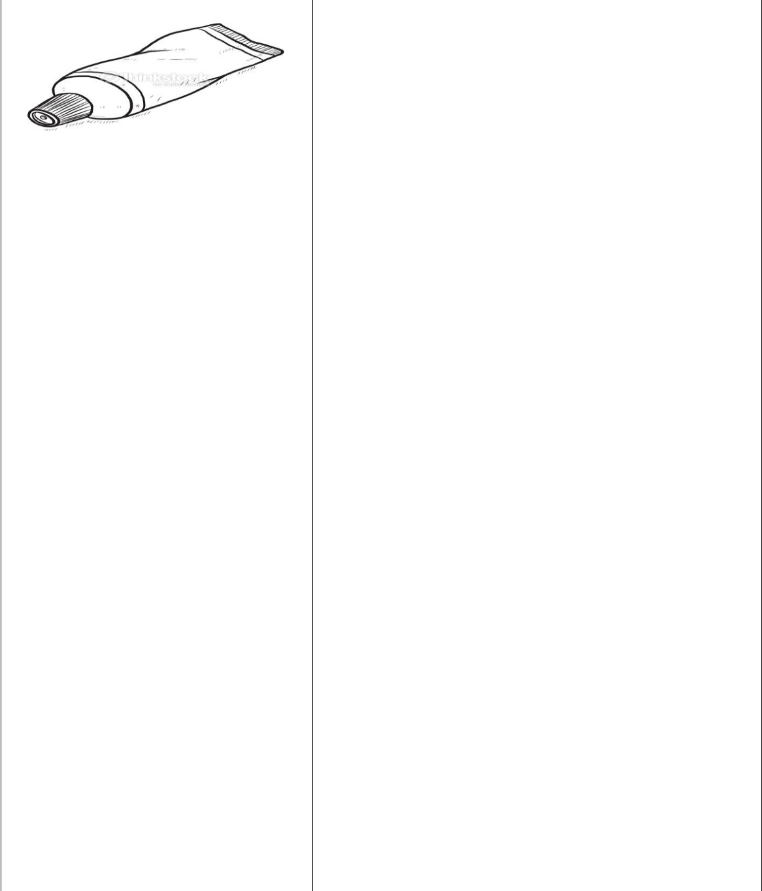

Salt

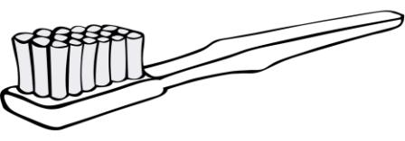

Water

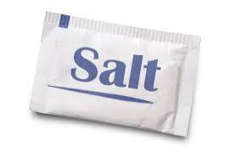

Toothpaste


Toothbrush
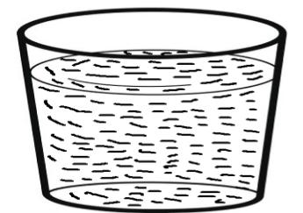

Chewing stick

• We take _____________ meals a day. (__/2marks)

- If I do not have a toothbrush I can use a

_________________________. (__/2marks)

- Clean teeth should be ______________. (white, brown)

(__/2marks)

E. Draw and colour yourself being checked teeth by a dentist.

(__/4marks)



SECTION B
- This is Kodjo vegetable garden.
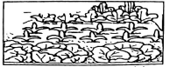
He sells some vegetable to neighbours. This is an __________________________ project.
(shop, market, enterprise)
- Atieno goes to school everyday. She sits on a desk at the corner. She is a _____________________.
(teacher, pupil, cook)
- "Do not make noise in class." This is a school _________________________.
(calendar, notice, rule)
- The weather is__________________________.
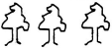
(cloudy, windy, calm)
- Draw and colour a river.
- ____________________________ can hurt us in school.
(Bag, Thorn trees, Chalk)
- Which colour is found at the bottom of our flag? __________________________.
(red, black, green)
- Joshua and Caleb are cleaning their classroom. It is a way of cleaning the ________________________.
(air, environment, weather)
- A good leader should be _______________________________
(honest, strong, cruel)
- This is a ___________________________
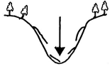
(plain, valley)
- This plant grows in ______________________ areas.
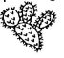
(dry, wet)
- We can fly a _______________________ in a windy day.
(shirt, kite, tree)
- Many trees growing together make a ______________________________
(valley, plain, forest)
- Which one is a wild animal? _______________________________
(chicken, eagle, turkey)
- Draw and colour a forest.
- The picture below shows a _______________________________ advertisement.
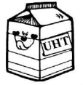
(food, life, clothe)
- Advertisement shows _______________________ products. (bad, sweet, good)
- Name this fruit ______________________________
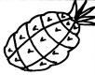
(Apple, pineapple)
- Lenox eats too much food. He will be _________________________________________
( sick, strong, healthy)
- Washing our hands prevent ___________________________
(worries, diseases, health)
- Draw and colour a ripe banana
- Draw a tooth brush.
- ________________________ is a source of food.
(plant, stone, sun)
- Susy ate meat and drunk milk. The foods are sources of ___________________________
(vitamins, proteins, fats)
- The food we eat in the morning is called _______________________________
( lunch, dinner, breakfast)
- A lemon tastes ____________________________
( sweet, sour, bitter)
- _________________________ can spread diseases.
(Going to school, Sharing toothbrush)
- Long and dirty hair carries _____________________________
(jiggers, lice, diseases)

ENGLISH LANGUAGE
School and home activities Sub-strand: Vocabulary, formation of words, continuous form of verbs, use of was/were.

A. Why should we listen attentively when other people are
talking? (__/6marks)

  - ____________________________________________________.
  - ____________________________________________________.
  - ____________________________________________________.

B. Write the name of the pictures by filling in the missing letters.

a. |  | (__/4marks)
a. |  | P__nc__l

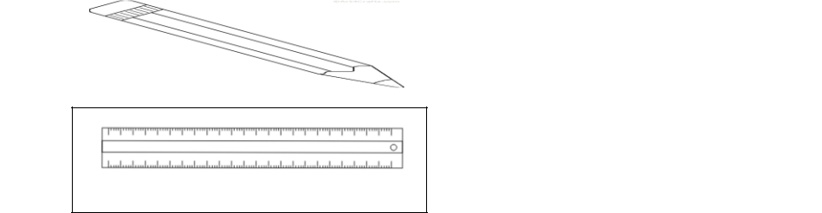
^{a.} R__l__r


^{a.} Er__s__r
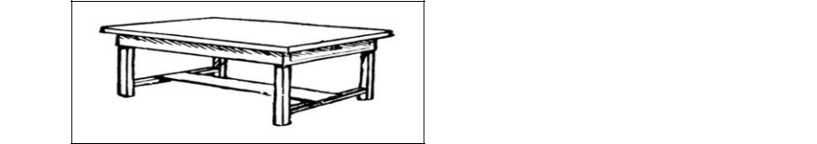

^{a.} T__bl__

C. Name 5 things we do at home. (__/5marks)
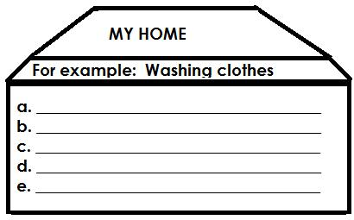


D. Make words using sound “pr” (__/5marks)
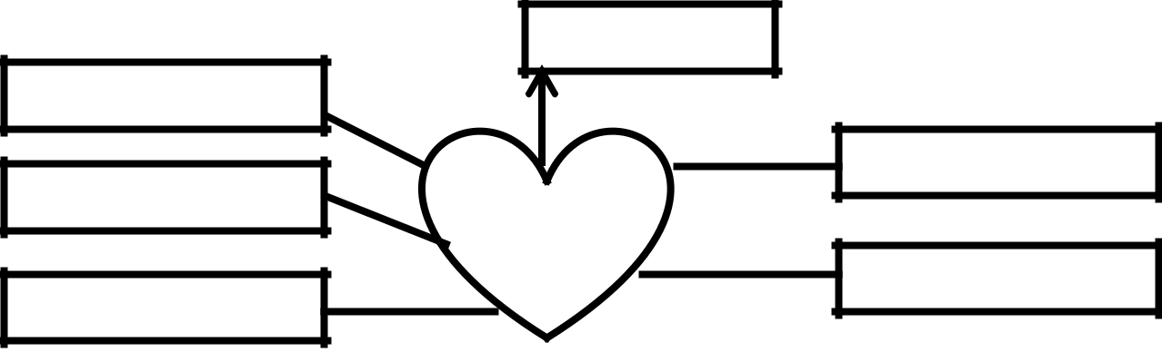

prize

“pr”

E. Use was or were to complete the sentences. (__/5marks)
- The teacher ______________ marking our books.
- The pupils _______________ listening to the teacher.
- Halima _____________ writing in her workbook.
- The children _____________ skipping.
- Otieno _____________ in class sweeping.

- Draw, name and colour 5 things we find in a school.
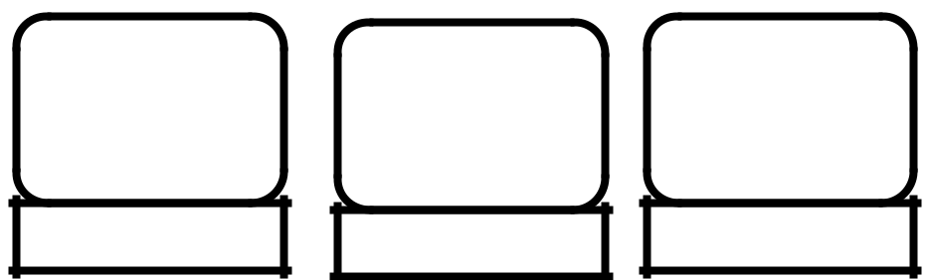
(__/5marks)
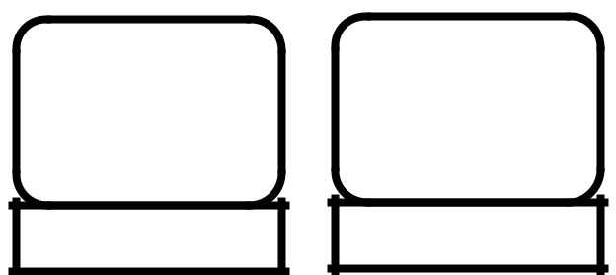

F. Arrange the words properly. (__/5marks)
  - bkucet- ___________________________.
  - rofwle- ____________________________.
  - ndwowi- __________________________.
  - eetr- ______________________________.
  - oobrm- ___________________________.

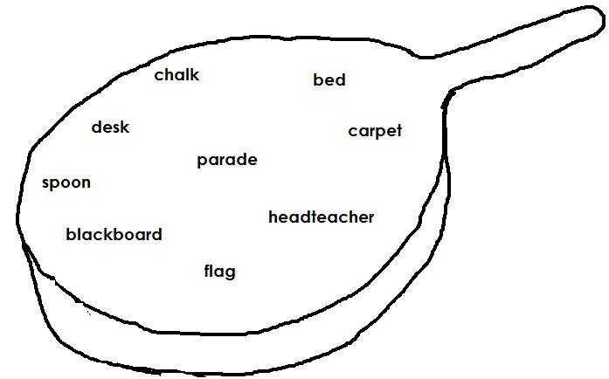
G. Colour the names of the things we find at home. (__/5marks)


- Read the short passage below and answer the questions.
My name is Lisa, I go to Lisala primary school, I like going

to school daily. My school is located at Panda village. It is a very nice place away from all the crowd and noise of the city.

My school has a head-teacher called Mrs. Linda. It has a big garden where we have grown colourful flowers and fruits. There are about five hundred pupils in our school.

My teacher Mrs. Lisala teaches us very well and makes us learn subjects in very creative and attractive way.

Questions.

  - What is the name of the write? __________________(1mark)
  - Where is the school located? ____________________ (1mark)
  - What is the name of their head-teacher? _____________(1mark)
- What is grown in their garden? ___________________(1mark)

- How many pupils are in the school? _______________(1mark)

MATHEMATICS
Fill in the missing numbers.
- 307= _______hundreds _______ones _______tens
- __________= 2 hundreds 9 tens 4 ones
- Write the number represented in the abacus below
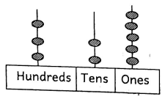
- Which one is smaller?
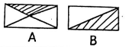_________________
Write the missing numbers.
- 23, 25, 27,_____, 31
- 48, 46, 44, 42, _____.
Add:
- 17 +5 = __________
- 3 8
+ 6
___
- Nevine has 19 crayons. Lenox has 8 crayons. How many crayons do they have altogether?
- Take away:
7 0
−3 0
____
- 28 − 28 = ___________
Add:
- 7 + 2 + 3 = ________
- 3 + 5+ 6 = _________
- Muli had 50 sweets. He gave 10 sweets to his friend Musyoka. How many sweets did he remain with? __________
Fill in the gaps.
- 13 − = 8
- 12 ÷ 2 =
- 4 × 3 =
- Eight put in groups of 4 is __________
- Two hands have _________ fingers.
- Which one is heavier?
___________________
- Tindi has sh. 50 note. How many sh. 10 coins can she get? ________________
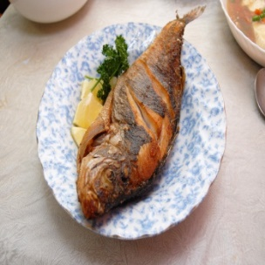
Write any need or want.

22. ___________________
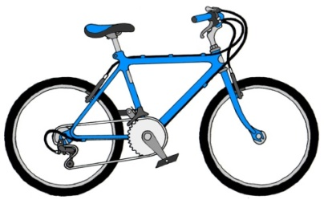

23. _____________________
LITERACY

TASK 1:
LISTENING AND SPEAKING
Teacher will ask the learner the following questions. The learner will answer the questions orally in English.
- What is your name in full? ______________________________
- How old are you? ______________________________
- Who is the Head teacher of your school? ______________________________
- How can you keep your school clean? ______________________________
- After collecting the rubbish, where should you put them? ______________________________
- Is it healthy to keep our school clean? ______________________________
- Which equipment can you use to keep the school clean? ______________________________
TASK 2:
READING ALOUD
The learner will read the following story aloud and the teacher listens.
Meher and her mother are going for a day trip in Mombasa. They are going by the express train from Nairobi city county.
After sometime Meher will feel happy and excited. The train moves along the rail. It takes the train six hours to reach Mombasa.

CRE
- _______________________created all of us.
(Satan, Angel, God)
- All chistians should ____________________________ their parents.
( abuse, obey, beat)
- Draw and colour the cross of Jesus
- ____________________________ was a disciple of Jesus christ.
(Elijah, Andrew, Ezekiel)
- ____________________________ was thrown in a den of lions
(Samson, Daniel, Meshack)
- Paul shares food with his friend Harrison. Sharing shows ______________________________
( love, richness, pride)
- The first book in the old testament is _____________________________
(Mark, Genesis, Mathew)
- __________________________ is the house of God.
(Home, Church, Cross)
- Jesus healed the ________________________ with paralysed hands.
(boy, army officer, man)
- Jesus stayed in the ______________________________ for three days.
(water, tomb, cross)

IRE
- None to be worshipped but ________________________________
(Allah, God, Issah)
- The messenger of Allah (sw) is _______________________________
( Issah, Musa, Muhammad)
- We should eat with our ______________________________ hand.
(right, left, both)
- Islam is a religion of __________________________
( peace, love, unity)
- The hadith was taught by ________________________________
(Muhammad, Issah, Dawud)
- We should say _____________________________ before any meal. (Bismillah, Taraweh)
- A good muslim prefect in class should not be _____________________________
( arrogant, humble, kind)
- When visiting the toilet we should enter with our ___________________________ leg first.
(right, left, both )
- We should _______________________________ our teachers when in school.
(hate, laugh, obey)
- We should say ____________________________when we wrong someone.
(Thank you, sorry, excuse)

KISWAHILI
SEHEMU YA B:
SEHEMU YA 3: UFAHAMU
Soma ufahamu ufuatao kisha ujibu maswali (alama 5)
Tura na Tengu walikuwa katika gredi ya pili katika shule ya msingi ya Mwangaza. Tura alikuwa mtoto goigoi na wa mchezo nyingi. Tengu alikuwa mvulana mpole sana na msafi. Yeye alikuwa mwenye bidii sana. Tura alipenda kusumbua watoto wenzake mwalimu akitoka. Kwa mchezo Tura ni hodari sana.
- Tura na __________________________ walikuwa gredi ya pili.
- Tura na Tengu wanasoma shule gani? __________________________
- Mtoto yupi anapenda kusumbua wenzake? __________________________
- Tura alikuwa hodari kwa? __________________________
- Katikati ya hawa wavulana, nani alikuwa na bidii? __________________________
SEHEMU YA 4: SARUFI (alama 15 )
Andika kwa herufi ndogo.
- NYOTA __________________________
- UBAO __________________________
Jaza 'li' au 'ta'
- Ben a ________________ nunua mkoba jana.
- Mwalimu wetu ha_______________kuja kesho.
Chora picha hizi

___________________________
- _____________________________
(yai, saa)
Andika kwa maneno au nambari
- Mbuzi 19 = _________________________
- Kalamu kumi na nane = __________________________________
Tumia "yangu”, “wangu” au "changu"
- Hiki ni kikombe ___________________________
- Hii ni nyumba ___________________________
Andika sentensi kwa wingi.
- Mtoto yule anacheka.
__________________________________________________
Jibu maamkuzi haya;
- Hujambo? _______________________________
- Shikamoo? _______________________________
(marahaba, sijambo)

Chagua jibu sahihi.
- Mama anaosha _____________________________ (viombo, vyombo)
- ____________________________ yangu anakamua ng'ombe. (Papa, Baba)
SEHEMU YA 5: KUANDIKA
Imla: (alama 5)
- ____________________________
- ____________________________
- ____________________________
- ____________________________
- ____________________________

KUSIKILIZA NA KUZUNGUMZA
Mwalimu atamwuliza mwanafunzi maswali yafuatayo. Kila mwanafunzi atajibu kwa Kiswahili.
- Kwa majina unaitwaje? ____________________________________
- Je, unapenda chakula gani? ____________________________________
- Kwa nini unapenda chakula hicho? ____________________________________
- Taja vyakula vitatu tunapata kwa wanyama.
_____________________,
___________________,
____________________
- Mnyana gani hutaga mayai? ____________________________________
- Ng'ombe utupatia vyakula kama gani?
SEHEMU YA 2:
KUSOMA KWA SAUTI
Soma hadithi hii kwa sauti;
Hapo zamani za kale, hali ya anga ilikuwa vizuri sana. Hewa ilikuwa safi, maji safi na mvua nyingi.
Watu wameharibu anga kwa matendo yao. Saa hii hata mvua ni kidogo. Miti zakatwa ovyo ovyo.
Wanyama wa pori pia wanakufa kwa sababu ya njaa. Tunaomba serikali yetu itusaidie.

