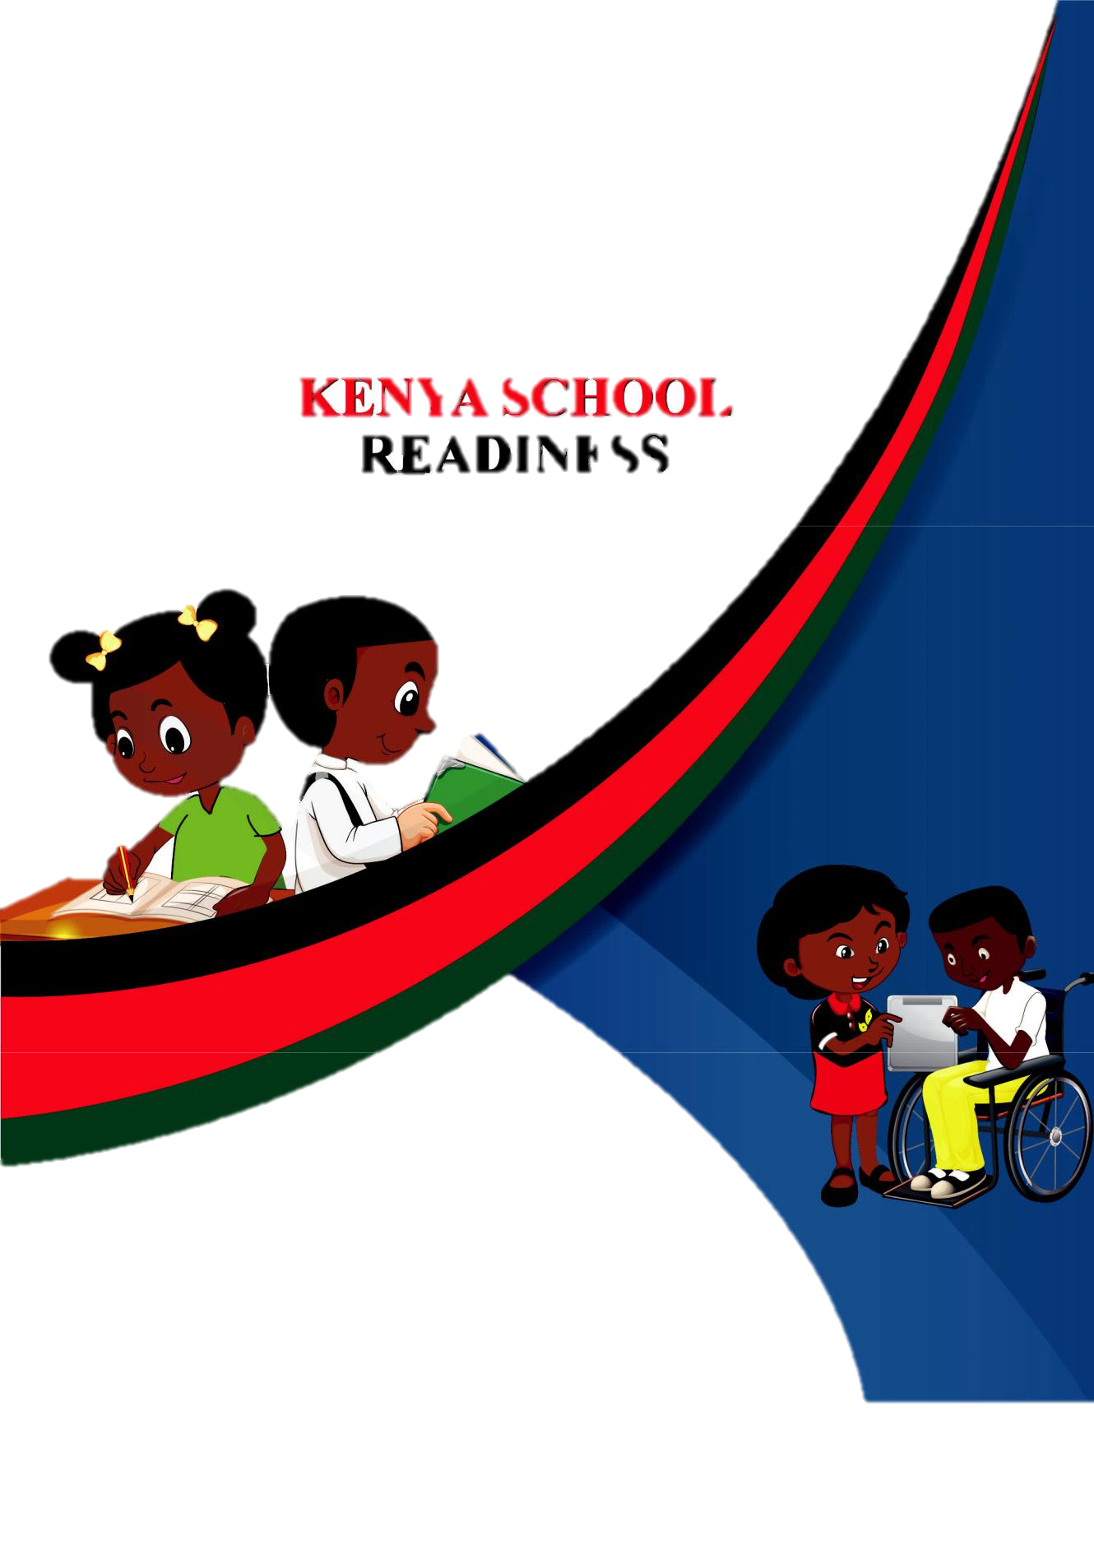

GRADE 1

HOMEWORK ACTIVITY

NAME:____________________________
COMPETENCE BASED CURRICULUM
G1
HOMEWORK
INTERGRATED ACTIVITIES GRADE ONE
NAME_____________________DATE:________________

- What is the colour of the sky during the day?
(Dark, blue) __________________ (1mk)

- We play kites when it is ____________________
(Sunny, windy) (1mk)

- Name two weather conditions when we can
we can use the object(2mks)
____________________ and ________________

4. Rain and dams are __________________of water.
(uses, sources) (1mk)
5. Plants needs ____________________ to grow. (1mk)
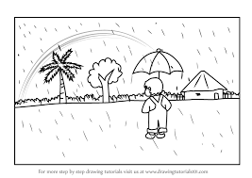
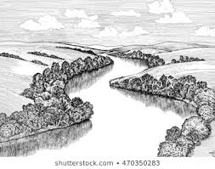
6. Name and colour 2 sources of water. (6mks)
_________________________ ___________________________
7. Circle the soil which becomes sticky when mixed with water. (1mk)
Sand loam clay

8. Name 3 things you need to plant maize seed. (3mks)
a)_____________________b) ____________________

c)____________________

9. Name the parts of a plant.94mks)
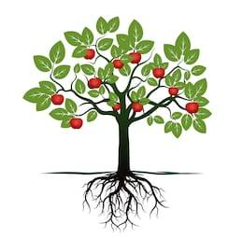

10. Very many trees makes a ______________________
(1mk) forest, home).

11. ______________________ gives us honey. (1mk)(Bees, cow)

12. A cow gives ____________________ and ______________ (1mk)

13. Write whether it is a good or bad healthy habit.
(4mks)
a)Bathing daily___________________________
b) Using a lot of sugar______________________
c) Drinking safe water ______________________
d) Resting after work_______________________
e) Doing exercises________________________

14. Fruits should be _____________________ before eating.
(1mk)
15.After shedding a tooth, you should gurgle ______________
Water. (sugary, salty) (1mk)
16.Milk teeth are _______________________ (1mk)
(Permanent, temporary)
17. Draw and colour types of medicines

Capsule | tablets | Ointments cream | inhaler

17.Draw and colour materials used to clean the body.(6mks)
Toothbrush | Soap | Pumice stone

C.R.E ACTIVITIES
1. God created me in His own _____________________
and ______________________ (1mk)

2.We take care of our teeth by _____________________
(cutting, brishing) (1mk)

3.Draw and colour two things created by God. ( 2mks)
sun | trees

4.What is prayer? (1mk)
______________________________________________________________________
______________________________________________________________________
5.Family members______________________together.
(share, hate) (1mk)

6.Sharing work brings ___________________________ (1mk)
Hatred, unity)

7.The bible has _______________________ books. (1mk)
(39, 66)

8.This is a __________________________ (1mk)
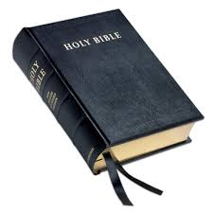

9.Goliath was killed by David with a sling and a _________________.

10. Joseph had ____________________ brothers (12,11)
(1mk)

IRE ACTIVITIES

1.Muslims worship in a _____________________
(Mosque, Temple) (1mk)

2. Name 3 things that Allah created. (1mk)
a)____________________________

b)____________________________

c)____________________________

3.Write the number of Rakaa (1mk)
a) Dhuhur
b)Fajr

4.We see things with our _____________________
(mouth, eyes) (1mk)

5.We say _______________________after drinking.
(Bismillah, Alhamdulillah) (1mk)

6.We wash ______________________after the toilet.
(hands, legs) (1mk)

7.We worship _____________________________
Allah, Muhammed) (1mk)

8. _____________________________pray has two rakat.
(Fajr, dhuhur) (1mk)

9. We pray ______________________ times a day.
(5,6 ) (1mk)

10. Allthat Allah created is ________________________
(bad, good) (1mk)

ASSESSMENT RUBRICS
 | EXCEEDING  EXPECTATIONS | MEETING  EXPECTATION | APPROACHING  EXPECTATION | BELOW  EXPECTIONS
 | 45-50 | 35-44 | 25-34 | 0-24

COMPETENCE BASED CURRICULUM
G1
FRENCH ACTIVITIES.
1.Write these sounds in French.
Aa___________
Kk___________
Pp___________
Hh__________
Zz__________
2.Underline five French speaking countries from those listed below.
Kenya Somalia
Burundi Rwanda
Tanzania USA
Cameroon Belgium
Chad
3(i).Fill in the missing letters of these greetings.
a.B_nj_ _r.
b.Sal_t!
c. _onsoi_.
d. B_n ap_rès midi?
d.Bo_nu_t!
(ii)Write down the meanings of the above greetings in English.
  - ___________________
  - ____________________
  - ___________________
  - ___________________
  - ___________________

COMPETENCE BASED CURRICULUM
G1
SHUGHULI ZA KISWAHILI
- Jaza silabi (ala.3)
- Ba _____ ______ bo _____
- dha ______ _____ _______ dhu
c) ya ______ yi _______ yu
- Tenganisha silabi kutoka kwa neno (ala. 3)
- Pete = ------------ + ……………
- dhahabu = ………….. + ………………+ ………………
- chaki =……………+ ……………
- Andika kwa herufi ndogo au kumbwa (ala. 3)
- CHUNGU …………………………………………………………………………………….
- Kikombe ……………………….……………………………………………………….
- KIJIKO …………………………..……………………………………………………….
- Soma na uchore (ala.3)
Kiti | chungu | upanga
- Tia mstari maneno yenye sauti ‘m’ (ala. 7)
Mama, lala, kumi, meza, sisi, mtoto, pita,
Simu, paka, pera, moto, lia, kula, simama, kinu

6.Andika jina la picha.


__________________ ________________
 ___________ 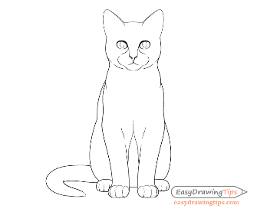____________

____________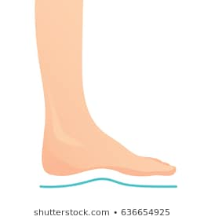 ____________
7.Andika vizuri (ala. 4)
- leshu………………………………………………………….
- tiki …………………………….…………………………….
- bukita…………………………..…………………………….
- musi………………………………………………………………….

8. Jaza pengo (ala 4)
Ch__ng__ m___z___
K__s__ k__l__mu
9. Andika kwa wingi(ala 6)
Umoja Wingi
a)Mwanafunzi ……………………………………………………….
b) Mtoto …………………………………………………………
c) Kitabu …………………………………………………………
d) Kinu ……………………………….…………………………
e) Mzazi ……………………………………………………………
f) Mkulima ……………………………………………………………
10. Andika nambari kwa majina (ala. 4)
a)5 …………………………………………………………………………………………………………………………………………
b) 2 ……………………………………………………………………………………………………………………………………..
c) 8………………….......…………………………………………………………………………………………………
d) 7 ………………………………………………………………………………………………………………………………………
VIWANGO VYA KUTATHIMINI
Kuzidisha  matarajio | Kufikia  matarajio | Kukaribia  matarajio | Mbali na  matarajio
45-50 | 35-44 | 25-34 | 0-24

KUSOMA NA KUANDIKA GREDI YA KWANZA

Tunga sentensi ukitumia maneno yafuatayo. (ala. 10)
- Mtoto
____________________________________________________________________
- Msichana
____________________________________________________________________
- Kitabu
____________________________________________________________________
- Kijiko
____________________________________________________________________
- Mvulana
____________________________________________________________________
Soma hadithi kisha ujibu maswali yafuatayo. (ala. 7)
Siku ya jumamosi Akelo na Maria walienda kutembea jiji la Nairobi. Waliona magari mengi na manyumba marefu. Pia waliona gari la moshi. Walifurahia sana.
- _________________ na ____________ walienda kutembea.
- Walitembea siku gani? _______________
- Walitembela muji upi? ________________
- Waliona vitu gani?
a) ___________________________________________________
b)___________________________________________________
c) ________________________________________________

- Kamilisha sentensi hizi. (ala. 3)
- Ukipewa kitu unasema ________________
(ndio, asante)
- Ukiomba kitu utasema ________________
(nipe, tafadhali)
- Ukimkosea mtu unasema _______________
(pole, sawa)

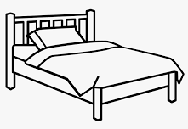

- Andika jina la picha kisha upake rangi (ala.12)


______________ ________________
Ab ch

_______________ _______________

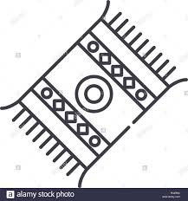

_______________ _______________

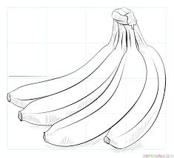
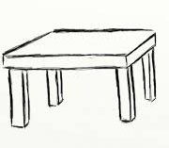

________________ _______________
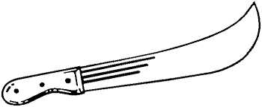

_______________ _______________
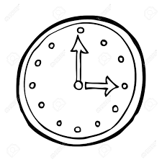
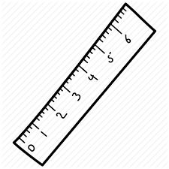
_______________ ______________

- Chagua jibu sahihi kukamilisha sentensi(ala8)
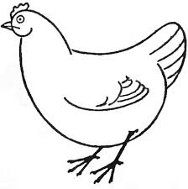

- Huyu ni _______________
- Ana miguu _____________________
(mine, miwili)
- Ana macho ______________________
(moja, mawili)
- Mwili wake umefunikwa na ___________
(manyoya, mabawa)

- Yeye hutumia ________________kuruka hewani (mabawa, miguu)
- Ni mnyama wa _____________________
( msituni, nyumbani)
- Chakula ni nafaka, majini na____________
( nyama, wadudu)
- Watoto wake ni ____________________
(Vifaranga, Ndama)
- Ana mdomo _______________________
(miwili, mmoja)

VIWANGO VYA UTHIMINI
Kuzidisha Matarajio | Kufikia matarajio | Kukaribia matarajio | Mbali na matarajio
45 – 50 | 35 – 44 | 25 – 34 | 0 – 24

COMPETENCE BASED CURRICULUM
G1
ENGLISH SECTION B
LITERACY
      - Write five sentences using ‘I am’
- ______________________________________________________________.
- ______________________________________________________________.
- ______________________________________________________________.
- ______________________________________________________________.
- ______________________________________________________________.

      - Make sentences using the following words;
- Boy
- School
- Cup
- Pencil
- Uncle
      - Name the pictures below

      - Read the following passage
Early one morning,a hunter took his huge net and went to the forest.He spread his net under a big tree. “Many birds come to this tree everyday,I am sure I will get a good catch today,”said the hunter.

COMPETENCE BASED CURRICULUM
G1
CREATIVE ARTS
- Name 4 different types of songs performed for different purposes in your community. The first answer is given.
- Wedding songs.
- …………………………………………………………………………………………
- …………………………………………………………………………………………
- …………………………………………………………………………………………
- …………………………………………………………………………………………
- Write the first verse of the Kenya National Anthem in English.
……………………………………………………………………………………………………………………………………………………………………………………………………………………………………………………………………………………………………………………………………………………………………………………………………………………………………………………………………………………………………………………………………………………………………………………………………………………………………………………
- Write the first verse of the Kenya National Anthem in Kiswahili.
……………………………………………………………………………………………………………………………………………………………………………………………………………………………………………………………………………………………………………………………………………………………………………………………………………………………………………………………………………………………………………………………………………………………………………………………………………………………………………………
- When do we sing the National Anthem in our school?
  - ………………………………………………………………………………………………………………………………………
  - ………………………………………………………………………………………………………………………………………

- Write the first verse and the chorus of the East African Anthem.
……………………………………………………………………………………………………………………………………………………………………………………………………………………………………………………………………………………………………………………………………………………………………………………………………………………………………………………………………………………………………………………………………………………………………………………………………………………………………………………………………………………………………………………………………………………………………………………………………………………………………………………………………………………………………………………………………………………………………………………………………………………………………………………………………………………………………………………………………………
- How do we stand when singing the National and East African Anthems?
………………………………………………………………………………………………………………………………………………
………………………………………………………………………………………………………………………………………………

- What does the Kenya National Anthem talk about?
………………………………………………………………………………………………………………………………………………………………………………………………………………………………………………………………………………………………………………………………………………………………………………………………………………………………………………………………………………………
- What is the message given by a lullaby song?
………………………………………………………………………………………………………………………………………………………………………………………………………………………………………………………………………………………………………………………………………………………………………………………………………………………………………………………………………………………

- Write 4 activities in your community when you sing.
………………………………………………………………………………………………………………………………………………………………………………………………………………………………………………………………………………………………………………………………………………………………………………………………………………………………………………………………………………………
……………………………………………………………………………………………………………………………………………………………
- Give three reasons why we sing.
………………………………………………………………………………………………………………………………………………………………………………………………………………………………………………………………………………………………………………………………………………………………………………………………………………………………………………………………………………………
- Write 4 communities that you know where we can learn different type of songs.
- …………………………………………………………………………………..
- …………………………………………………………………………………..
- …………………………………………………………………………………..
- ……………………………………………………………………………………
- Write four activities that we do when singing. The first answer is given.
- Clapping.
- ……………………………………….……………………………………………………………….
- ……………………………………….……………………………………………………………….
- ……………………………………….……………………………………………………………….
- ………………………………………..……………………………………………………………….

- Write 4 instruments that we can use to accompany our singing. The first answer is given.
- A hand drum.
- ……………………………………………….
- ……………………………………………….
- ……………………………………………….
- ……………………………………………….
- Which language is our school anthem written in?

……………………………………………………………………………

- A drum produce sound through beating. Write down how the following instruments produce sound.
- A kayamba …………………………………………………………….
- A shaker. ………………………………………………………………
- A jingle ………………………………………………………………
- A tambourine. ………………………………………………………………
- Write 3 sources of sound found in your home.
- ……………………………………………………………………..
- ……………………………………………………………………..
- ……………………………………………………………………..
17. Colour the parts of a plant.

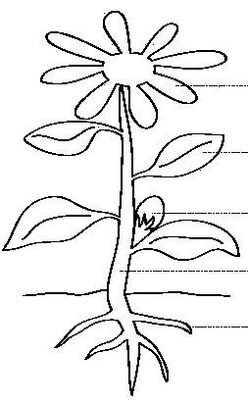

18. This is a line.


19. This is a line.


20. This is a line.
(curved, wavy, straight)

20. Complete the pattern
        - = ===

  - X X X

  - USUSUS

21. Draw and colour

car | cat | house
22. Colour the fruits we eat

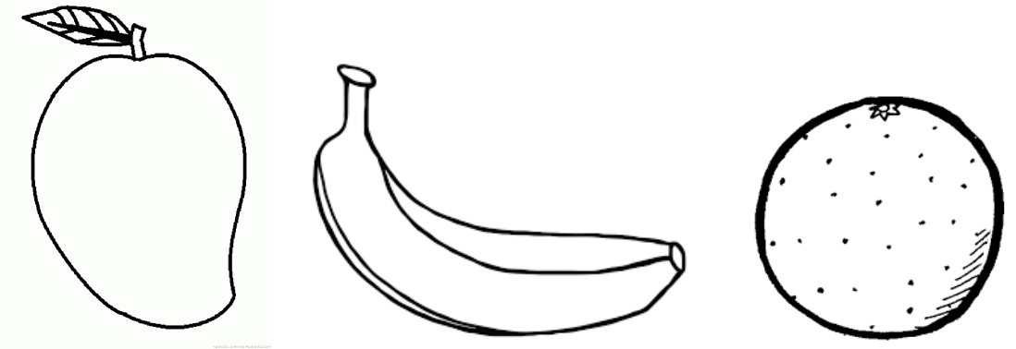

ENGLISH
G1

Fill in the missing sounds

1. | R |  |  |  |  |  | ler
2. | B |  |  |  |  |  | ll
3. | F |  |  |  |  |  | ther
4. | M |  |  |  |  |  | ther
5. | Fl |  |  |  |  |  | g
Name the pictures
6. |  |  |  |  |  |  | 7. | 8.
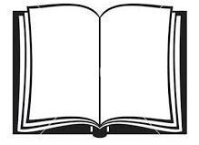
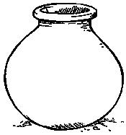
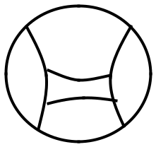

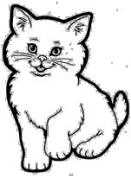


______________________ ___________________________

MATHEMATICS
G1

Count and write

1.
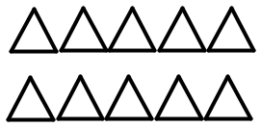


2.
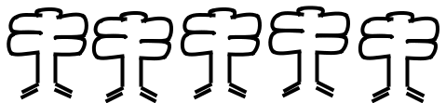

3.

 | Add
4. | 2 | + | 6 | =
5. | 3 | + | 4 | =
6. | 5 | + | 1 | =
7. | 7 | + | 0 | =

Write in words
- 3

- 9

- 8

Write the next number
- 16, 17, 18,

- 31, 32, 33,

- 23, 24, 25,

14. |  |  | 7 |  |  |  | 15. |  |  |  |  |  |  |  |  | 16. |  |  | 9
 |  |  |  |  |  |  |  |  |  |  |  |  | 8
 |  | 6 |  |  |  |  |  |  |  |  | 3 |  |  |  |  |  |  | 2
Place value
17. | 41 = |  |  |  |  |  |  | tens and |  |  |  |  |  |  |  | ones
18. | 64 = |  |  |  |  |  |  | tens and |  |  |  |  |  |  |  | ones
19. | 30 = |  |  |  |  |  |  | tens and |  |  |  |  |  |  |  | ones
20. | 19 = |  |  |  |  |  |  | tens and |  |  |  |  |  |  |  | ones
 |  |  |  |  |  |  |  |  |  | 5

Match the similar objects

21.



22.



23.

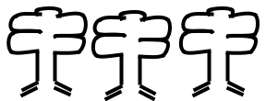

24.

25.

Name the shapes (star, circle, rectangle, oval, triangle)


26. 28.



27. 29.


30.

